Visual Statistics Appendix

Telecom Customer Churn Intelligence
Emmanuel Onuoha — 21 August 2026
This appendix presents selected statistical and decision-support visuals from the independent technical report. The dataset is fictional. Associations are not causal, and retention economics are scenario estimates.
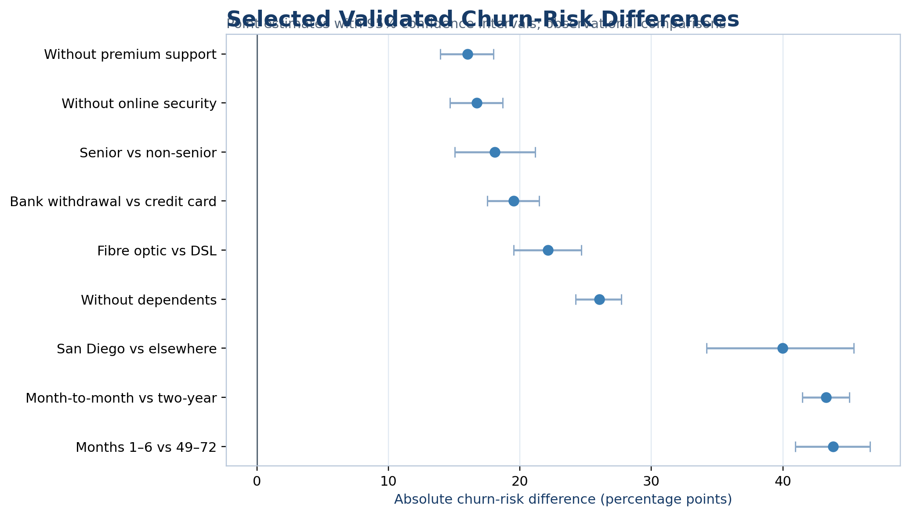
Figure A1. Selected validated churn-risk differences with 95% confidence intervals.
Early tenure and month-to-month contracts show the largest absolute descriptive risk differences. Confidence intervals quantify sampling uncertainty but do not remove confounding.
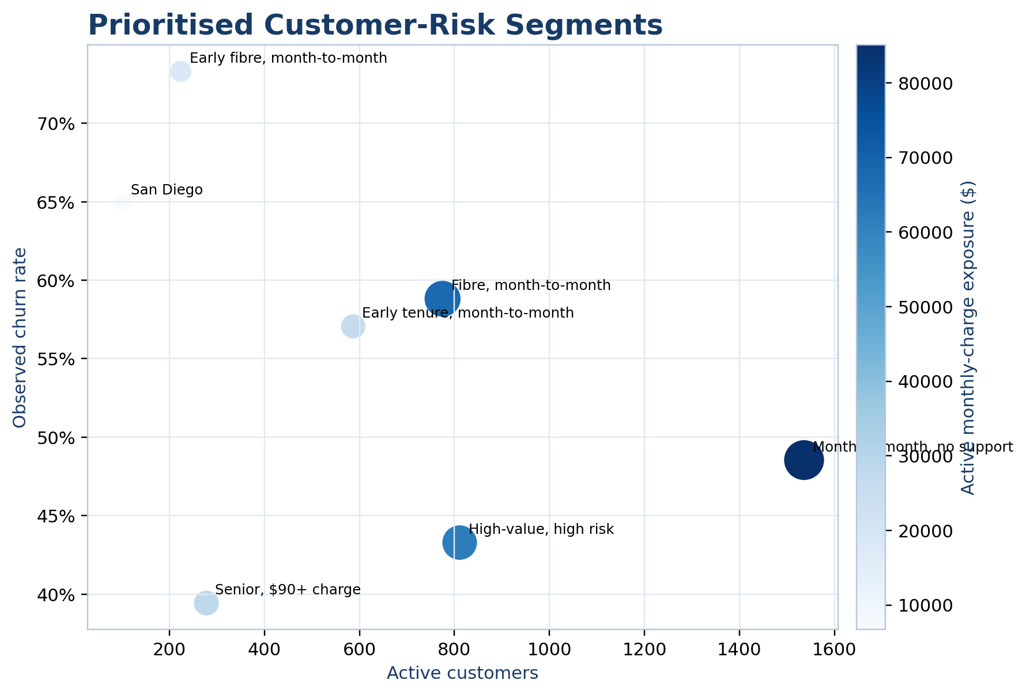
Figure A2. Prioritised risk segments.
The largest segments combine substantial churn exposure with meaningful active-customer value. Segments overlap and should not be summed.
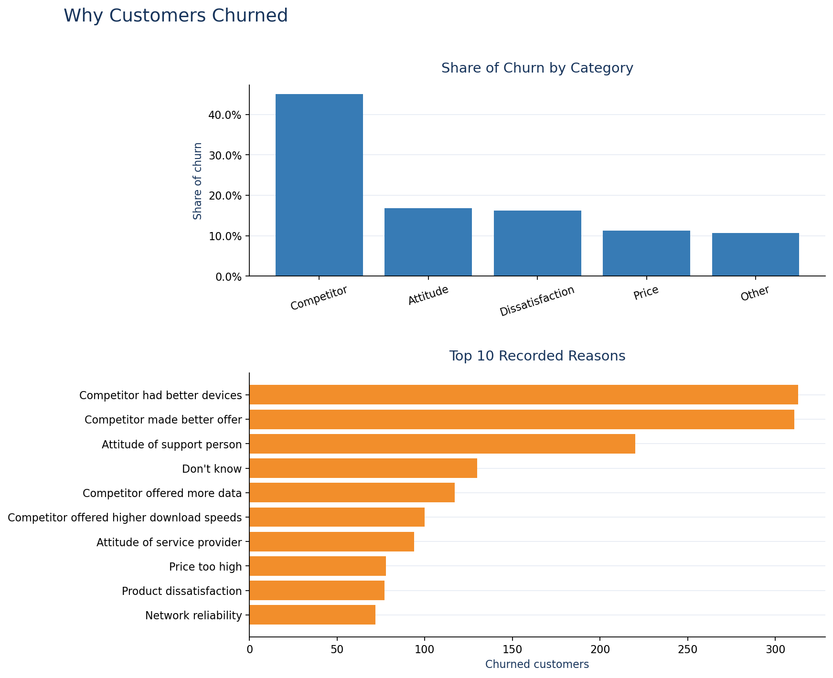
Figure A3. Retrospective churn categories and recorded reasons.
Competitor-related reasons dominate retrospective records. These post-churn fields were excluded from predictive modelling.
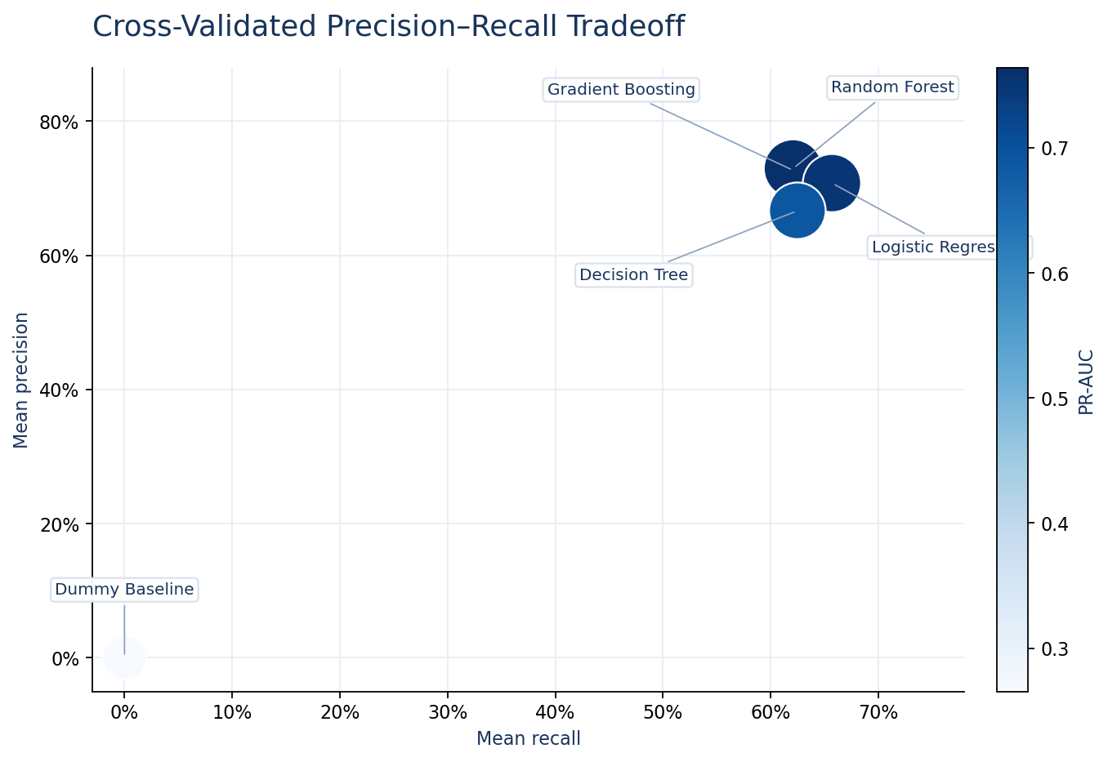
Figure A4. Cross-validated precision–recall trade-off.
Logistic regression was selected for its balance of discrimination, recall, calibration, and interpretability rather than the highest ROC-AUC alone.
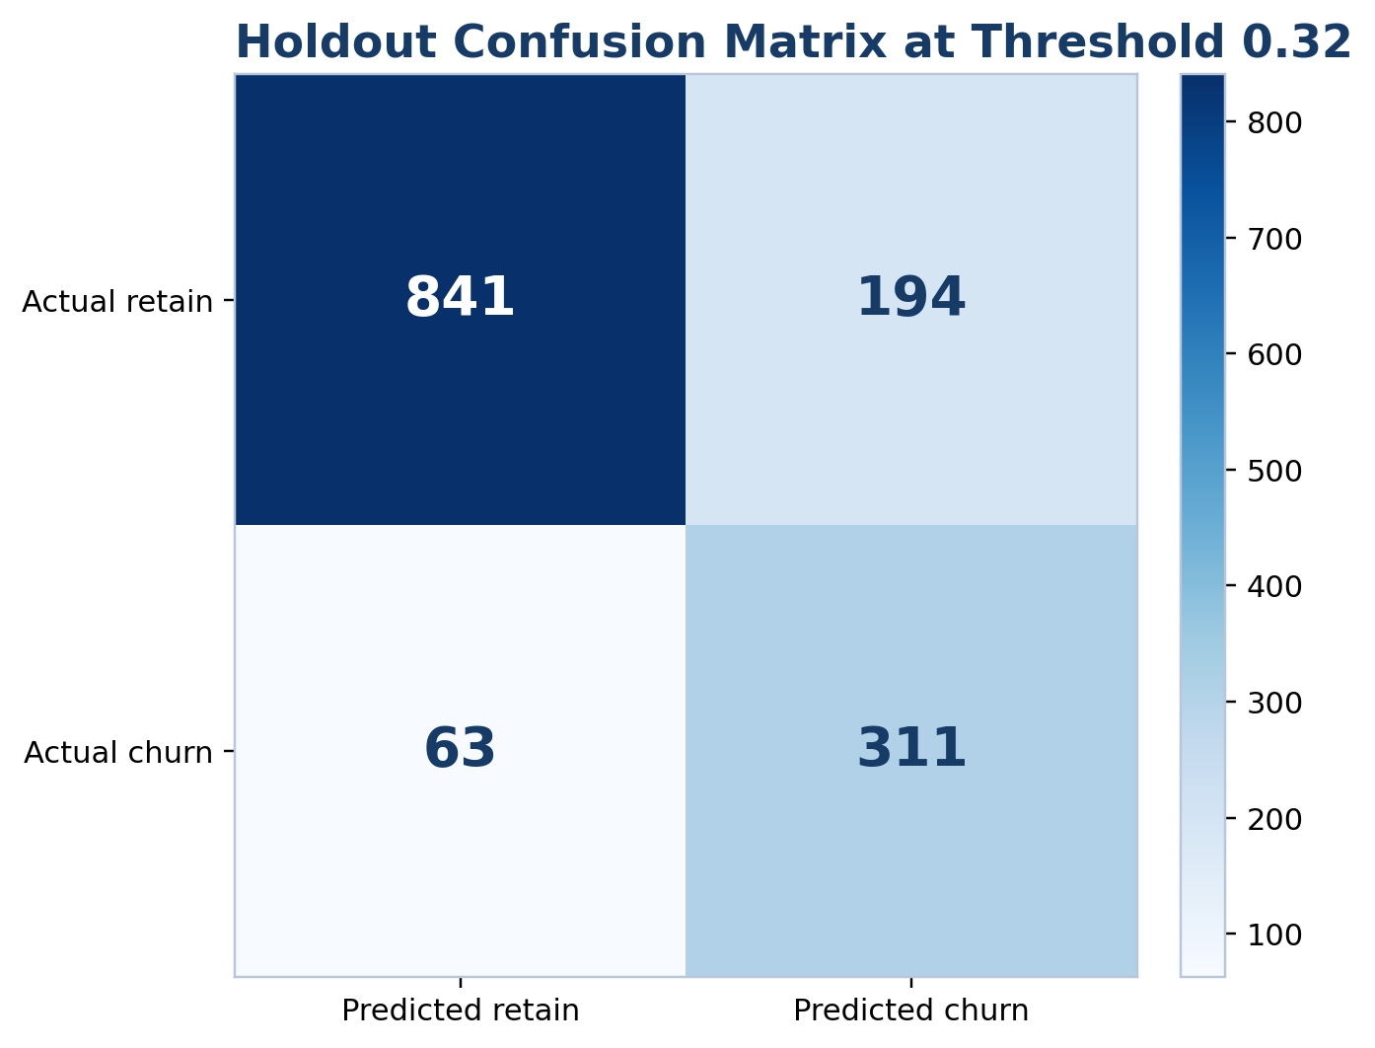
Figure A5. Holdout confusion matrix at threshold 0.32.
The selected operating point captured 311 of 374 holdout churners while flagging 505 of 1,409 customers.
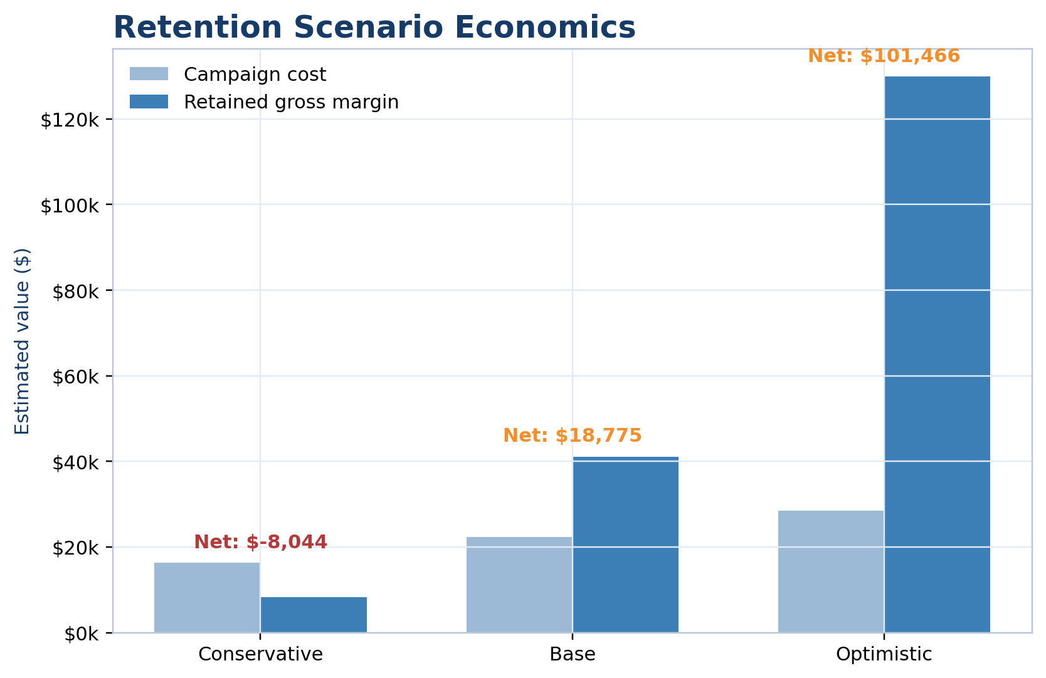
Figure A6. Scenario-based retention economics.
The range from negative conservative net benefit to strongly positive optimistic benefit demonstrates sensitivity to campaign assumptions.
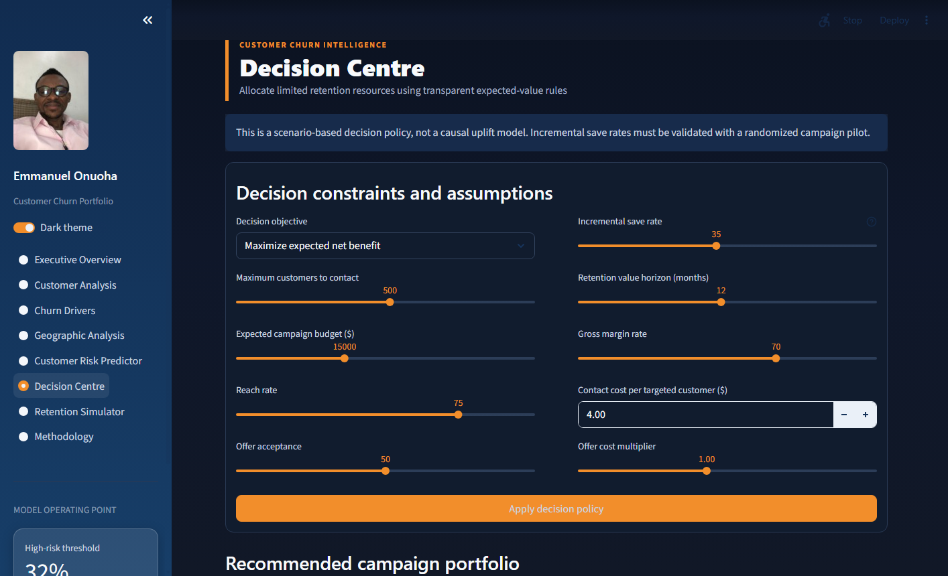
Figure A7. Implemented prescriptive Decision Centre.
The interactive implementation exposes campaign assumptions, capacity, budget, and decision objective to the user.
——————————————————
Developed and Designed by Emmanuel Onuoha

