**Assign #1**

260683698 Duan Li

Q1.

import java.util.LinkedList;

public class Queue {

private LinkedList<Student> participants;

public Queue(){

participants = new LinkedList<Student>();

}

/**

* This method is used to put student in the queue.

* @param s Student to put in the queue.

*/

public void enqueue(Student s){

participants.add(s);

}

/**

* This method is used to remove the first student in the queue from the queue.

* @throws EmptyQueue when there is no student in the queue.

*/

public void dequeue() throws EmptyQueue{

if(!participants.isEmpty()){

participants.pop();

}

else throw new EmptyQueue();

}

}

public class Student {

private String name;

private int age;

private int ID;

/**

* This is the constructor for Student.

* @param name The name of the student.

* @param age The age of the student.

* @param ID The ID number of the student.

* @throws AgeTooSmall when the person is less than 15 years.

* @throws InvalidID when the ID number is invalid (not begins with 22)..

*/

public Student(String name, int age, int ID) throws AgeTooSmall, InvalidID{

if (age<15) throw new AgeTooSmall();

if (ID>=22000 && ID<23000) throw new InvalidID();

this.name = name;

this.age = age;

this.ID = ID;

}

/**

* Return the age of the student.

* @return the age of the student.

*/

public int getAge(){

return age;

}

/**

* Return the name of the student.

* @return the name of the student.

*/

public String getName(){

return new String(name);

}

/**

* Return the ID number of the student

* @return the ID number of the student

*/

public int getID(){

return ID;

}

}

Q2

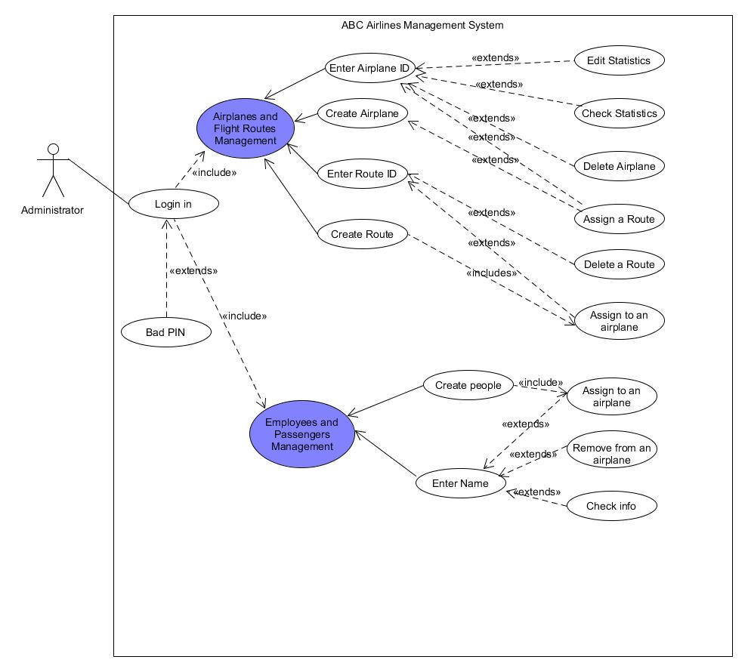

Title: Edit (Airplane) Statistics

Description: This allows administrator to edit statistics of an airplane.

Primary Actor: Administrator

Preconditions: Administrator is logged into system

Postconditions: The statistics of the selected airplane is edited.

Order list of sub-activities: 1. Administrator enter the airplane ID.

2. System displays list of option actions for the airplane.

3. Administrator clicks “Edit Statistic” button.

4. System displays all attributes of the airplane, the administrator can see the current values and edit some values.

5. Administrator clicks “Confirm”.

6. System changes the edited attributes of the airplane and displays a confirmation message.

Extensions:

2a. The airplane ID entered is invalid.

* 2a1. System displays error message saying the airplane ID is invalid and asks the administrator to enter the ID again.
* 2a2. Administrator either backs out of this use case or enters the ID again.

6a. The administrator entered some invalid values.

* 6a1. System displays error message saying the value the administrator tried to change to is invalid.
* 6a2. Administrator either backs out of this use case (the value remains unchanged) or tries again.

Q3.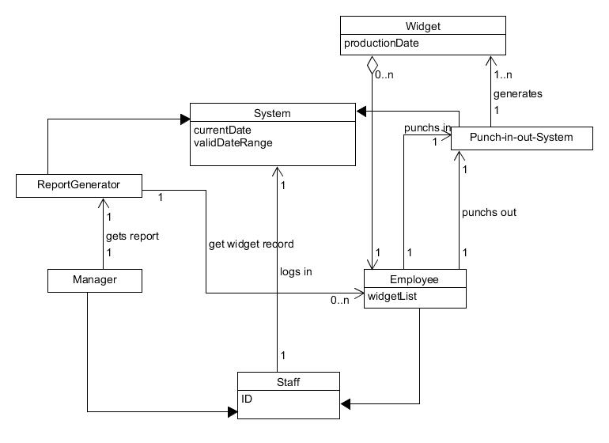

Q4

