Software Engineering Lab Assignment
Secure Information Hiding System Using Steganography

Course | CSE 3206 – Software Engineering Lab
Project Type | Secure data hiding system using steganography
Recommended SDLC | V-Model
Primary Actors | General User, Administrator
Student ID: | 23524202129  23524202051  23524202047  23524202095

1. Introduction
Software Development Life Cycle (SDLC) is a structured process used to plan, analyze, design, develop, test, deploy, and maintain software systems efficiently. Selecting the correct SDLC model is important because it directly affects software quality, development speed, risk handling, testing discipline, and documentation quality.
The selected project is Secure Information Hiding System Using Steganography. The system allows users to hide secret text or files inside digital media, optionally protect hidden data with a password, and later extract the hidden data when the correct credentials are provided. The system also includes user authentication and operation logging for monitoring purposes.

2. Problem Analysis
The Secure Information Hiding System is intended for academic use and aims to provide a secure and user-friendly method for hiding confidential information inside digital media. The product scope focuses on secure data hiding, ease of use, and preservation of data integrity.
According to the SRS, the system supports two main user classes:
- General User: embeds and extracts secret data using a simple interface.
- Administrator: manages user access and monitors system usage.
The key functional requirements include registration and login, cover media upload, secret text or secret file input, optional password protection, embedding and extraction of hidden data, download of the stego file, prevention of extraction with incorrect credentials, and logging of embedding and extraction operations.
The non-functional requirements emphasize performance, security, usability, reliability, and portability. The project also has practical constraints such as cover-file capacity limits, the effect of lossy media formats on extraction accuracy, and the need to complete development within the academic semester.

Factors Affecting SDLC Selection
- Project size (small / medium / large)
- Requirement clarity (clear / changing)
- Risk level (low / high)
- Time constraints
- Budget
- Customer involvement
- Team expertise

4. Comparison of SDLC Models
To choose the most appropriate SDLC model, a comparison matrix was prepared. The following scoring scale was used: 1 = Very Poor Fit, 2 = Poor Fit, 3 = Average Fit, 4 = Good Fit, and 5 = Excellent Fit.
Criteria | Weight | Waterfall | V-Model | Iterative | Spiral | Agile
Requirement clarity/stability | 5 | 5 | 5 | 3 | 3 | 2
Security and data integrity | 5 | 3 | 5 | 4 | 5 | 3
Strong testing and validation | 5 | 3 | 5 | 4 | 4 | 3
Suitability for semester project | 4 | 5 | 4 | 4 | 2 | 4
Risk handling | 3 | 2 | 3 | 3 | 5 | 3
Ease of documentation and planning | 3 | 4 | 4 | 4 | 2 | 3
Ease for student team execution | 3 | 4 | 4 | 4 | 2 | 3
Weighted Total |  | 105 | 124 | 104 | 95 | 83

5. Selected SDLC Model
Chosen Model: V-Model
The V-Model is the most appropriate SDLC model for the Secure Information Hiding System Using Steganography. It is a strong fit because the requirements are already well defined, the system needs disciplined verification and validation, and the project must demonstrate both correctness and documentation quality in an academic setting.
This project contains security-sensitive functions such as login, password-protected extraction, rejection of incorrect credentials, and logging of operations. These requirements benefit from a model in which each development phase is paired with a corresponding testing phase. The V-Model supports that structure directly.
Compared with Waterfall, the V-Model places greater emphasis on testing throughout the development lifecycle. Compared with Agile and Iterative models, it is better suited to a project with stable requirements. Compared with Spiral, it is simpler and more practical for a student project completed within a semester.

6. Justification
The Secure Information Hiding System requires a structured development process because the system must satisfy security, reliability, and correctness requirements. Users must be able to register, authenticate, upload files, hide confidential information, and later extract that information safely. The system must also reject invalid extraction attempts and maintain operational logs.
The V-Model is the best choice because it provides a direct relationship between development phases and testing phases. Requirements can be validated through acceptance testing, design can be checked through system and integration testing, and modules can be verified through unit testing. This reduces defects, improves traceability, and makes the final product easier to evaluate.
Therefore, the V-Model offers the best balance of structure, testing discipline, academic suitability, and project manageability for this system.

Use Case Diagram
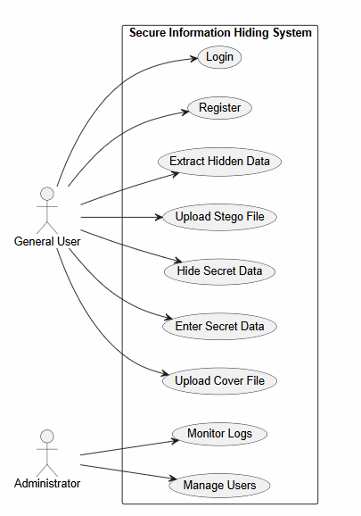

8. User Stories
- As a general user, I want to register an account so that I can use the system securely.
- As a general user, I want to log in with username and password so that only authorized users can access features.
- As a general user, I want to upload a cover media file so that I can hide secret information inside it.
- As a general user, I want to enter secret text or upload a secret file so that I can conceal confidential data.
- As a general user, I want to protect hidden data with a password so that unauthorized users cannot extract it.
- As a general user, I want to embed secret data into a cover file so that my information remains hidden.
- As a general user, I want to download the stego file so that I can store or share the protected file.
- As a general user, I want to upload a stego file for extraction so that I can recover hidden information later.
- As a general user, I want the system to extract hidden data only when the correct password is provided so that my data remains secure.
- As a general user, I want the system to block extraction when wrong credentials are entered so that unauthorized access is prevented.
- As an administrator, I want to manage user access so that the system remains controlled and secure.
- As an administrator, I want to monitor embedding and extraction logs so that system activities can be tracked.

9. Conclusion
After analyzing the project requirements and comparing common SDLC models, the V-Model is the most appropriate choice for the Secure Information Hiding System Using Steganography. The project has clear and stable requirements, moderate security risks, and a strong need for systematic testing and validation.
The V-Model supports these needs by linking each development phase with a corresponding testing activity. It is also practical for a student team working within a semester and aligns well with the goals of documentation, evaluation, and reliable implementation.

