[Fhernandezm@unal.edu.co](mailto:Fhernandezm@unal.edu.co)

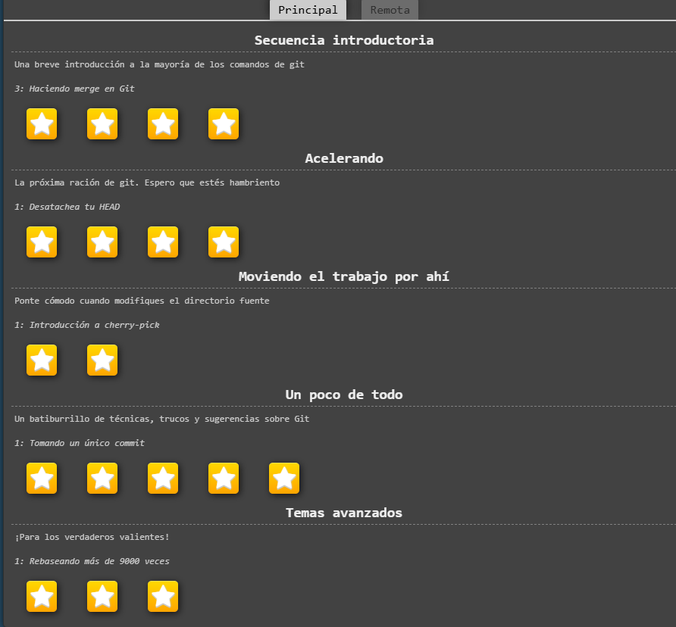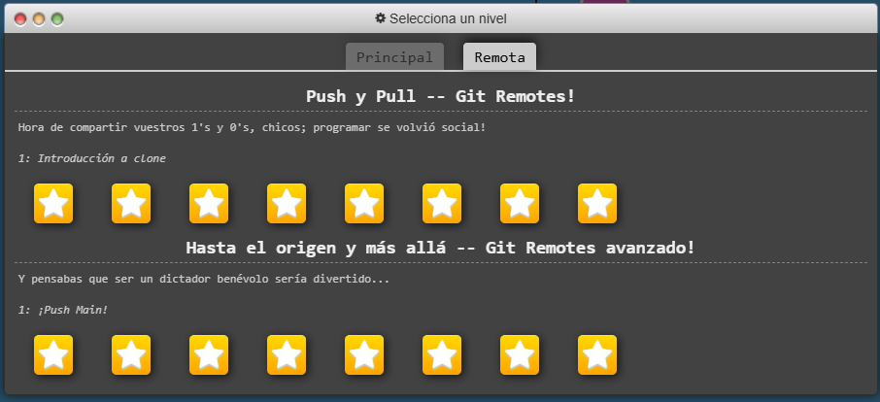

[Juserranor@unal.edu.co](mailto:Juserranor@unal.edu.co)

