# Seting Up a Spyder Python Project: Data Realigner

1. Creating a new Spyder python project and adding Emotibit modules
   1. Open Spyder
   2. Go to the Projects/New Project menu
   3. Create a new project. A new folder will be automatically added to the specified location

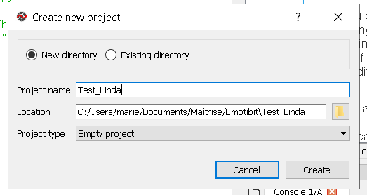

* 1. Add the Emotibit_Biometric_Lib master files and folders (downloader from github <https://github.com/EmotiBit/EmotiBit_Biometric_Lib>) to the newly created project folder.

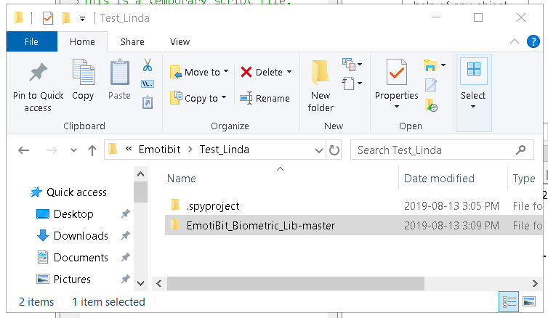

In Spyder they will appear in the Project Explorer

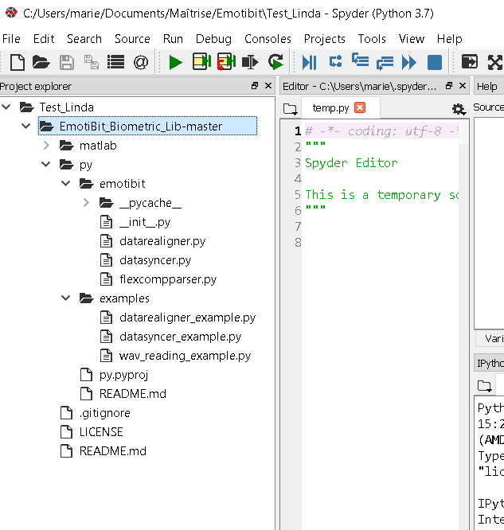

1. Add the path to the Emotibit modules (or libraries)
   1. In Spyder, go to the Tools/ PYTHONPATH manager menu
   2. Click ok « + Add Path » and select the path to the EmotiBit_Biometric_Lib\py folder (inside your newly created project folder)
   3. Make sure the folder is checked before closing the PYTHONPATH manager
   4. Optional: Click on the Synchronize button to permanently add the path to your computer environment variables

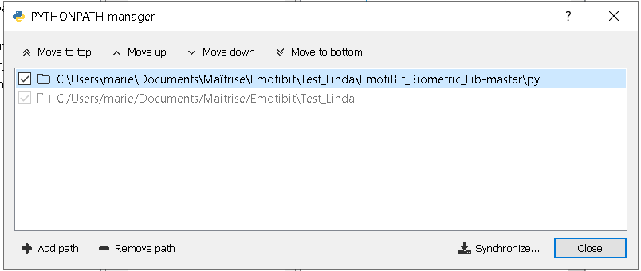

1. Make the code run
   1. Open the EmotiBit_Biometric_Lib\py\examples\datarealigner_example.py file by double clicking on it in the Project Explorer
   2. Change the lines 20-21 for the path your Emotibit files
   3. Change the line 23 to the data_type you want to load (one at a time)
   4. Change the lines 43-44 for your Flexcomp corresponding files
   5. Change the line 88 for a path and file name where the realigned data will be saved
   6. Save your new code with ctrl-s
   7. In the Project Explorer right click on the datarealigner_example.py and select Run

**Please note the the code may take several minutes to execute**

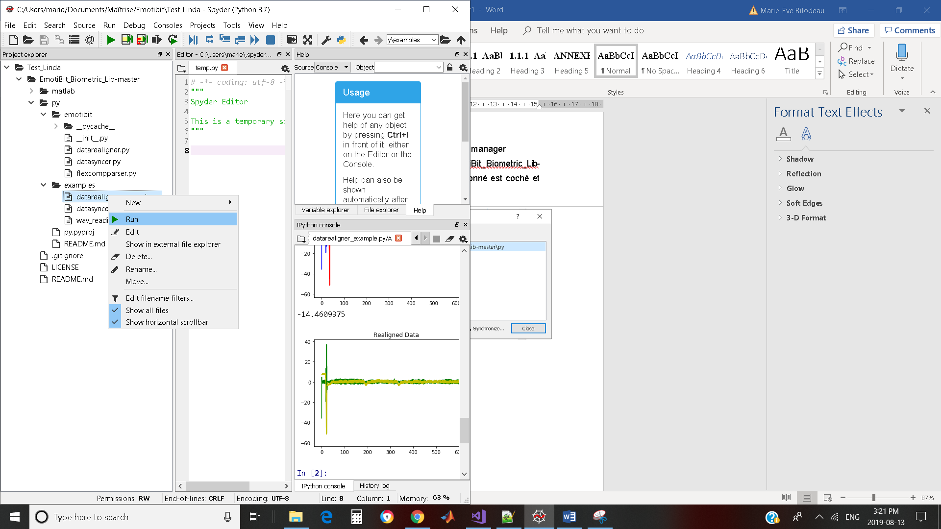

Here is an example of the console results

The first lines are the Emotibit and Flexcomp data being loaded.

The first graph shows the data before it is realigned.

The found delay is printed (here -14,4609375s).

The second graph shows the data realigned.

The final realigned data is saved to the specified .txt file (line 88)

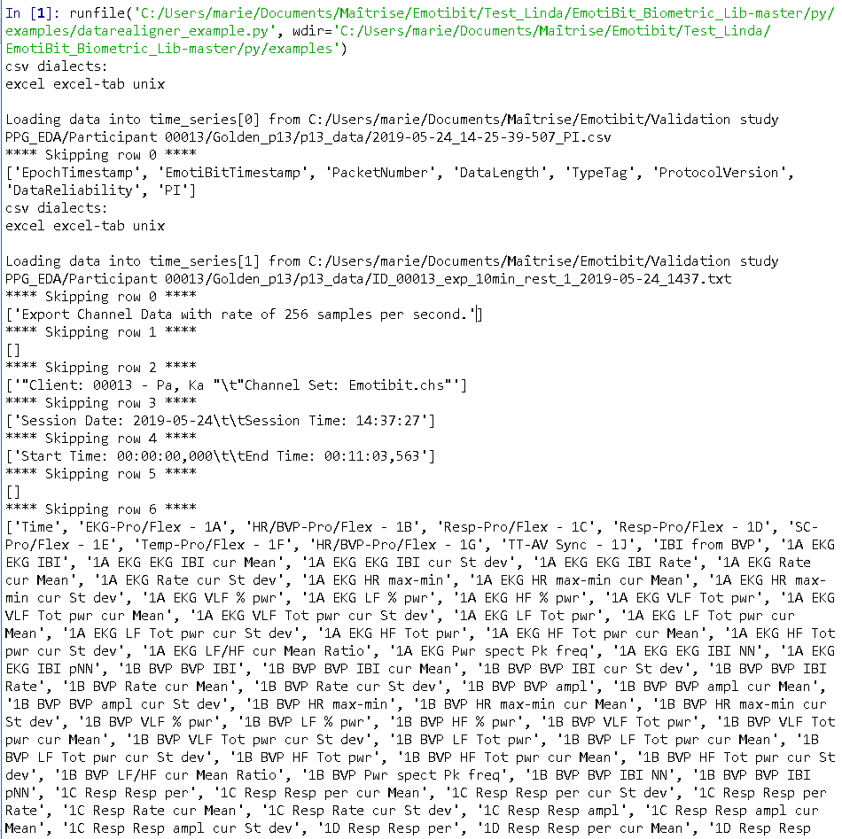

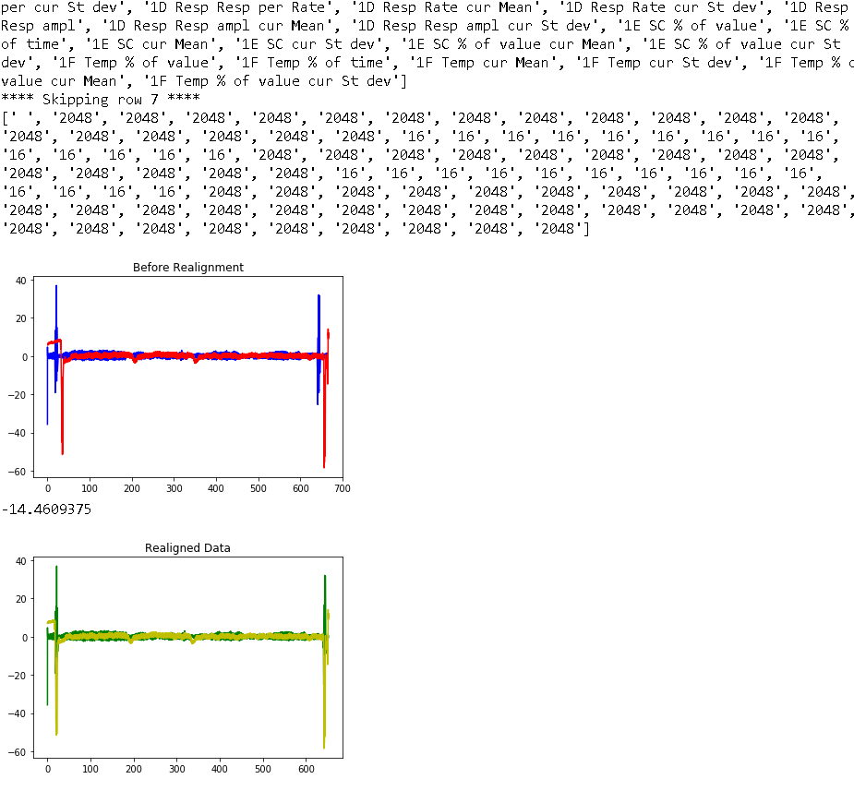

1. To be able to zoom in Figures
   1. Go to the Tools/Preferences menu
   2. In the Preference window, click on “IPython console” then on the “Graphics” tab.
   3. Check “Automatically load Pylab and NumPy modules”
   4. In the Graphics backend section select “Automatic”
   5. Click Apply and Ok

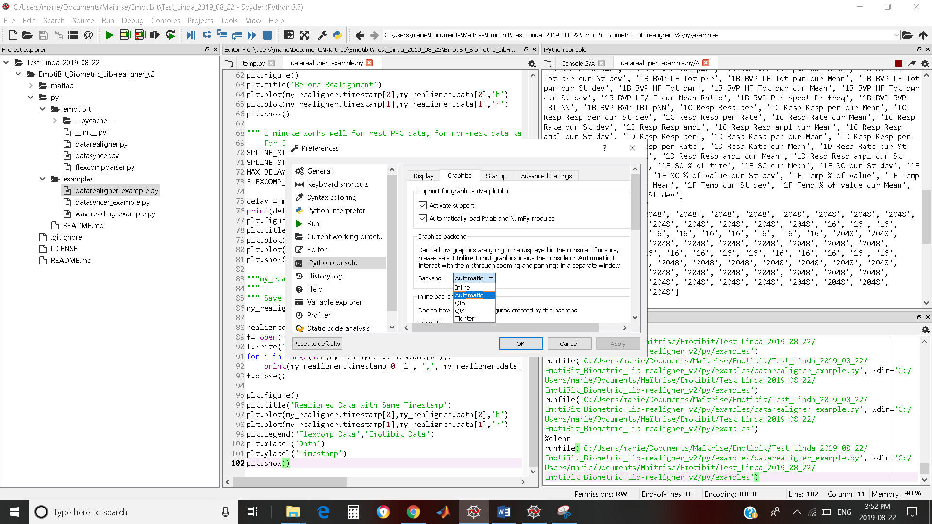

* 1. Restart the kernel
     1. In IPython console panel, right click on the datarealigner_example.y/A console and click on “Restart kernel”

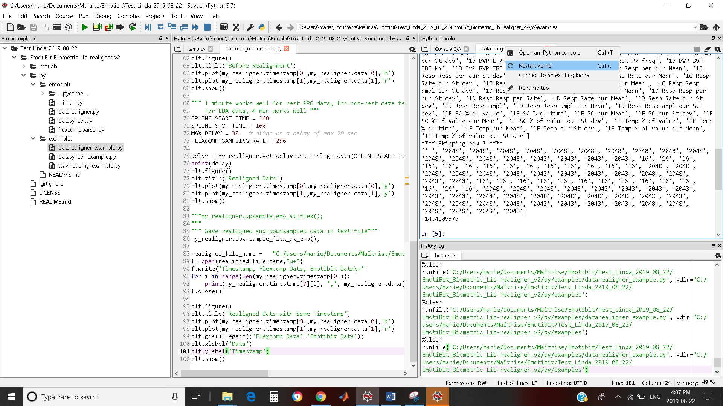

* 1. Now if you re-run the datarealigner_example the figure will apprear in pop-up windows and you’ll be able to zoom and pan the signals

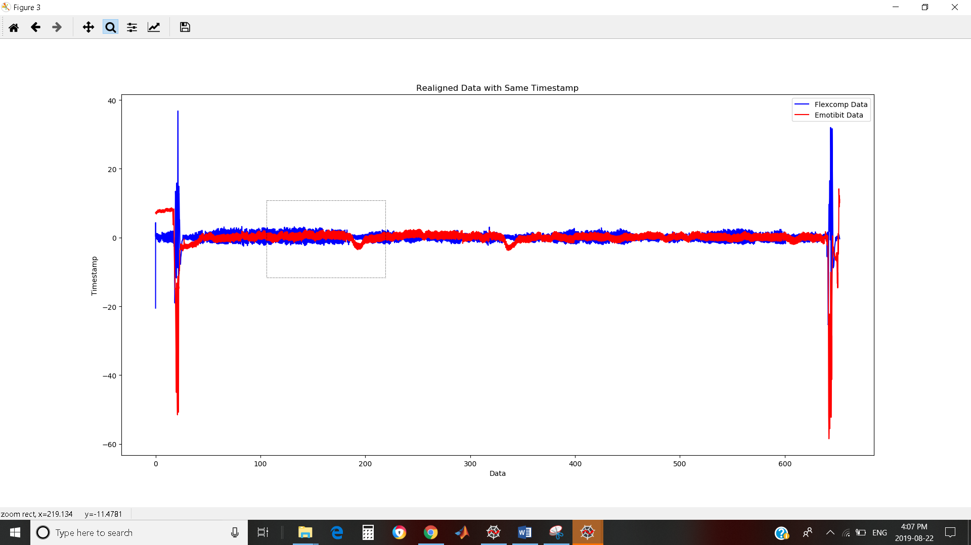

# DATA Realigner Example code explanation

1. First we get the Emotibit and Flexcomp data from the files

This is done by the get_data_from_datasyncer function (called at line 54)

This function used the same code as the datasyncer_example.py file

* The golden Emotibit data is stored in my_syncer.time_series[0].timestamp, my_syncer.time_series[0].data variables
* The golden Flexcomp data is stored in my_syncer.time_series[1].timestamp, my_syncer.time_series[1].data variables

1. The Emotibit and Flexcomp data are then loaded into the realiger, the DC component are removed and the Emotibit data is inverted (line 59 at True, required only for PPG)
2. The Emotibit and Flexcomp data are realigned (line 75) using lines 70-73 variables

Ex: SPLINE_START_TIME = 100

SPLINE_STOP_TIME = 160

MAX_DELAY = 30 # align on a delay of max 30 sec

FLEXCOMP_SAMPLING_RATE = 256

A subsection (here 1min) of the Emotibit data is upsampled (with a spline) at the flexcomp sampling rate and then iteratively moved over the Flexcomp data (here on a range of +/- 30s) to find the perfect fit.

* The realiged Flexcomp data is stored in my_realigner.timestamp[0], my_realigner.data[0] variables
* The realigned Emotibit data is stored in my_realigner.timestamp[1], my_realigner.data[1]

This portion of code only realign both data, the data rates are not modified

1. The Emotibit and Flexcomp data rates are then matched (line 86) and the data are saved (lines 88-93)

Line 86 takes the realigned data and downsamples Flexcomp data at Emotbit rate (with a spline)