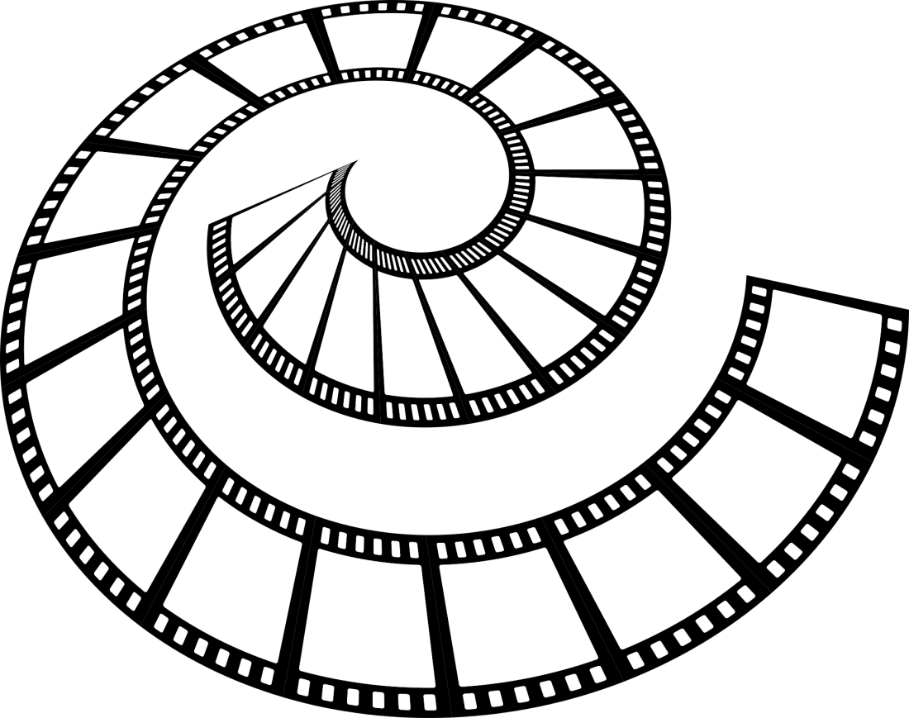

Relatório PAP

Pedro Marques  
12º F2  
2016/2017

# Índice

Chapter 1 #

Section 1.1 #

Section 1.2 #

Section 1.3 #

Chapter 2 #

Section 2.1 #

Section 2.2 #

Section 2.3 #

Chapter 3 #

Section 3.1 #

Section 3.2 #

Section 3.3 #

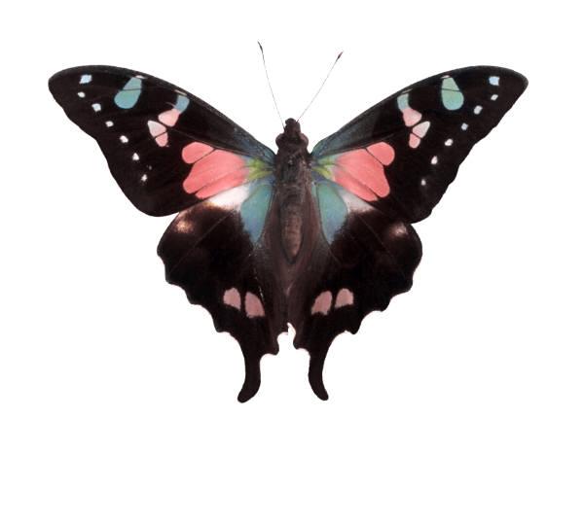

# MEDIAN HEADING 1|ONE

On the Insert tab, the galleries include items that are designed to coordinate with the overall look of your document. You can use these galleries to insert tables, headers, footers, lists, cover pages, and other document building blocks. When you create pictures, charts, or diagrams, they also coordinate with your current document look. On the Insert tab, the galleries include items that are designed to coordinate with the overall look of your document. You can use these galleries to insert tables, headers, footers, lists, cover pages, and other document building blocks. When you create pictures, charts, or diagrams, they also coordinate with your current document look

## Heading 2|two

You can easily change the formatting of selected text in the document text by choosing a look for the selected text from the Quick Styles gallery on the Write tab. On the Insert tab, the galleries include items that are designed to coordinate with the overall look of your document. You can use these galleries to insert tables, headers, footers, lists, cover pages, and other document building blocks. Most controls offer a choice of using the look from the current theme or using a format that you specify directly.

The quote is bold and distinctive. The galleries include items that are designed to coordinate with the overall look of your document.

On the Insert tab, the galleries include items that are designed to coordinate with the overall look of your document. You can use these galleries to insert tables, headers, footers, lists, cover pages, and other document building blocks. When you create pictures, charts, or diagrams, they also coordinate with your current document look.

### Heading 3|three

To change the overall look of your document, choose new Theme elements on the Page Layout tab. To change the looks available in the Quick Style gallery, use the Change Current Quick Style Set command. Both the Themes gallery and the Quick Styles gallery provide reset commands so that you can always restore the look of your document to the original contained in your current template.

You can easily change the formatting of selected text in the document text by choosing a look for the selected text from the Quick Styles gallery on the Write tab. You can also format text directly by using the other controls on the Write tab. Most controls offer a choice of using the look from the current theme or using a format that you specify directly.

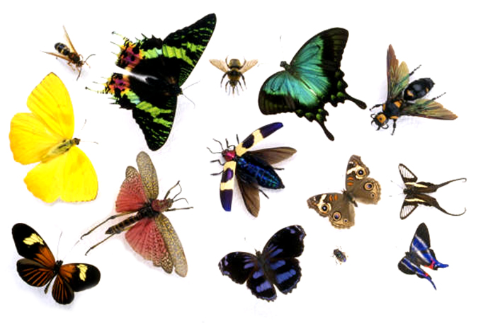

# BIBLIOGRAPHY

**First reference.** The text begins at the left margin of the paper. Lines are double-spaced. When the entry is longer than one line, the second line is automatically indented.

**Additional references.**