Performing a Super iCybie (SiC) upgrade

Abstract

A document which contains the steps taken to upgrade two iCybie robotic dogs to make them compatible to interfacing directly with a computer. Part two will address a connection to the robot from Eclipse.

**Introduction**

The iCybie with Revision ‘D’ motherboard, manufacture date 24 May 2001, is a canine-style anima containing code on an internal ROM which manifests its behaviors. This robot also contains an external connection where a 40-pin (flash memory) card can be utilized to expand the internal memory. Although the original robot comes with a dummy card, an aftermarket accessory, the walk-up charger contains a chipped memory card containing *.h and *.bin files loaded by a bootstrap program.

If the robot is prepared by a hardware modification where the internal ROM can be accessed, it is possible to connect it to a computer using a 9-pin serial port.

**Preparing the Robot**

The robot can be modified with the introduction of the MAX233CPP integrated circuit in line between the modem of the robot and a three-terminal external I/O port. At the external port, a stereo jack is installed to the top right of the battery compartment. A cable can now be connected, built to adapt the stereo jack to three pins—pin 2, 3, and 5—while pins 1, 4, and 6, 7 and 8 are connected together on the 9-pin serial.

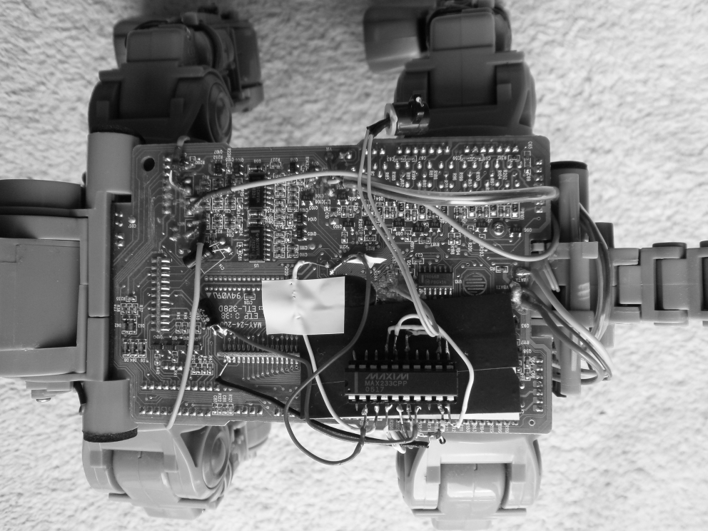

Fig.1. The addition of MAX233 to upgrade to RS-232.

The modification consists of soldering a wire harness to a DIP socket, as well as connecting to the power supply, ground, and TxD-RxD of the serial port. The MAX233 is connected to the robot according to the schematic, shown in Fig.2.

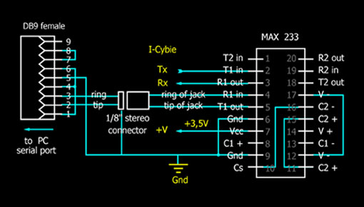 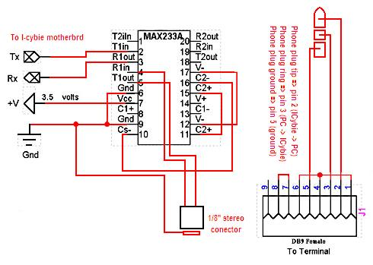

Figure 2. IC in circuit. MAKE YOUR OWN

Words.

**Preparing the Memory Card**

The memory card contains two 128K x8 CMOS multi-purpose flash, for a total of 2 x 1 Mbit / 256kB addressable memory, numbered SST39VF010. When the card is acquired with the walk-up charger, the card contains *.bin files which load to the iCybie internal memory upon boot.

In order to configure the robot’s internal memory to use the hardware modification, two files—*cromnist-h.bin* and *cromnist-l.bin*—need to be uploaded to the memory card. With the memory card installed in the robot, on boot the files are used to add an 8kB program, *C-ROM*, to the bootstrapper, interrupting the process to include the hardware connection.

To use the Downloader.exe program original supplied, a second program AllowIo.exe which opens the parallel port at 0x378. To run the program Downloader.exe, a *.bat file is required with the following contents:

allowio.exe downloader.exe 0x378

The program then will run, shown in Fig.3.

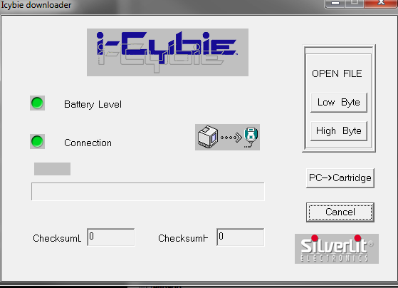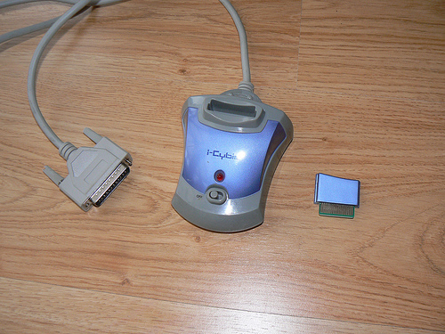

Fig.3. Downloader program showing connection to the hardware unit.

Selection of the two files: *cromnist-l.bin* by opening the file from the folder containing the downloader program using “Low Byte”, *cromnist-h.bin* using “High Byte”, then using “PC 🡪 Cartridge” will save the files onto the memory card.

**Applying the CROM program**

Having everything ready, it is now possible to upgrade the robot’s system ROM to include the CROM bootstrap. THIS STEP DOES NOT WORK. How about ICBURN?

**Using ICBURN**

This returns the message: “FATAL: can't determine file type 'crominst-l.bin'”.

Have contacted the author of the software. I was given the advice:

For “icburn” the usage is:

usage: icburn [flags] base_filename

     (version 0.01

     Sends image file to cartridge via Downloader

     Downloader with cartridge must be attached to parallel port

     input files:

           base_filename-l.bin = lower half

           base_filename-h.bin = upper half

           (or) filename.ic3 = all in one file

     flags:

           -t trust-me mode (don't verify)

So use “icburn crominst” where the two BIN files are in the current folder.

ICBURN is more reliable than the SilverLit downloader, but it depends on your parallel port hardware.

Getting the error:

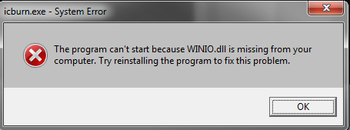

Fig.4. WinIo.dll error.

Which I can remedy with a library I acquired from the parallel-port debugger project.

This does not work either, I now get:

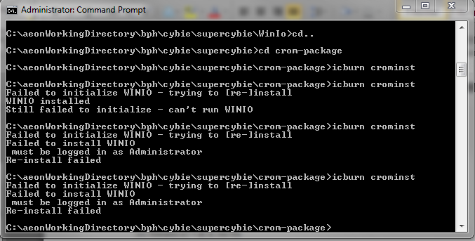

Fig.5. Manually installing WinIo.dll.

But it is clearly noted the command prompt is in Administrator mode.

Project on hold again. After some thought…

Having found the correct version of WinIO.dll for ICBURN, I can now run the program. The first thing to do is to test that the downloader is talking correctly to the parallel port by showing two green lights in the program window, as shown in the right-side of Fig.6.

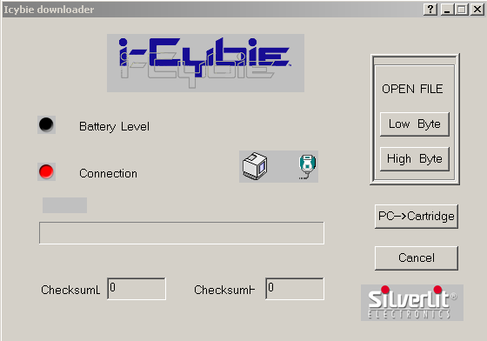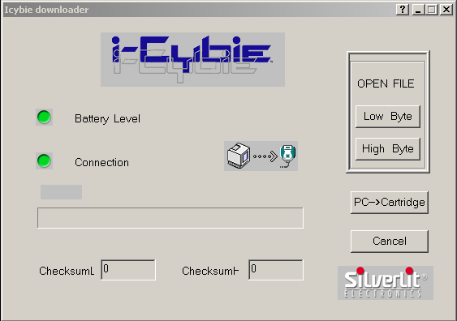

Fig.6. Left: Downloader program not connected; Right: Downloader program connected.

If the downloader program is running, it will interfere with the icburn program, so it must be closed during the first burn. If a second burn is required, the downloader program can be used to reset the interface, the it should be closed. Using the command: icburn -t cromnist

Will yield the following behavior in the command-prompt:

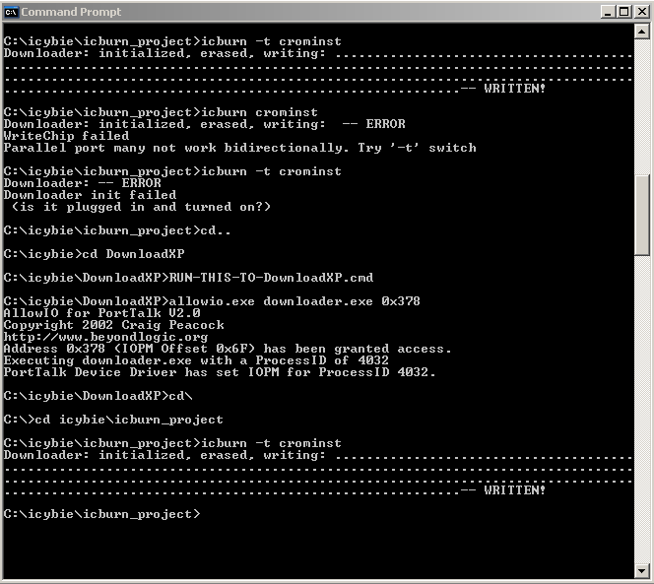

Fig.7. Successful writing of Cromnist bootloader to iCybie memory card.

Fig.7. shows two operations of writing, to test repeatability of the process. The error shown is because a second burn command was issued before the connection was reset—by running the downloader program to connect then disconnect.

Once the CROMNIST bootloader has been successfully written, starting iCybie will show two steady red eyes, shown in Fig.8. If the bootloader is wrong, then the eyes will flash yellow and green.

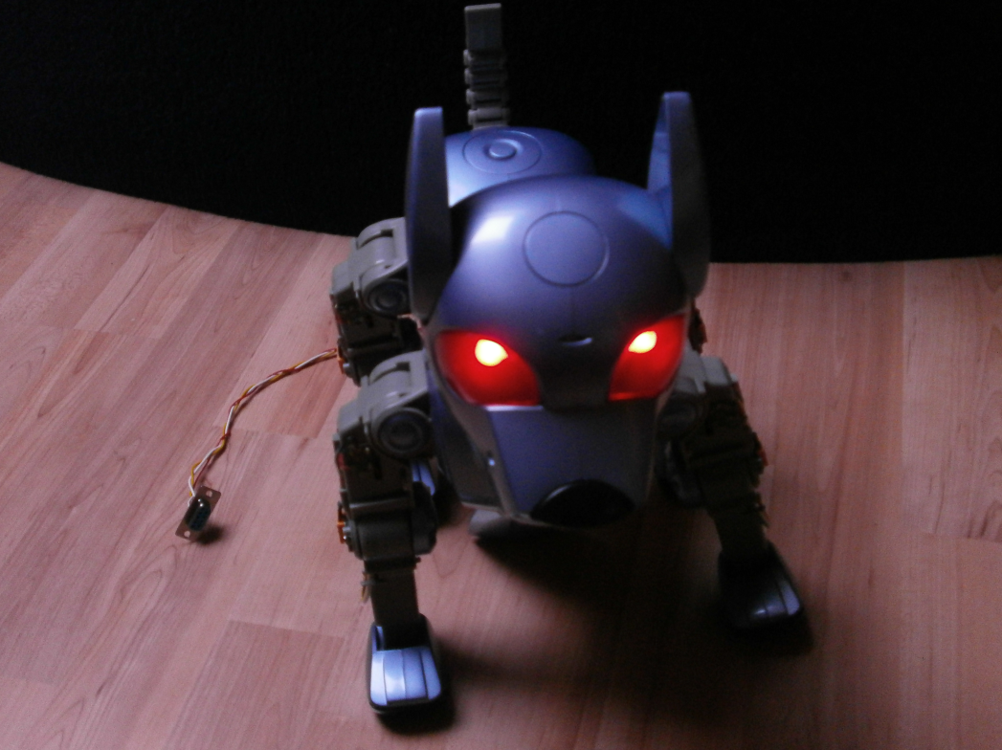

Fig.8. iCybie with CROMNIST card.

Fig.8 also shows the 9-pin serial cable connected to the robot. The next step is to connect the serial cable to the computer and install the bootloader image into the iCybie ROM so that the SiC upgrade is complete.

1. Connect your cable between iCybie and your PC,
2. Use bray’s terminal (http://) set to 9600 baud, 8 data bits, no parity, no handshake,
3. Place the CROMINST cartridge in the side of your iCybie (press it in tightly),
4. Connect up the battery. You don't have to worry about the battery door.

If you see a bunch of U’s on your terminal program - congratulations the serial from iCybie to your PC is working, shown in Fig.9. If not please check your connections.

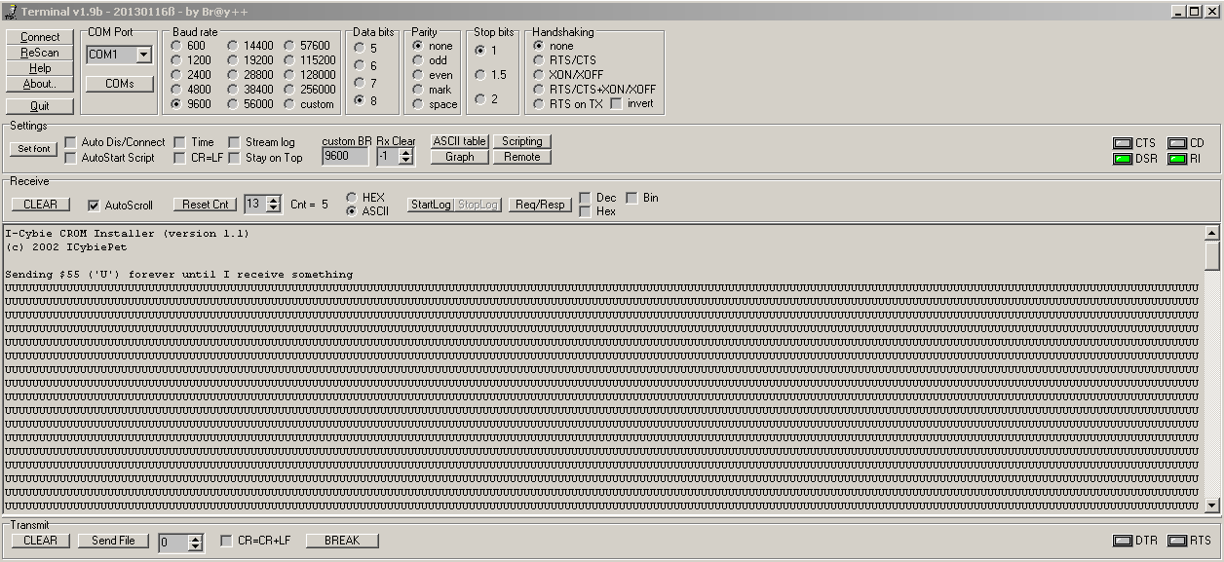

Fig.9. iCybie talking to the terminal via the serial port.

When you see a bunch of U’s, press any key on your keyboard. If the serial connection from your PC to ICybie is working, the U’s will stop and you will get the CROMINST menu.

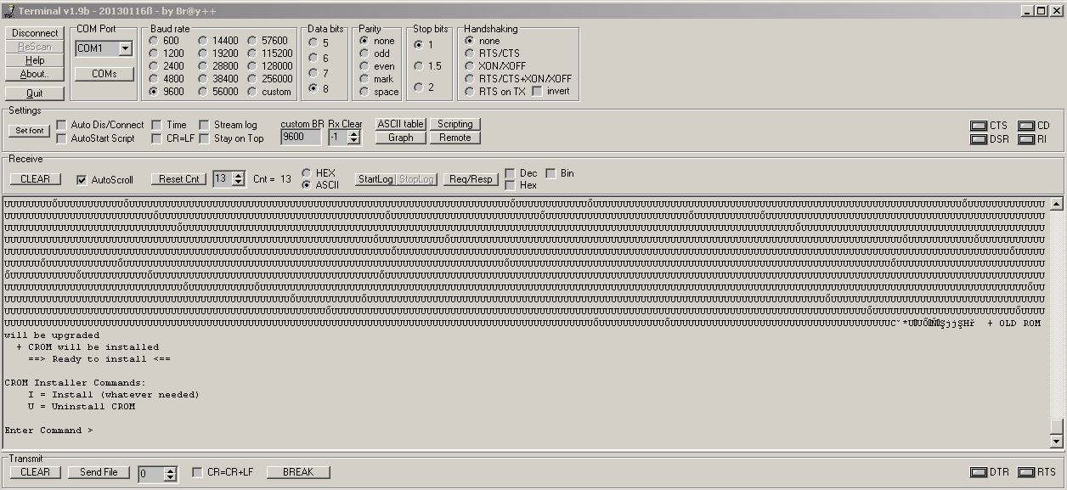

Fig.10. CROMINST menu to upgrade ROM.

*CROM Installation*

Type ‘I’ in the send command box to install CROM and any other upgrades. You will be presented with a screen shown in Fig.11.

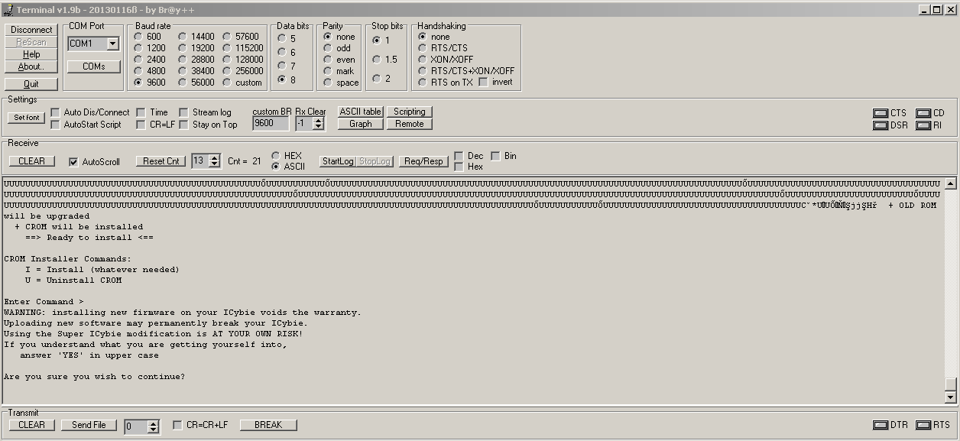

Fig.11. CROM installation prompt.

If you are ready to take the plunge, type ‘YES’ (in upper case). It will take a very short time and then tell you it is done.

Type: ‘YES’ and you will be presented with the screen shown in Fig.12.

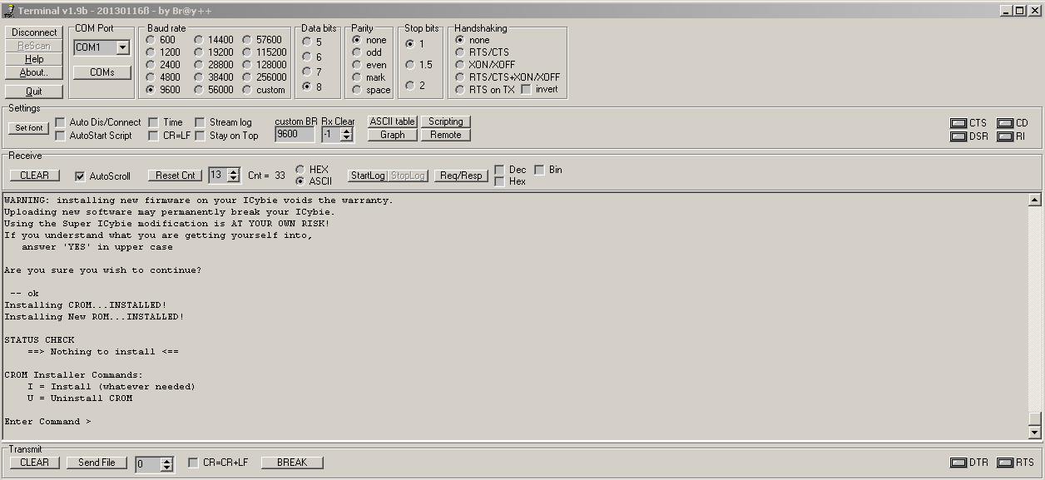

Fig.12. New ROM installed into iCybie.

To finish up:

1. Disconnect at the terminal application,
2. Disconnect the cable from the computer,
3. Unplug and remove the battery,
4. Remove the cable from iCybie,
5. Remove the cartridge,
6. Plug in the battery again, close the battery door, and make sure iCybie is still sane.

You use the CROMINST program \***ONCE**\* to patch the system ROM. Then you put the Walkup personality back on the cartridge or use the more sophisticated Z2 iCybie personality.