Two distinct spatial and temporal variations of PM2.5 and PM10 concentrations in urban and rural areas of Mongolia

Erdenebayar Munkhtsetseg

Atsushi Shimizu

Atsushi Matsuki

2024-10-15

Abstract

PM2.5 and PM10 data for the 4 distinct sites of Mongolia from 2008 to 2020 is found …. …

**Abstract:**

Air particulate matter (PM), poses significant health risks and environmental challenges globally. Mongolia, a country characterized by diverse geographical features and climatic conditions, experiences notable variations in PM2.5 and PM10 concentrations. This manuscript explores the spatial and temporal patterns of PM2.5 and PM10 across Mongolia, identifying/delineating two distinct variations. Utilizing extensive datasets and advanced analytical methods, this study provides comprehensive insights into the dynamics of air quality in Mongolia, which is crucial for formulating effective mitigation strategies and policies.

**Keywords:** Air pollution, particulate matter, PM2.5, PM10, spatial variation, temporal variation, Mongolia, urban pollution, rural pollution, meteorological factors.

# 1. Introduction

Demonstrating temporal and spatial variations of air particulate matter has become important for understanding characteristics of particulate matter in the climate system, providing valuable information for well-established air quality measures, and illustrating the good trace data for health studies. Because particulate pollutants have a great impact on human health (Dockery and Pope,1994; Harrison and Yin, 2000; Hong et al., 2002), high atmospheric concentrations of these pollutants was a major concern particularly in urban areas, in the last 2-3 decades. Recent studies highlight that even low concentrations of these pollutants can lead to various health issues, and may associate with morbidity and mortality across the life span (Zigler et al., 2017). Children exposed to high levels of air pollution show increased rates of asthma, decreased lung function growth, and increased risk of early markers of cardiovascular disease (Bourdrel et al., 2017; Gauderman et al., 2015; Hehua et al., 2017). Short-term exposure with high level of PM10 resulted the chronic cardiovascular disease in Mongolia (Enkhjargal 2020). In addition to these health issues, (prenatal) neurodevelopmental impacts such as effects on intelligence, attention, autism, and mood, while aging populations experience accelerated cognitive decline when exposed to high levels of pollution is detected (Power et al., 2016). Long-term exposure to low levels of particulate matter, such as concentrations as low as 10 μg/m3 (equilibrium to WHO Air Quality Guidelines), has been linked to increased lung cancer in the EU (Hvidtfeldt et al. 2021), with similar evidences reported in Canada (Bai et al., 2019), and significantly higher rates captured in China with concentrations up to 30 μg/m3. Apparently, pollutants of particulate matters has effects to various health issues with the different thresholds and exposure durations. On the other hand, concentrations of particulate matter is ephederemal, yet vary depending on whether the pollution cause is natural or industrial, local or transported, seasonal or non-seasonal.

It is well-informed that concentrations of air particulate matter solely depend on urbanization and economic situations to the area of the interest of the country. Globally, 7.3 billion people are directly exposed to unsafe average annual PM2.5 concentrations, and 80% of them living in low- and middle-income countries, where economies often rely heavily on polluting industries. A similar pattern of the significant disparities in air quality among income and racial/ethnic groups, as well as between urban and rural areas was reported in USA (Liu et al., 2021). Despite this disparity, meteorological effects such as dust storm, stagnant weather plays important role in the spatiotemporal variability of PM10 and PM2.5. For an instance, in Mongolia, the atmospheric environment related to urban and rural air pollution are strongly characterized by its temperate and dry climatic conditions. Siberian anticyclonic activity governed over Mongolia, which create a significant vulnerability to winter air pollution in the populated areas. The monthly mean concentrations of PM10 (PM2.5) reached annual maximum in December and January due to winter synoptic governing conditions in Ulaanbaatar, capital city of Mongolia (Jugder). Despite this, the spring dust storms creates another polluted season in UB. On spring, the dust storm from the Gobi Desert contribute significantly to increased aerosols in the atmosphere and ambient air pollution, leading to sporadic peaks in PM10 concentrations reaching as high as 64-234 µg/m³ per day or exceeding 6000 µg/m³ per hour (Jugder). A such changes in PM10 and PM2.5 to stagnant weather conditions, and local or transported dust was also observed in other countries China (Wang), Korea (Kim) and Japan (). Many research findings/Numerous research findings have advanced the field, and air quality indices is widely used for providing guidance, and public perception of air quality has been improved (Mirabelli et al., 2020). However, more in-depth and diversified research on air pollution and its health effects is essential, with the detailed information is necessary (Tan et al 2021) to have accuracy of assessing exposure to air pollution during developmentally relevant time periods, such as trimesters or months (Becerra et al., 2013; Gong et al., 2014; Kalkbrenner et al., 2014) or weeks (Chiu et al., 2016) More importantly, the increased concentrations of particulate matters has a significant effects on the climate system, altering the solar incidence, cloud formation, and precipitation. Because a comprehensive research studies on dust and aerosol, particularly from the dust source regions is invaluable. Much effort has been giving on this topic like… this and this … although most existing studies in Mongolia are spatially focused either in urban featured winter pollution or rural areas featuring dust storms, and temporally short-term, varying from weeks to several months, with only a few extending to 4-5 years (Soyol-Erdene).

Therefore, we aimed to demonstrate the distinct temporal and spatial variations of PM2.5 and PM10 across urban and rural Mongolia using extensive data from 2008 to 2020. The present study will contribute significantly to the understanding of air particulate matter patterns in Mongolia and providing comprehensive data insights for policymakers and public health sectors. Our findings is useful not only for addressing national health impacts but also beneficial for understanding air particulate matter as ambient air pollution, and tackling atmospheric aerosol effects in the climate system, and revealing their transboundary effects to the downwind regions in South-east Asia.

# 2. Data & Methods

## 2.1 Study area descriptions

Fine and coarse particulate matter monitoring sites were located at Dalanzadgad (43.57°N, 104.42°E), Sainshand (44.87°N, 110.12°E) and Zamyn-Uud (43.72°N, 111.90°E) in the Gobi Desert, and at Ulaanbaatar (–) in capital city of Mongolia (Figure 2.1).

The map demonstrates: - (spring wind speed, it … - elevation with the population number.

The spring is defined as dust season for Mongolia, and Gobi is the one of the 3 major Asian dust sources those are Gobi, Taklamahan and Sahara.

In the last 2 decades, due to poverty and natural disasters there is population immigration has taken place from the rural to urban, especially to capital city of Mongolia. Due to tiny infrastructure to provide the mega city with the dense population, it introduces the urban pollution.

Therefore, Ulaanbaatar air particulate matter mainly reflects the coal burning, and partly, natural dust.

|  |
| --- |
| Figure 2.1: Study sites |

## 2.2 Study data and data analysis

### 2.2.1 Data and datasets

Particulate matter with aerodynamic diameters less than 2.5 (PM2.5) and 10 (PM10) were measured at these sites using an instrument that measures light scattering by air- borne particulates. Meteorological parameters, including wind speed, wind direction and visibility were determined by automatic instruments and are detailed in previous articles (Jugder et al., 2011, 2012; Nishikawa, Sugimoto). The instruments for measuring particulate matters were placed 2.0 m above the ground level (AGL) at Dalanzadgad, Sainshand and Zamyn-Uud (Table 2.1). Wind sensors and visibility (meteorological optical range-MOR) sensors with a maximum measurement range of 20 km were installed at a height of 3 m AGL at the three Gobi sites. At the Ulaanbaatar site, the wind sensor height and a visibility sensor was placed at 15 m AGL.

|  |
| --- |
| Table 2.1: Data |

Datasets were obtained from measurements at Dalanzadgad, Sainshand, and Zamyn-Uud from January 2009 to May 2018, and at Ulaanbaatar from the end of April to May 2008. The data used in the study are based on hourly means derived from 1 and 10 min averages.

### 2.2.2 Data quality analysis

*Missing data* We examined the PM data quality, and removed spikes those are above 7 , and when PM10,,. Due to electricity shortage and equipment malfunctions contributed to the bad data, and missing data. In Sainshand station, … was … Each stations has some features, we treated each stations separately to remove suspective data.

*Missing data handling with the statistical packages* At last, we filled the missing data with 3-hour maxgaps with imputeTS package for univariate time series, and larger gaps using mtsdi R package (well-used for time-series data), and improved the missing data percents by… from … to … Additionally, meteorological parameters such as wind speed, direction, and visibility are integrated into the analysis to elucidate their impact on PM levels.

The MTSDI method (Junger, Santos, and Ponce de Leon (2003), Junger and Leon (2012)) uses the EM algorithm with the Autoregressive Integrated Moving Average (ARIMA) method, also known as Box–Jenkins model (Box et al. (2015), Meyler, Kenny, and Quinn (1998)). The data provided by ARIMA (p, d, q) depend on the number of autoregressive terms (p), the number of differences (d), and the number of terms in the moving average (q) (Meyler, Kenny, and Quinn (1998)). Default configuration was used. The mtdsi method is widely used to impute missing data like in cosmic data Fernandes, Lucio, and Fernandez (2017). Similar multiple imputation methods have been applied for multivariate solar data Zhang et al. (2020), highly univariate seasonal data even with the large amount of missing data Chaudhry et al. (2019), missin data imputation and modeling for leaching processes He et al. (2017). Recently, Motesaddi Zarandi et al. (2022b) used the mtdsi method to imputing missing data air pollution in Tehran (We used the complete data of temperature (°C), relative humidity (RH) (%), wind speed (m/s), barometric pressure (BP) (mbar), PM10, PM2.5, NO2, CO, and CVD variables to impute SO2 and O3 with the mtdsi R package.).

|  |  |  |  |  |  |  |  |
| --- | --- | --- | --- | --- | --- | --- | --- |
| |  | | --- | | (a) A workflow of data mining, missing data imputation and data filling | | |  |  |  | | --- | --- | --- | | |  | | --- | | (b) Visibility, WS, WD | |  |  |  |  | | --- | --- | | |  | | --- | | (c) A data quality check and validation | | |

Figure 2.2: A workflow of data quality improvements

### 2.2.3 Data analysis

Ground-based monitoring data from urban and rural Gobi sites are compared to capture distinct variability. Temporal variations are examined through comprehensive time-series analysis, considering seasonal trends, diurnal patterns, and long-term trends.

# 3. Results

## 3.1 Spatio-temporal variations of PM10 and PM2.5

### 3.1.1 Spatial distinct variations among sites

|  |  |
| --- | --- |
| Distinct varitions of PM10 and PM2.5  Distinct varitions of PM10 and PM2.5 | A Scatter plot between PM10 and PM2.5  A Scatter plot between PM10 and PM2.5 |

[AND] The analysis reveals two distinct spatial and temporal variations in PM2.5 and PM10 concentrations across Mongolia. In the first pattern, urban areas, especially the capital city Ulaanbaatar, exhibit significantly higher PM levels compared to rural regions (Batmunkh et al., 2020). This disparity is attributed to anthropogenic activities, including residential heating, industrial emissions, and vehicular traffic. Temporally, winter months coincide with peak pollution levels in urban centers due to increased heating demand and temperature inversions exacerbating pollutant accumulation (Dashdondog et al., 2019).

Conversely, rural and remote areas display lower PM concentrations, with seasonal variations influenced by factors such as dust storms, wildfires, and agricultural practices (Battsengel et al., 2021). Spring and summer elevated PM levels in these regions, primarily driven by dust storms originating from arid landscapes and biomass burning activities. Moreover, meteorological conditions, including wind patterns and precipitation, play a crucial role in dispersing pollutants and shaping temporal trends (Enkhbat et al., 2020).

### 3.1.2 Temporal variations of PM10 and PM2.5 for the study sites

#### 3.1.2.1 Annual variations of PM10 and PM2.5

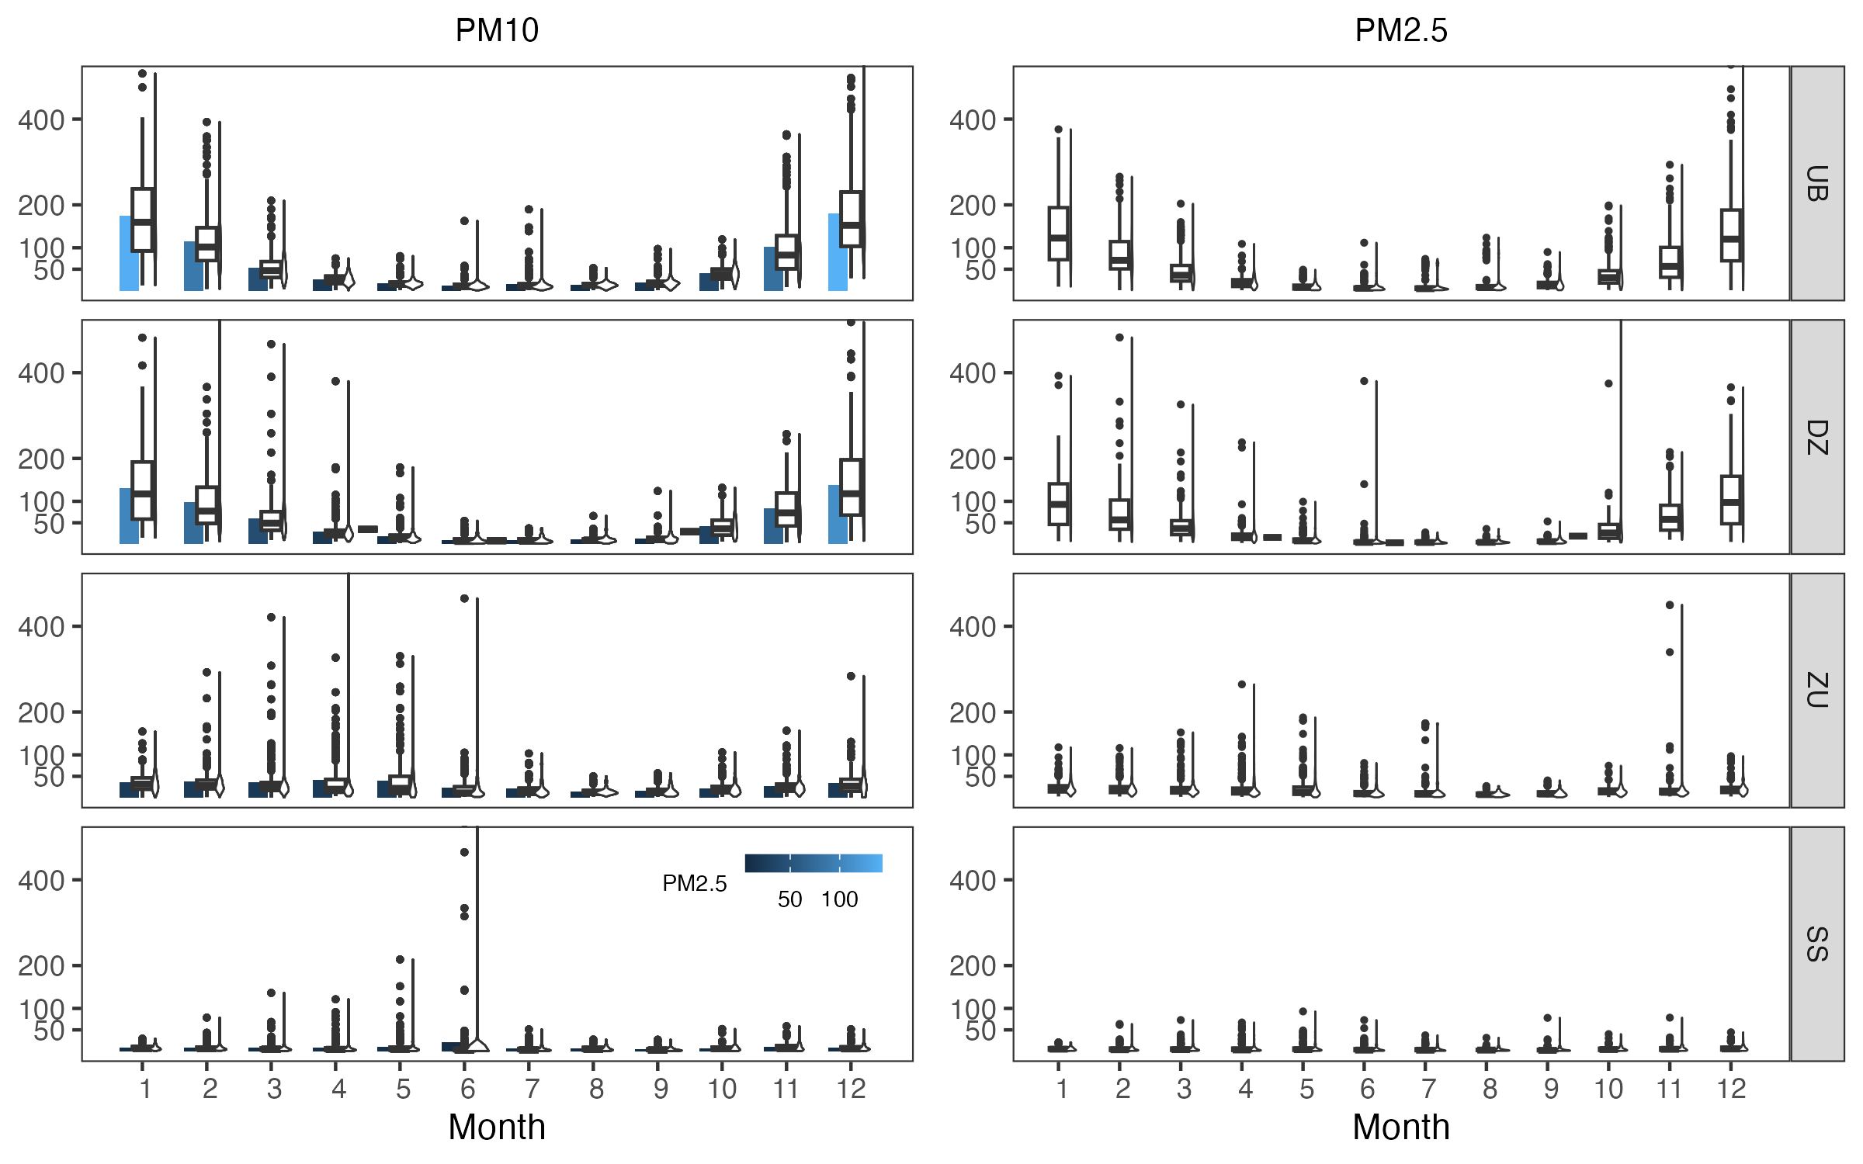

Annual variations of PM10 and PM2.5

#### 3.1.2.2 Daily variations of PM10 and PM2.5

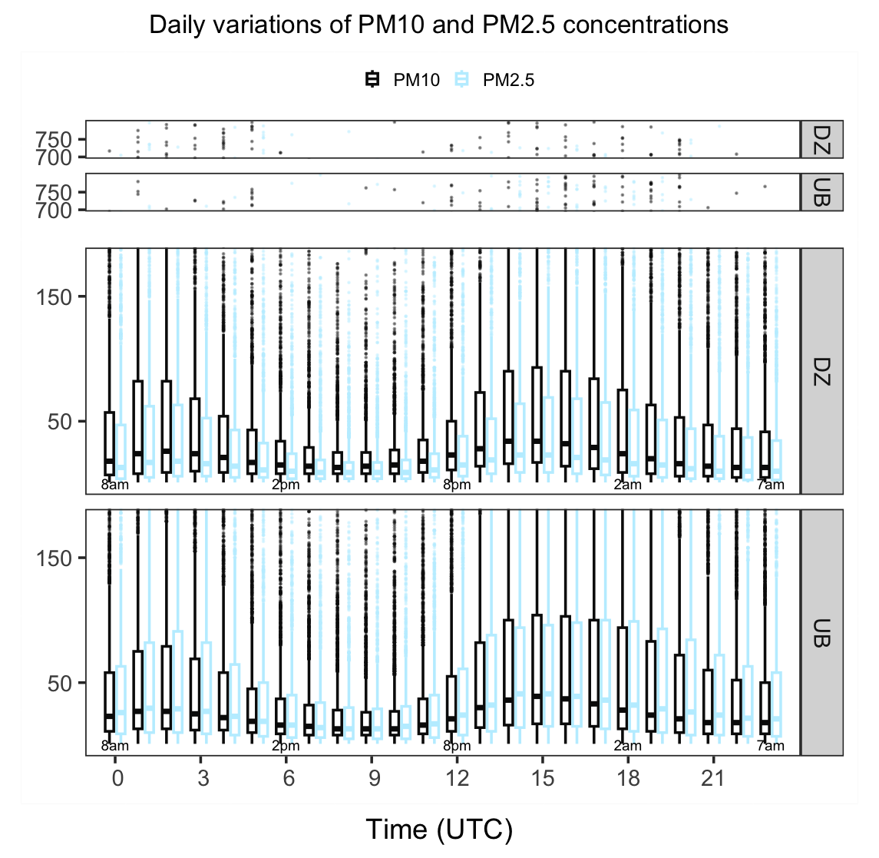

Daily variations of PM10 and PM2.5

To demonstrate the temporal variations of PM10/PM2.5: by illustrating annual and seasonal changes from 2008 to 2020. a) Discuss the changes in the seasonal maximums (peaks)

1. Discuss the changes in duration of the dusty or polluted periods
2. Discuss the inter-annual variations

## 3.2 Meteorological and urban heating influence on PM10 and PM2.5 variations

### 3.2.1 Relationships between meteorological major factors and variations of PM10 and PM2.5

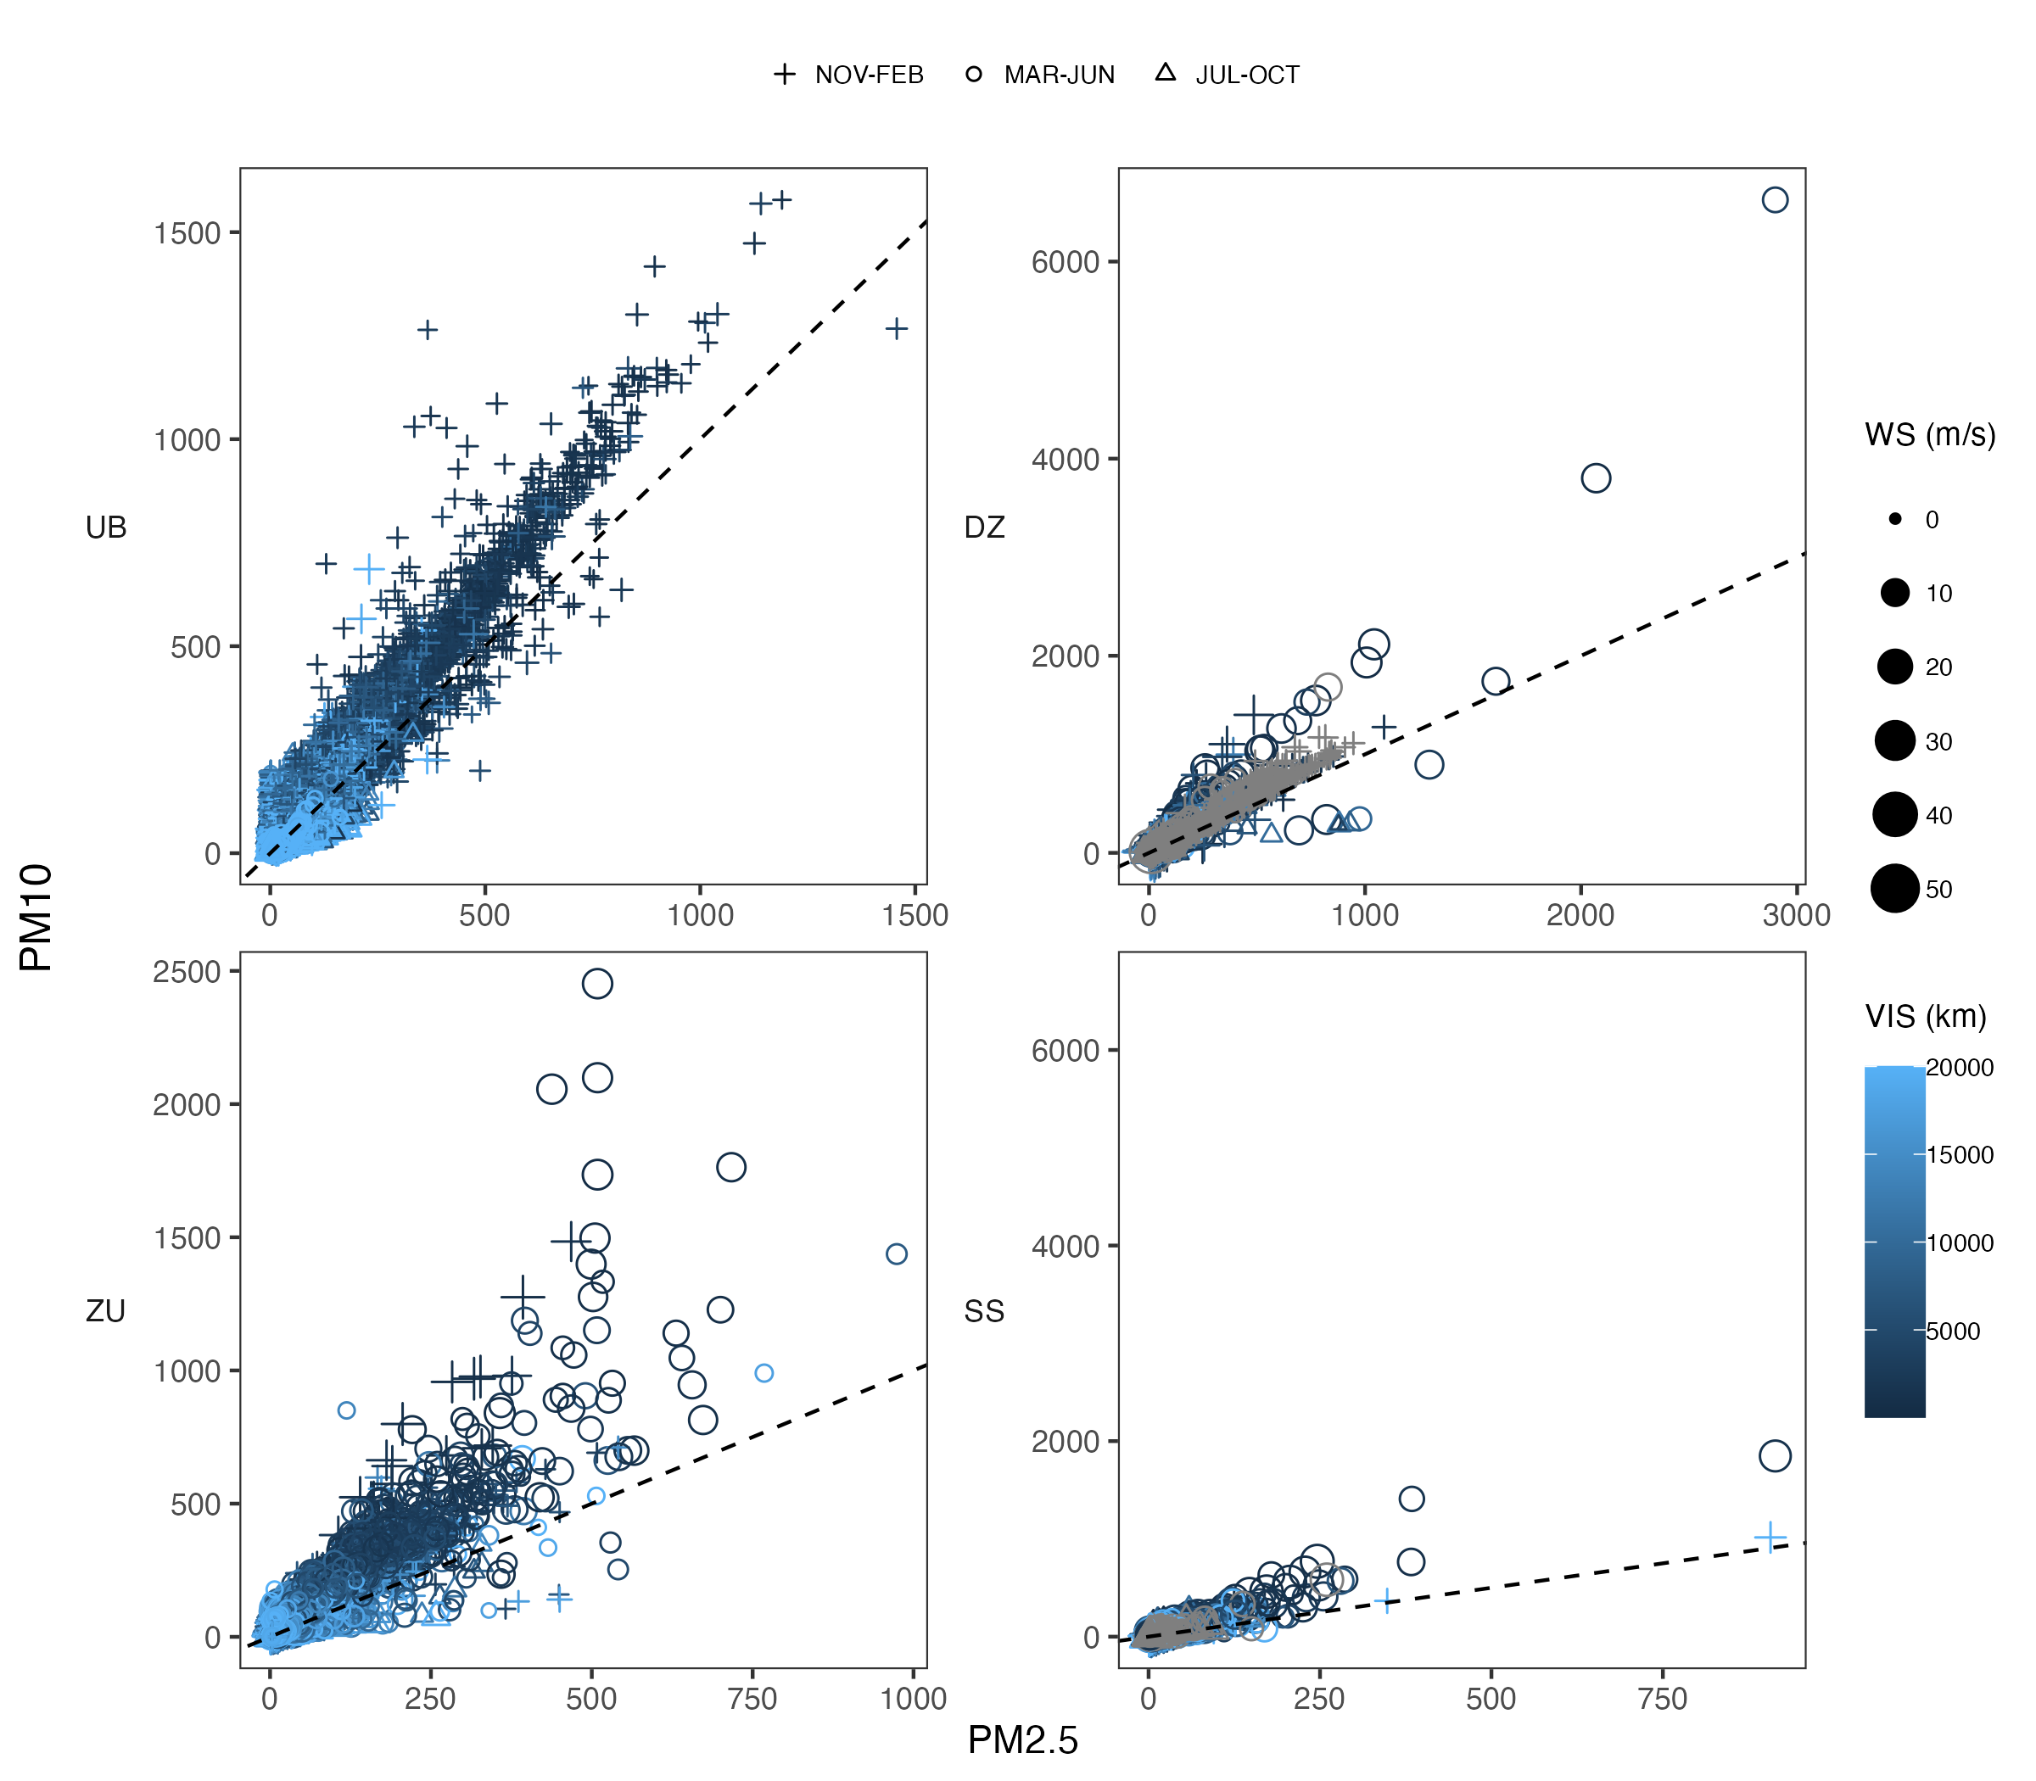

Relationships between meteorological major factors and variations of PM10 and PM2.5 PM2.5

### 3.2.2 PCA analysis

|  |  |
| --- | --- |
| PCA var Interrelations among variables with PCA analysis | PCA  PCA |

## 3.3 Interannual, seasonal trends of PM10 and PM2.5 variations

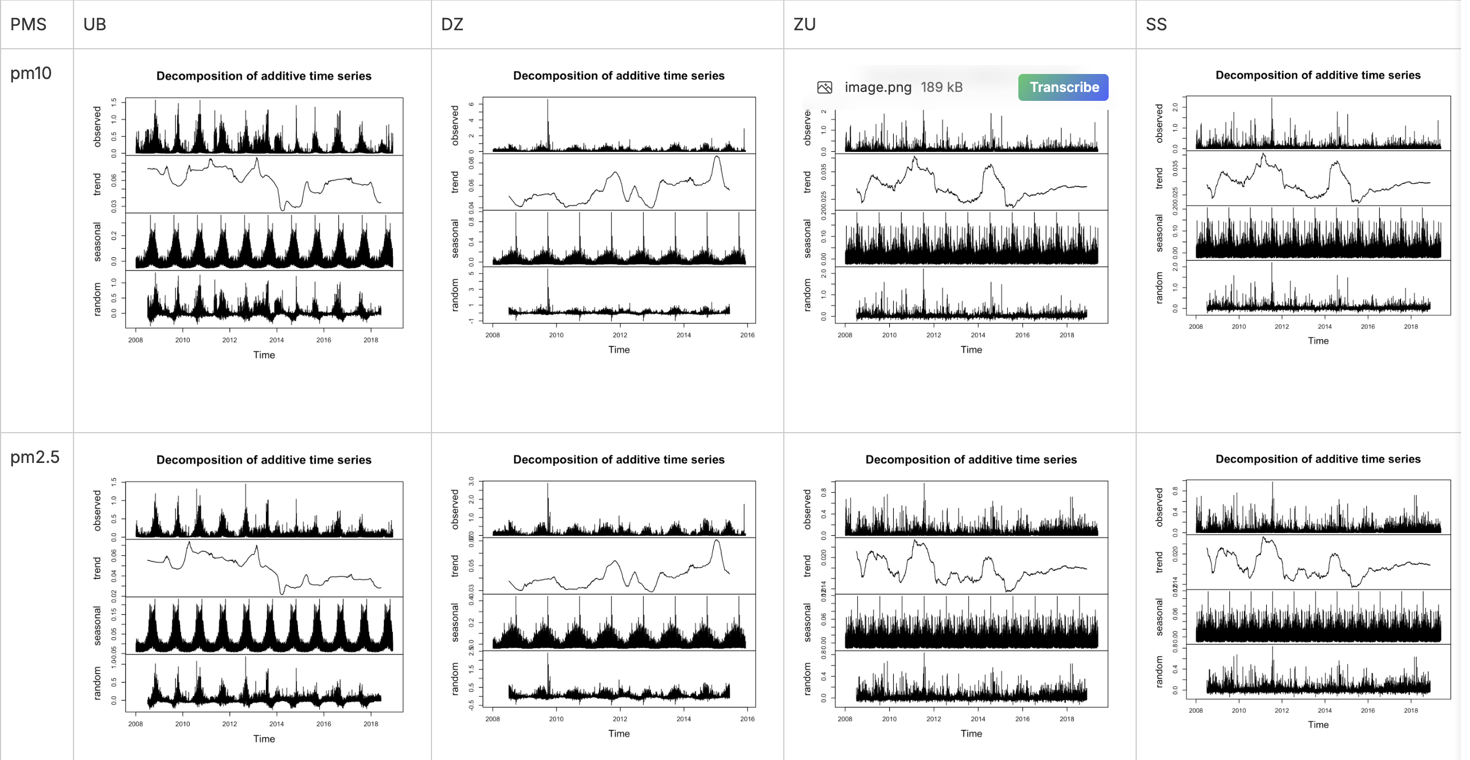 # Discussion {#sec-discussion} x The observed spatial and temporal variations in PM2.5 and PM10 concentrations underscore the intricate interplay between anthropogenic and natural factors shaping air quality in Mongolia. While urban areas grapple with pollution stemming from industrialization and urbanization, rural regions contend with the impacts of climatic events such as dust storms and wildfires. This stark dichotomy necessitates tailored interventions that address the specific challenges faced by different regions.　Effective air quality management strategies must account for these disparities, emphasizing targeted interventions tailored to specific regions and seasons.

To combat air pollution effectively, holistic strategies integrating regulatory measures, technological innovations, and public awareness campaigns are imperative. In urban areas, transitioning to cleaner heating technologies, improving public transportation infrastructure, and enforcing emissions standards can significantly mitigate pollution levels. In rural regions, initiatives focusing on sustainable land management practices and early warning systems for dust storms and wildfires are essential.

Furthermore, international collaboration and knowledge sharing can play a pivotal role in addressing Mongolia’s air quality challenges. Leveraging expertise and resources from global partners can enhance monitoring capabilities, foster innovation, and support capacity-building efforts in air quality management.

# 4. Conclusions

This manuscript highlights the complexity of air pollution dynamics in Mongolia, characterized by two distinct spatial and temporal variations in PM2.5 and PM10 concentrations.

Future work requires to : By elucidating the contributing factors and underlying mechanisms driving these patterns, this study provides valuable insights for policymakers, urban planners, and environmental stakeholders. Addressing air quality challenges in Mongolia necessitates multifaceted approaches that integrate regulatory measures, technological innovations, and public awareness campaigns to safeguard human health and ecological well-being.

Motesaddi Zarandi et al. (2022a) # References {.unnumbered}

{#refs}

Box, George EP, Gwilym M Jenkins, Gregory C Reinsel, and Greta M Ljung. 2015. *Time Series Analysis: Forecasting and Control*. John Wiley & Sons.

Chaudhry, Aizaz, Wei Li, Amir Basri, François Patenaude, et al. 2019. “A Method for Improving Imputation and Prediction Accuracy of Highly Seasonal Univariate Data with Large Periods of Missingness.” *Wireless Communications and Mobile Computing* 2019.

Fernandes, Ronabson Cardoso, Paulo Sérgio Lucio, and José Henrique Fernandez. 2017. “Data Imputation Analysis for Cosmic Rays Time Series.” *Advances in Space Research* 59 (9): 2442–57.

He, Dakuo, Zhengsong Wang, Le Yang, and Wanwan Dai. 2017. “Study on Missing Data Imputation and Modeling for the Leaching Process.” *Chemical Engineering Research and Design* 124: 1–19.

Junger, W, and APde Leon. 2012. “Mtsdi: Multivariate Time Series Data Imputation.” *R Package 0.3* 3.

Junger, W, N Santos, and A Ponce de Leon. 2003. “Missing Data Imputation in Multivariate Time Series via EM Algorithm.” *Cadernos Do IME* 15 (8): 21.

Meyler, Aidan, Geoff Kenny, and Terry Quinn. 1998. “Forecasting Irish Inflation Using ARIMA Models.”

Motesaddi Zarandi, Saeed, Mostafa Hadei, Seyed Saeed Hashemi, Elahe Shahhosseini, Philip K Hopke, Zahra Namvar, and Abbas Shahsavani. 2022a. “Check.” *Environmental Science and Pollution Research*, 1–13.

———. 2022b. “Effects of Ambient Air Pollutants on Hospital Admissions and Deaths for Cardiovascular Diseases: A Time Series Analysis in Tehran.” *Environmental Science and Pollution Research*, 1–13.

Zhang, Wenjie, Yonghong Luo, Ying Zhang, and Dipti Srinivasan. 2020. “SolarGAN: Multivariate Solar Data Imputation Using Generative Adversarial Network.” *IEEE Transactions on Sustainable Energy* 12 (1): 743–46.