LTS Pricing Calculator — Feedback Form (v3)
Updated with the new branding and the reworked "cost of not using LTS" section — please review and mark up anything else you'd like changed.
What changed since the last form: colours updated to match the LTS site (ltstest.dedicated.co.za) — navy header/hero, teal-to-blue logo and accents, teal buttons · the "cost of NOT using LTS" section rebuilt around Susan's four categories (learner & programme admin, monitoring & follow-up, reporting & compliance, management time), with an editable trainee count instead of one auto-summed figure.

How to give feedback
- On each screenshot, use Word's Draw tab to circle, underline or highlight anything you want changed — click the Draw tab, pick a pen or highlighter, and mark directly on the image (in Word desktop: Draw tab > select a pen > draw on the picture; if you don't see the Draw tab, go to File > Options > Customize Ribbon and tick "Draw").
- No Draw tab? You can also use Insert > Shapes (e.g. an oval or arrow) to point at things, or just describe what to change in words.
- Type your written comments in the box underneath each screenshot.
- There's an "Overall feedback" box at the end for anything general, not tied to one screen.
- Save the file and send it back — that's all we need.
Reviewed by: _______________________________
Date: _______________________________

1. Top bar & hero
The header (logo, live cost estimate, login) and the pricing calculator hero banner, in the new navy/teal colour scheme.
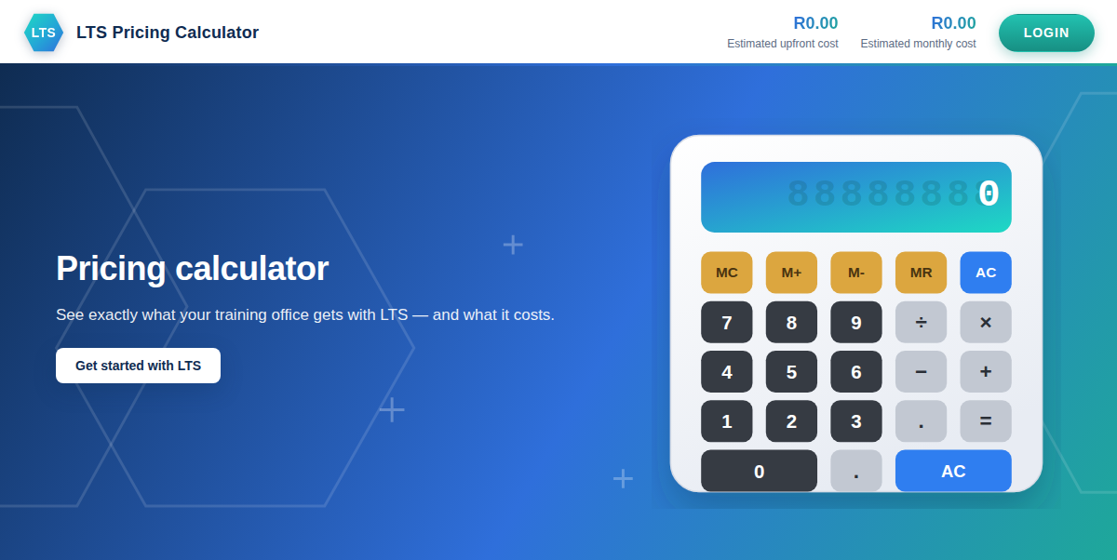
Your comments on this screen:

2. Products
Both products currently listed: the core platform, and the Time Sheet add-on.
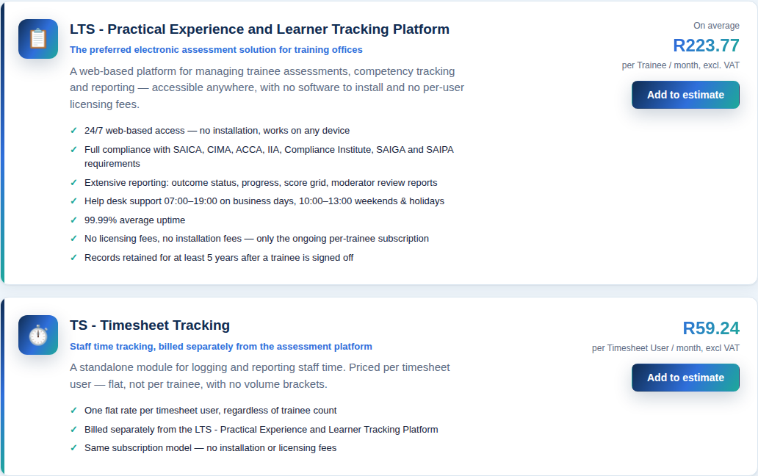
Your comments on this screen:

3. Estimate — line items
A platform line (60 trainees, 2-Year Contract) plus a Time Sheet line (3 users), on the Estimate tab.
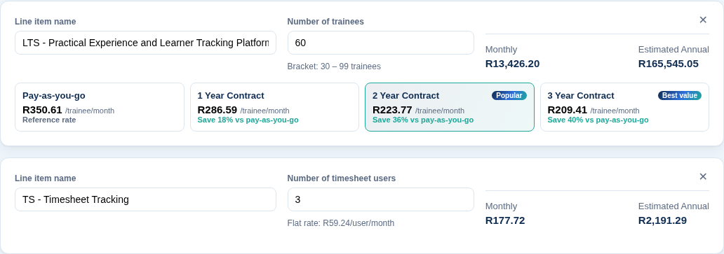
Your comments on this screen:

4. Totals & call to action
The running total for the estimate, VAT toggle, and Export to Excel.
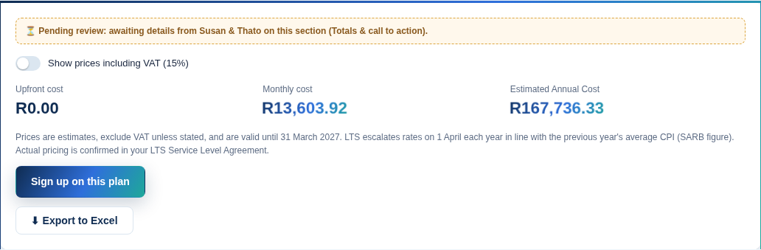
Your comments on this screen:

5. The cost of NOT using LTS
Rebuilt around Susan's four hidden-cost categories, with an editable trainee count and a category-by-category breakdown.
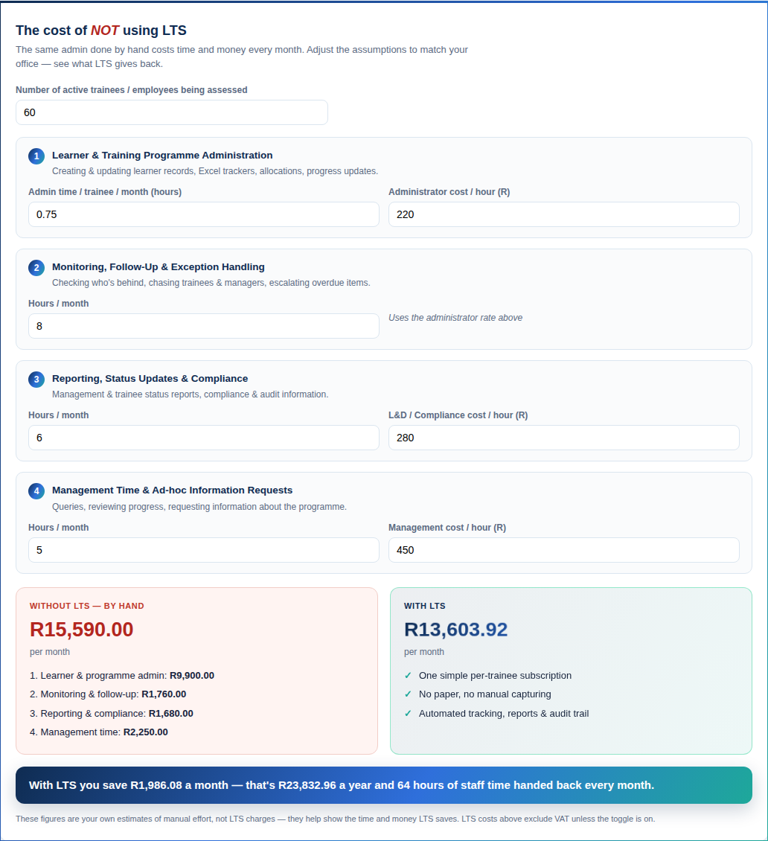
Your comments on this screen:

Overall feedback
Anything general — the idea as a whole, priorities for what to fix first, or anything not tied to a specific screen above.
Your comments on this screen:

