LTS Pricing Calculator — Feedback Form
Please review the screens below and mark up anything you'd like changed.

How to give feedback
- On each screenshot, use Word's Draw tab to circle, underline or highlight anything you want changed — click the Draw tab, pick a pen or highlighter, and mark directly on the image (in Word desktop: Draw tab > select a pen > draw on the picture; if you don't see the Draw tab, go to File > Options > Customize Ribbon and tick "Draw").
- No Draw tab? You can also use Insert > Shapes (e.g. an oval or arrow) to point at things, or just describe what to change in words.
- Type your written comments in the blue box underneath each screenshot.
- There's an "Overall feedback" box at the end for anything general, not tied to one screen.
- Save the file and send it back — that's all we need.
Reviewed by: _______________________________
Date: _______________________________

1. Top bar & hero
The header (logo, live cost estimate, login) and the pricing calculator hero banner.
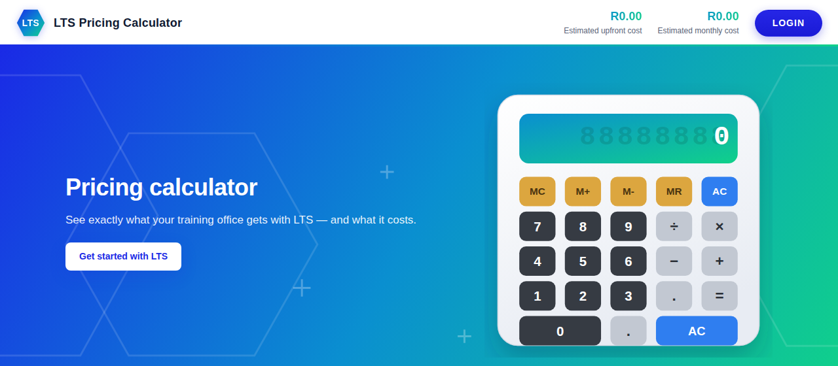
Your comments on this screen:

2. Products
Both products currently listed: the core platform, and the new Time Sheet add-on.
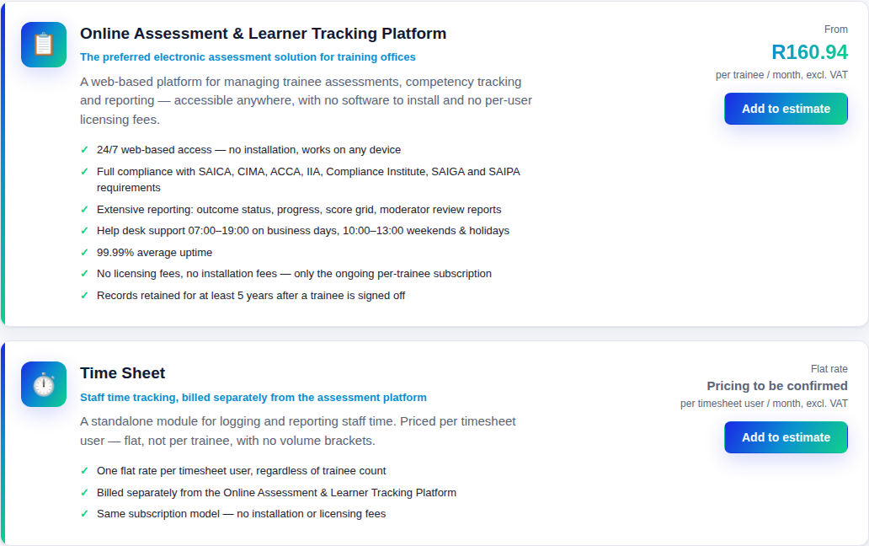
Your comments on this screen:

3. Estimate — line items
A platform line (60 trainees, 2-year contract) plus a Time Sheet line, on the Estimate tab.
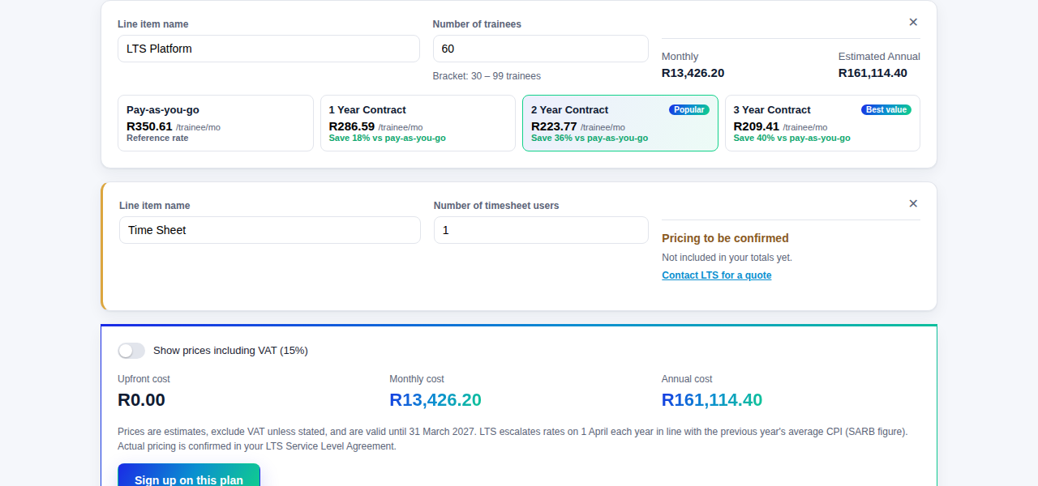
Your comments on this screen:

4. Totals & call to action
The running total for the estimate, VAT toggle, and the export / save / share buttons.
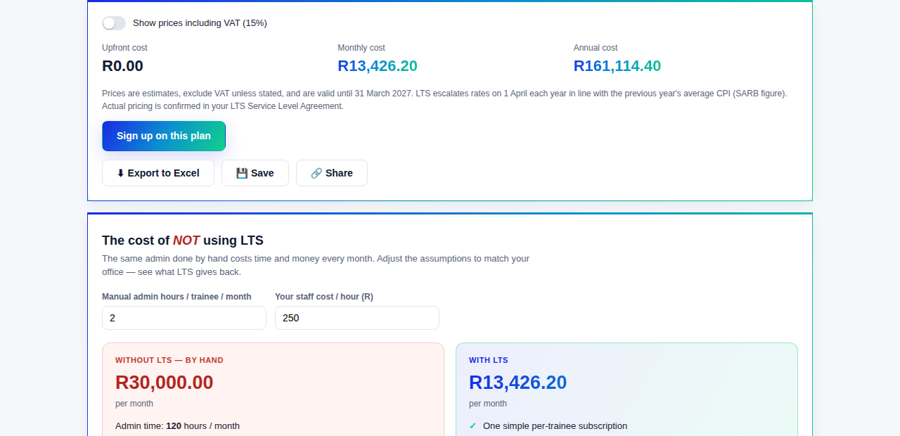
Your comments on this screen:

5. The cost of NOT using LTS
The manual-vs-LTS comparison, showing the time and money LTS saves.
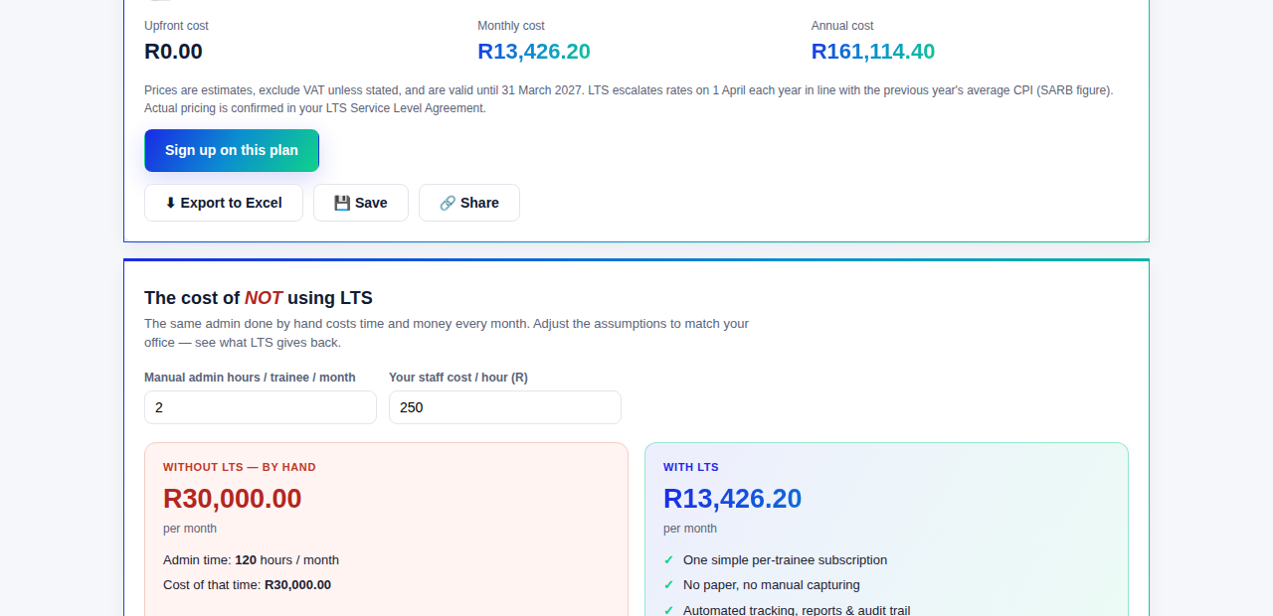
Your comments on this screen:

Overall feedback
Anything general — the idea as a whole, priorities for what to fix first, or anything not tied to a specific screen above.
Your comments on this screen:

