Bibliography

https://www.bdc.ca/en/articles-tools/start-buy-business/start-business/how-start-business-canada
- Close to 40% of new businesses with one-to-four employees don’t make it to their fifth birthday.

https://www.bdc.ca/en/about/analysis-research/entrepreneurship-skills
- Only 1.3 individuals out of 1,000 are starting new businesses
- The stages
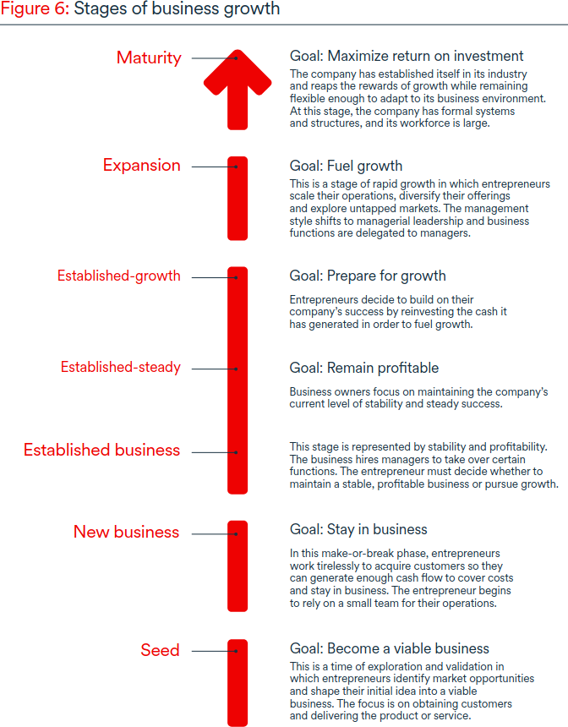
The journey is not always linear
– the amount of time spent in each
stage of growth varies per business
– a business can fall into a hybrid
state of two or more stages
– it’s possible to fall back to a
previous stage before advancing
on the growth journey
– decline and exit can happen at any
point in the business journey

https://www.bdc.ca/en/about/analysis-research/consumer-trends
- generation percentages
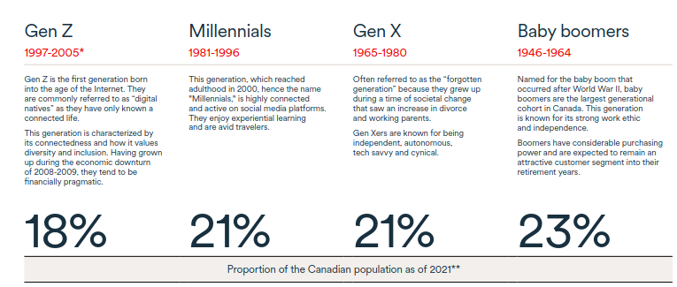
- what customers value
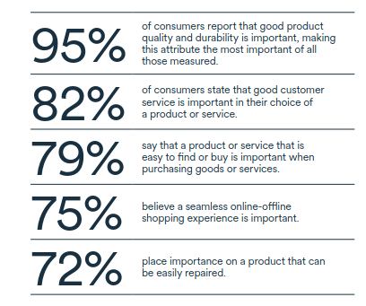

https://www.bdc.ca/globalassets/digizuite/42504-report-investment-financing-outlook-survey-july-2023.pdf
- stats on financing
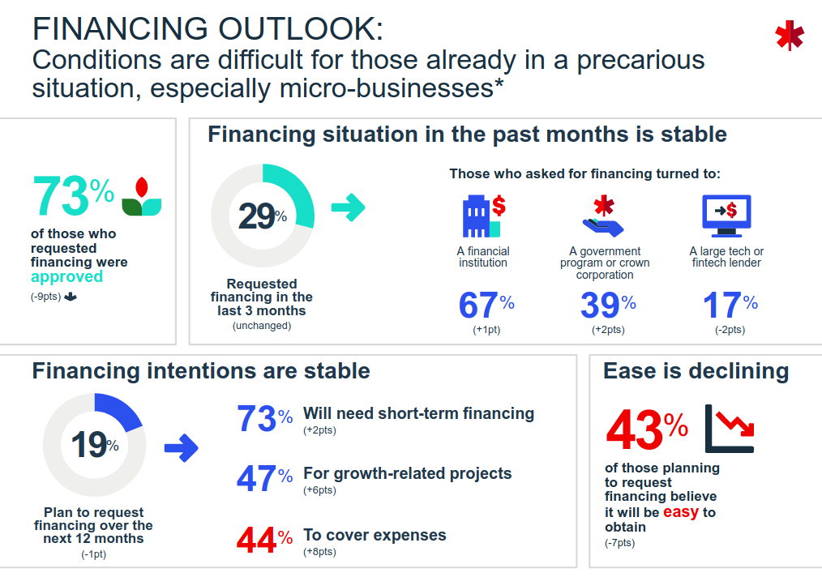
- employee count
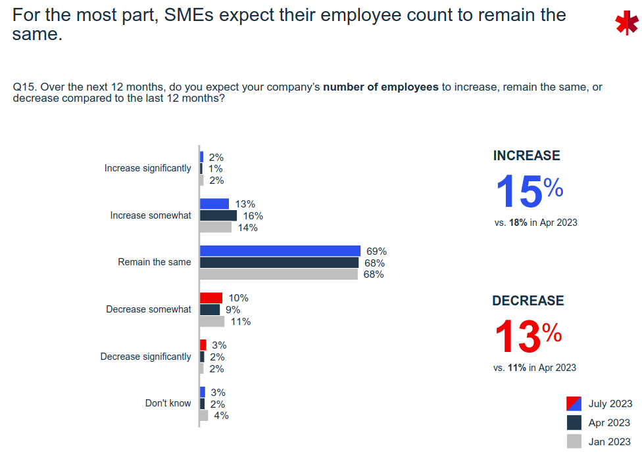

https://www.bdc.ca/globalassets/digizuite/41066-report-canada-venture-capital-landscape-2023.pdf
- VC has slowed down
- $40 million avg exit value
- IPO is rare (single digits a year)
- VC avg deal size $14 million
- Half of investments are follow-on

https://www.bdc.ca/globalassets/digizuite/40309-report-growth-ambition-march-2023.pdf
- Things you want to grow
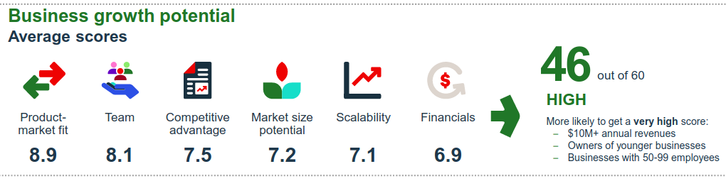
https://dais.ca/wp-content/uploads/2023/10/Getting-to-Scale-FINAL-online.pdf
- Canada, wisely, has been part of this wider trend.
Previous investments in developing and supporting
Canada’s startup ecosystem have now put the
country in a position to tackle the next challenge:
building a vibrant ecosystem for supporting and
fostering the success of our scale-ups.
- In addition, we uncovered a collection of issues that
are potentially limiting firm growth and creating
conditions where Canadian founders are opting
for early exits.
- Finally, while many scale-
ups have already begun selling internationally, we
uncover a number of small issues that could help
boost international sales.

https://www.gemconsortium.org/file/open?fileId=51147
- New entrepreneurs frequently declare that they take social and
environmental implications into account when making strategic decisions
about the future of their business

https://www.gemconsortium.org/news/canada-performance-strong-compared-to-peers-in-latest-gem-global-report
- There is a marked contrast between entrepreneurship in Europe and North America. Canada and the US have TEA levels at least twice those of most European countries. Exits are also very different. Exits can mean two things – the business closes down, or it continues under new management. Canada and the US have exit rates two to three times higher than most European countries, in both categories. This indicates that there is much more churn in North America – more startups and more failures. In general, there is a correlation between high startup rates and high exit rates in all GEM countries.
- Also, GEM uses a number of different metrics to measure entrepreneurs’ motivation. One metric is “to continue a family tradition”. On this count, Canada ranks very highly among Level A countries, second only to Saudi Arabia.

https://www150.statcan.gc.ca/n1/daily-quotidien/231127/dq231127a-eng.htm
- Rising interest rates and debt costs was the third most expected obstacle, with over two in five (42.7%) businesses expecting this over the next three months.
- Among the businesses that identified a skills gap or employee skill deficiencies, over three-fifths (62.3%) plan to provide internal or on-the-job training to address these gaps or deficiencies over the next 12 months, led by businesses in mining, quarrying, and oil and gas extraction (76.5%); finance and insurance (75.8%); and arts, entertainment and recreation (73.8%).

https://ised-isde.canada.ca/site/sme-research-statistics/en/key-small-business-statistics/key-small-business-statistics-2022
- Businesses that began operations with a large number of employees had a higher survival rate than businesses that began with a smaller number of employees.

https://ised-isde.canada.ca/site/sme-research-statistics/en/determinants-entrepreneurship-canada-state-knowledge
- In Canada, and much of the , markets are increasingly dominated by fewer firms than in 2006.
- While venture capital in Canada is mostly invested in the expansion stage—good for 3rd highest and comparable to Israel and the United States—it does not perform as well in terms of investment in early stage venture capital where it ranked 8th.

https://thoughtleadership.rbc.com/proof-point-the-ranks-of-canadian-entrepreneurs-are-shrinking/
- Strong labour markets and higher hourly wages for employees probably have something to do with it. For example, an employee working in professional, scientific, and technical services earns 20% more per hour (on average) than a self-employed worker in the same sector. Employers are also offering more flexible working arrangements previously only available to the self-employed.

https://www.torontomu.ca/diversity/reports/SupportingEntrepreneurshipAndSMEs.pdf
- While some organizations have found new
opportunities due to the pandemic (e-commerce or an expanded talent pool made available by
the shift to remote work, for instance), firms still struggle to identify the skills and competencies
they need.
- Another key takeaway is that SMEs often have limited capacity to dedicate to human resources,
recruitment, training, upskilling and other functions essential to meeting their skills needs.

https://www-oecd-ilibrary-org.proxy.queensu.ca/industry-and-services/financing-smes-and-entrepreneurs-2022_e9073a0f-en
- The analysis shows only a modest focus on SMEs in recovery packages, with SME-related
polices representing just 4.1% of total policy measures, and SME-specific funding just 2.2% of total funding (compared to 17% and 25.5% respectively in rescue packages).
- In terms of policy focus, recovery packages place emphasis on innovation, digitalisation and greening, with innovation accounting for the highest number of SME-related policies and digitalisation for the highest volumes of financial support.

https://onlinelibrary-wiley-com.proxy.queensu.ca/doi/full/10.1002/smj.3010
- Because entrepreneurs face many alternatives that cannot be pursued at once, entrepreneurs must adopt (implicitly or explicitly) a process for choosing among entrepreneurial strategies.
- This paper explores the interplay between these unique conditions that shape the entrepreneurial choice process, finding that often, the process will not yield a single best strategy but instead several equally attractive strategic alternatives.

https://online.hbs.edu/blog/post/characteristics-of-successful-entrepreneurs
- While many things can go wrong when launching a new venture, many things can go right. According to Entrepreneurship Essentials, entrepreneurs who actively manage the relationship between risk and reward position their companies to “benefit from the upside.”
- “Of startups that have more than one employee, 70 percent survive at least two years, half last at least five years, and a quarter last 15 years,” says Harvard Business School Professor William Sahlman in Entrepreneurship Essentials. “Even then, only a small fraction of the survivors get to be significant employers.”

https://www.indeed.com/career-advice/career-development/challenges-facing-entrepreneurship
- For entrepreneurs whose organization is doing well, they may consider partnering with other professionals or businesses.

https://www.shopify.com/ca/blog/challenges-of-entrepreneurship
- It’s no surprise then that 72% of entrepreneurs are directly or indirectly affected by mental health issues, compared to 48% of non-entrepreneurs.
- You put many hours into building a brand, finding a product, packaging, setting a shipping strategy, and finessing the look of a store to make sure everything is perfect.
- The only thing worse than an imperfect launch is not launching at all.
- “We wanted to get to market as quickly as possible, and our way of getting to market was going to these bike shops, taking that feedback, and putting it out there. After that, we’ve made boatloads of improvements based on customer feedback.

