STA2023 – Statistical Methods I
Instructor: Dr. Emil Agbemade
Chapter 6. The Normal Probability Distribution
Table of Contents
6.1 Properties of the Normal Distribution 2
Uniform Distribution 2
The Normal Distribution 4
Properties of the Normal Curve 5
Area Under a Normal Curve 8
6.2 Applications of the Normal Distribution 10
Standardizing a Normal Random Variable 11
Finding Areas Under the Normal Curve: 11
Find the Value of a Normal Random Variable 16
6.3 Assessing Normality 18
Using a Frequency Histogram: 18
Using a Normal Probability Plot: 19

By the end of this chapter, students should be able to:
- Describe a uniform distribution and use it for probability calculations.
- Describe properties a normal distribution
- Use the normal distribution for probability calculations.
- Assess if data is well approximated by a normal distribution.

6.1 Properties of the Normal Distribution
- In chapter 5, we talked about discrete random variables, where a random variable, X, had a finite or countable number of outcomes.
- In chapter 6, we will talk about continuous random variables, where a random variable had an infinite number of outcomes.

Uniform Distribution
- Imagine your friend is always running late. Let the random variable X represent the time from when you are supposed to meet your friend until they show up. Suppose your friend could be on time (x = 0) or up to 30 minutes late (x = 30), with all equal intervals of time between x = 0 and x = 30 being equally likely.
  - This means that your friend is just as likely to be 3-4 minutes late as they are to be 25-26 minutes late.
  - Since any two intervals of equal length between 0 and 30, inclusive, are equally likely, the random variable X is said to follow a uniform probability distribution.
- For a discrete random variable, the value of a random variable is usually substituted into a formula or table. For continuous variables, it’s not as easy.
- For example, what is the probability that your friend is exactly 12.898746541 minutes late?

Definition: A probability density function (pdf) is

- The figure below shows a very basic probability density function.

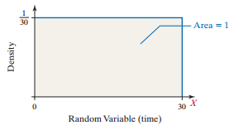
- We can use area under the curve to represent the probability of observing a value of the random variable in that interval.
Example 1: Refer to the situation listed above.
- What is the probability that your friend will be between 10 and 20 minutes late?
- You are scheduled to meet at 10am with your friend. Suppose it is 10am right now. There is a 20% probability that your friend will arrive within the next _____ minutes.

Example 2: Computers can create random numbers often called a random number generator (note that with computers, it’s often seen as “pseudo” random as often times it’s not truly random). However, suppose you randomly generate a number between 0 and 10.
- What is the probability that number you select is between 2 and 5?
- What is the probability that the number you select is exactly 4.35?

The Normal Distribution
- Not too many random variables follow a uniform distribution, but many random variables follow a bell-shaped distribution.
  - For example, IQ scores and birth weights of babies are commonly bell-shaped.
- If we took a random sample of 10,000 adults, we could create a histogram of IQ scores. As we increase the sample size, the histogram becomes more and more close to a smooth curve (as seen with the red curve below).
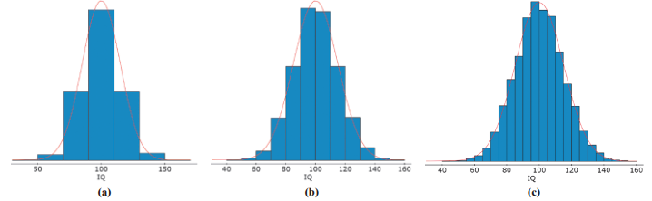
- We can use this red curve to model the probability distribution of a continuous random variable.
Definition: A continuous random variable is normally distributed, or has a normal probability distribution,

- Any normally distributed random variable follows a bell-shaped curve like above, but how does each distribution differ?
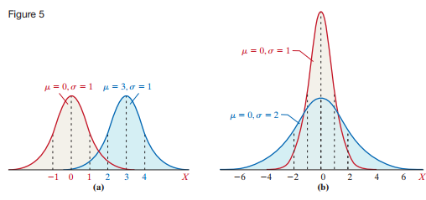

Properties of the Normal Curve
- To define a normal distribution, we need to know the mean and standard deviation of the random variable. Using those, we can list the properties of the distribution:



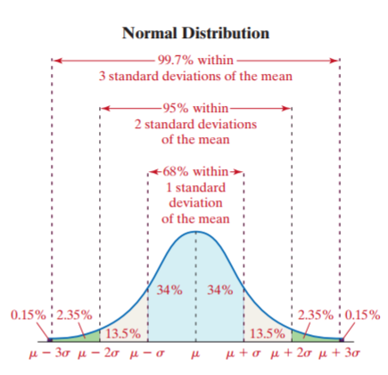
Example 3: The relative frequency distribution given in the table below represents heights of a pediatrician’s three-year-old female patients. The raw data indicate that the mean height is μ = 38.72 inches with a standard deviation of σ = 3.17 inches.
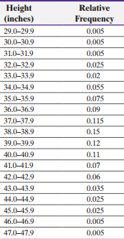
- Look at the relative frequency histogram on the next page. Comment on the shape of the distribution.
- Look at the normal curve with μ = 38.72 and σ = 3.17 on the relative frequency histogram. Does is appear that this model fits the data well?

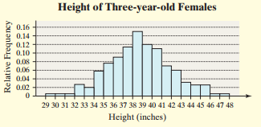

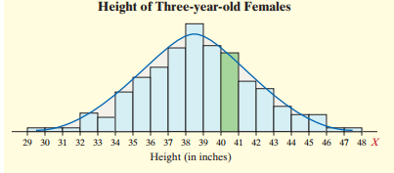

- How do we create that curve to graph?
- The probability density function of a normal random variable is given by the following formula:

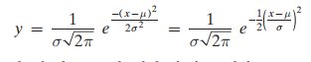
- Don’t worry too much about the equation. We won’t physically use it, but methods we cover have used this for us.

Area Under a Normal Curve
- Suppose that a random variable X is normally distributed with mean μ and standard deviation σ. The area under the normal curve for any interval of values of the random variable X represents either:

Note: Since P(X = a) = 0 for all values of a, then the following also holds:
Example 4: The serum total cholesterol for males 20-29 years old is approximately normally distributed with mean μ = 180 mg/dL and σ = 36.2 mg/dL.
- Sketch out a normal curve with the parameters labeled.
- An individual with 200 mg/dL is considered to have high cholesterol. Shade in the region under the normal curve to the right of x = 200.
- Suppose that the area under the normal curve to the right of x = 200 is 0.2903. Give two interpretations of this result.

Example 5: The length of human pregnancies is approximately normally distributed with a mean of 266 days and a standard deviation of 16 days.
- Sketch out a normal curve with the parameters labeled.
- An individual whose birth lasts 259 days or less is considered preterm. Shade in the region under the normal curve that represents the proportion of births that are preterm.
- The area to the left of x = 259 is equal to .3309. Give two interpretations of this result.

6.2 Applications of the Normal Distribution
- If X is a normally distributed random variable, the area under the normal curve represents the proportion of a population with a certain characteristic.
  - How do we find the area under the normal curve?
- We have two options: by hand with tables or with technology (Excel).

Standardizing a Normal Random Variable
- Definition: Suppose that the random variable X is normally distributed with mean μ and standard deviation σ. Then the random variable:

- This result shows us that any normal random variable X can be transformed into a standard normal random variable Z whose mean is 0 and standard deviation is 1.
- The means that we can use a table to find the area to the left of a specified z-score.
  - For example, IQ scores can be modeled by a normal distribution with µ = 100 and σ =15. An individual whose IQ is 120:

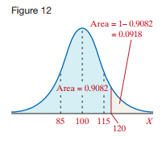

Finding Areas Under the Normal Curve:
By-Hand Approach
Step 1: Draw a normal curve and shade the desired area.

Step 2: Convert the value of x to a z-score using:
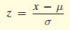
Step 3: Use Table V in the textbook (or at the end of these notes) to find the area to the left of the z-score.

Example 6: A pediatrician obtains the heights of her three-year-old female patients. The heights area approximately normally distributed, with mean 38.72 inches and standard deviation 3.17 inches. Use the normal model to determine the proportion of three-year-old females who are shorter than 35 inches.

- Not all problems will involve areas to the left. How do we find other areas?
Problem | Solution (by hand)
Find the area to the left of x.  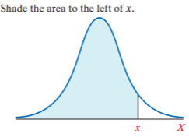 | Convert the value of x to a z-score.  Use Table V to find the area to the left.
Find the area to the right of x.  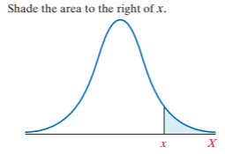 | Convert the value of x to a z-score.  Use Table V to find the area to the left.  Find the final answer by doing 1 minus the area to the left.
Find the area between x1 and x2.  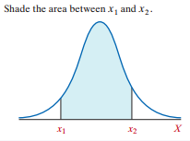 | Convert the values of x to z-scores.  Find the area to the left of them both (called z1 and z2).  Final answer is (area to the left of z2) – (area to the left of z1).

Example 7: The scores earned on the mathematics portion of the SAT, a college entrance exam, are approximately normally distributed with a mean of 516 and standard deviation of 116. What is the probability that a randomly selected test taker would earn:
- Less than 500 points?
- More than 600 points?
- Between 525 and 550 points?

Find the Value of a Normal Random Variable
- What happens if we have an area under the curve, but we want to find the value associated with it?

By-Hand Approach
Step 1: Draw a normal curve and shade the desired area.

Step 2: Use Table V to find the z-score that corresponds to the shaded area. You must convert this area to the area to the left of this z-score.

Step 3: Obtain the normal value using the formula x = μ + zσ

Example 8: The heights of a pediatrician’s three-year-old female patients are
approximately normally distributed, with mean 38.72 inches and standard deviation 3.17 inches.
- Find the height of a three-year-old female at the 20th percentile.
- Find the heights that separate the innermost 80% of heights from the bottom and top 10% of heights.

6.3 Assessing Normality
- In the real world, many variables (but not all) are bell-shaped. If you are provided with data, how can you assess normality?
- We have 2 basic methods to determine this:
  - Look at a frequency histogram.
  - Look at a normal probability plot.

Using a Frequency Histogram:
- This is the most straight-forward way to assess if a random variable can be well approximated by a normal curve.
- Generally, we want to see the following in a plot:
  - Bell shaped with a single peak.
  - The histogram should be roughly symmetric (with no strong skews).
  - There should be few outliers.

Example 11: Consider the weight times at two different restaurants. Consider the frequency distributions of the weight times below:
Restaurant A:
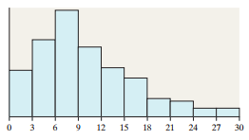
Restaurant B:
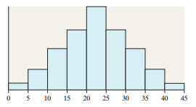
Which restaurant’s wait time could be modeled by a normal distribution, if any?

Using a Normal Probability Plot:
- This plot is very common, especially if you go into higher level statistics courses.
- In a normal probability plot, we compare two things:
  - The actual value of the observations.
  - The expected z-score if the data was normally distributed.
- An ideal normal plot would have actual values perfectly associated with the expected z-scores, so they should create a straight line.

Example 12: Consider the table below of finishing time for six randomly selected races of a greyhound. Does it appear that finishing time is normally distributed?

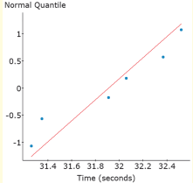

Area under the curve (Table V):
