1.0 Introduction
Manufacturing processes are now data-driven and one major challenge currently facing the manufacturing companies is how to process the large volume of data being generated from different systems that made up their manufacturing plants in a way that ensure quick generation of insights that can help to understand their operations and most importantly, improve its efficiency and effectiveness as well as to drive the overall productivity. By convention, organisational data are stored in a data warehouse in raw form. The data warehouse is essentially made up of different relational databases from different units within the organisation that are linked together to ensure integration of all organisational data.
To extract, transform and load data from the relational database requires proficiency in Structured Query Language (SQL). The complexities of modern manufacturing processes and the data generated from them require a sophisticated expertise in SQL to extract meaningful insights from them as quickly as possible. This poses a challenge to manufacturing data professionals, especially those with limited technical background. Thankfully, we are now in the era of generative AI in which Large Language Models are being deployed to speed up the manufacturing processes including data analytics. This project is embarking on to create a system that provide an NL interface to SQL database by leveraging on the knowledge of python libraries and LLM coding ability through the use of vibe coding techniques that use natural language instead of the technically sophisticated SQL queries to generate meaningful insight from the manufacturing databases. The project covers prompt specification/design, implementation/test and demonstration and assessment of the limitations of the system.
- The NL-SQL Interface System Architecture

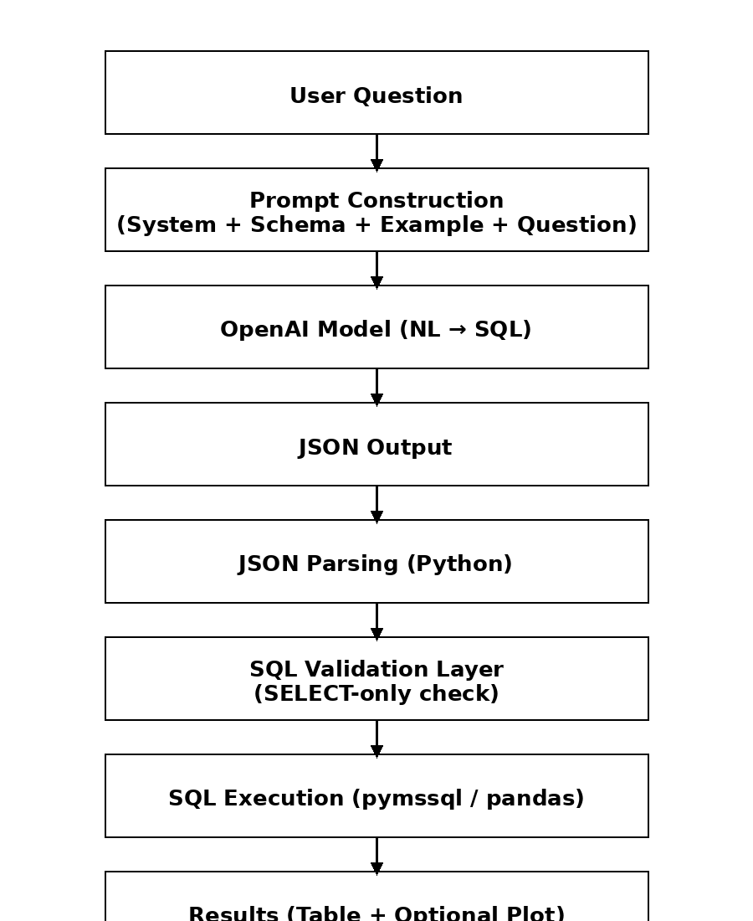
Figure 1: NL-SQL Interface Flowchart.
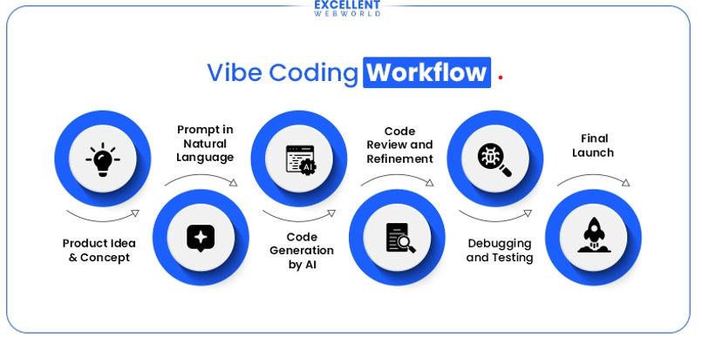
Figure 2: Vibe Coding Workflow
Source: Assignment brief
The flowchart of the proposed NL interface to SQL system is shown above. It uses an iterative pipeline where questions are written in natural language as queries and fed into the NL interface as prompts which then produces a JSON outputs with SQL queries that are then executed against the database using pandas and pymssql libraries to generate tables and optional plots that provide insights to drive the manufacturing processes.
There is also a feedback loop used to review the strengths and weaknesses of the first response from the LLM and to handle errors like hallucinated, invalid or illogical SQL queries, null results, or logically inconsistent outputs. This will lead to the prompt being refined to ensure the generation of new queries that meet the expected standard. The loop is important because it reflects what happens in real-life system design workflow and helps to identify and deal with the generic issues in system development such as hallucination, invalid syntax, poor query logic. It also helps to perform the prompt engineering and system evaluation aspect of the project by providing the opportunity to remove incorrect assumptions and ambiguity in the natural language queries thereby ensuring the generation of logically and operationally valid SQL outputs.
2.1 Prompt Engineering
The NL interface to the SQL was implemented using Openai module in python. The module contains OpenAI() class which offers smooth interaction with the GPT model, specifically, ChatGPT. I selected OpenAI ChatGPT ahead of other options because of its sophistication, precision, performance edge over others in terms of SQL reasoning, consistency and documentation, availability of GPT-4o mini with maximum input and output token limit of 128,000 and most importantly, affordability ()
To use the OpenAI Class on python, I had to import it from the openai library:
from openai import OpenAI
Then, I instantiated it by setting it to a variable called client as shown below:
client = OpenAI()
To use OpenAI in a project requires the user to generate OpenAI API Authentication Key (API Keys) which is essentially a unique string of character that acts like a password that helps organisations to track the users, set usage limits and billing, and ensure security through controlled access to different levels of usage. Generating API key is free on ChatGPT, another reason for using it.
Initiating a chat on the OpenAI() requires sending a request to the API using chat completion function as show below:
Response = client.chat.completion.create()
The function takes two arguments: the model (i.e. ChatGPT model) and the messages.
The response/output of the NL model is then printed using:
print(response.chioces[0].message.content)
The messages argument is made up of three parts:
- System: this sets the context for the role of the AI and how it should respond to questions
- User: the contains the user’s prompt or messages which could be a question, follow-up response, request, etc. It can also be used to set contexts such as the schema of the database being queried and important tables that may support the model to generate a valid and logical response.
- Assistant: his usually follows the user message and it is essentially the model’s first response resend with the user message to reshape or reinforce the model’s initial response.
Please note that I avoid using the assistant part of the message in this project to avoid overfitting the model and ensure the generalisation of its response.
The NL interface used in this project takes the following form:

system = """You are an expert data analyst and SQL generator for the AdventureWorks database.
Your task is to translate a user’s natural language manufacturing or business question into a safe, correct SQL Server query and a brief explanation.
Rules:
1. Only generate read-only SQL.
2. Allowed query types are:
- SELECT
- Common Table Expressions (CTEs)
- ORDER BY
- GROUP BY
- HAVING
- JOINs
- window functions
- recursive CTEs if needed
3. Do not generate:
- INSERT
- UPDATE
- DELETE
- DROP
- ALTER
- TRUNCATE
- EXEC
- MERGE
- stored procedures
4. The SQL dialect is Microsoft SQL Server (AdventureWorks).
5. Prefer fully qualified table names, for example:
Production.WorkOrder
Production.Product
Production.ProductInventory
6. Use TOP for row limits, not LIMIT.
7. If the question is ambiguous, make the smallest reasonable assumption and state it briefly.
8. If the question cannot be answered from the provided schema, say so clearly.
9. Use joins only where supported by the schema provided.
10. Return output in valid JSON only.
You must return exactly this JSON structure:
{
"question_understanding": "short restatement of the task",
"assumptions": ["assumption 1", "assumption 2"],
"sql": "single SQL Server query as a string",
"explanation": "brief explanation of how the query works",
"result_shape": "what the output table should contain",
"validation_checks": ["check 1", "check 2"],
"plot_suggestion": {
"recommended": true,
"plot_type": "bar|line|pie|none",
"x": "column name or null",
"y": "column name or null",
"title": "plot title or null"
}
}
Additional requirements:
- The SQL must be executable as written.
- Do not wrap SQL in markdown fences.
- If no chart is appropriate, set plot_suggestion.plot_type to "none" and other plot fields to null.
- If aggregation is used, ensure all non-aggregated selected columns are included in GROUP BY.
- If ranking is requested, prefer ORDER BY and TOP, or window functions where appropriate.
- If multi-level bill-of-materials logic is requested, use a recursive CTE."""

database_schema = """Production.WorkOrder
- WorkOrderID (PK)
- ProductID (FK -> Production.Product.ProductID)
- OrderQty
- StockedQty
- ScrappedQty
- StartDate
- EndDate
- DueDate
- ScrapReasonID

Production.Product
- ProductID (PK)
- Name
- ProductNumber
- MakeFlag
- FinishedGoodsFlag
- Color
- SafetyStockLevel
- ReorderPoint
- StandardCost
- ListPrice
- ProductSubcategoryID

Production.ProductInventory
- ProductID (FK -> Production.Product.ProductID)
- LocationID (FK -> Production.Location.LocationID)
- Shelf
- Bin
- Quantity

Production.Location
- LocationID (PK)
- Name
- CostRate
- Availability

Production.WorkOrderRouting
- WorkOrderID (FK -> Production.WorkOrder.WorkOrderID)
- ProductID
- OperationSequence
- LocationID (FK -> Production.Location.LocationID)
- ScheduledStartDate
- ScheduledEndDate
- ActualStartDate
- ActualEndDate
- PlannedCost
- ActualCost

Production.BillOfMaterials
- BillOfMaterialsID (PK)
- ProductAssemblyID
- ComponentID
- StartDate
- EndDate
- UnitMeasureCode
- BOMLevel
- PerAssemblyQty

Production.TransactionHistory
- TransactionID
- ProductID
- ReferenceOrderID
- ReferenceOrderLineID
- TransactionDate
- TransactionType
- Quantity
- ActualCost"""
user_question = "One question from each section”
user_content = f"""Database: AdventureWorks
Task: Convert the following natural language request into SQL Server SQL.
Schema summary:
{database_schema}
Business context:
- This database represents a manufacturing company.
Important table hints:
- Work orders: Production.WorkOrder + Production.Product
- Inventory: Production.ProductInventory + Production.Location + Production.Product
Natural language request:
{user_question}

Output requirements:
- Return valid JSON only.
"""
message = [
{
"role": "system",
"content": system
},
{
"role": "user",
"content": user_content # MUST be a string
}
]
response = client.chat.completions.create(
model="gpt-4o-mini",
messages=message # ✅ correct
)
print(response.choices[0].message.content)
2.3 ChatGPT Model Selection Justification
The "gpt-4o-mini" was selected for the development tasks such as prompt testing and debugging, etc because it is relatively cheaper and better at SQL generation, reasoning over schema and prompt engineering iterations compare to other OpenAI models . Using the API on python also requires subscription for access, £5-£10 prepaid credit subscription was chosen because it offers tokens that should be enough to complete the tasks involved in the project
3.0 Output Generation and Data Engineering
This section discusses the implementation of the NL SQL interface to solve manufacturing problem through the use of vibe coding techniques
3.1 Question Selection Justification
The questions selected from part A to E are those that focus on problems that are generally associated with inventory and location/assembly management.
3.2 Question 1-Inventory Analysis: “Which 10 products have the highest on-hand quantity in total, and where is that stock located?”
First Response
{
"question_understanding": "Identify the top 10 products with the highest total on-hand quantity and their locations.",
"assumptions": ["On-hand quantity is derived from the Production.ProductInventory table.", "Only the top 10 products will be returned."],
"sql": "WITH ProductStock AS ( SELECT pi.ProductID, SUM(pi.Quantity) AS TotalOnHand FROM Production.ProductInventory pi GROUP BY pi.ProductID ) SELECT p.Name, ps.TotalOnHand, l.Name AS LocationName FROM ProductStock ps JOIN Production.Product p ON ps.ProductID = p.ProductID JOIN Production.ProductInventory pi ON p.ProductID = pi.ProductID JOIN Production.Location l ON pi.LocationID = l.LocationID ORDER BY ps.TotalOnHand DESC OFFSET 0 ROWS FETCH NEXT 10 ROWS ONLY;",
"explanation": "The query first calculates the total on-hand quantity for each product using a Common Table Expression (CTE) and the Production.ProductInventory table. It then joins this data with the Production.Product and Production.Location tables to retrieve the product names and their corresponding locations. Finally, it orders the results by total on-hand quantity in descending order and limits the output to the top 10 products.",
"result_shape": "The output table contains columns for product name, total on-hand quantity, and location name.",
"validation_checks": ["Ensure quantities are correctly aggregated per product.", "Verify location data is accurately represented."],
"plot_suggestion": {
"recommended": true,
"plot_type": "bar",
"x": "Name",
"y": "TotalOnHand",
"title": "Top 10 Products by On-Hand Quantity"
}
}
Analysis of the Response
Strengths
- Inventory aggregation at product level: **SUM(pi.Quantity) AS TotalQuantity**
- Products were ranked as expected: **ROW_NUMBER() OVER (ORDER BY poh.TotalQuantity DESC)**
- Filters the top 10 before joining them with the location table
Weaknesses
- The output doesn't show the amount of stock at each location which may also be important to a line manager. Therefore we should add: **pi.Quantity AS LocationQuantity**
- The validation check 2 "Make sure only the top 10 records based on total quantity are returned." needs to be redefined because there are more than 10 product rows due to the fact that some products are spread across different locations. To fix this, we can include the following in the validation checks: “Verify that exactly 10 distinct ProductID values are returned.”, “Verify that TotalQuantity equals the sum of LocationQuantity values for each product.”
- "x": "Name". This appears too generic. The rp.Name AS ProductName and "x": "ProductName" should be used to correct this.
Improved Response
The highlighted quality-control issues were fixed using the few-shot prompting techniques which led to the generation of an improved output below:
{
"question_understanding": "Identify the top 10 products with the highest total on-hand quantity and show the locations where that stock is held.",
"assumptions": [
"On-hand quantity means the sum of ProductInventory.Quantity across all inventory locations for each product."
],
"sql": "WITH ProductOnHand AS ( SELECT p.ProductID, p.Name AS ProductName, SUM(pi.Quantity) AS TotalQuantity FROM Production.Product AS p JOIN Production.ProductInventory AS pi ON p.ProductID = pi.ProductID GROUP BY p.ProductID, p.Name ), RankedProducts AS ( SELECT poh.ProductID, poh.ProductName, poh.TotalQuantity, ROW_NUMBER() OVER (ORDER BY poh.TotalQuantity DESC) AS rn FROM ProductOnHand AS poh ) SELECT rp.ProductID, rp.ProductName, rp.TotalQuantity, pl.Name AS LocationName, pi.Quantity AS LocationQuantity FROM RankedProducts AS rp JOIN Production.ProductInventory AS pi ON rp.ProductID = pi.ProductID JOIN Production.Location AS pl ON pi.LocationID = pl.LocationID WHERE rp.rn <= 10 ORDER BY rp.TotalQuantity DESC, rp.ProductName, pl.Name;",
"explanation": "The query first aggregates on-hand quantity across all locations for each product, then ranks products by total quantity and selects the top 10. It finally joins back to inventory and location tables to show where the stock is held and the quantity at each location.",
"result_shape": "A table with ProductID, ProductName, TotalQuantity, LocationName, and LocationQuantity for the top 10 products by total on-hand inventory.",
"validation_checks": [
"Verify that exactly 10 distinct ProductID values are returned.",
"Verify that TotalQuantity equals the sum of LocationQuantity values for each product."
],
"plot_suggestion": {
"recommended": true,
"plot_type": "bar",
"x": "ProductName",
"y": "TotalQuantity",
"title": "Top 10 Products by Total On-Hand Quantity"
}
}
The snippet from the table generated from the SQL query is shown here (see the attached notebook for details)
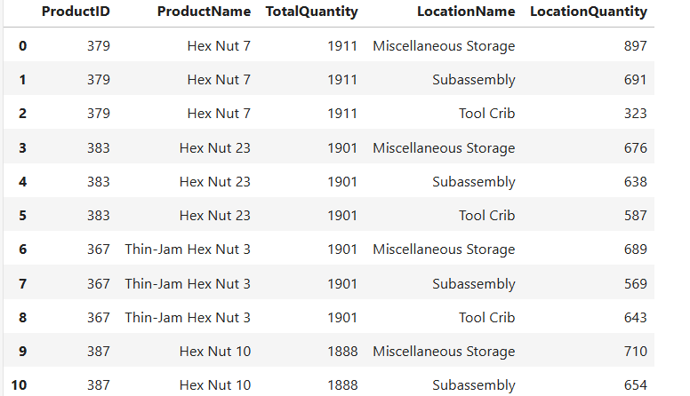

The table shows the products with the highest on-hand quantities spread across the different locations. The sum of a particular products form different locations adds up to it overall total quantity. For instance, the sum of Hex Nut 7 in three different locations adds up to 1911 (897 +691+323)
3.3 Question 2-Work Center Loading Proxy: By manufacturing location (work center), count the number of operations scheduled per week.
First Response
{
"question_understanding": "Count the number of operations scheduled per week by manufacturing location.",
"assumptions": ["Each operation corresponds to a unique WorkOrderRouting entry.", "The week starts on Sunday."],
"sql": "WITH WeeklyOperations AS (SELECT WEEK(ScheduledStartDate) AS WeekNumber, LocationID, COUNT(*) AS OperationsCount FROM Production.WorkOrderRouting GROUP BY WEEK(ScheduledStartDate), LocationID) SELECT WeekNumber, LocationID, OperationsCount FROM WeeklyOperations ORDER BY WeekNumber, LocationID;",
"explanation": "This query uses a Common Table Expression (CTE) to first group the scheduled operations by week and location, counting the number of operations for each combination. The weekly number is derived from the ScheduledStartDate, and the results are ordered by week number and location ID.",
"result_shape": "The output will contain three columns: WeekNumber, LocationID, and OperationsCount.",
"validation_checks": ["Check if the ScheduledStartDate column is valid and has no NULL values.", "Ensure that the COUNT function accurately reflects the number of scheduled operations."],
"plot_suggestion": {
"recommended": true,
"plot_type": "bar",
"x": "WeekNumber",
"y": "OperationsCount",
"title": "Number of Operations Scheduled per Week by Manufacturing Location"
}
}
Analysis of First Response
Strengths
- Correct table selection
- Consistent JSON output
- Correct aggregation/grouping logic
- Correct time grouping
Weakness
- Failure to exclude null schedule dates which may cause logically invalid grouping. We need to add WHERE WR.ScheduledStartDate IS NOT NULL to correct this
- Change the ordering from Location, year, week to year, week, location to ensure ease of trend analysis
- Use both week and year for plotting instead of week alone. This will prevent misleading axis labelling over multiple years.
Improved Response to Question 2
The few-shot prompting techniques was used again to generate an improved output below:
{
"question_understanding": "Count the number of operations scheduled each week for each manufacturing location (work center).",
"assumptions": [
"Each row in Production.WorkOrderRouting represents one scheduled operation.",
"Weekly grouping is based on ScheduledStartDate.",
"Manufacturing locations are represented by Production.Location."
],
"sql": "SELECT L.Name AS LocationName, DATEADD(WEEK, DATEDIFF(WEEK, 0, WR.ScheduledStartDate), 0) AS WeekStart, COUNT(*) AS OperationCount FROM Production.WorkOrderRouting WR JOIN Production.Location L ON WR.LocationID = L.LocationID WHERE WR.ScheduledStartDate IS NOT NULL GROUP BY L.Name, DATEADD(WEEK, DATEDIFF(WEEK, 0, WR.ScheduledStartDate), 0) ORDER BY WeekStart, LocationName;",
"explanation": "The query joins routing rows to manufacturing locations, groups them by the start of the scheduled week, and counts the number of operations scheduled for each work center in each week.",
"result_shape": "A table containing LocationName, WeekStart, and OperationCount.",
"validation_checks": [
"Verify that rows with null ScheduledStartDate are excluded.",
"Verify that each WorkOrderRouting row is counted once.",
"Check that OperationCount is grouped by both location and scheduled week."
],
"plot_suggestion": {
"recommended": true,
"plot_type": "line",
"x": "WeekStart",
"y": "OperationCount",
"title": "Weekly Scheduled Operations by Manufacturing Location"
}
}
The snippet from the table produced from the SQL query is shown here:
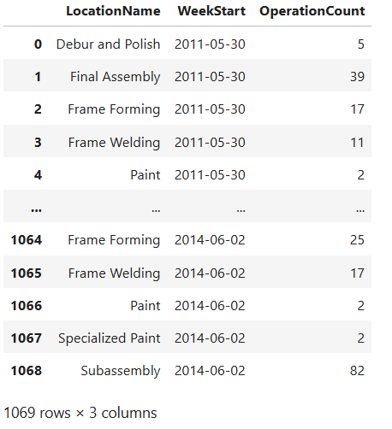
As shown in the table able, the OperationCount column contains the scheduled operations per week for each location
3.4 Question 3-Where-used Analysis: Given a component part, list all parents/subassemblies it is used in (multi-level).
First Response
{
"question_understanding": "List all parent products or subassemblies that use a given component part in a multi-level bill of materials.",
"assumptions": ["A specific component part will be provided to identify its parent assemblies.", "The input component part will be identified by its ProductID."],
"sql": "WITH RecursiveBOM AS (SELECT BOM.ProductAssemblyID, BOM.ComponentID, 1 AS BOMLevel FROM Production.BillOfMaterials AS BOM WHERE BOM.ComponentID = @ComponentID UNION ALL SELECT BOM.ProductAssemblyID, BOM.ComponentID, RBOM.BOMLevel + 1 FROM Production.BillOfMaterials AS BOM INNER JOIN RecursiveBOM AS RBOM ON BOM.ComponentID = RBOM.ProductAssemblyID) SELECT P.ProductID, P.Name FROM RecursiveBOM AS RBOM INNER JOIN Production.Product AS P ON RBOM.ProductAssemblyID = P.ProductID",
"explanation": "This query uses a recursive CTE to get all parent products (assemblies) that use the specified component part. It starts from the direct assemblies and continues to find higher level assemblies, returning the results as a list of products.",
"result_shape": "The output table will contain the ProductID and Name of the parent products.",
"validation_checks": ["Ensure the provided @ComponentID exists in the BillOfMaterials table.", "Check for circular references in the Bill of Materials."],
"plot_suggestion": {
"recommended": false,
"plot_type": "none",
"x": null,
"y": null,
"title": null
}
}
Analysis of First Response
Strengths
- It used the right operations logic, starting from the components and then scale up to the parent assemblies
- It used the most appropriate technique for a multi-level where-used analysis which is the recursive CTE
- Correct table selection
- Consistent JSON output
## Weakness
- The query returns on the assembly ID ProductAssemblyID. It would be a better idea to return the assembly names in addition to the assembly ID
- Add filter to the BOM row to avoid obsolete or inactive relationship
- The query returns on the assembly ID **ProductAssemblyID**. It would be a better idea to return the assembly names in addition to the assembly ID
Improved Response
{
"question_understanding": "List all parent assemblies and subassemblies in which a given component part is used across multiple BOM levels, considering only current BOM relationships.",
"assumptions": [
"The component part is identified by a SQL Server parameter named @ComponentID.",
"Only active Bill of Materials relationships should be included, so rows with EndDate not null are excluded.",
"Parent assembly names should be returned in addition to assembly IDs.",
"A recursive CTE is required to trace usage across multiple BOM levels."
],
"sql": "WITH RecursiveBOM AS ( SELECT BOM.ProductAssemblyID, BOM.ComponentID, 1 AS BOMLevel FROM Production.BillOfMaterials AS BOM WHERE BOM.ComponentID = @ComponentID AND BOM.EndDate IS NULL UNION ALL SELECT BOM.ProductAssemblyID, BOM.ComponentID, RB.BOMLevel + 1 FROM Production.BillOfMaterials AS BOM INNER JOIN RecursiveBOM AS RB ON RB.ProductAssemblyID = BOM.ComponentID WHERE BOM.EndDate IS NULL ) SELECT DISTINCT RB.ProductAssemblyID, P.Name AS ParentAssemblyName, RB.BOMLevel FROM RecursiveBOM AS RB JOIN Production.Product AS P ON RB.ProductAssemblyID = P.ProductID ORDER BY RB.BOMLevel, ParentAssemblyName;",
"explanation": "The query starts from the specified component and finds assemblies that currently use it by filtering the Bill of Materials to active rows where EndDate is null. It then recursively moves upward through higher BOM levels to identify parent assemblies and subassemblies, and joins to the Product table to return readable parent assembly names.",
"result_shape": "A table containing ProductAssemblyID, ParentAssemblyName, and BOMLevel for all active parent assemblies and subassemblies that use the given component.",
"validation_checks": [
"Verify that @ComponentID is provided before execution.",
"Check that only BOM rows with EndDate IS NULL are included.",
"Check that each returned ProductAssemblyID is a valid current parent or ancestor of the component.",
"Confirm that duplicate parent assemblies are removed.",
"Verify that BOMLevel increases correctly as the recursion moves upward."
],
"plot_suggestion": {
"recommended": false,
"plot_type": "none",
"x": null,
"y": null,
"title": null
}
}
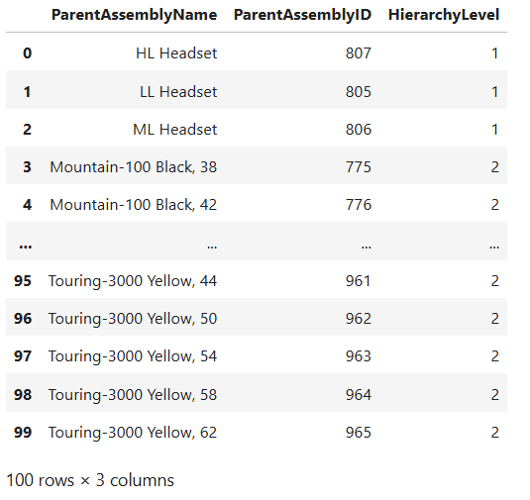
The table shows the parent assembly with assembly ID and hierarchy levels for a given product.
3.5 Question 4 -Classification: “Can we predict whether a work order will incur any scrap?”
First Response
{
"question_understanding": "Predict if a work order will incur any scrap based on features.",
"assumptions": [
"Assuming 'scrap' refers to any non-zero ScrappedQty in the WorkOrder table.",
"Assuming vendor mix is not directly supported in the given schema."
],
"sql": "WITH WorkOrderScrap AS ( SELECT w.WorkOrderID, CASE WHEN w.ScrappedQty > 0 THEN 1 ELSE 0 END AS ScrapOccurred, p.Name AS ProductName, pc.ProductSubcategoryID, pr.LocationID, COUNT(wor.OperationSequence) AS OperationCount, SUM(w.OrderQty) AS TotalQuantity FROM Production.WorkOrder w JOIN Production.Product p ON w.ProductID = p.ProductID LEFT JOIN Production.WorkOrderRouting wor ON w.WorkOrderID = wor.WorkOrderID LEFT JOIN Production.Location pr ON wor.LocationID = pr.LocationID GROUP BY w.WorkOrderID, w.ScrappedQty, p.Name, pc.ProductSubcategoryID, pr.LocationID ) SELECT * FROM WorkOrderScrap",
"explanation": "This query uses a CTE to evaluate each work order for scrap occurrence by checking the ScrappedQty. It joins the WorkOrder and Product tables to get product details and uses left joins with the WorkOrderRouting and Location tables to count operations and identify locations. The final SELECT retrieves the result with necessary features.",
"result_shape": "The output will contain columns for WorkOrderID, ScrapOccurred (1 or 0), ProductName, ProductSubcategoryID, LocationID, OperationCount, and TotalQuantity.",
"validation_checks": [
"Check if the data accurately reflects scrap status for each work order.",
"Ensure the counts of operations and total quantities are correct."
],
"plot_suggestion": {
"recommended": true,
"plot_type": "bar",
"x": "ProductName",
"y": "TotalQuantity",
"title": "Total Quantity by Product with Scrap Occurrence"
}
}
Analysis of First Response
Strengths
- Correct target grain, e.g. one row per **WorkOrderID**
- binary scrap_flag
- product and quantity features,
- routing-derived location feature
Weaknesses
- Generation of SQL table instead of providing the results of the model used, its overall assessments, recommendations and limitations.
- Wrong plot suggestion- the bar chat is usually not a good analytical plot
- There is not column for the location visited
The output generated from the prompt for question 4 was just a table needed to build the models started in the assignment brief instead of a qualitative response that answers whether or not we can predict a work order will incur any scrap.
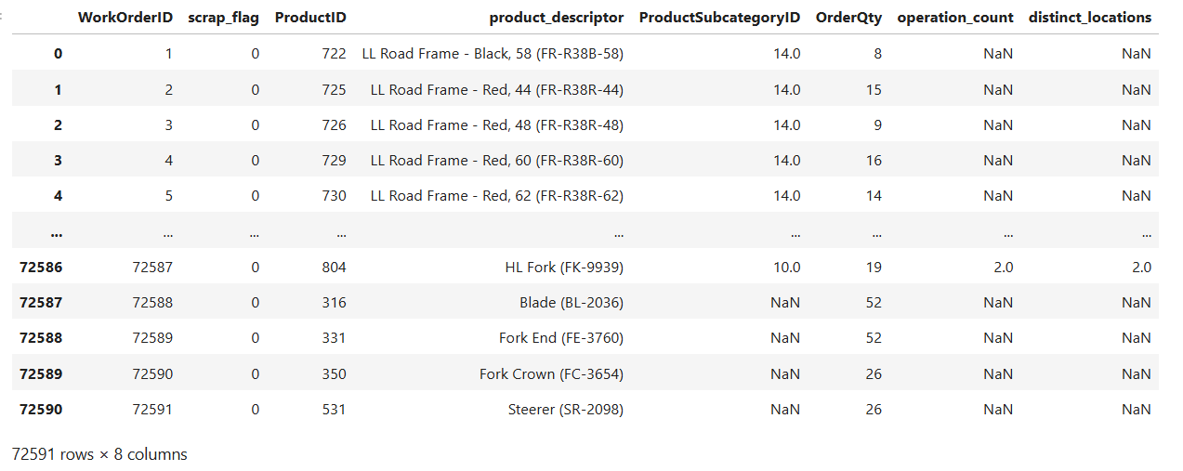
ChatGPT was prompted to clarify this using this prompt:
“Since the assignment is about vibe coding using Natural Language, why can't I just use a prompt to generate the answer to the question from the NL instead of building the models”,
ChatGPT gave this response:

“You can use NL prompts—but not instead of building the model for this assignment. What you’re proposing is a pure LLM answer (reasoning without data). What the assignment expects is a data-driven analytical pipeline (NL → SQL → data → model → insight).”

ChatGPT explained further that the prompting by vibe coding alone is not enough because the problem requires predictive analysis, not descriptive. What this means is that the question require ChatGPT to learn pattern from the historical data in the database, estimate the probabilities of each work order incurring scrap or not and based on that, group them into the binary scrap class, then carry out performance evaluation of the predictive power of the models by calculating their accuracy, precision, recall, F-score, roc_auc_score, confusion matrix, classification_report, and then plot ROC curve.
ChatGPT concludes that "An LLM alone cannot learn from your database unless you explicitly feed it the data." This conclusion outlines the limitation of the reasoning ability of the LLM in its current state and by extension the limit of using vibe coding techniques via NL-SQL interface to solve quantitative manufacturing problems that require more than just expressing opinions. If the LLM must answer such a question in its current state, it will have to perform "hallucinated analytics" that will requires it guessing the pattern instead of using actual historical data. This approach will be methodologically incorrect.
However, ChatGPT suggests further that the LLM in its current state can only be used to perform the following tasks in relation to the question asked:
- Generate the SQL query for the required table
- Determine the predictive feature for whether an order will incur scrap or not (in this case operation_count)
- Recommend what the company can do to reduce scrap
To implement these suggestions the data generated from the SQL query was pre-processed, cleaned, and used to build both Logistic Regression and Random Forest Classifier models. This was combined with NL interpretation layers to form an hybrid system with the flowchart shown below:
Upgraded Architecture for the Hybrid Analytical System
User (Natural Language)
↓
Prompt Engineering (Schema + Examples)
↓
LLM → SQL Generation
↓
SQL Execution (Database)
↓
DataFrame (Python)
↓
Feature Engineering
↓
Machine Learning Models
↓
Evaluation Metrics
↓
LLM Interpretation Layer
↓
Business Insights & Recommendations
The output from the upgraded hybrid system is shown below:
Overall assessment: Logistic Regression outperformed Random Forest significantly in classifying scrap risk with a higher ROC-AUC and better precision and recall for the scrap class.
Best model: Logistic Regression is the better model due to its superior ROC-AUC of 0.9487 and a more balanced performance across both classes, especially in precision and recall for detecting actual scrap incidents.
Top drivers:
- ProductSubcategoryID_14.0
- OrderQty
- Operation Count
Shop-floor recommendations:
- Focus on optimizing processes for Product Subcategories with high scrap risk.
- Monitor order quantities closely as they may influence the likelihood of incurring scrap.
- Implement targeted training for operations that show a high correlation with scrap occurrences.
Limitations:
- Logistic Regression may struggle with non-linear relationships, limiting its applicability in more complex scenarios.
- The Random Forest model, while achieving higher accuracy, showed poor recall for scrap incidents, potentially leading to missed opportunities for quality control.
3.6 Question 5-Classification: Forecast which finished goods will be at risk of stockout given recent transaction history and current on-hand.
Like in question 4, the limitation of the NL interface was exposed again as the output generated from it was just the SQL query that produced the table needed to build the models for the classification tasks. To answer this question will require the use of the hybrid approach of building the model and using the NL to interpret the outcomes and make business recommendations. The snippet from the table generated for question 5 is show below:
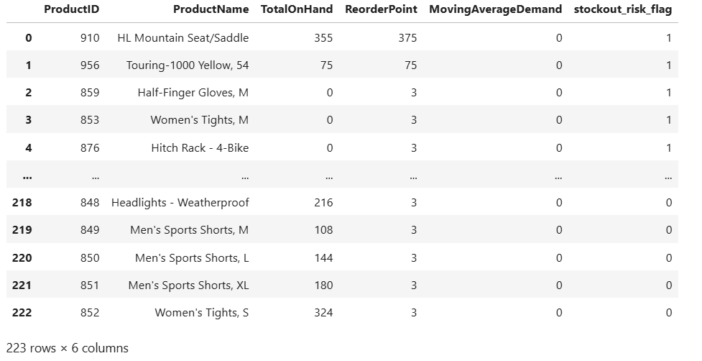

4.0 Prompt Log of the Project

# | Stage | User Prompt / Task | Assistant Response Summary | Validation Used | Result
1 | System Design | Build NL→SQL system | Designed architecture | Conceptual | Initial design
2 | API Setup | Fix API errors | Corrected API usage | API test | Working
3 | Environment Setup | Link API key | Used os.getenv | Print test | Key accessible
4 | Execution Errors | Run notebook | Fixed .ipynb issue | Runtime | Fixed
5 | Jupyter Issue | Fix get_ipython | Explained misuse | Run test | Improved
6 | Prompt Engineering | Design system prompt | Structured JSON rules | Inspection | Stable
7 | Schema Integration | Add schema | Used f-string | .print | Embedded
8 | Debugging | Fix KeyError | Correct placeholders | Debug | Fixed
9 | Debugging | Fix tuple | Removed comma | Type check | Correct
10 | API Call Fix | Invalid model | Used gpt-4o-mini | API test | Working
11 | Message Format | Fix nested messages | Flattened content | Print | Valid
12 | First Output | Inventory SQL | Generated SQL | Review | Flawed
13 | SQL Refinement | Fix top-10 | Used CTE | Logic | Improved
14 | Output Improvement | Add location qty | Enhanced SQL | Review | Better
15 | JSON Handling | Parse output | json.loads | Test | Structured
16 | Safety Layer | Validate SQL | SELECT-only check | Test | Safe
17 | Prompt Improvement | Few-shot | Added example | Compare | Better
18 | String Fix | Fix braces | Used {{}} | Print | Stable
19 | Alignment | Correct question | Matched brief | Review | Improved
20 | Table Validation | Check tables | Correct joins | Conceptual | Correct
21 | New Query | Weekly ops | Generated SQL | Review | Correct
22 | SQL Refinement | Improve grouping | DATEADD | Logic | Robust
23 | Advanced Query | BOM recursion | Recursive CTE | Review | Correct
24 | SQL Improvement | Add names | Joined Product | Review | Usable
25 | Business Logic | Filter BOM | EndDate NULL | Validation | Correct
26 | Final Refinement | Improve recursion | Optimised | Logic | Near perfect
27 | Quality Review | Evaluate SQL | Critical review | Analysis | 9/10
28 | Analytics Transition | Move to ML | Defined pipeline | Conceptual | Ready
29 | Feature Selection | Choose features | Selected predictors | Reasoning | Good
30 | Encoding Strategy | Handle descriptor | Dropped/encoded | Data check | Controlled
31 | One-hot Encoding | Encode subcategory | pd.get_dummies | Run | Done
32 | Feature Validation | Check X | Removed IDs | Inspect | Clean
33 | Model Training | Train LR/RF | Built models | Fit | Trained
34 | Evaluation | Metrics | ROC-AUC | Sklearn | Robust
35 | Confusion Matrix | Generate | Added matrix | Metrics | Visible
36 | LLM Layer | Interpret results | Insights | Prompt test | Working
37 | Pipeline | Integrate | End-to-end | Conceptual | Complete
38 | Stockout Task | New problem | Designed table | Prompt | Started
39 | Prompt Design | user_content8 | Structured prompt | Inspect | Stable
40 | SQL Gen | Stockout SQL | Generated | Review | Flawed
41 | SQL Fix | Aggregation | Used SUM | Logic | Correct
42 | Logic Fix | Risk logic | Comparison rule | Concept | Correct
43 | Prompt Improve | Add understanding | Few-shot | Compare | Better
44 | SQL→DF | Execute query | pd.read_sql | Run | Success
45 | Error Fix | Tuple issue | Fixed call | Runtime | Clean
46 | Param Fix | numpy error | Cast int | Type | Fixed
47 | Final Table | Scrap dataset | Generated | Inspect | Ready
48 | Justification | Why ML | Explained | Concept | Valid
49 | Feature Final | Confirm features | Validated | Review | Final
50 | System Final | Full pipeline | Integrated | Design | Complete

5.0 Conclusion
The outcome of this project re reveals that LLM models can be effectively deployed to generate SQL queries that can be used to solve manufacturing problems that are within the domain of descriptive analysis. However, they models lack the capacity to perform machine learning tasks like prediction and classification which requires statistical processing of historical data. Therefore, using for ML task required an hybrid system that integrate NL query generation with the statistical and machine learning skills of a human analyst to ensure the validity of the outcomes. The NL model can then be used to build the interpretation layer for interpreting the results and making business recommendations.
AI Declaration
AI was used to:
- Interpret the first output generated by the Client model for each question
- Generated improved user content for the second output for each question
- Implement the LLM decision layer for question 4
- Reformat the prompt log

