

Tribhuvan University
Faculty of Humanities and Social Sciences

THRIFT STORE
An Online Second-Hand Goods Marketplace

A PROJECT REPORT

Submitted to
Department of Computer Application
NIST College

In partial fulfillment of the requirements for the
Bachelor of Computer Application (BCA)

Submitted by
Santosh Shrestha
(6-2-1014-26-2022)
4 April, 2026

Under the Supervision of
Samish Shrestha



Tribhuvan University
Faculty of Humanities and Social Sciences
NIST College

SUPERVISOR'S RECOMMENDATION

I hereby recommend that this project prepared under my supervision by Santosh Shrestha entitled "THRIFT STORE”: An Online Second-Hand Goods Marketplace" in partial fulfillment of the requirements for the degree of Bachelor of Computer Application is recommended for the final evaluation.

..................................
Signature

Samish Shrestha
SUPERVISOR
Department of Computer Application
NIST College, Banepa


Tribhuvan University
Faculty of Humanities and Social Sciences
NIST College, Banepa
LETTER OF APPROVAL

This is to certify that this project prepared by SANTOSH SHRESTHA entitled “THRIFT STORE” in partial fulfillment of the requirements for the degree of Bachelor in Computer Application has been evaluated. In our opinion it is satisfactory in the scope and quality as a project for the required degree.

SIGNATURE of Supervisor  Mr. Samish Shrestha  Department of Humanities and Social Science  NIST College Banepa, Kavre | SIGNATURE of HOD/Coordinator  Mr. Samish Shrestha  Department of Humanities and Social Science  NIST College Banepa, Kavre
SIGNATURE of Internal Examiner  Internal Examiner | SIGNATURE of Internal Examiner  External Examiner

Abstract
Thrift Store is a full-stack web-based e-commerce platform developed to facilitate the buying and selling of second-hand goods in Nepal. The system is built using Node.js with Express.js framework on the backend, PostgreSQL as the relational database managed through Prisma ORM, and vanilla HTML/CSS/JavaScript with Tailwind CSS on the frontend. The platform integrates eSewa, Nepal's leading digital payment gateway, for secure online transactions using HMAC-SHA256 signature verification. Real-time chat functionality is implemented using Socket.io, enabling direct bidirectional communication between buyers and sellers.
To enhance platform intelligence and user experience, several algorithms are integrated. The Haversine Algorithm is used to calculate geographical distances between buyers and sellers for location-based filtering and delivery estimation. A dynamic ratings algorithm aggregates user feedback to compute seller credibility scores. Efficient product retrieval is achieved using optimized search algorithms with keyword matching and indexing. Additionally, a content-based filtering recommendation system suggests relevant products to users based on their browsing history and preferences.
The application follows a Model-View-Controller (MVC) architectural pattern with a service layer, ensuring clean separation of concerns. Key features include JWT-based user authentication, role-based access control, a product listing and admin approval workflow, granular order management with item-level status tracking, Firebase OTP-based phone verification, a seller rating system, and in-app push notifications. The platform is implemented in TypeScript for type safety and employs Prisma ORM for schema-driven database access. With 13 database models and over 30 REST API endpoints, Thrift Store represents a production-capable solution for Nepal's growing second-hand goods market.

Keywords: E-Commerce, Thrift Store, Node.js, Express.js, TypeScript, PostgreSQL, Prisma, eSewa, Socket.io, JWT, Nepal

Acknowledgement
I would like to express my deepest gratitude to my project supervisor, Samish Shrestha for their invaluable guidance, continuous support, and constructive suggestions throughout the development of this project. Their expertise and encouragement were instrumental in shaping this work.

I am also thankful to the Head of the Department and all the faculty members of the Department of Computer Application at NIST College for their support and motivation during the course of this project.

I extend my sincere thanks to Tribhuvan University and the Faculty of Humanities and Social Sciences for providing this opportunity to undertake such a practical and meaningful project.

Finally, I would like to thank my family and friends for their constant encouragement and support throughout the duration of this project.

Santosh Shrestha
6-2-1014-26-2022
BCA 6th Semester, NIST College

TABLE OF CONTENT
Abstract iii
Acknowledgement iv
List of Tables vii
List of Figures viii
CHAPTER 1: INTRODUCTION 1
1.1 Introduction 1
1.2 Problem Statement 1
1.3 Objectives 2
1.4 Scope and Limitation 3
1.5 Development Methodology 4
1.6 Report Organization 4
CHAPTER 2: BACKGROUND STUDY AND LITERATURE REVIEW 5
2.1 Background Study 5
2.1.1 E-Commerce and C2C Marketplaces 5
2.1.2 Node.js and Express.js 5
2.1.3 TypeScript 5
2.1.4 PostgreSQL and Prisma ORM 5
2.1.5 JWT Authentication and Bcrypt 6
2.1.6 Socket.io for Real-Time Communication 6
2.1.7 eSewa Payment Gateway 6
2.1.8 Firebase Phone Authentication and Multer 6
2.2 Literature Review 7
2.2.1 OLX Nepal and Facebook Marketplace (Local Context) 7
2.2.2 ThredUp and Poshmark (Global Context) 7
2.2.3 PERN-Stack and Full-Stack TypeScript Applications 7
2.2.4 Trust and Rating Systems in Online Marketplaces 7
2.2.5 Digital Payment Adoption in Nepal 8
CHAPTER 3: SYSTEM ANALYSIS AND DESIGN 9
3.1 System Analysis 9
3.1.1 Requirement Analysis 9
3.1.2 Feasibility Analysis 12
3.1.3 Data Modelling 13
3.1.4 Process Modelling (DFD) 17
3.2 System Design 18
3.2.1 Architectural Design 18
3.2.2 Database Schema Design 19
3.2.3 Interface Design (UI/UX) 20
3.2.4 Sequence Diagram: eSewa Payment Flow 20
3.4 Algorithm Details 21
Algorithm 3.4.1: Haversine Distance Calculation 21
Algorithm 3.4.2: Product Search Algorithm 22
Algorithm 3.4.3: Product Rating Algorithm 22
Algorithm 3.4.4: Content-Based Filtering 23
Chapter 4: Implementation and Testing 26
4.1 Implementation 26
4.1.1 Tools Used 26
4.1.2 Implementation Details of Modules 26
4.2 Testing 28
4.2.1 Unit Test Cases 29
4.2.2 System Test Cases 30
CHAPTER 5: CONCLUSION AND FUTURE RECOMMENDATIONS 33
5.1 Conclusion 33
5.2 Lesson Learnt / Outcome 33
5.3 Future Recommendations 34
References 36

List of Tables
Table 3.1: Use Case Description - UC-01: Browse/Search Products .................................10
Table 3.2: Use Case Description - UC-02: List a Product .................................................10
Table 3.3: Use Case Description - UC-03: Place an Order ................................................11
Table 3.4: Use Case Description - UC-04: Process Payment via eSewa ............................11
Table 3.5: Use Case Description - UC-05: Real-Time Chat ..............................................12
Table 3.6: Data Dictionary - User ......................................................................................14
Table 3.7: Data Dictionary - Product .................................................................................14
Table 3.8: Data Dictionary - Order ....................................................................................15
Table 3.9: Data Dictionary - OrderItem .............................................................................15
Table 3.10: Data Dictionary - PaymentTransaction ..........................................................16
Table 3.11: Technology Stack Overview ...........................................................................20
Table 4.1: Tools Used ........................................................................................................21
Table 4.2: Unit Test Cases .................................................................................................25
Table 4.3: System Test Cases .............................................................................................26

List of Figures
Figure 3.1: Use Case Diagram - Thrift Store ........................................................................9
Figure 3.2: Level-0 Data Flow Diagram (Context Diagram) ..............................................13
Figure 3.3: Level-1 Data Flow Diagram ............................................................................13
Figure 3.4: Three-Tier System Architecture .......................................................................17
Figure 3.5: Entity Relationship Diagram ............................................................................18
Figure 3.6: Sequence Diagram - eSewa Payment Flow ......................................................19

CHAPTER 1: INTRODUCTION

1.1 Introduction
In the contemporary digital landscape, Nepal's consumer economy is undergoing a significant transformation. The traditional method of buying and selling second-hand goods relies heavily on physical stores, word-of-mouth referrals, or general-purpose social media platforms that are not optimized for e-commerce. This unorganized market often leads to inefficiencies including lack of price transparency, absence of buyer-seller trust mechanisms, and no structured order management.

With the increasing penetration of internet services and digital payment platforms like eSewa and Khalti in Nepal, there is a viable opportunity to digitize the thrift goods market. The success of fintech solutions and ride-hailing services in Nepal demonstrates that Nepali consumers are increasingly comfortable transacting digitally. However, the second-hand goods segment has not benefited proportionally from this digital transformation.

Thrift Store is a full-stack web-based e-commerce platform developed to fill this gap. Built using Node.js with Express.js and TypeScript, PostgreSQL with Prisma ORM, and a Tailwind CSS frontend, the platform enables users to list pre-owned items for sale, browse and purchase products, communicate with sellers in real-time via Socket.io, and transact securely through eSewa. The platform also incorporates an admin approval workflow, phone OTP verification, a seller rating system, and in-app notifications, making it a comprehensive and production-capable solution for Nepal's thrift economy.

1.2 Problem Statement
Despite the growing interest in second-hand and sustainable shopping in Nepal, the current market structure remains fragmented. The specific problems identified include:
- Lack of a Centralized Platform: There is no dedicated, trusted digital marketplace for second-hand goods in Nepal. Buyers and sellers rely on informal channels with no quality control.
- Absence of Trust Mechanisms: Neither buyers nor sellers have verified records of each other. There is no rating or review system to build seller reputation.
- No Digital Payment Integration: Transactions are mostly cash-based, which lacks security, transparency, and record-keeping. There is a clear need for integration of local payment gateways like eSewa.
- Inefficient Communication: Buyers have no direct channel to communicate with sellers about product condition, negotiation, or delivery arrangements.
- No Product Quality Control: Without a verification mechanism, low-quality or fraudulent listings diminish buyer trust and platform integrity.
- No Order Tracking: Buyers have no visibility into the status of their purchases after payment, and sellers have no structured way to manage fulfillment.

Thrift Store addresses all of these issues by providing a structured, secure, and feature-rich digital marketplace.

1.3 Objectives
The general objective of this project is to develop a fully functional online platform for buying and selling second-hand goods in Nepal. The objectives are categorized into functional and non-functional objectives.
1.3.1 Functional Objectives
- To implement a secure user authentication and authorization system with role-based access control (USER and ADMIN roles) using JWT and Bcrypt.
- To develop a product management system with multi-image uploads, category filtering, and an admin approval workflow to ensure quality control.
- To integrate eSewa payment gateway using HMAC-SHA256 signature generation for secure digital transactions.
- To implement a real-time bidirectional chat system using Socket.io for direct buyer-seller communication.
- To build a comprehensive order management system with item-level status tracking for both buyers and sellers.
- To develop a seller rating and review system (1-5 stars) linked to completed orders for trust building.
- To implement phone OTP verification via Firebase to ensure user authenticity before product listing.
- To build an admin panel for product approval management and platform oversight.
1.3.2 Non-Functional Objectives
- Security: Passwords shall be hashed using Bcrypt. API endpoints shall be protected by JWT. Payment transactions shall use HMAC-SHA256 cryptographic signatures.
- Performance: API responses shall be returned within 2 seconds under normal load. Real-time messages shall be delivered within 500 milliseconds.
- Usability: The user interface shall be responsive and accessible on both desktop and mobile browsers using Tailwind CSS.
- Maintainability: The codebase shall follow MVC architecture in TypeScript with a service layer for clean separation of concerns.
- Scalability: The database schema shall support future expansion without major restructuring.

1.4 Scope and Limitation
1.4.1 Scope
The scope of Thrift Store includes the following functionalities:
- User registration, login, and profile management with photo upload
- Product listing with up to 5 images, title, description, price, category, gender, location, and refundability
- Admin panel for product approval, rejection (with reason), and user management
- Product browsing with category and seller filtering
- Shopping cart and order placement with multi-product support
- eSewa sandbox payment gateway integration
- Real-time buyer-seller messaging using Socket.io
- Order tracking with item-level status: Pending → Processing → Shipped → Delivered → Received
- Seller rating (1-5 stars) and review system
- Phone OTP verification via Firebase
- In-app notification system for product and order status events
1.4.2 Limitations
- The eSewa payment gateway is currently in sandbox (test) mode and has not been tested with live NPR transactions.
- The platform is web-based only; native mobile applications for iOS/Android are not included.
- Delivery logistics and courier integration are not implemented; physical delivery is arranged between buyer and seller.
- Search functionality is basic (filter by category/seller); full-text search and AI recommendations are not included.
- Real-time GPS tracking of sellers or delivery agents is not implemented.

1.5 Development Methodology
The project was developed using the Incremental Development Methodology, which divides the system into manageable increments that are developed, tested, and integrated progressively. This approach was chosen for its flexibility in accommodating evolving requirements and its suitability for a complex full-stack application developed over a single semester.

The development proceeded through seven increments: (1) Project setup, database schema design using Prisma, and basic JWT authentication. (2) Product management with Multer image uploads and admin approval workflow. (3) Order management system with buyer/seller views and item-level status tracking. (4) eSewa payment gateway integration with HMAC-SHA256 signatures and transaction tracking. (5) Real-time Socket.io chat with JWT authentication at socket level. (6) Seller rating system, Firebase phone OTP verification, and notification system. (7) Frontend polish with Tailwind CSS, comprehensive testing, and documentation.

1.6 Report Organization
This report is organized into five main chapters. Chapter 1 provides the background, problem statement, objectives, scope, and methodology. Chapter 2 presents the background study covering all key technologies and a review of similar existing systems. Chapter 3 covers system analysis and design including use case descriptions, DFDs, ER diagram, architecture diagram, and data dictionaries. Chapter 4 details the implementation of all modules with tools used, and presents unit and system test cases. Chapter 5 concludes with lessons learned and future recommendations.

CHAPTER 2: BACKGROUND STUDY AND LITERATURE REVIEW

2.1 Background Study

2.1.1 E-Commerce and C2C Marketplaces
Electronic commerce (e-commerce) refers to commercial transactions conducted over the internet. Thrift Store operates as a Consumer-to-Consumer (C2C) marketplace, a model where individual users can both list and purchase items from one another. Unlike B2C (Business-to-Consumer) platforms, C2C marketplaces require robust trust mechanisms such as ratings and verification systems, since transactions occur between private individuals without a corporate seller guarantee. The platform serves as a trusted intermediary providing verification, payment processing, and dispute awareness.

2.1.2 Node.js and Express.js
Node.js is a JavaScript runtime built on Chrome's V8 engine, designed for building scalable network applications using an event-driven, non-blocking I/O model. Express.js is a minimal and flexible Node.js web application framework that provides a robust set of features for building REST APIs. Thrift Store uses Express.js 5.2.1 as the backend framework to define route handlers, apply middleware, and serve static frontend files. The non-blocking nature of Node.js is particularly beneficial for real-time features like Socket.io chat.

2.1.3 TypeScript
TypeScript is a strongly-typed superset of JavaScript developed by Microsoft. It adds optional static typing, interfaces, and generics to JavaScript. The entire backend of Thrift Store is written in TypeScript 5.9.3, which significantly reduces runtime errors through compile-time type checking, improves code documentation, and enhances maintainability. TypeScript's integration with Prisma provides end-to-end type safety from database queries to API responses.

2.1.4 PostgreSQL and Prisma ORM
PostgreSQL is a powerful, open-source object-relational database system known for its reliability, extensibility, and ACID compliance. Prisma is a next-generation ORM for Node.js and TypeScript that provides a type-safe database client generated from the schema definition. Thrift Store uses Prisma 6.4.1 for all database interactions, with schema migrations tracked in the prisma/migrations/ directory. This combination ensures type-safe queries, automatic schema evolution, and a visual database browser via Prisma Studio.

2.1.5 JWT Authentication and Bcrypt
JSON Web Tokens (JWT) are an open standard (RFC 7519) for securely transmitting information between parties as a signed JSON object. In Thrift Store, JWTs are generated upon login, containing the user's id, email, role, and name, with a 2-day expiration. Bcrypt is a password-hashing function that incorporates a salt to protect against rainbow table attacks. All user passwords are hashed using Bcrypt with a salt factor of 10 before storage, ensuring that even if the database is compromised, plaintext passwords cannot be recovered.

2.1.6 Socket.io for Real-Time Communication
Socket.io is a JavaScript library that enables real-time, bidirectional, event-based communication between web clients and servers. It builds on the WebSocket protocol but provides additional fallback mechanisms. Thrift Store uses Socket.io 4.8.3 to power its chat system. The Socket.io server applies JWT authentication middleware at the connection level, assigns users to personal notification rooms (user-{userId}) and conversation-specific rooms (chat-{conversationId}), and persists all messages to the database before broadcasting.

2.1.7 eSewa Payment Gateway
eSewa is Nepal's first and largest digital wallet and payment gateway, operated by F1Soft International Pvt. Ltd. It supports online payment integration through its RC-Epay API. Thrift Store integrates eSewa using HMAC-SHA256 digital signatures for payment request verification. The integration supports sandbox testing with merchant code EPAYTEST and handles payment callbacks to update transaction and order status in the database.

2.1.8 Firebase Phone Authentication and Multer
Firebase is a Google-backed mobile and web development platform. Thrift Store uses Firebase's phone authentication to generate custom tokens for OTP-based phone verification, required before users can list products. Multer is a Node.js middleware for handling multipart/form-data, primarily used for file uploads. The platform uses Multer to handle product image uploads (up to 5 files, 5MB each) and user profile photos, stored in dedicated directories with uniquely generated filenames.

2.2 Literature Review

2.2.1 OLX Nepal and Facebook Marketplace (Local Context)
OLX Nepal and Facebook Marketplace are the most widely used platforms for second-hand goods trading in Nepal. While they provide basic listing and browsing capabilities, both platforms suffer from significant limitations: they lack integrated digital payment solutions, there is no admin quality control or product approval workflow, communication relies on external contact methods rather than built-in chat, and there is no order management or fulfillment tracking. Thrift Store addresses all these gaps with its integrated payment, real-time chat, order tracking, and admin approval system.

2.2.2 ThredUp and Poshmark (Global Context)
ThredUp and Poshmark are leading US-based online thrift stores that provide comprehensive second-hand shopping experiences. Poshmark's social commerce features — including follow, share, and seller ratings — demonstrate the importance of community and trust in C2C platforms. ThredUp's emphasis on quality verification through a curated acceptance process informs Thrift Store's admin approval workflow. However, both platforms are designed for Western markets and do not support Nepali payment systems, making them inaccessible for the target user base.

2.2.3 PERN-Stack and Full-Stack TypeScript Applications
Research on PERN-stack (PostgreSQL, Express, React, Node.js) based e-commerce applications establishes that modern full-stack JavaScript applications achieve high developer productivity and type safety when using TypeScript and Prisma ORM. Studies highlight that Prisma's generated types eliminate an entire category of type mismatch errors that commonly occur with raw SQL queries. This informed Thrift Store's decision to use TypeScript throughout the backend with Prisma as the data access layer.

2.2.4 Trust and Rating Systems in Online Marketplaces
Seminal research by Resnick et al. on reputation systems in online marketplaces demonstrates that seller rating mechanisms significantly increase buyer confidence and transaction completion rates. Their study of eBay's feedback system shows that sellers with higher ratings command higher prices for identical goods. Thrift Store's rating system (1-5 stars, linked to completed orders with a unique constraint per reviewer-seller-order triplet) is designed following these principles to ensure authentic, non-duplicate reviews that build meaningful seller reputation.

2.2.5 Digital Payment Adoption in Nepal
Research on digital payment adoption in Nepal indicates that eSewa has the highest penetration rate among digital wallets, with over 20 million users as of 2024, making it the optimal payment gateway for a Nepali e-commerce platform. Studies on payment security emphasize the necessity of HMAC-based signature verification for preventing transaction tampering, a technique fully implemented in Thrift Store's payment module using Node.js's built-in crypto module.

CHAPTER 3: SYSTEM ANALYSIS AND DESIGN

3.1 System Analysis

3.1.1 Requirement Analysis
i. Functional Requirements
The functional requirements define what the system must do. These are illustrated via the Use Case Diagram in Figure 3.1. The main actors are: Guest User (browse only), Registered User / Buyer / Seller (full platform access), and Administrator (platform management).

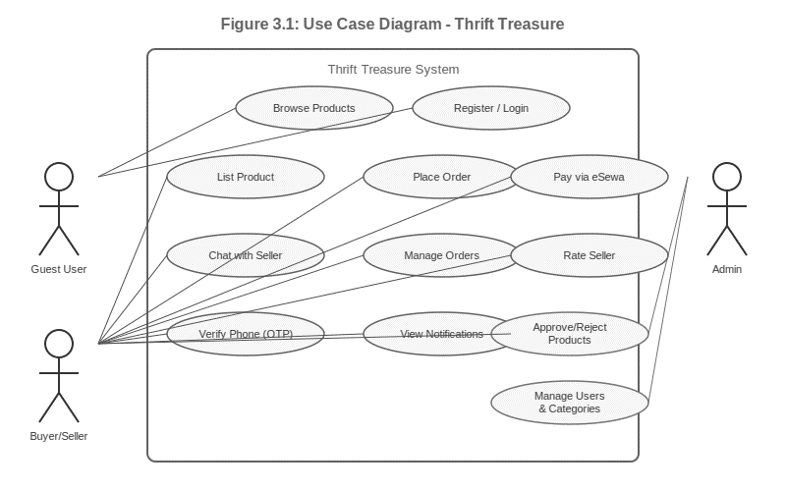
Figure 3.1: Use Case Diagram - Thrift Store

The following use case descriptions detail the key interactions:

Use Case | UC-01: Browse and Search Products
Use Case ID | UC-01
Actor | Guest User / Registered User
Precondition | None (public endpoint)
Description | Any user can browse the product catalog. Products can be filtered by category, seller, or status. Only APPROVED products are visible to the public.
Postcondition | User is presented with a filtered list of available products.
Alternate Flow | If no products match the filter, an empty list is returned with an appropriate message.

Table 3.1: Use Case Description - UC-01: Browse/Search Products

Use Case | UC-02: List a Product
Use Case ID | UC-02
Actor | Registered User (Seller)
Precondition | User is authenticated (JWT) and phone is verified.
Description | The seller fills in product details (title, description, price, quantity, category, gender, location, refundable) and uploads up to 5 images. The system enforces a daily product limit. The product is saved with PENDING status awaiting admin approval.
Postcondition | Product created with PENDING status; seller receives a PRODUCT_SUBMITTED notification.
Alternate Flow | If phone is not verified, a 403 error is returned. If daily limit is exceeded, a 429 error is returned.

Table 3.2: Use Case Description - UC-02: List a Product

Use Case | UC-03: Place an Order
Use Case ID | UC-03
Actor | Registered User (Buyer)
Precondition | User is authenticated; products are APPROVED and in stock.
Description | Buyer submits an order with an array of product IDs and quantities. System validates availability, calculates total, creates Order and OrderItem records. Buyer is redirected to payment.
Postcondition | Order created with PENDING status; ORDER_PLACED notifications sent to buyer and relevant sellers.
Alternate Flow | If any product is out of stock or not approved, a 400 error is returned.

Table 3.3: Use Case Description - UC-03: Place an Order

Use Case | UC-04: Process Payment via eSewa
Use Case ID | UC-04
Actor | Buyer, eSewa Payment Gateway
Precondition | Order has been created; buyer initiates payment.
Description | System generates unique transaction UUID and HMAC-SHA256 signature, creates a PENDING PaymentTransaction, and returns payment form data. Frontend redirects buyer to eSewa sandbox. On payment completion, eSewa sends callback to /api/payment/simple/esewa-callback. System verifies signature and updates transaction and order payment status.
Postcondition | PaymentTransaction.status = COMPLETED; Order.paymentStatus = COMPLETED.
Alternate Flow | If eSewa callback indicates failure, status is set to FAILED and buyer is redirected to failure page.

Table 3.4: Use Case Description - UC-04: Process Payment via eSewa

Use Case | UC-05: Real-Time Chat
Use Case ID | UC-05
Actor | Buyer, Seller
Precondition | Both users are authenticated; Socket.io connection established with JWT.
Description | Buyer initiates a conversation with a seller. Both join the conversation room (chat-{conversationId}). Messages are persisted to the database before being emitted, ensuring history is preserved for offline users.
Postcondition | Messages delivered in real-time; conversation and message records saved to database.
Alternate Flow | If JWT verification fails at socket connection, the connection is rejected.

Table 3.5: Use Case Description - UC-05: Real-Time Chat
ii. Non-Functional Requirements
- Availability: The system shall be available 99% of the time during operational hours.
- Response Time: API endpoints shall respond within 2 seconds; real-time messages within 500ms.
- Security: Passwords hashed with Bcrypt; API endpoints protected with JWT; payment requests signed with HMAC-SHA256.
- Scalability: The MVC + service layer architecture and Prisma migrations allow horizontal and vertical scaling.
- Maintainability: Full TypeScript codebase with strict mode, clean module boundaries, and centralized error handling.

3.1.2 Feasibility Analysis
Technical Feasibility
All technologies used (Node.js, Express.js, TypeScript, PostgreSQL, Prisma, Socket.io) are mature, open-source, and well-documented with large community support. The development machine (standard laptop with 8GB+ RAM) is sufficient for local development. eSewa provides free sandbox credentials. Firebase provides a free authentication tier. All tools are available at no cost, making the project technically feasible.
Operational Feasibility
The system is designed with an intuitive Tailwind CSS interface following standard web conventions, minimizing the learning curve for end users. The admin panel provides clear tools for product management. Buyer and seller workflows are clearly separated with role-based access control. The system can be operated by non-technical administrators once deployed.
Economic Feasibility
Development uses entirely open-source and free technologies. Cloud hosting for initial deployment can be done using free tiers of services such as Railway (PostgreSQL + Node.js), Vercel, or Render. The primary cost is development time. eSewa integration uses free sandbox credentials for testing. The economic cost of development and initial deployment is minimal.

3.1.3 Data Modelling
The database design is represented using an Entity-Relationship (ER) Diagram. The system consists of 10 core tables: User, Category, Product, Order, OrderItem, PaymentTransaction, UserRating, Notification, Conversation, and Message. The ER diagram below illustrates the entities, their attributes, and the relationships between them.

Data Dictionary
The following tables define the structure of the primary database entities:

Field Name | Data Type | Constraints | Description
id | Int | PK, Auto-increment | Unique identifier for each user
name | String | Optional | User's display name
email | String | Unique, Not Null | User's email address for login
password | String | Not Null | Bcrypt-hashed password
role | Enum (ADMIN/USER) | Default: USER | Determines access level
phone | String | Optional, Unique | Phone number for OTP verification
phoneVerified | Boolean | Default: false | Flag for phone OTP status
photo | String | Optional | Path to uploaded profile image
dailyProductCount | Int | Default: 0 | Daily product listing counter
lastProductDate | DateTime | Optional | Date of last product listing
createdAt | DateTime | Auto-set | Account creation timestamp
updatedAt | DateTime | Auto-updated | Last update timestamp

Table 3.6: Data Dictionary - User

Field Name | Data Type | Constraints | Description
id | Int | PK, Auto-increment | Unique identifier for each product
title | String | Not Null | Product listing title
description | String | Optional | Detailed product description
price | Float | Not Null, > 0 | Product price in NPR
quantity | Int | Default: 1 | Available quantity
images | String[] | Array | Array of image file paths
status | Enum | Default: PENDING | PENDING/APPROVED/REJECTED /  OUT_OF_STOCK
gender | String | Optional | MEN/WOMEN/UNISEX/KIDS
refundable | Boolean | Default: true | Whether item is refundable
location | Json | Optional | { address, lat, lng } for geolocation
rejectionReason | String | Optional | Admin's reason for rejection
sellerId | Int | FK → User | Reference to seller's user account
categoryId | Int | FK → Category | Reference to product category
purchaseDate | DateTime | Optional | When seller originally purchased item

Table 3.7: Data Dictionary - Product

Field Name | Data Type | Constraints | Description
id | Int | PK, Auto-increment | Unique identifier for each order
buyerId | Int | FK → User, Not Null | Reference to buyer's user account
total | Float | Not Null | Total order amount in NPR
status | Enum | Default: PENDING | PENDING/PROCESSING/PARTIALLY_DELIVERED/DELIVERED/CANCELLED
paymentStatus | Enum | Default: PENDING | PENDING/COMPLETED/FAILED/CANCELLED
createdAt | DateTime | Auto-set | Order creation timestamp
updatedAt | DateTime | Auto-updated | Last update timestamp

Table 3.8: Data Dictionary - Order
Field Name | Data Type | Constraints | Description
id | Int | PK, Auto-increment | Unique identifier for each order item
orderId | Int | FK → Order, Not Null | Reference to parent order
productId | Int | FK → Product, Not Null | Reference to ordered product
quantity | Int | Not Null, ≥ 1 | Quantity ordered
price | Float | Not Null | Price at time of purchase
status | Enum | Default: PENDING | PENDING/PROCESSING/SHIPPED/DELIVERED/RECEIVED/CANCELLED
cancelledReason | String | Optional | Reason if status is CANCELLED
deliveredAt | DateTime | Optional | Timestamp when marked delivered

Table 3.9: Data Dictionary - OrderItem

Field Name | Data Type | Constraints | Description
id | Int | PK, Auto-increment | Unique identifier for each transaction
orderId | Int | FK → Order, Not Null | Reference to associated order
transactionId | String | Unique, Not Null | System-generated UUID (TT-{timestamp}-{random})
transactionCode | String | Optional | eSewa's transaction reference code
amount | Float | Not Null | Transaction amount in NPR
status | Enum | Default: PENDING | PENDING/COMPLETED/FAILED/CANCELLED
paymentMethod | String | Not Null | Payment method (e.g., eSewa)
paymentData | String | Optional | Serialized eSewa request payload
paymentResponse | String | Optional | Serialized eSewa callback response
createdAt | DateTime | Auto-set | Transaction initiation timestamp
completedAt | DateTime | Optional | Transaction completion timestamp

Table 3.10: Data Dictionary - PaymentTransaction

3.1.4 Process Modelling (DFD)
Level-0 DFD (Context Diagram)
The Level-0 DFD shows the system as a single process with its external entities and data flows. External entities include: Buyer/Seller (submits registrations, products, orders; receives responses), Administrator (sends approvals/rejections; receives pending products), eSewa Gateway (receives payment requests; sends callbacks), and Firebase/Twilio (provides OTP verification services).

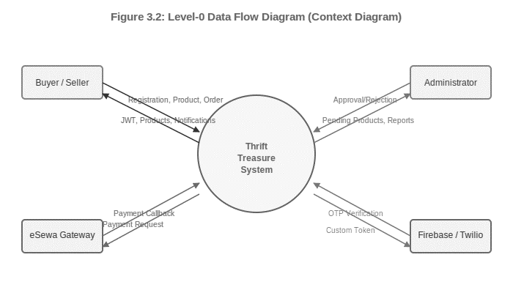
Figure 3.2: Level-0 Data Flow Diagram (Context Diagram)

Level-1 DFD
The Level-1 DFD decomposes the system into six major processes: P1 Authentication (JWT, Bcrypt, phone OTP), P2 Product Management (CRUD, images, admin approval, rate limiting), P3 Order Management (cart, checkout, status tracking), P4 Payment Processing (eSewa API, HMAC signature, transaction tracking), P5 Real-Time Chat (Socket.io, conversation/message persistence), and P6 Ratings and Reviews (1-5 stars, order-linked). Each process interacts with shared data stores (D1: Users DB, D2: Products DB, D3: Orders DB) managed by PostgreSQL via Prisma.

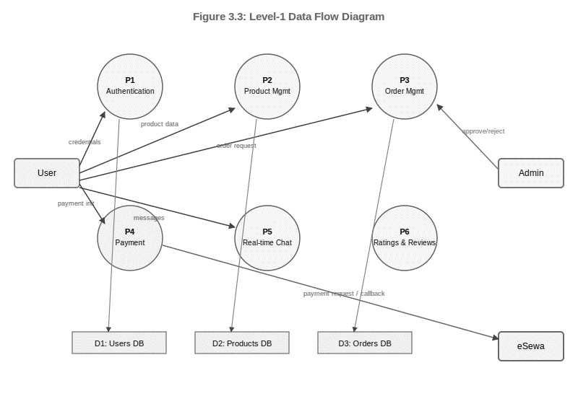
Figure 3.3: Level-1 Data Flow Diagram

3.2 System Design

3.2.1 Architectural Design
Thrift Store follows a Three-Tier Architecture with a service layer within the application tier. The three tiers are: (1) Presentation Layer — static HTML/CSS/JS files served by Express.js; (2) Application Layer — Express.js REST API and Socket.io server with MVC+service pattern in TypeScript; (3) Data Layer — PostgreSQL database accessed through Prisma ORM.

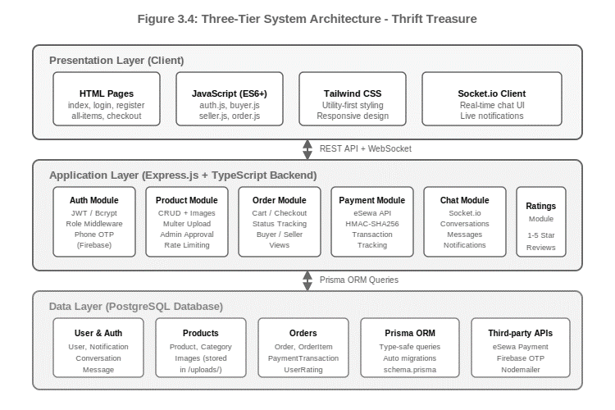
Figure 3.4: Three-Tier System Architecture - Thrift Store

3.2.2 Database Schema Design
The database is normalized to Third Normal Form (3NF) to reduce data redundancy and ensure referential integrity. All relationships are enforced via Foreign Keys in PostgreSQL. The schema is managed through Prisma migrations (13 migration files tracking schema evolution from initial setup through the chat system addition). The ER diagram below illustrates all entities and their relationships.

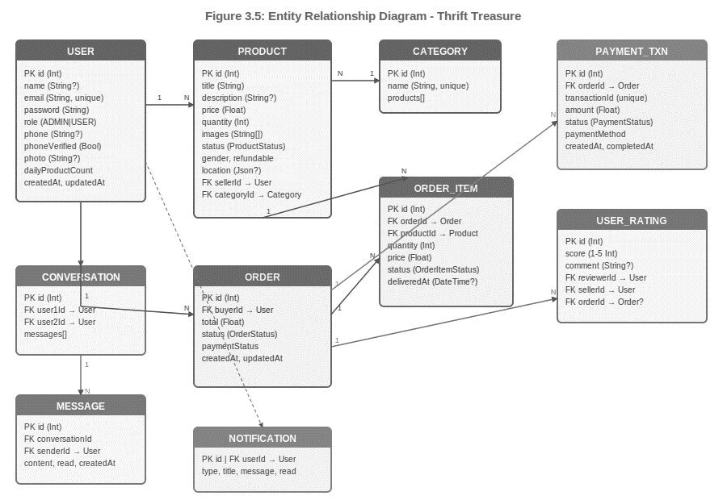
Figure 3.5: Entity Relationship Diagram - Thrift Store

3.2.3 Interface Design (UI/UX)
The frontend is designed as a multi-page application using HTML5 and Tailwind CSS for a consistent, responsive design system. Key interfaces include: index.html (landing page with hero section), all-items.html (product catalog with category filters), product-details.html (product view with seller info and purchase option), checkout.html (order summary and eSewa payment), orders.html (buyer order history), seller-orders.html (seller order management), chat-inbox.html (real-time messaging), admin.html (product approval panel), and seller-profile.html (public seller profile with ratings).

3.2.4 Sequence Diagram: eSewa Payment Flow
The sequence diagram below illustrates the complete payment flow from order placement through eSewa callback verification.

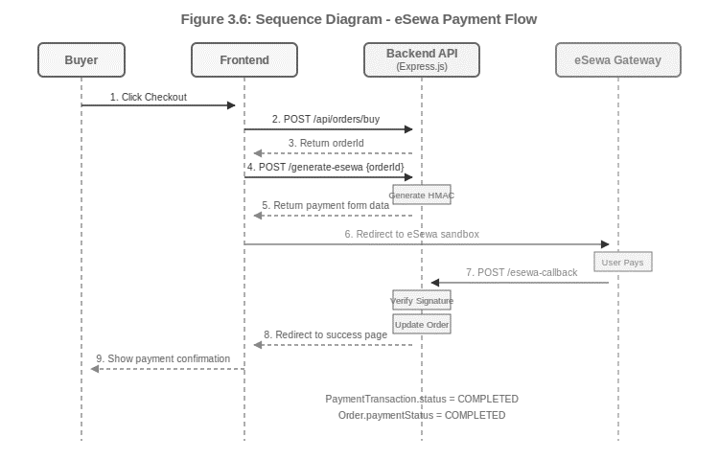
Figure 3.6: Sequence Diagram - eSewa Payment Flow

3.4 Algorithm Details
A key algorithmic component of the thrift store e-commerce system is the intelligent product discovery, recommendation, and location-based services mechanism.

Algorithm 3.4.1: Haversine Distance Calculation
Purpose: Calculate distance between two geographic coordinates.

Input
lat1, lon1 (Decimal): First location coordinates
lat2, lon2 (Decimal): Second location coordinates

Output
distance (Decimal): Distance in kilometers

Pseudocode
FUNCTION calculateHaversineDistance(lat1, lon1, lat2, lon2):
R ← 6371
φ1 ← lat1 × (π / 180)
φ2 ← lat2 × (π / 180)
Δφ ← (lat2 - lat1) × (π / 180)
Δλ ← (lon2 - lon1) × (π / 180)
a ← sin²(Δφ / 2) + cos(φ1) × cos(φ2) × sin²(Δλ / 2)
c ← 2 × atan2(√a, √(1 - a))
distance ← R × c
RETURN distance
END FUNCTION

Algorithm 3.4.2: Product Search Algorithm
Purpose: Retrieve products based on user keyword input.

Input
query (String), product_list (List)

Output
matched_products (List)

Pseudocode
FUNCTION searchProducts(query, product_list):
query ← toLowerCase(query)
matched_products ← empty list
FOR EACH product IN product_list DO
IF query IN product.title OR query IN product.description THEN
APPEND product TO matched_products
END IF
END FOR
RETURN matched_products
END FUNCTION

Algorithm 3.4.3: Product Rating Algorithm
Purpose: Calculate average rating.

Input
ratings_list (List)

Output
average_rating (Decimal)

Pseudocode
FUNCTION calculateAverageRating(ratings_list):
total ← 0
count ← length(ratings_list)
IF count = 0 THEN
RETURN 0
END IF
FOR EACH rating IN ratings_list DO
total ← total + rating
END FOR
RETURN total / count
END FUNCTION

Algorithm 3.4.4: Content-Based Filtering
Purpose: Recommend similar products.

Input
target_product, product_list

Output
recommended_products (List)

Pseudocode
FUNCTION recommendProducts(target_product, product_list):
recommended_products ← empty list
FOR EACH product IN product_list DO
score ← 0
IF product.category = target_product.category THEN
score ← score + 1
END IF
IF product.brand = target_product.brand THEN
score ← score + 1
END IF
IF product.color = target_product.color THEN
score ← score + 1
END IF
IF product.price_range = target_product.price_range THEN
score ← score + 1
END IF
IF score ≥ 2 THEN
APPEND product TO recommended_products
END IF
END FOR
RETURN recommended_products
END FUNCTION

Component | Technology | Version | Purpose
Runtime | Node.js | LTS | JavaScript server execution
Backend Framework | Express.js | 5.2.1 | REST API + static file serving
Language | TypeScript | 5.9.3 | Type-safe backend development
Database | PostgreSQL | 15+ | Relational data persistence
ORM | Prisma | 6.4.1 | Type-safe DB access + migrations
Authentication | jsonwebtoken | 9.0.3 | JWT token generation and verification
Password Hash | Bcrypt | 6.0.0 | Secure password storage
File Upload | Multer | 2.1.1 | Product & profile image handling
Real-time | Socket.io | 4.8.3 | WebSocket chat & notifications
Email | Nodemailer | 8.0.1 | Email delivery
HTTP Client | Axios | 1.13.2 | Server-to-server HTTP calls
Validation | class-validator | 0.14.3 | Input validation decorators
Payment | eSewa RC-Epay | Sandbox | Nepali digital payment gateway
Phone OTP | Firebase Admin SDK | Latest | Custom OTP token generation
Frontend CSS | Tailwind CSS | 3.x | Utility-first responsive styling
CASE Tool | Draw.io / Prisma Studio | Latest | Diagrams + DB management
Version Control | Git & GitHub | Latest | Source code management
IDE | Visual Studio Code | Latest | Development environment

Table 3.11: Technology Stack Overview

Chapter 4: Implementation and Testing

4.1 Implementation

4.1.1 Tools Used
Category | Tool / Technology | Version | Purpose
Runtime | Node.js | LTS | JavaScript server runtime
Framework | Express.js | 5.2.1 | REST API framework
Language | TypeScript | 5.9.3 | Type-safe backend
Database | PostgreSQL | 15+ | Relational data storage
ORM | Prisma | 6.4.1 | Database access & migrations
Auth | jsonwebtoken + Bcrypt | 9.0.3 / 6.0.0 | JWT + password hashing
File Upload | Multer | 2.1.1 | Multipart image uploads
Real-time | Socket.io | 4.8.3 | WebSocket messaging
Payment | eSewa RC-Epay | Sandbox | Digital payment processing
Phone Auth | Firebase Admin SDK | Latest | OTP verification
Validation | class-validator | 0.14.3 | Input validation
Frontend | Tailwind CSS + Vanilla JS | 3.x / ES6+ | Responsive UI
IDE | Visual Studio Code | Latest | Development environment
Version Control | Git & GitHub | Latest | Source code management
DB Browser | Prisma Studio | Built-in | Visual database management
Diagram Tool | Draw.io | Latest | UML and flow diagrams

Table 4.1: Tools Used

4.1.2 Implementation Details of Modules
A) Authentication Module (src/auth/)
The authentication module handles user registration and login. During registration, the password is hashed using bcrypt.hash() with salt factor 10. The photo upload is handled by Multer, saving to /public/uploads/users/ with a unique filename. Login verifies the submitted password against the stored hash using bcrypt.compare(). On success, a JWT is generated with payload {id, email, role, name} and 2-day expiration. The auth middleware (auth.middleware.ts) extracts the Bearer token from the Authorization header, verifies it using the JWT_SECRET_KEY, and attaches the decoded payload to req.user for use by downstream handlers.
B) Product Management Module (src/product/)
Product creation passes through a middleware pipeline: (1) auth.middleware — verifies JWT; (2) phone verification check — queries User.phoneVerified; (3) productLimit.middleware — checks dailyProductCount against limit; (4) upload.middleware — processes up to 5 image files via Multer, validating MIME type (JPEG/PNG/GIF/WebP) and size (max 5MB each). The product is saved with PENDING status. The admin endpoint GET /api/products/admin/pending returns all PENDING products. PATCH operations update status to APPROVED or REJECTED with a rejectionReason. On approval, a Notification record is created and emitted to the seller's Socket.io room.
C) Order Management Module (src/order/)
When a buyer POSTs to /api/orders/buy with [{productId, quantity}], the service validates each product's availability and APPROVED status, calculates the total, creates one Order record and N OrderItem records within a Prisma transaction to ensure atomicity. The order status machine transitions: PENDING → PROCESSING (when seller processes first item) → PARTIALLY_DELIVERED (when some items are delivered) → DELIVERED (all items delivered) → CANCELLED. Item status has its own six-state machine: PENDING → PROCESSING → SHIPPED → DELIVERED → RECEIVED → CANCELLED. Sellers update items via PUT /api/orders/item/:orderItemId/status.
D) eSewa Payment Module (src/esewa/)
The payment flow: (1) POST /api/payment/simple/generate-esewa receives orderId, retrieves order total, generates transactionId (TT-{timestamp}-{6-char-random}), calculates breakdown (subtotal, tax 13%, service charge NPR 30, delivery NPR 100), generates HMAC-SHA256 signature, creates PENDING PaymentTransaction, returns payment form data. (2) Frontend renders hidden form and auto-submits to eSewa sandbox URL. (3) POST /api/payment/simple/esewa-callback receives eSewa's signed response, verifies HMAC signature, updates PaymentTransaction.status to COMPLETED/FAILED, and updates Order.paymentStatus accordingly.
E) Real-Time Chat Module (src/chat/)
The Socket.io server applies authentication middleware on every connection: the JWT from socket.handshake.auth.token is verified, and userId is extracted and stored on the socket. On connection, the socket automatically joins the personal room user-{userId}. The joinChat event handler adds the socket to room chat-{conversationId} after verifying the user is a participant. The sendMessage handler validates content, persists the Message record to the database via Prisma, then emits the message event to all sockets in the conversation room. This ensures delivery to all active participants and persistence for offline users.
F) Seller Rating Module (src/ratings/)
POST /api/ratings/rate-seller validates the score (1-5 integer) and checks the unique constraint on (reviewerId, sellerId, orderId) before creating the UserRating record. The uniqueness is enforced both by a Prisma unique constraint at the schema level and a try-catch in the service layer. GET /api/ratings/seller/:sellerId is a public endpoint that returns all ratings for a seller along with aggregated average score, providing potential buyers with reputation information.
G) Notification System
The Notification model stores all platform events with typed NotificationType enums: PRODUCT_SUBMITTED, PRODUCT_APPROVED, PRODUCT_REJECTED, ORDER_PLACED, ORDER_STATUS_CHANGED, ITEM_STATUS_CHANGED, DAILY_LIMIT_REACHED. Each notification has a title, message, read flag, and optional JSON metadata. Real-time delivery is achieved via Socket.io: after creating the database record, the server emits a notification event to the user's personal room (user-{userId}). Unread notifications can be retrieved via GET /api/notifications and marked read via PATCH.

4.2 Testing
Testing was conducted across two phases: unit testing of individual API endpoints and system testing of end-to-end workflows. All tests were performed manually using Postman for API testing and browser-based testing for frontend flows.

4.2.1 Unit Test Cases

TC No. | Test Case | Input Data | Expected Output | Actual Output | Status
TC-01 | User Registration - Valid | name: 'Ram Thapa', email: 'ram@test.com', password: 'Test@1234' | HTTP 201; user created; JWT token returned | HTTP 201; account created; token returned | PASS
TC-02 | User Registration - Duplicate Email | email: 'ram@test.com' (existing) | HTTP 400; 'Email already exists' | HTTP 400; correct error message | PASS
TC-03 | Login - Valid Credentials | email: 'ram@test.com', password: 'Test@1234' | HTTP 200; JWT token with {id, email, role} | HTTP 200; valid JWT returned | PASS
TC-04 | Login - Wrong Password | email: 'ram@test.com', password: 'WrongPass' | HTTP 401; 'Invalid credentials' | HTTP 401; correct error message | PASS
TC-05 | Create Product - Valid (Phone Verified) | Auth token + product data + 2 images | HTTP 201; product created with PENDING status | HTTP 201; product in PENDING status | PASS
TC-06 | Create Product - Phone Not Verified | Auth token; phoneVerified=false | HTTP 403; 'Phone not verified' | HTTP 403; correct error message | PASS
TC-07 | Create Product - Daily Limit Exceeded | Auth token; dailyCount at limit | HTTP 429; DAILY_LIMIT_REACHED notification | HTTP 429; notification created | PASS
TC-08 | Admin Product Approval | Admin JWT + productId | HTTP 200; product status = APPROVED | HTTP 200; status updated; notification sent | PASS
TC-09 | Place Order - Valid | Auth token + [{productId:1, quantity:1}] | HTTP 201; Order + OrderItems created | HTTP 201; order and items created | PASS
TC-10 | Place Order - Out of Stock | productId with quantity=0 | HTTP 400; 'Product unavailable' | HTTP 400; correct error | PASS
TC-11 | Generate eSewa Payment | Auth token + valid orderId | HTTP 200; payment form data with HMAC sig | HTTP 200; valid signature returned | PASS
TC-12 | Rate Seller - Valid | Auth token + score:4, comment:'Good' | HTTP 201; UserRating created | HTTP 201; rating saved | PASS
TC-13 | Rate Seller - Duplicate | Same reviewer + seller + orderId | HTTP 409; 'Already rated' | HTTP 409; unique constraint message | PASS
TC-14 | Unauthenticated API Access | GET /api/orders/my-orders (no token) | HTTP 401; 'No token provided' | HTTP 401; correct rejection | PASS

Table 4.2: Unit Test Cases

4.2.2 System Test Cases

TC No. | Test Scenario | Steps | Expected Result | Status
ST-01 | Complete Registration and Login Flow | 1. Open register page 2. Fill all fields with valid data 3. Submit registration 4. Navigate to login 5. Enter credentials and submit | User registered successfully; JWT stored in localStorage; user redirected to home | PASS
ST-02 | Product Listing and Admin Approval Flow | 1. Login as seller 2. Verify phone via OTP 3. Fill product form with 3 images 4. Submit listing 5. Login as admin 6. Approve the product | Product visible on public all-items page after admin approval; seller receives PRODUCT_APPROVED notification | PASS
ST-03 | Complete eSewa Purchase Flow | 1. Login as buyer 2. Browse and select product 3. Place order 4. Click Pay via eSewa 5. Complete sandbox payment | Order status updated to PROCESSING; paymentStatus = COMPLETED; buyer receives ORDER_PLACED notification | PASS
ST-04 | Seller Order Management Flow | 1. Login as seller 2. View seller-orders page 3. Update item status to Processing 4. Update to Shipped 5. Update to Delivered | Each status update persists correctly; buyer sees updated item status; ITEM_STATUS_CHANGED notification delivered | PASS
ST-05 | Real-Time Chat Flow | 1. Login as buyer 2. Open product detail page 3. Click 'Chat with Seller' 4. Send a message 5. Login as seller in another tab 6. Observe message delivery | Message delivered to seller in real-time without page refresh; message persisted in database | PASS
ST-06 | Phone Verification Flow | 1. Login as unverified user 2. Attempt to list product (expect 403) 3. Navigate to phone verification 4. Enter phone number 5. Enter OTP and verify | 403 error before verification; after OTP verified, product listing succeeds; User.phoneVerified = true | PASS
ST-07 | Product Rejection and Notification | 1. Seller creates product 2. Admin navigates to pending products 3. Admin rejects with reason 'Low quality images' 4. Seller checks notifications | Rejection notification with rejection reason delivered to seller; product status = REJECTED | PASS
ST-08 | Seller Rating Flow | 1. Buyer receives order items 2. Navigate to seller-profile page 3. Submit rating: 5 stars, 'Excellent item' 4. Refresh seller profile | Rating saved; seller's average rating displayed on profile; second rating attempt for same order blocked | PASS

Table 4.3: System Test Cases

All 14 unit test cases and 8 system test cases executed successfully, confirming that the core functional requirements of the Thrift Store platform — authentication, product lifecycle, order management, eSewa payment processing, real-time chat, and ratings — are implemented correctly and behave in accordance with their specifications.

CHAPTER 5: CONCLUSION AND FUTURE RECOMMENDATIONS

5.1 Conclusion
Thrift Store is a fully functional, feature-rich online marketplace for second-hand goods, developed as the capstone project for the Bachelor of Computer Application program at Tribhuvan University. The project successfully achieves all stated objectives, delivering a comprehensive e-commerce platform tailored for the Nepali market with features that address real gaps in the current second-hand goods ecosystem.

The platform demonstrates the practical application of modern full-stack web development including Node.js, Express.js, TypeScript, PostgreSQL, Prisma ORM, Socket.io, eSewa payment gateway integration, and Firebase OTP authentication. Complex features such as real-time bidirectional messaging, HMAC-SHA256 cryptographic payment signatures, a multi-stage order management state machine, and a phone-verification-gated product listing system have been successfully implemented and tested.

The development process reinforced the value of TypeScript for large-scale backend development, Prisma ORM for schema-driven database management, and the MVC+service layer pattern for maintainable code organization. The incremental development methodology allowed for progressive feature integration while maintaining system stability. Overall, Thrift Store represents a production-capable solution that can meaningfully contribute to Nepal's growing digital commerce landscape.

5.2 Lesson Learnt / Outcome
- TypeScript's static type system significantly reduces runtime errors in complex backend systems. The investment in type definitions pays off during refactoring and debugging. Prisma's generated types create end-to-end type safety from database to API response.
- Integrating a real payment gateway requires meticulous handling of cryptographic signatures, edge cases in callback processing, and thorough sandbox testing. The HMAC-SHA256 implementation provided hands-on experience in applied cryptography.
- Socket.io's room-based architecture maps naturally to chat applications. Authenticating sockets at the connection level (not just per-message) is essential for security in real-time systems.
- Prisma migrations enable iterative schema evolution without data loss. Planning the database schema carefully from the beginning (including status enumerations) saved significant refactoring effort compared to schema-less approaches.
- Centralized error handling middleware in Express.js with a consistent JSON response format ({message, status, errors}) greatly simplifies API debugging and improves the developer experience for frontend integration.
- The MVC+service layer pattern proved valuable for code organization in a complex application with 9 modules, making it easier to add features (like the chat and rating systems) without disrupting existing functionality.
- Working with Nepal-specific technologies (eSewa, Firebase with Nepali phone numbers) provided practical experience in localizing e-commerce solutions for emerging markets.

5.3 Future Recommendations
- Mobile Application: Develop native iOS and Android applications using React Native to increase platform accessibility and reach Nepal's predominantly mobile internet users.
- Advanced Search: Implement full-text search using PostgreSQL's built-in full-text search capabilities or Elasticsearch to allow keyword-based product discovery beyond category filtering.
- AI-Based Recommendations: Integrate a recommendation engine that suggests products based on browsing history, purchase patterns, and similar user behavior.
- Live Payment Integration: Transition the eSewa integration from sandbox to production mode and add support for Khalti, ConnectIPS, and mobile banking for broader payment coverage.
- Delivery and Logistics Integration: Partner with courier services in Nepal and integrate delivery tracking APIs to provide end-to-end shipment visibility.
- Progressive Web App (PWA): Convert the frontend to a PWA to enable offline product browsing, push notifications, and home screen installation on mobile devices.
- Real-Time GPS Tracking: Implement real-time location tracking for delivery using WebSockets to allow buyers to track their orders in transit.
- Dispute Resolution: Add a formal dispute resolution system with admin arbitration for handling buyer-seller conflicts over product condition or delivery issues.
- Multi-language Support: Add Nepali (Devanagari) language localization to make the platform accessible to users with limited English proficiency.
- Automated Testing: Implement a comprehensive automated test suite using Jest and Supertest for continuous integration to maintain code quality as the platform scales.

References
[1] M. C. Christensen and R. H. Thayer, The Project Manager's Guide to Software Engineering's Best Practices. IEEE Computer Society Press, 2001.

[2] A. H. Hofmann, Scientific Writing and Communication: Papers, Proposals, and Presentations, 3rd ed. Oxford University Press, Nov. 2016.

[3] Prisma, "Prisma ORM Documentation," prisma.io. [Online]. Available: https://www.prisma.io/docs. [Accessed: 2026].

[4] Express.js, "Express 5.x - Node.js web application framework," expressjs.com. [Online]. Available: https://expressjs.com. [Accessed: 2026].

[5] Socket.io, "Socket.IO Documentation," socket.io. [Online]. Available: https://socket.io/docs/v4. [Accessed: 2026].

[6] eSewa Pvt. Ltd., "eSewa RC-Epay Developer Documentation," developer.esewa.com.np. [Online]. Available: https://developer.esewa.com.np. [Accessed: 2026].

[7] Firebase, "Firebase Authentication - Phone Number," Google. [Online]. Available: https://firebase.google.com/docs/auth/web/phone-auth. [Accessed: 2026].

[8] P. Resnick, R. Zeckhauser, E. Friedman, and K. Kuwabara, "Reputation Systems," Communications of the ACM, vol. 43, no. 12, pp. 45–48, Dec. 2000.

[9] JWT.io, "JSON Web Tokens - Introduction," Auth0. [Online]. Available: https://jwt.io/introduction. [Accessed: 2026].

[10] PostgreSQL Global Development Group, "PostgreSQL 15 Documentation," postgresql.org. [Online]. Available: https://www.postgresql.org/docs/15/. [Accessed: 2026].

[11] Nepal Telecommunications Authority, "MIS Annual Report 2022/23," NTA, Kathmandu, Nepal, 2023. [Online]. Available: https://nta.gov.np. [Accessed: 2026].

[12] F1Soft International Pvt. Ltd., "eSewa Digital Wallet," esewa.com.np. [Online]. Available: https://esewa.com.np. [Accessed: 2026].

[13] Multer Contributors, "Multer - Node.js middleware for multipart/form-data," GitHub. [Online]. Available: https://github.com/expressjs/multer. [Accessed: 2026].

