Algorithm

I The building blocks of algorithms

* Algoritm : step by step process that describes how to solve a problem
* Most of the time there are multiple algorithms to solve the same problem
* The best one is the fastest one
* Algorithm 3 basic blocks : sequencing/selection/iteration

1. Sequencing

* Sequential execution of operations

1. Selection

* Decision to execute one operation vs an other one

1. Iteration

* Repetition of the same operations a certain number of times or until true/false (bolean)

II Expressing an algorithm

* Natural language/flow charts/pseudocode/programming languages

1. Natural language

* No imposed structure
* Ambiguous/too vague

1. Flow charts

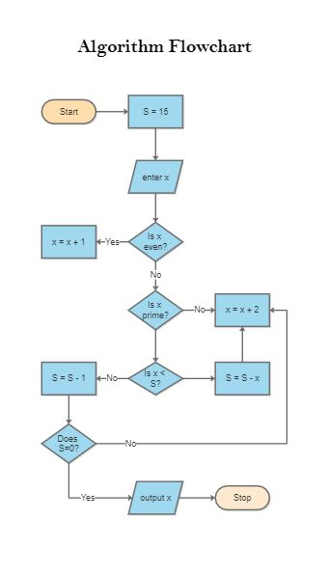

* Diagram with boxes connected by arrows
* Visualize the algorithm at a high level
* Forces us to think carefully about sequencing/selection

1. Pseudocode

* Code that uses constructs of a programming language but doesn’t run anything
* Every programmer writes pseudocodes differently
* Can help to become familiar with programming terms without worrying about syntax/specifics
* Gives an independent way to express an algorithm so programmers from any language can translate it into their language of choice

1. Programming languages

* Once the algorithm is written (natural language/flow chart/pseudo code or a combination of them) its time to turn it into a running code
* ***function*** : instructions that accomplish a specific task (instructions are executed from top to bottom)
* ***var*** : for the different variables
* ***return*** : result of the task