Docker

Local daemons :
- Background processes that run on local computer system
→ without direct user interaction (starting when the system boots up)
- Focus on managing/maintaining various functions within the local machine
→ managing system ressources/hardware interfaces/user sessions
→ Running scheduled tasks/supporting applications
→ performing logging
→ handle security tasks
- Persistance : usually remain active as long a s the sytem is running

Metadata :
- Data that provides information about other data making it easier to understand/use/manage
→ Data managment, sharing, preservation/Search Engine Optimization(SEO)
- Descriptive : describes content/quality/condition..
→ Book : title/author/publication date…
- Structural : organization of the data and how it relates to other data
→ Book : table of contents/page numbers/chapter
- Administrative : provides information to help manage the data
→ Date of creation/acces rights/data provenance/preservation information..
- Ex Web page :
→ Title tag/meta descriptions/keywords/Author/Last update date
- Metadata standards to ensure consistency/interoperability :
→ Dublin Core : vocabulary terms to describe web ressources (video/images/web pages..)
→ MARC (Machine-Readable Cataloging) : used by librairies to represent an exchange bibliographic data
→ EXIF (Exchangeable Image File Format) : used to describe image files

Install Docker Desktop

1) Set up Docker’s package repository
# Add Docker's official GPG key:
sudo apt-get update
sudo apt-get install ca-certificates curl
sudo install -m 0755 -d /etc/apt/keyrings
sudo curl -fsSL https://download.docker.com/linux/ubuntu/gpg -o /etc/apt/keyrings/docker.asc
sudo chmod a+r /etc/apt/keyrings/docker.asc

# Add the repository to Apt sources:
echo \
"deb [arch=$(dpkg --print-architecture) signed-by=/etc/apt/keyrings/docker.asc] https://download.docker.com/linux/ubuntu \
$(. /etc/os-release && echo "$VERSION_CODENAME") stable" | \
sudo tee /etc/apt/sources.list.d/docker.list > /dev/null
sudo apt-get update
- To install the latest version :
sudo apt-get install docker-ce docker-ce-cli containerd.io docker-buildx-plugin docker-compose-plugin
- To verify that the Docker Engine installation is successfull :
sudo docker run hello-world

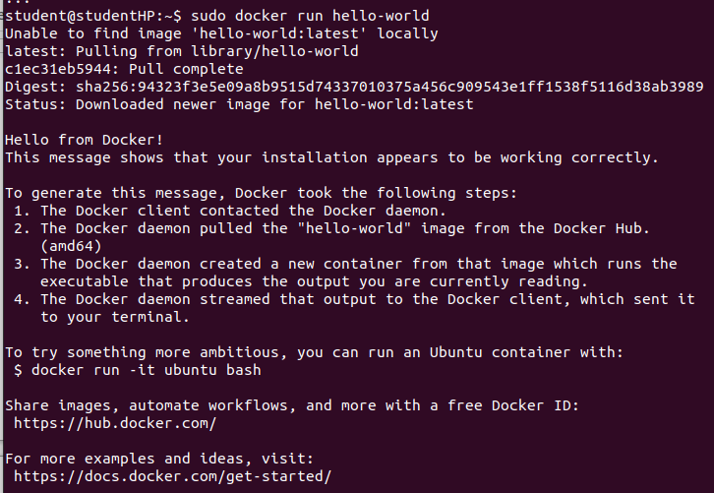
2) Launch Docker Desktop
systemctl --user start docker-desktop

What is a container ?
- It’s a sandboxed process running on a host machine that isolated from all processes running on a host machine :
→ Runnable instance of an image : create/start/stop/move/delete a countainer using Docker API/CLI
→ Can be run on local/virtual machines or deployed to the cloud
→ Is portable
→ Is isolated from other containers
→ Runs it’s own software/baniaries/configurations…

What is an image ?
- A running container uses an isolated filesystem which is provided by an image
- The image must contain everything needed to run the application
→ all dependencies/configurations/scripts/binaries…
- It also contains other configuraitons for the container
→ Environment variables/default command to run/other metadata

Docker Object Label

- Labels : mechanism for applying metadata to Docker objects :
→ Images/containers/local daemons/volumes/Networks/Swarm nodes/Swarm services
- Labels are used to organize our :
→ images
→ Record licensing informations
→ Annotate relationships between containers/volumes/network

A) Label keys/values
- Label : key/value pair stored as a sting
- We can specify multiple lables for an object but each key must be unique whitin an object
- If the same key is given multiple values : the most recently written value overwrites all previous values

1) Key format recommandations
- Label key : left-hand side of the key/value pair
- Keys are alphanumeric strings which contains periods (.) and hyphens (-)
- Most Docker users use images created by other organizations
- Guidelines preventing inadvertent duplication of labels across objects :
→ Authors of 3rd party tools should prefic each label key with the reverse DNS notation of a domain they own : com.example.some-label
→ Don’t use a domain in our label key without domain owner’s permission
→ com.docker., io.docker., org.dockerproject. namespaces are reserved by Docker for internal use
→ Label keys should only countain lower-cases alphanumeric characters, non consecutive (.) + (-)
→ (.) separates namespace fields : label keys without namespaces are reserved for CLI used (terminal) allowing CLI users to interactively label Docker objects using shorter typing-friendly strings
2) Value guidelines
- Lable values can countain any data type that can be represented as a string : JSON, XML, CVS, YAML
- The onlyrequirement is that the value be serialized to a string first using a mechanis specific to the type of structure
→ TO serialize JSON into a string : JSON.stringify() JS method.
- Docker doesnt deserialize the value : can’t treat JSON/XML docs as a nested structure when querying/filtering by label value, unless we build this functionality into 3rd party tooling.

Manage Labels on Objects

- Each type of object has mechanisms for adding/managing/using them
→ These links provide a good place to start learning how to use mabels in Docker deployements
→ Labels on images/containers/local daemons/volumes/networks are static for the lifetime of the object
→ To change those labels you need to recreate the object
→ Labels on Swarm nodes and services can dynamically updated

A) Images/containers
1) Adding Label to images

- The Label instruction adds metadata to an image : be sure to use double quotes not single ones !
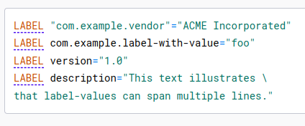

- An image can have multiple labels : we can specify multiple labels on a single line
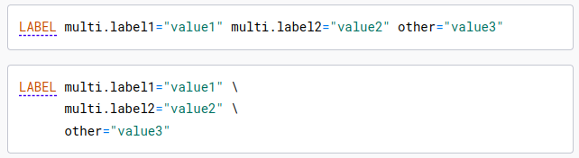

- Labels incuded in base/parent images (FROM line) are inherited by our image
- If a label already exists but with a different value : the most recent one overrides the previous ones
- To view an image’s label : docker image inspect command
- To just show the labels : --format
