Errors in Golang

I Intro

- Go uses error values to indicate an abnormal state :
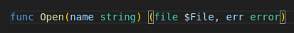

→ the os.Open function returns a non-nil error value when it fails to open a file :
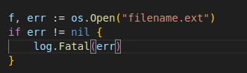

→ if an error occurs it calls log.Fatal to print the error message and stop

II Error type

- The error type is an interface type
- Error variable : any value that can describes itself as a string :
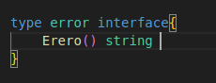

1) errorString : most commonly used error implementation
- error package’s unexported :
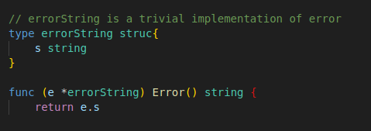

- We can construct one of these values with the errors .New function
→ It takes a string that it converts to an errors.errorString and returns an error value :
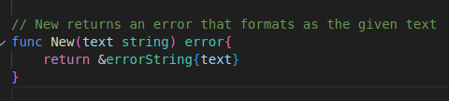

- exemple of how we can use errors.New :
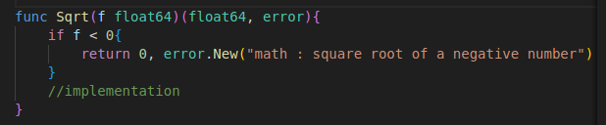

- A caller passing a negative argument to Sqrt receives a non-nil error value
→ Whose representation is an errors.errorString value
→ The caller can accesss the error string by calling the error’s method or just by printing it :
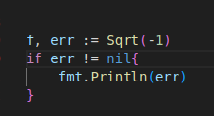

- It’s the error implementation’s responsability to summarize the context
→ the error returned by Sqrt is missing information about the invalid argument :
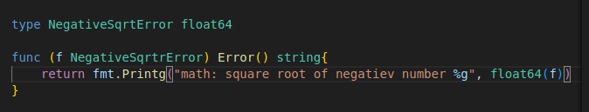

- The json package specifies a SyntaxError type that the json.Decode returns when it encounters a syntax error parsing a JSON blob :
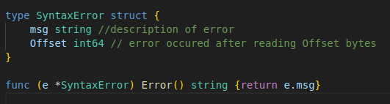

- The Offset field isn’t even shown in the default formatting of the error but callers can use it to add file and line information to their error messages :
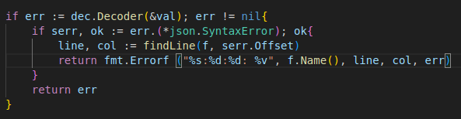

- The error interface requires only an Error method ; specific error implementations might have additionnal methods
→ the net package returns errors of type error following the usual convention
→ Some of the error implementations have additional methods defined by the net.Error interface :
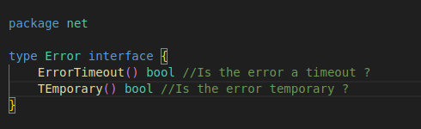

- Client code can test for a net.Error with a type assertion ans then distinguish transient network errors from permanent ones
→ a web crawler might sleep and retry when it encounters a temporary error and give up otherwise :
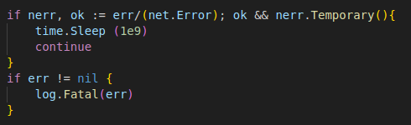

III Simplifying repetitive error handling

- Language design/conventions of go encourage us to explicitly check for errors when they occur
- Consider an App Engine application with an HTTP handler that retrieves a record from the datastore and formats it with a template :
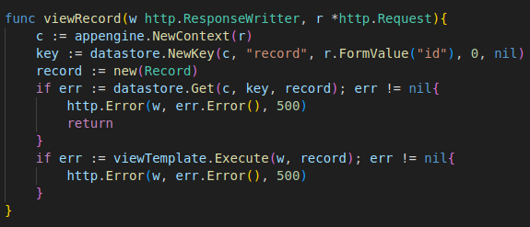

- Errors returned by datastore and viewTemplate present the same error message (HTTP status code 500)
- We can simplify the code as following :
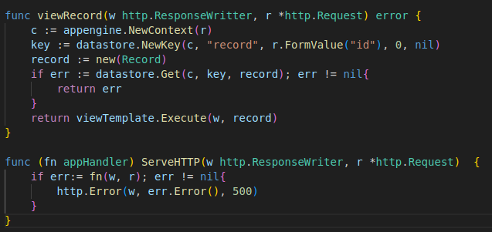
→ This is simpler than the original version but the http package doesn’t understand functions that return errors
→ To fix this we can implement the http.Handler interface’s serveHTTP method on aapHandler
- The serveHTTP method calls the appHAndler function and displays the returned error tot the user
→ The method’s receiver function (fn) is a function : the method invokes the function by calling the receiver in the expression fn (w, r)
- Now when registering viwRecord with the http package, we use the Handle function (instead of HandleFunc) as appHandler is an http.Handler (not an http.HandlerFunc)
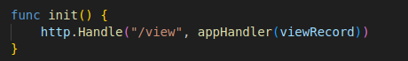

- Rather than just displaying the error string it would be better to give the user a simple message with an appropriate HTTP status code while logging the full error to the App Engine developer console for dubugging purposes by creating an appError struct containing an error an some other fields :
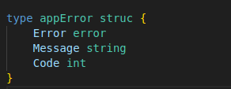

- Next we modify the appHandler type to return *appError values :

- Then we make appHandler’s ServeHTPP method display the appError to the user with the correct HTTP status Code and log the full Error to the developper console :
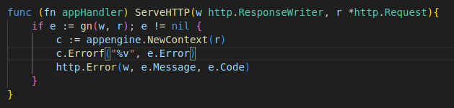
- Finally we can update viewRecord to the new function signature and have it return more context when it encounters an error :
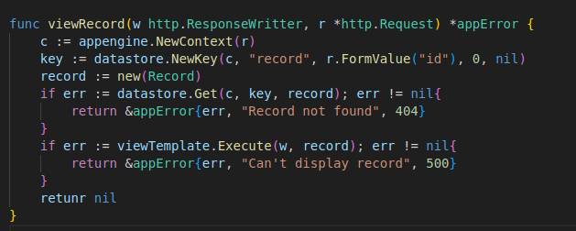

- This version of viewRecord has the same length as the original but now each lines has specific meaning and provide a friendlier user experience
We can further improve the error handling :
- give the eror handler a pretty HTML template
- make debugging easier by writing the stack to the HTTP response when the user is an admin
- write a constructor function for the appError that stores the stack trace for easier debugging
- Recover from panics inside the appHandler
→ Logging the error to the console as « critical » while telling the user « a serious error has occured »

