Input/output

I Io

1) io.Reader/io.Writer
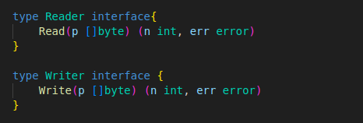

- io.Writer : takes a slice of bytes which are written to the interface of implementation
→ returns the number of bytes written and an error if anything went wrong
- io.Reader : a slice of bytes is passed into the implementation and modified
→ Up to len(p) bytes will be wrtitten into the slice
→ Returns the number of bytes written

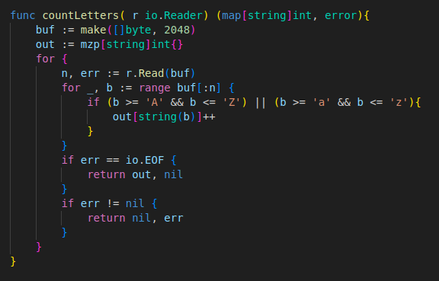

- We create our buffer once and reuse it on every call to r.Read
→ Using a single memory allocation to read from a potentially large data source
→ If the Read method were written to return a []byte it would require a new allocation on evry single call
→ To further reduce the allocations we could create a pool of buffers when the programm launches
- We use the n value returned from r.Read to know how many bytes were written to the buffer
→ We iterate over a subslice of our buf slice to process the data that was read
- The reading from r is done when the error returned from r.Read is io.EOF
→ It’s not really an error : indicates that there’s nothing left to read
→ When io.EOF is returned : we’re finished processing and the result is returned
- Getting inexpectedly to the end of an io.Reader return io.ErrUnexpectedEOF

We can create an io.Reader from a string (using the strings.NewReader function)
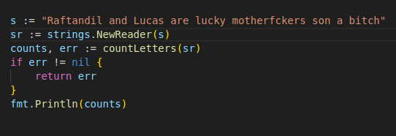

- io.Reader/io.Writer are often chained together
- countLetters depends on an io.Reader : we can use the same function to count letters in a gzip-compressed file

we create an *os.File which meets the io.reader interface
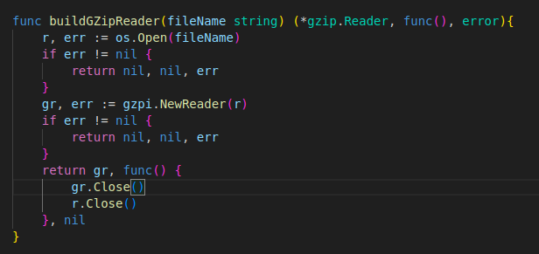

- After making sure it’s valid we pass it to the gzip.NewReader function which returns *gzip.Reader
- If it’s valid we return the *gzip.Reader and a closure that cleans up our ressources when it’s invoked

*gzip.Reader implements io.Reader : we can use countLetters
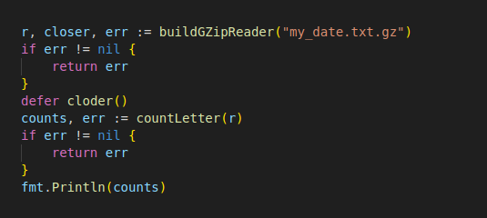

- io Package defines interfaces that combines 4 interfaces in various way (io.Reader/io.Writer/io.Closer/io.Seeker)
→ Includes io.ReadCloser/io.ReadSeeker/io.ReadWriterCloser/io.ReadWriteSeeker/io.WriteCloser & io.WriteSeeker
→ We have to use these interfaces to specify what our functions are supposed to do with the data
→ Rather than just use an os.File as paramater we can use the interfaces to specify what our function’ll do with the parameter (makes our intent clearer & our code compatible with these interfaces)

2) io helper functions

a) io.Copy
- standard function for copying from an io.Reader to an io.Writer

b) io.MultiWriter
- Returns an io.Writer that writes to multiple io.Writer instances at the same time

c)io.MultiReader
- Returns an io.Reader that reads from multiple io.Reader instances one after the other

d) io.LimitReader
- Returns an io.Reader that reads only up to a specified number of bytes from the supplied io.Reader

e) io.Closer
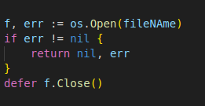

- io.Closer : implemented by os.File that needs to do cleanup when reading/writing is complete
- Usually Close is called via a defer
→ If we are opening the ressource in a loop we can’t use defer : it’ll not run until the function exists
→ Instead we should call Close before the end of the loop iteration
→ If there are errors that can leda to an exit : we must call Close there too

f) io.Seeker
- Used for random acces to a ressource
- The valid values for whence (int) : constants io.SeekStart/io.SeekCurrent & io.SeekEnd

