ForumGo

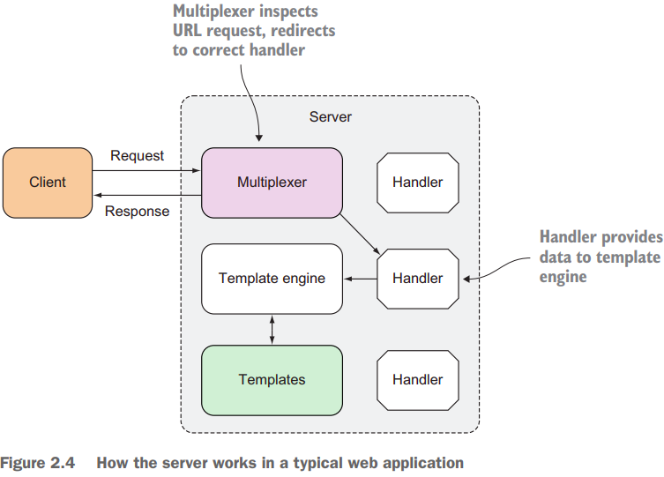

main.go
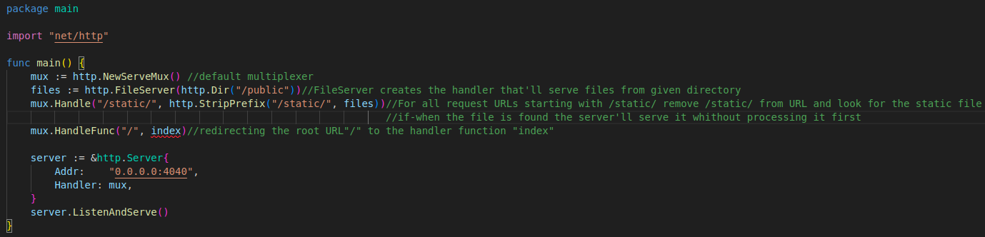
handler.go

1) Authenticate : access control using cookies
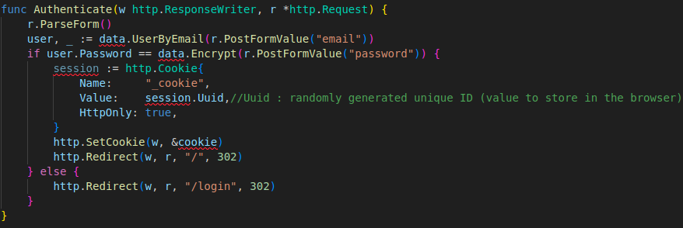

- Authenticate the user by creating a Session struct
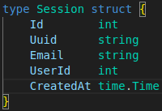

- Create the cookie struct
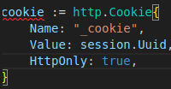

→ Name : abitrary
→ Value : unique data stored in the browser
→ HttpOnly : set to only allow HTTP or HTTPS to access the cookie
→ To add the cookie to the response header : http.SetCookie(writer, &cookie)

2) Index
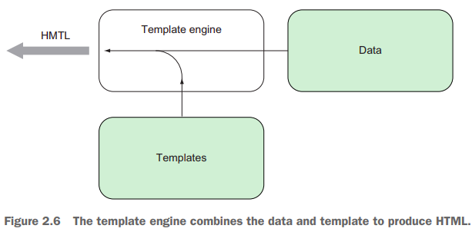

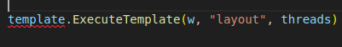

- We take the set of templates we parsed earlier and execute the layout template using ExecuteTemplate
→ Executing the template : taking content from the template files combine it with data from another source and generate the final HTML content
→ why only the layout template and not the other ones ?:the layout template includes the other ones, if we execute it the other’ll be exectuted aswell. If we execute only one of the other templates we would only get part of the HTML we want.

Utils.go

1) GenerateHTML
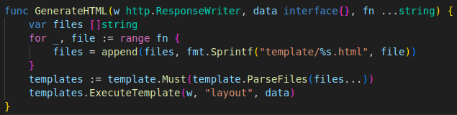
- data : empty interface type (can take in any type)
- fn : « … » indicates that the GenerateHTML function is a variadic funciton (can take ≥ 0 parameters in the last variadic parameter). Variadic parameters need to be the last parameter for the variadic function.
- The GenerateHTML function is needed to clean upthe others handlerfuncs
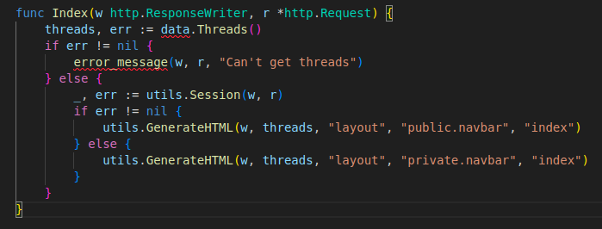

thread.go

1) Thread struct
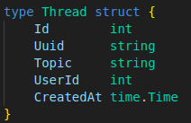

- It should correspond to the Data Definition Language (SQL) that’s used ti create the relationnal db table clalled threads
→ We need to create those tables : createdb forum (in the console)
→ Once the table created we make a setup.sql file to create the database table for forum
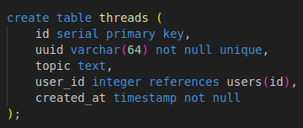

→ We just have to do the same thing for users, sessions and post struct

- psql -f setup.sql -d forum : create the necessary database tables in the forum db
→ in the data.go file we need to create a global variable Db which is a pointer to sql.DB (representation of a pool of db connections) and an init func to initialize Db at the start of our web app (we need Db to execute our queries)
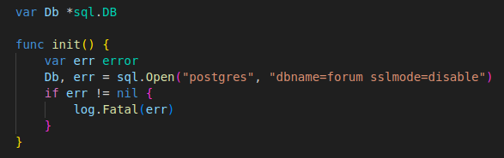

2) Thread()
- We need to create a func every time we need interactions between the struct and the db
- The Thread func is used to extract all threads in the db for the index handler func
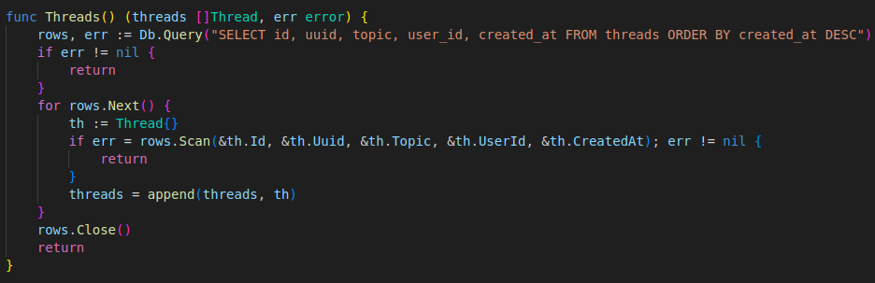
→ we return a slice of the Thread struct : we need to create the slice and continually append to it until we’re done with all the rows

index.html

- how to get the data in the struct to the template ?
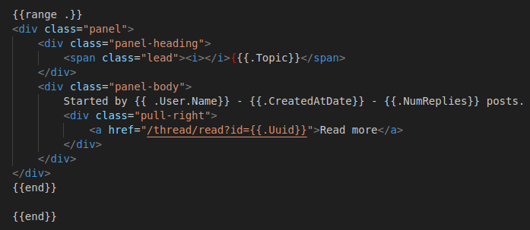

- (.) : represent the data that’s passed into the template to be combined to generate the final output
- {{range .}} : it’s the threads variable extracted earlier using the Thread func (slice of Threads struct)
- range : data passed in is either a slice or an array of structs
→ Allows to iterate through and acces the structs using their name fields
→ {{.Topic}} : access the Topic field of the Threads struct
- For the named fields not present in the Thread struct {{.NumReplies}}… : we use methods
- Methods are functions attached to any named types (except pointers/interfaces), by attaching a function to a pointer to a Thread struct we allow the function to acces the thread
→ The Thread struct (receiver) is changed after calling the method
- The NumReplies method is shown below
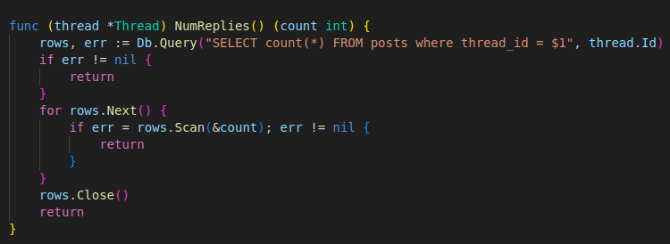

→ Opens a connection to the db, gets the count of threads using an SQL query and scans it into the count parameter passed into the method
→ Returns this count which is used to replace .NumReplies in the HTML by the template engine
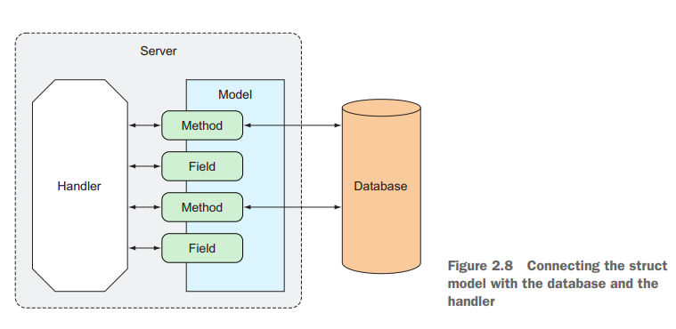
- By providing a combination of functions/methods on the data struct (User, Session, Thread & Post) we create a data layer that shields us from directly accessing the database in the handler functions.

Wrapping up
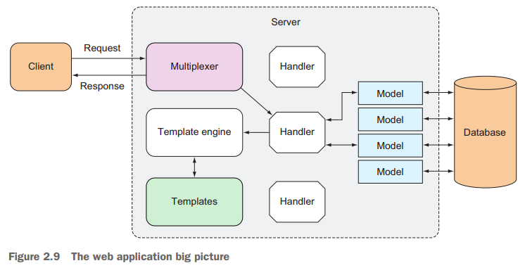

- We went through an overview of the various building blocks of a Go Webapp
→ The client sends a request to the server
→ this is received by the multiplexer which directs it to the correct handler
→ The handler processes the request
→ When the data is needed : it’ll use ≥1 data structs that model the data in the database
→ The model connects with the database triggered by functions/methods on the data struct
→ Precessing completed : the handler triggers the template engine sometimes sending in data from the model
→ The template engine parses template files to create templates which are combines with data to produce HTML
→ The generated HTML is sent back to the client as part of the response

