Go Web Service

I Intro

One of the most popular use of Go is writing web services that provide services/data to other web services or apps. Basic web services are software programs that intercat with other software programs : instead of having a human as the end user it’ll be a software program
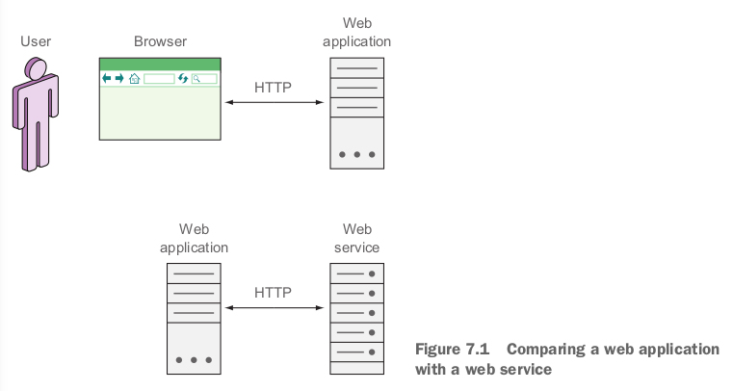
- The 2 most popular types of web services are : SOAP-based and REST-based
→ SOAP : mostly used in enterprise systems (more complex) : function driven
→ REST : more popular un publicly available web services (more flexible) : data driven

II SOAP-base web services

- Protocol for exchanging structured data defined in XML
- SOAP is higly structured and the XML used for data transport can be complex
- Every operation/input/output is clearly defined in the WSDL
- WSDL is the contract between client/server defining the service and how it’s provided
- SOAP places it message content into an enveloppe : independant of the mean of transporting the data
→ Here we’ll be only referring to SOAP messages being moved arround using HTTP
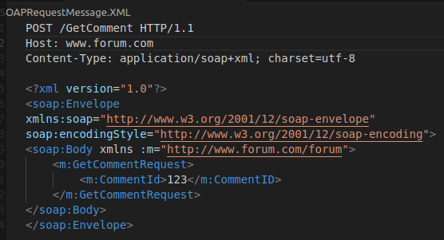

- We need to create a file .XML
- The SOAP body contains the request message : request for a comment for the ID 123
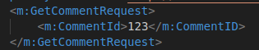

- This example is simplified : the real one is a lot more complex
- He’s a simplified example of SOAP response message
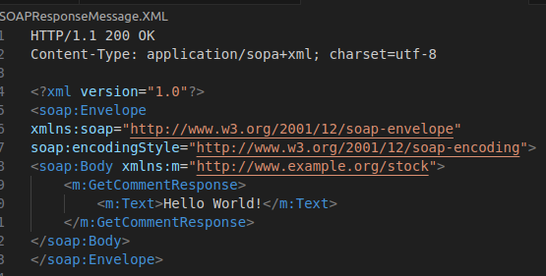

- The response message is in the SOAP body : it’s a response with the text « Hello World ! »
- All the data about the message is contained in the envelope
→ The information sent through HTTP is almost entirely in the SOAP envelope
- Here’s what a simple WSDL message looks like
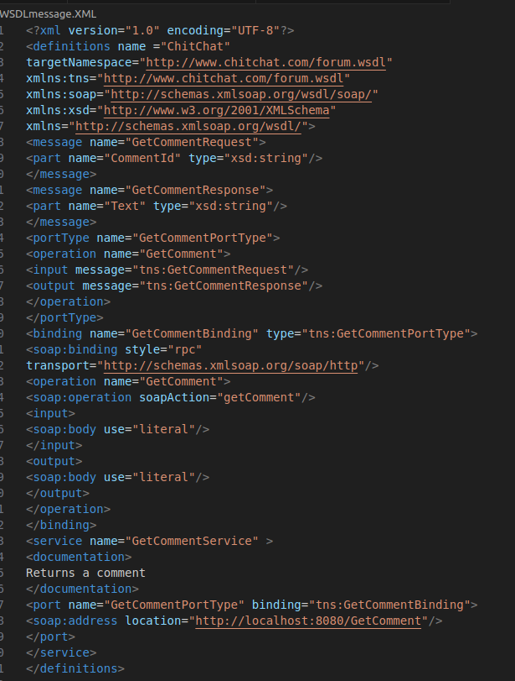

- WSDL message defines a service : GetCommentService with a port : GetCommentPortType that’s bound to the binding GetCommentsBiding
- The service is defined at the location http://localhost:8080/GetComment
- The rest of the message gets into the derails of the service
- In practise SOAP request messages are generated by a SOAP client (from WSDL) which is used by the rest of the code to interact with the server
→ As long as the WSDL is well defined the SOAP client is robust
→ Throwback : each time we change the service the client needs to be regenerated

III REST-based web services

- REST (Representationnal State Transfer) : used in designing programs that talk to each other by manipulating resources using a standard few actions
→ We expose models (ressources) and only allows a few actions (verbs) on them
- When used over HTTP a URL represents a resource : HTTP methods are used as verbs to manipulate them
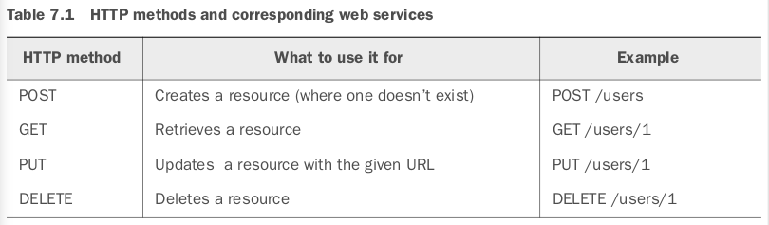
- There’s a mapping between the use of HTTP methods and the database Crud operations
→ It’s not a 1-1 mapping nor is it the only mapping
→ We can use both POST and PUT to create a new resource (they both’ll be correctly RESTful)
- The main difference between POST and PUT
→ For PUT we need to know exactly which resource it’ll replace (replacing existing resource)
→ The state of the server doesnt change regardless of the number of times we repeat our call
→ create/modify resource : only one resource is created at the provided URL
→ For POST it’ll create a new resource with a new URL (new resource without knowing the URL)
→ Everytime we call it : it’ll create a new ressource with a new URL
- Another method PATCH is often used to partially update a resource

