Net/http library

Net/Http library is divided in 2 parts :
- Client : Client, Response, Header, Request, Cookie
- Server : Server, ServeMux, Handler/HandleFunc, ResponseWriter, Header, Request, Cookie
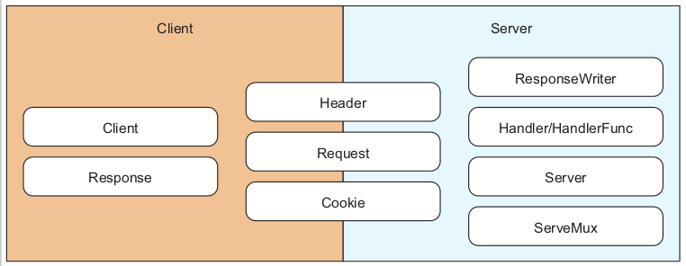

I Serving Go

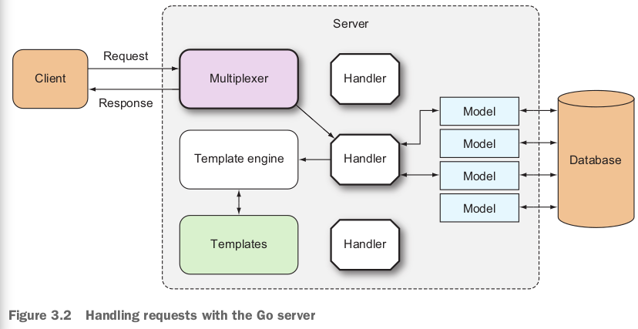
- Net/http library provides capabilitiies for starting up an HTTP server that handles requests/sends responses to those requests. It also provides an interface for a multiplexer and default multiplexer.

A) Go web server
- Creating a server : ListenAndServe with the network address as 1st parameter and the handler that takes care of the request as 2cd parameter
→ network address : « » the default is all network interfaces at port 80
→ handler parameter is nil : DefaultServeMux (default multiplexer) is used
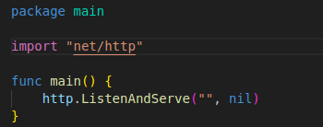

-The following listing does the same thing as the previous code but allow more configurations

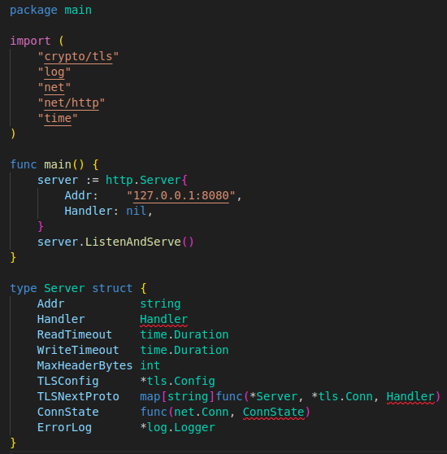

B) Serving through HTTPS

- Used to encrypt/protect communications between the client and the server (for creditcard/password/login)
- HTTPS : layering HTTP on top of SSL(Secure Socket Layer)/TLS(Transport Security Layer)
- To use and serve web app through HTTPS : ListenAndServeTLS
- SSL : provides data encryption/authentication between 2 parties (client/server) using PKI (Public Key Infrastruct)
- SSL/TLS certificate : used to provide data encryption/authentication
→ X.509 formatted piece of data : contains information/public key stored at a web server
→ Usually signed by a certificate authority (CA)
→ Client makes the request to the server : returns with the certificate, will generate random key and use the certificate to encrypt it
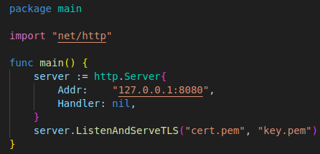

- cert.pem file : SSL certificate (need to get it from a CA like VeriSign, Thawte, Comodo SSL)
→ But just for testing we can generate our own certificates (go library : crypto library group)
- key.perm file : private key for the server

1) Generating our own SSL cirtificate/server private key
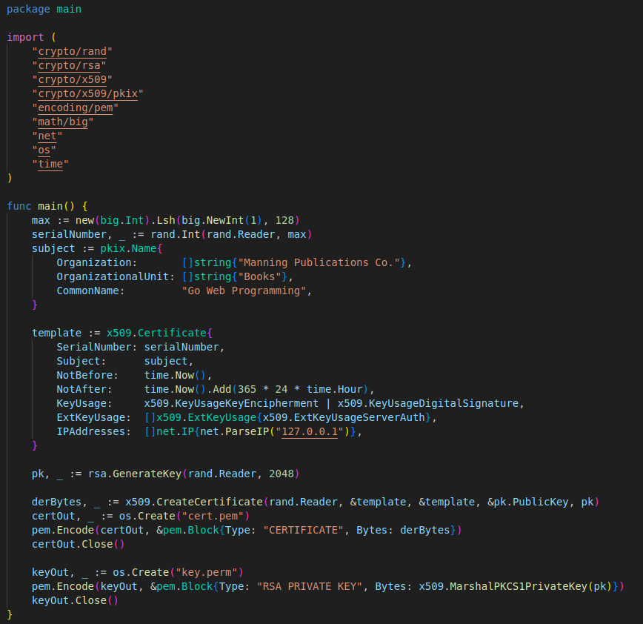
- SSL : X.509 certificate with extended key usage set to server authentication (crypto/x509 library)
- Private key : required to create the certificate
→ We take the private key created fo the certificate and save it into a file for the server private key file

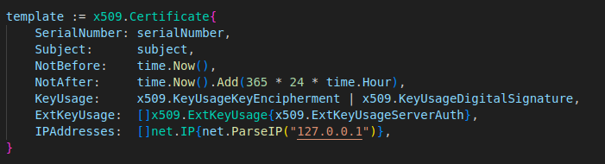
1) Certificate struct : set certificate configuration
- SerialNumber : unique number issued by the CA (here a very large integer randomly generated)
- Subject : distinguished name for the certificate
- validity period : lasting one year from creation datesage : indicate that this X.509 certificate is used for server authentification
- IPAddresses : set the certificate up to run from the IP 127.0.0.1 only.

2) Create Private key
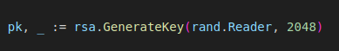

- RSA private key struct that’s created has a public key we can access
→ Usefull when we use the x509.CreateCertificate function to create our SSL certificate
- CreateCertificate : has as parameters the certificate struct, the public/private key to create a slice of DER-formatted bytes
- encoding/pem library : encode the certificate into the cert.pem file
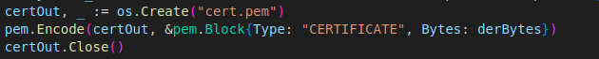

- PEM encode/save the key intothe key.pem file
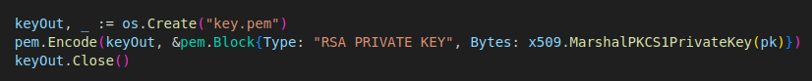
- To display something we’ll add the Hello handler function :
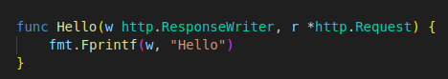

- To start the server and use the Hello handler function we add this code to the main :
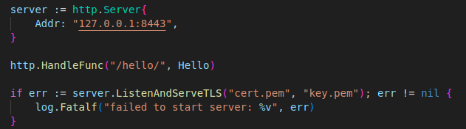

→ We use the port 8443 because it’s the one commonly used for HTTPS trafic
→ The standard HTTPS port is 443 but unlike 8443 it requires root/admin privileges
→ when accessing https://127.0.0.1:8443/hello/ it’ll say that’s it’s not secure since we made the certificate/key
C) Handlers/HandlerFunc

1) Handling requests
- Handler : interface that has a method (ServerHTTP) with 2 parameters (HTTPResponseWriter interface/pointer to a Request struct)
→ Anything that has a method called ServeHTTP with this method signature is a handler :
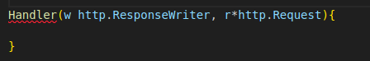

- If the ListenAndServe’s 2cd parameter is a handler, why is the default value a multiplexer : DefaultServeMux ?
→ ServeMux has a method named ServeHTTP with the same signature
→ ServeMux is an instance of the Handler struct and DefaultServeMux is an instance of ServeMux
→ It’s a special type of handler : redirect our requests to different handlers depending on the provided URL
→ If we use a handler instead of the default multiplexer we’ll be able to respond

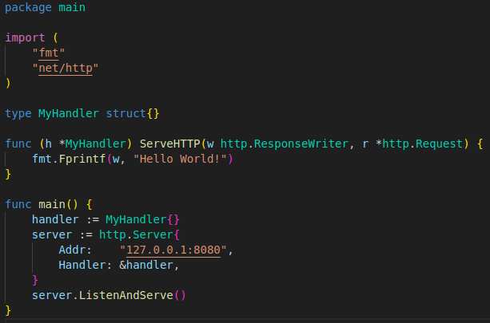

- http://localhost:8080 in the browser : we’ll see « Hello World! »
- http://localhost:8080/anything/at/all : we’ll still see « Hello World ! »
→ We created a handler and attached it to our server : we’re no longer using multiplexers
→ There’s no longer any URL matching to to route the request to a particular handler : all the requests going into the server will go to this handler
- In our handler : ServeHTTP method does all the processing : doesnt do anything except returning « Hello World ! »
→ That what it does for all requests into the server
→ That’s why we use a multiplexer : most of the time we want the server to respond to more than 1 request

2) More handlers
- Using different handlers instead of different URLs
→ We don’t specify the Handler field in the Server struct : it’ll use the DefaultServeMux as the handler
→ http.Handle func : used to attach a handler to DefaultServeMux
- Some func like Handle : func for the http package AND methods for ServeMux
→ calling them calls DefaultServeMux’s corresponding functions
→ calling http.Handle calls DefaultServeMux’s Handle method
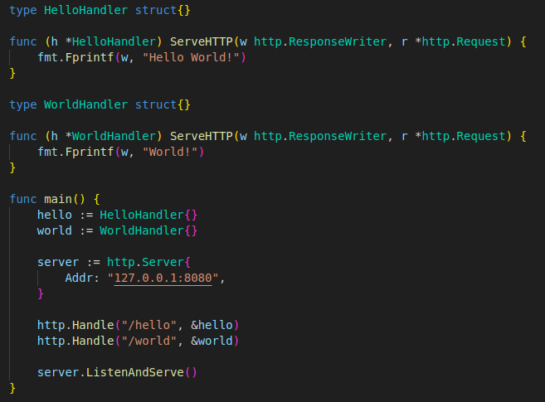

- We create 2 handlers and attach the handler to the respective URLs
→ http://localhost:8080 : 404 error
→ http://localhost:8080/hello : « Hello World ! »
→ http://localhost:8080/world : « World ! »

3) Handler functions
- Functions that behave like handlers : same signature as the ServeHTTP method (w http.ResponseWriter, r *http.Request)
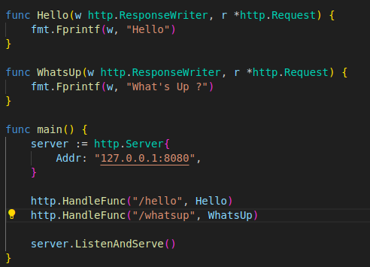

- HandlerFunc : will adapt a function X with the appropriate signature into a Handler with a method X
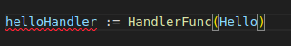

→ HandlerFunc : converts Hello func into a Handler and registers it to DefaultServeMux
→ HandlerFunc : convenient way to create handlers

4) htpp.HandleFunc source code
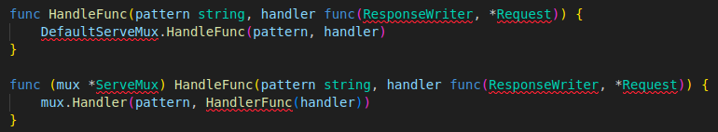
- The func handler is converted into an actual handler by HandlerFunc
- Using handler functions is cleaner why use handlers ?
→ If we have an existing interface/ want to use a type as a handler : add a ServeHTTP method to that interface, we’ll get a handler that we can assign to an URL
→ Allows to build more modular webApps

D) Chaining handlers/handler functions
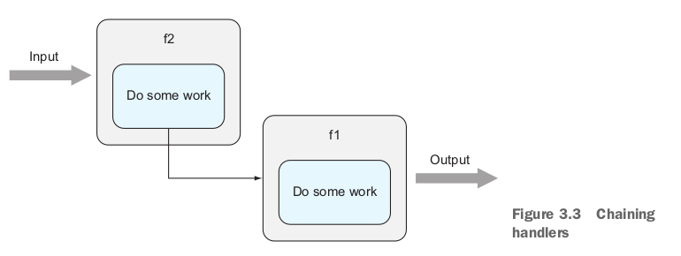

- Go has some functionnal langage’s features
→ We can pass a func f into another func f2 for f2 to do its processing and then call f1
- Every time we call a handler we want to log it down somewhere it was called
→ Logging/similar functions like security/error handling : cross-cuttong concerns
→ These functions are common : we want to avoid adding them everywhere : code duplication/dependencies
- Chaining is a common way to cleanly separate cross-cuttong concerns away from you other logic

1) Chaining 2 handler functions
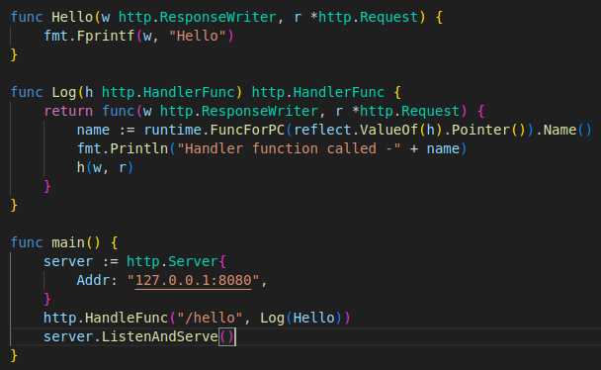

- Log func : takes in/returns a HandlerFunc (Hello is a HandlerFunc)
→ Sends the Hello func into the Log func : chains the Log and Hello funcs
- Log(Hello) : Log returns an anonymous func that takes a ResponseWriter and a pointer to a Request (HandlerFunc)
→ Inside the anonymous func we print out the name of the HandlerFunc (Hello) then it calls it
→ result : we’ll get « Hello » in the browser and in the console « Handler function called – main.Hello »
- If we can chain together 2 handler funcs we can chain more : we can stack handlers to perform multiple actions
→ Pipeline processing

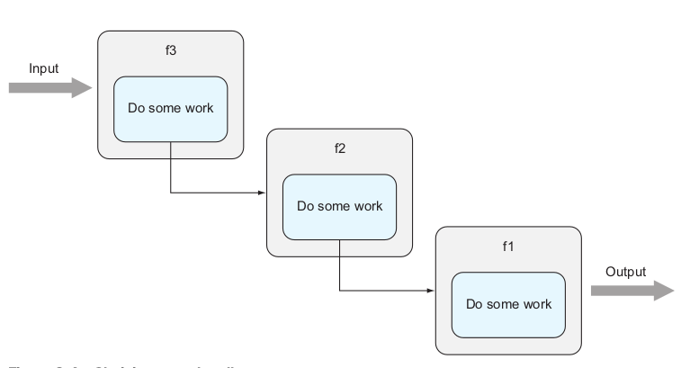
- We have the Protect func : seeks for the user’s authorization before executing the handler
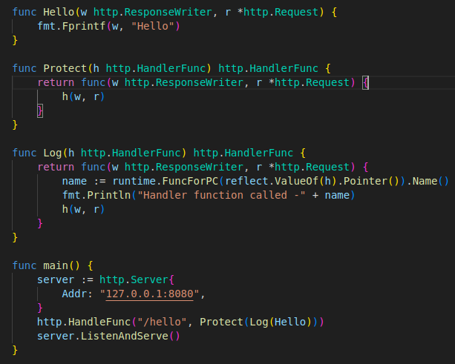

→ To use the Protect func : we chain them together
→ http.HandleFunc(« /hello », Protect(Log(Hello)))
- The mechanism for chaining handlers is very similar to the one for chaining handler funcs

2) chaining handlers
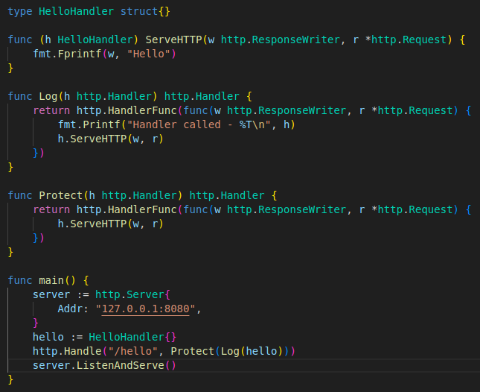

- Log func takes/returns a Handler (instead of returning an anonymous func)
→ instead of executing the hundler func we take the handler and call it s ServeHTTP function
- Instead of resgistering a hanlder func we register the handler

E) ServeMux/ DefaultServeMux
- ServeMux is an HTTP request multiplexer, it accepts an HTTP request and redirects it to the correct handler acccording to the URL request
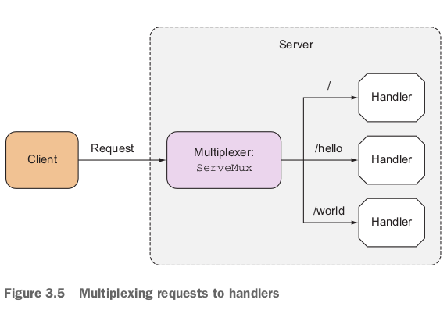

- ServeMux : struct with the map of entries that maps a URL to a handler
→ It’s also a handler because it has a ServeHTTP method
→ ServeMux’s serveHTTP method finds the URL most closely matching the requested one and calls the corresponding handler’s ServeHTTP
- DefaultServeMux is an instance of ServeMux that’s publicly available into the net/http library
→ It’s the instance of ServeMux that’s used when no handler is provided to the Server struct
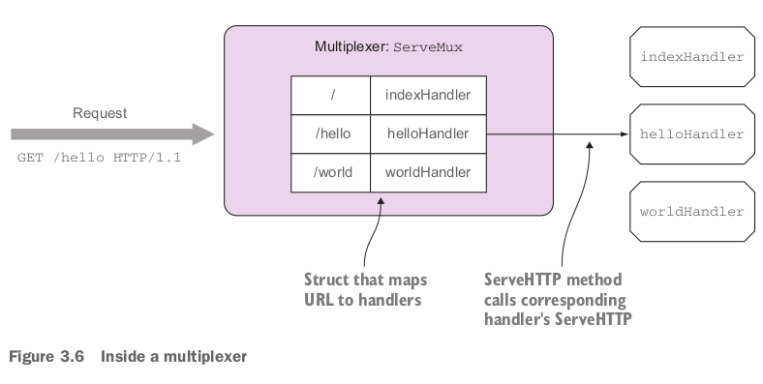
- In the previews exemples the requested URL /hello matches nicely with the registered URL in the multiplexer
- What happens if we call the URL /random ? Or URL /hello/there ?
→ It depends on how the URLs are registered
→ If we register the root URL (/) as in the figure above : any URL that doesn’t match will land on the root URL
→ If we call /random and dont have the handler for this request : the root URL’s handler’ll be called (IndexHandler)
→ It the same if we call /hello/there (what is contrary to the Principle of Least Surprise)
→ The reason is : we registered the helloHandler to the URL /hello instead of /hello/
→ For any registered URL that doesn’t end with (/) : ServeMux‘ll try to match the exact URL pattern
→ URL /hello/ : when /hello/there/ is requested if ServeMux can’t find the exact match it’ll start looking for URLs that start with /hello/ , there’s a match so helloHandler’ll be called

The Principle of Least Surprise : Principle of Least Astonishement
- General principle : when designing we should do the lesat surprising thing
- The result of doing something should be obvious/consistent/predictable
- ex : if we place a button right next to a door : we’d expect the button to do something with the door
→ Ring the bell or open the door
→ If the button turns off the corridor lights isntead : that’d be agaisnt the Principle of Least Surprise
→ It’s doing something that the user wouldn’t be expecting

F) Other multiplexers
- what it takes to be a handler/multiplexer : to implement the ServeHTTP
- It’s possible to create alternative multiplexers to net/http’s ServeMux
- A number of third-party multiplexers are availaible (Gorilla Toolkit : www.gorillatoolkit.org)
- Gorilla Toolkit has 2 different multiplexers that work differtently : mux/pat
- For now we’ll see a lithweight but effective third-party multiplexer : HttpRouter
- One of the main complains about ServeMux is that it doesn’t support variables in pattern matching agaisn the URL
- ServeMux handles /threads well to retrieve and display all threads in the Forum but it’s difficult to handle /thread/123 for retrieving and displaying the thread with id 123
→ To process such URLs our handler’ll need to parse the request path and extract the relevant sections
- ServeMux don’t allow the use of /thread/123/post/456 if we want to retrieve the post with id 456 from the thread with id 123 (not without a lot of unecessary parsing complexity)
- The HttpRouter library overcomes certain of these limitations
→ Documentation : (https://github.com/julienschmidt/httprouter)

1) Using HttpRouter
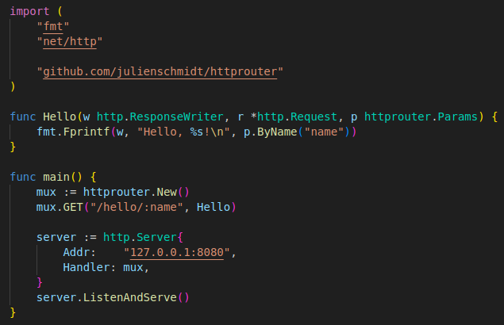

- We create the multiplexer by calling the new function :
- Instead of using HandleFunc to register the handler functions we use the method names :

→ We’re registering a URL for the GET method to the Hello func
→ If a GET request is sent the Hello func’ll be called, if we send any other HTTP request it wont
→ The URL now has a named parameter : can be replaced by any value and be retrieved later by the handler
→ When we start the server and go to http://localhost:8080/hello/ in the browser : we get « error 404 »
→ We ave to go to http://localhost:8080/hello/name : we get « Hello name ! »
→ We can replace « name » by anything and it’ll replace it for ex : http://localhost:8080/hello/you : we’ll get « Hello you ! »
- The handler func has changed aswell

→ it now takes a 3rd parameter : p httprouter.Params that contains the named parameters which we can retrieve by using the ByName method
- Instead of using DefaultServeMux : we pass out multiplexer into the server struc
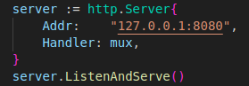

- To add the package needed : go get github.com/julienschmidt/httprouter

G) Using HTTP/2
- It’s included by default in Go when we launch a server
- If it’s not included just add the package : go get golang.org/x/net/http2
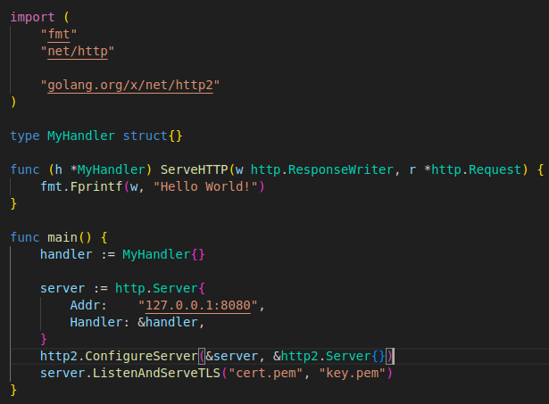

- To check if the server is running in HTTP/2 : use cURL
- cURL : command-line too l that allows users to get/send files through a URL
→ It supports a large number of common internet protocols (including HTTP, HTTPS, HTTP/2)
→ It’s installed by default in many Unix variants but also available for windows (https://curl.se/download.html)
→ To use cURL with HTTP/2 we need to link it to nghttp2 a C library that provides support for HTTP/2
→ curl -I --http2 --insecure https://localhost:8080/
→ We need to run it against HTTPS : because we created our own certificate/private key by default cURL won’t work (to force it we need to use the flag –insecure)

NOT WORKING IDK WHY but we should get this result in the console :
HTTP/2.0 200
content-type:text/plain; charset=utf-8
content-length:12
date:Frid, 26 Jul 2024 20:33:01 GMT

Summary

- Go as a lot of standard libraries to build web apps (net/http and html/template)
- Using good frameworks is easier/saves time : IT’S IMPORTANT TO LEARN THE BASICS OF WEB PROGRAMMING IN GO before using them
- net/http : aloow HTTP to be layered on top of SL to be more secured (creating HTTPS)
- Go handlers can be any struct that has a method named ServeHTTP with 2 parameteres
→ HTTPResponseWriter interface and a pointer to a Request struct
- Handler functions are func that behave like handlers : have the same signature as the ServeHTTP method
→ Are used to process requests
- Handlers/handle funcs can be chained to allow modular processing of requests through separation of concerns
- Mutiplexers are also handlers
→ ServeMux is an HTTP request multiplexer : accepts an URL and redirects it to the correct handler according to the URL in the request
→ DefaultServeMux is an instance of ServeMux that is used as the default multiplexer
- net/http supports HTTP/2 by default (or not sinc it’s not working or maybe i’m not using it the right way)

