Write a query to display the name (first_name, last_name) and salary for all employees whose salary is not in the range $10,000 through $15,000

QUERY

Select first_name,last_name,salary from employee_details where salary not between 10000 and 15000;

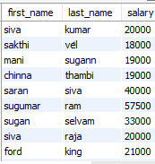

.Write a query to display the name (first_name, last_name) and department ID of all employees in departments 30 or 100 in ascending order.

Query

select first_name,last_name,dep_id from employee_details where dept_it in('30','100') order by dept_it;

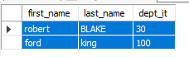

write a query to display the name (first_name, last_name) and hire date for all employees who were hired in 1987

Query

select first_name,last_name,hire_date from employee_details where year(hire_date)=1987;

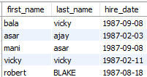

Write a query to display the first_name of all employees who have both "b" and "c" in their first name

Query

select first_name from employee_details where first_name like "b%" or first_name like 'c%';



Write a query to display the last name of employees whose names have exactly 6 characters.

Query

select last_name from employee_details where last_name like '______';



Write a query to select all record from employees where last name in 'BLAKE', 'SCOTT', 'KING' and 'FORD'

Query

select * from employee_details where last_name in('BLAKE','SCOTT','KING','FORD');

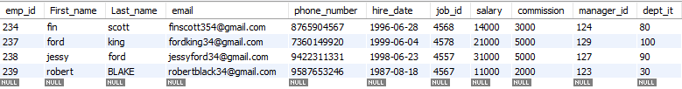

Write a query to list the number of jobs available in the employees table

Query

select count(distinct job_id) from employee_details;



Write a query to get the highest, lowest, sum, and average salary of all employees.

Query

select max(salary) as Highestsalary,min(salary) as lowestsalary,sum(salary) as totalsalary,round(avg(salary),0) as averagesalary from employee_details;

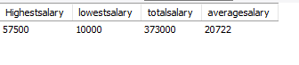

Write a query to find the manager ID and the salary of the lowest-paid employee for that manager

Query

select manager_id ,min(salary)from employee_details ;



Write a query to get the department ID and the total salary payable in each department.

Query

select dept_it,sum(salary) from employee_details group by dept_it;

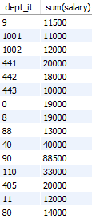

Write a query to get the minimum salary from employees table.

Query

select min(salary)from employee_details;