3. Install and configure Apache Kafka and Zookeeper on Ubuntu

Contents

Step 1: Download Apache Kafka using Wget tool 1

Step 2: Extract the contents on WSL2 1

Opening WSL from a new shell 2

Step 3: Start Zookeeper 3

Step 4: Start Apache Kafka 4

Step 5: Setup the $PATH environment variable 4

Step 6: Explore the Kafka distribution 6

# Step 1: Download Apache Kafka using Wget tool

Open your Ubuntu terminal and run the following command:

$ wget <https://archive.apache.org/dist/kafka/3.0.0/kafka_2.13-3.0.0.tgz>

We can run the “ls” command to see the downloaded archive.

$ ls

kafka_2.13-3.0.0.tgz

# Step 2: Extract the contents on WSL2 Now we can download and extract the contents to a directory of your choice, for example ~/kafka_2.13-3.0.0.

$ tar xzf kafka_2.13-3.0.0.tgz

If you are not in your home directory then move the Kafka files as below:  
  
$ mv kafka_2.13-3.0.0 ~  
$ cd ~

Let’s list the directory contents

$ ls

We can remove the downloaded archive to save space.

$ rm kafka_2.13-3.0.0.tgz

Check that the archive is deleted

$ ls  
  
Open a Shell and navigate to the root directory of Apache Kafka. For this example, the Kafka download is expanded into the ~/kafka_2.13-3.0.0 directory.  
  
$ cd ~/kafka_2.13-3.0.0

Check if Kafka is working

Now you are in the folder where you have extracted the downloaded Tar file Run the following command:

$ bin/kafka-topics.sh

### Opening WSL from a new shell

Open a new PowerShell window or Command Prompt as Administrator.

You can list all distributions with:

**wsl.exe -l**

To launch any distribution, you can also use this for command line:

**wsl.exe -d <name_of_the_distribution>**

**like:**

**C:\Users\steve>wsl --distribution Ubuntu**

**steven@DESKTOP-UAL52A2:/mnt/c/Users/steve$ cd ~**

**steven@DESKTOP-UAL52A2: ~$**

# Step 3: Start Zookeeper

From your Ubuntu terminal, at the root of Apache Kafka, run the following command to start Zookeeper:

~/kafka_2.13-3.0.0/bin/zookeeper-server-start.sh ~/kafka_2.13-3.0.0/config/zookeeper.properties

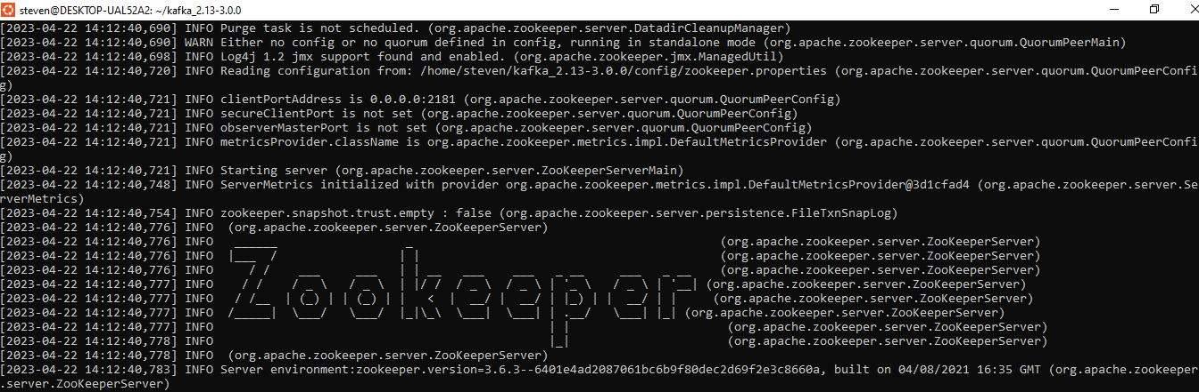

# Step 4: Start Apache Kafka

Open a new PowerShell window or Command Prompt as Administrator and run the following command to start Apache Kafka.

**PS C:\Windows\system32> wsl --distribution Ubuntu**

**steven@DESKTOP-UAL52A2:/mnt/c/Windows/system32$ cd ~**

~/kafka_2.13-3.0.0/bin/kafka-server-start.sh ~/kafka_2.13-3.0.0/config/server.properties

  
Ensure to keep both shell windows opened, otherwise you will shut down Kafka or Zookeeper.  
  
**Kafka is now started, congratulations!**

# Step 5: Setup the $PATH environment variable

Open a new PowerShell window or Command Prompt as Administrator

**PS C:\Windows\system32> wsl --distribution Ubuntu**

**steven@DESKTOP-UAL52A2:/mnt/c/Windows/system32$ cd ~**

In order to easily access the Kafka binaries, you can edit your PATH variable by adding the Kafka bin directory to your system run commands in ~/.bashrc :

Open ~/.bashrc file in vi editor

Hit ‘I’ to insert.

Append “:~/kafka_2.13-3.0.0/bin” to the PATH without the quotes.

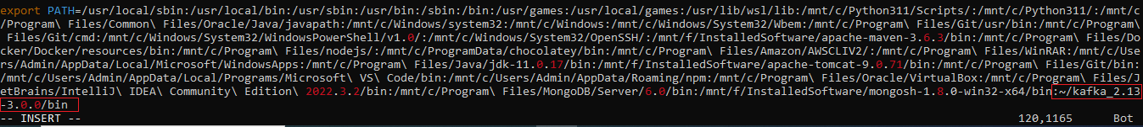

Press Esc button then type “:wq” without the quotes to save and exit.

**Note: If Path variable does not exist in .bashrc file, you can instead add the following to the end of .bashrc:**

**PATH=$PATH:~/kafka_2.13-3.0.0/bin**

Verify that it has been correctly added to the end of the file:

**$ tail -3 ~/. bashrc**

The above [tail command](https://linuxhandbook.com/tail-command/) will show the last 3 lines of the specified file.

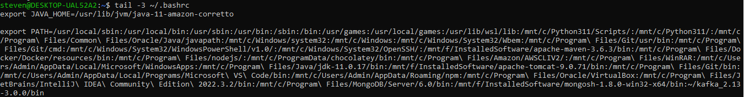

Reload ~/.bashrc file

**$ source ~/.bashrc**

This ensures that you can now run the Kafka commands without prefixing them.

After reloading your shell, the following should work from any directory

**kafka-topics.sh**

Check if Kafka is added to Path

Open a new terminal and run the following:

**kafka-topics.sh --version**



# Step 6: Explore the Kafka distribution

Now let’s explore the Kafka distribution.

**PS C:\Windows\system32> wsl --distribution Ubuntu**

**steven@DESKTOP-UAL52A2:/mnt/c/Windows/system32$ cd ~**

Open a new PowerShell window or Command Prompt as Administrator

  
We’ll cd into the Kafka installation directory and list the contents.



The site‑docs folder just has a tar file containing all of the documentation that you'll find online.

  
  
Let's check out the libs folder. This folder stores all of the binaries Kafka needs to run.



You'll notice there at the bottom the archive for ZooKeeper.

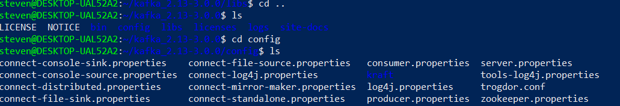  
Then we have the config folder. This is an important folder because here you'll find all of the files you'll need to configure all of the components of Apache Kafka.



This is the Kafka server's config file. Settings are stored as key-value pairs.

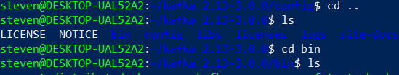

Finally, the bin folder. This folder contains all of the binaries to get Kafka up and running.



It also contains batch files in a ‘windows’ sub directory that do about the same thing as the shell scripts under the main ‘bin’ folder.

***********************************************************************************************