2. Install and configure WSL2 Ubuntu on Windows

Contents

Step 1: Install WSL2 and Ubuntu 1

Step 2: Set up your Linux username and password 2

Step 3: Disable IPv6 on WSL2 3

Step 4: Install Java JDK 11 4

Step 5: Get the location of JDK executable 5

Step 6: Set JAVA_HOME variable 6

Uninstall WSL Distro Using Windows Command Prompt or PowerShell 7

Update WSL Distro Using Windows Command Prompt or PowerShell 8

# Step 1: Install WSL2 and Ubuntu

To install WSL2, make sure you're on Windows 10 version 2004 and higher (Build 19041 and higher) or Windows 11.

To check your Windows version do Windows logo key + R, type winver, select OK

Enter this command in **an administrator PowerShell** or Windows Command Prompt.

wsl --install

# Step 2: Set up your Linux username and password

Setup your username and password as discussed in the video.

Check the WSL distributions on your computer.  
  
wsl --list

Verify the following on Windows Features

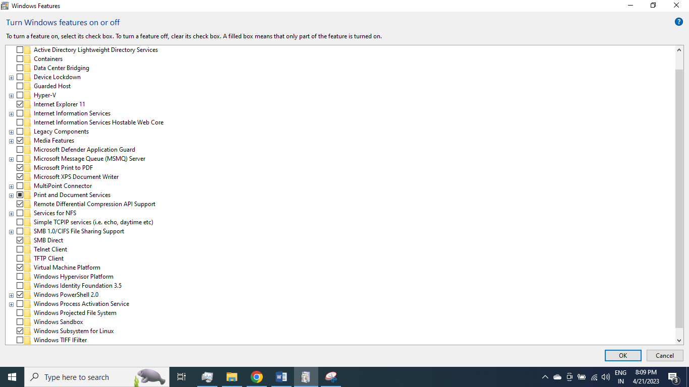

**Virtual Machine Platform** and **Windows Subsystem for Linux** should be checked.

# Step 3: Disable IPv6 on WSL2

sudo sysctl -w net.ipv6.conf.all.disable_ipv6=1

sudo sysctl -w net.ipv6.conf.default.disable_ipv6=1

sudo sysctl net.ipv6.conf.lo.disable_ipv6

sudo sysctl -p

To check if IPv6 is enabled or disabled, from an Ubuntu terminal window:

$ cat /proc/sys/net/ipv6/conf/all/disable_ipv6

0 means it’s enabled and 1 is disabled.

Displays protocol statistics and current TCP/IP network connections, from a Powershell Window or Command Prompt:

PS C:\Windows\system32>netstat -tunap

PS C:\Windows\system32>netstat -a

# Step 4: Install Java JDK 11

You may be prompted for your password.

wget -O- https://apt.corretto.aws/corretto.key | sudo apt-key add -

sudo add-apt-repository 'deb https://apt.corretto.aws stable main'

sudo apt-get update;

sudo apt-get install -y java-11-amazon-corretto-jdk

You may need to set the following options to enable copy/paste in Ubuntu terminal.

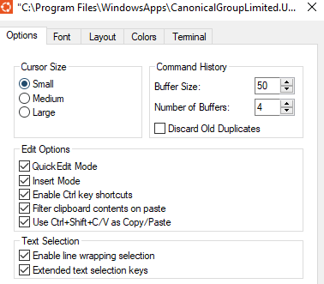

Upon completion, you should get a similar output when doing java -version:

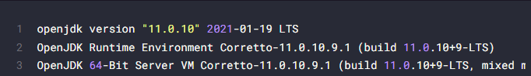

# Step 5: Get the location of JDK executable

[Use the which command](https://linuxhandbook.com/which-command/) to get the location of Java Compiler executable:

which java

The problem here is that the location it gives is actually a [symbolic link](https://linuxhandbook.com/symbolic-link-linux/). You’ll have to follow it a couple of times:

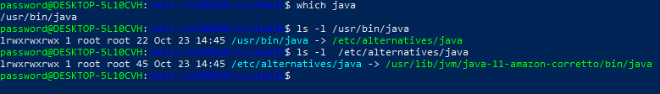

And when you find a path like /usr/lib/jvm/java-11-amazon-corretto/bin/java/bin/java, you **remove the /bin/java** from it to get something like **/usr/lib/jvm/java-11-amazon-corretto.**

An easier method is to follow the symbolic link and get to the actual executable file directly using this command:

readlink -f `which java` | sed "s:/bin/java::"



# Step 6: Set JAVA_HOME variable

export JAVA_HOME=/usr/lib/jvm/java-11-amazon-corretto

Check the value of JAVA_HOME directory:

echo $JAVA_HOME



Back up your bashrc file (in case you mess it, you can get it back):

cp ~/.bashrc ~/.bashrc.bak

echo "export JAVA_HOME=/usr/lib/jvm/java-11-amazon-corretto

" >> ~/.bashrc

Verify that it has been correctly added to the end of the file:

tail -3 ~/.bashrc

The above [tail command](https://linuxhandbook.com/tail-command/) will show the last 3 lines of the specified file.



# Uninstall WSL Distro Using Windows Command Prompt or PowerShell

You can find the distro name by running the command:

wsl --list

To unistall a WSL distro, run the command as administrator:

wsl --shutdown

wslconfig /unregister Ubuntu

OR

----

winget rm --name <distro_name>

For example:

winget rm --name Ubuntu

# 

# Update WSL Distro Using Windows Command Prompt or PowerShell

The Linux kernel used by WSL is updated automatically.

We can run the following command to update manually.

PS C:\Windows\system32> wsl --update

***********************************************************************************************