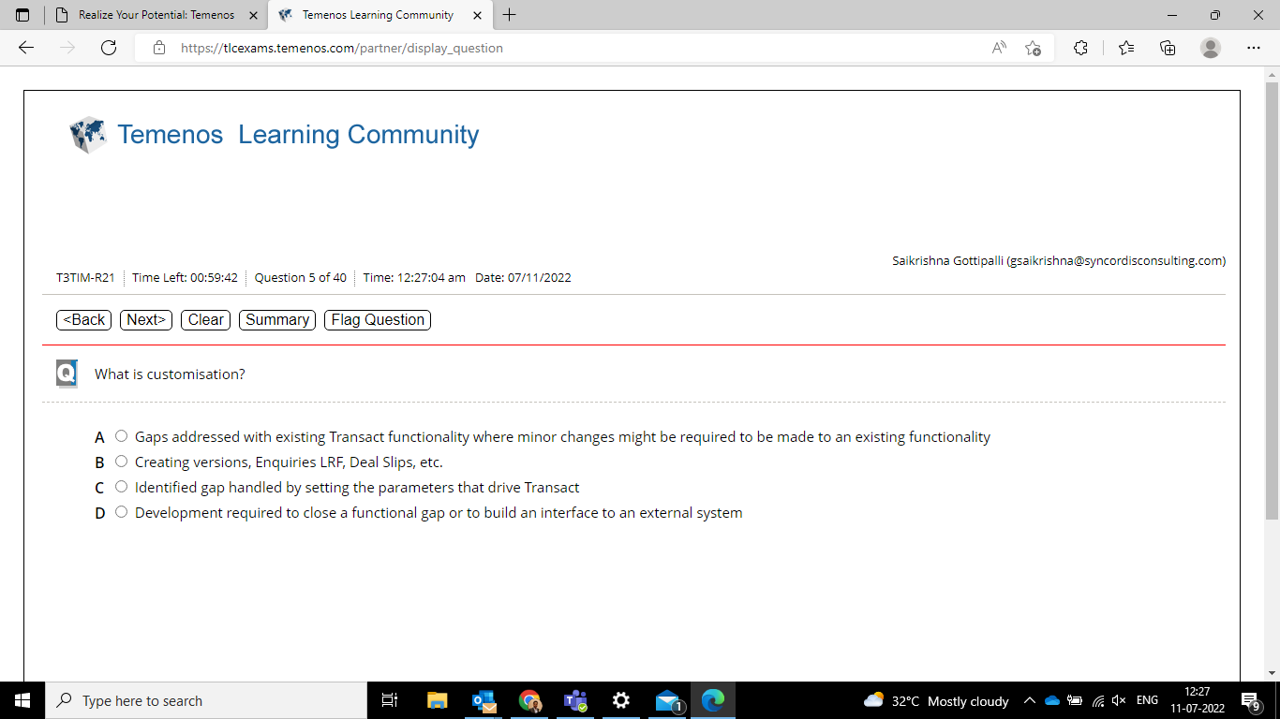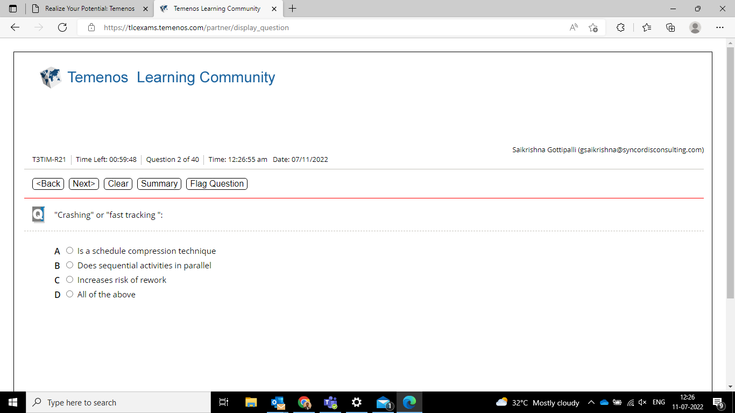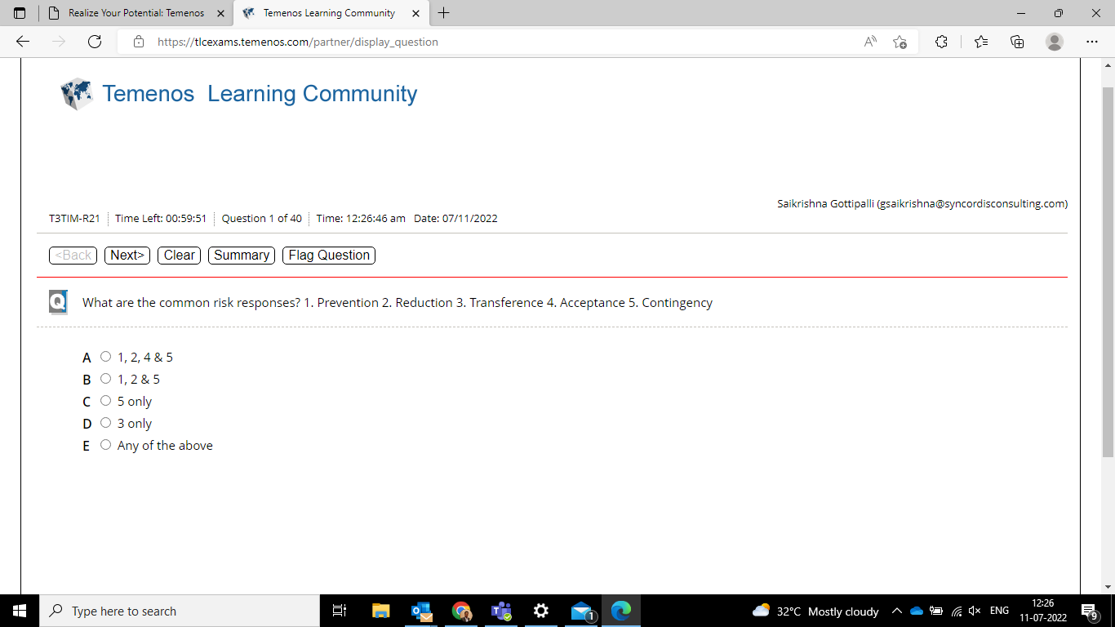



QUESTION NO.1 IS PURE GUESS