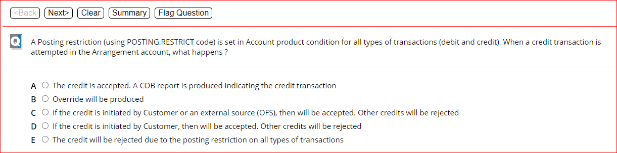

B

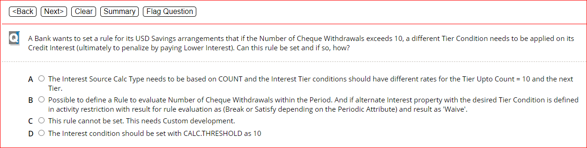

A

D

E

C

A

A

A

D

E

A

E

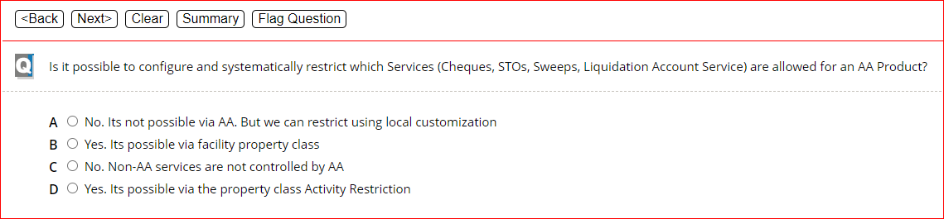

D

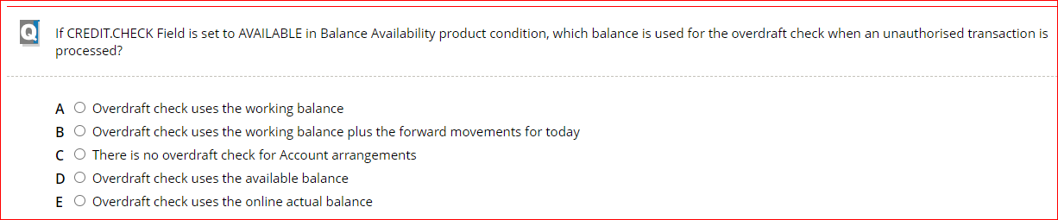

D

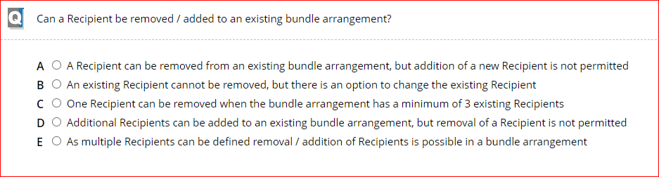

E

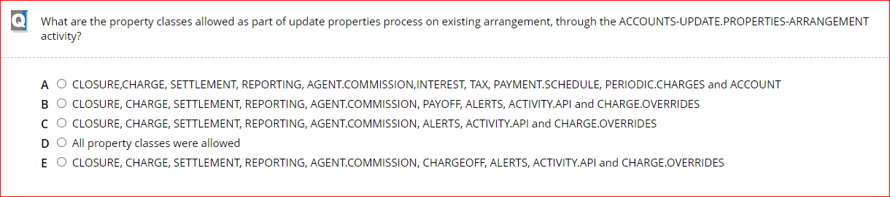

D

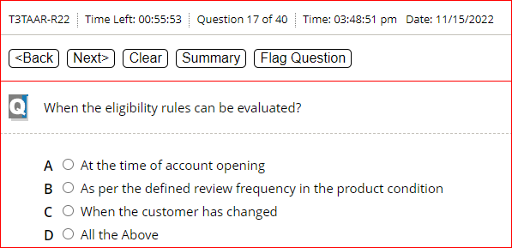

D

D

E

B

A

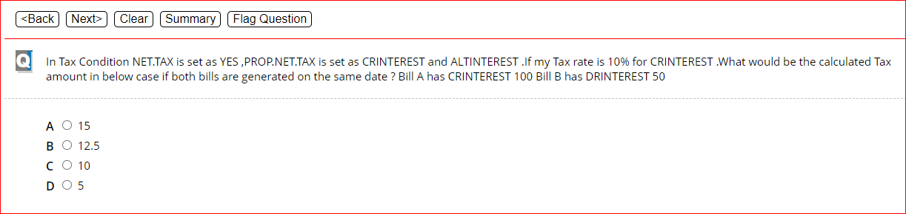

D

A

B

B

B

C

A

D

B

B

A

D

D

D