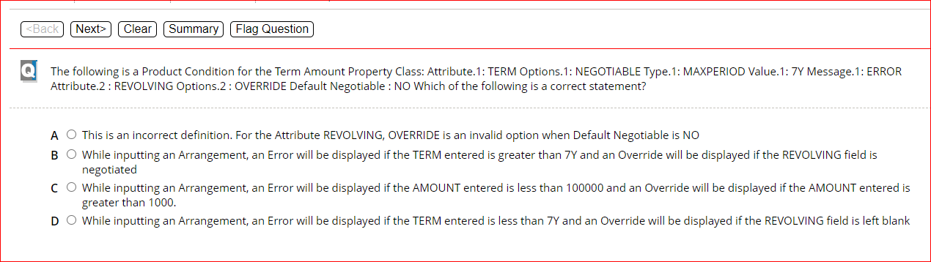

B.

D

C

B

A

A

A

D

**D**

B

B

A

A

B

B

D

A

C

B

B

D

A

B

A

C

E

