Java

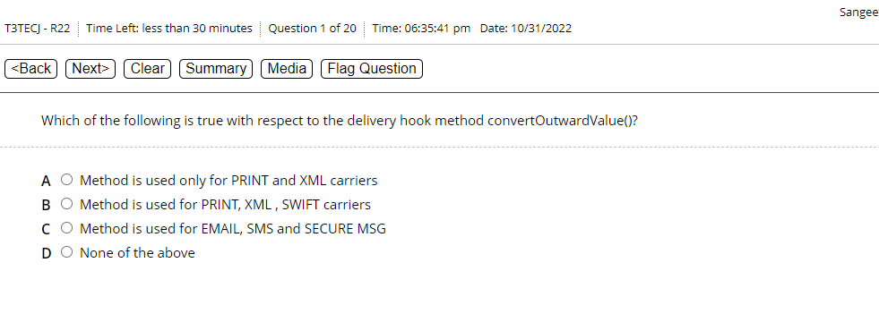

A)

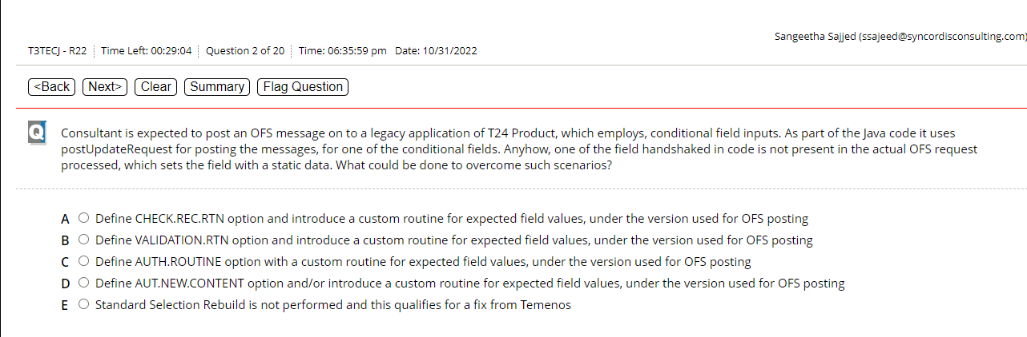

Leave this question

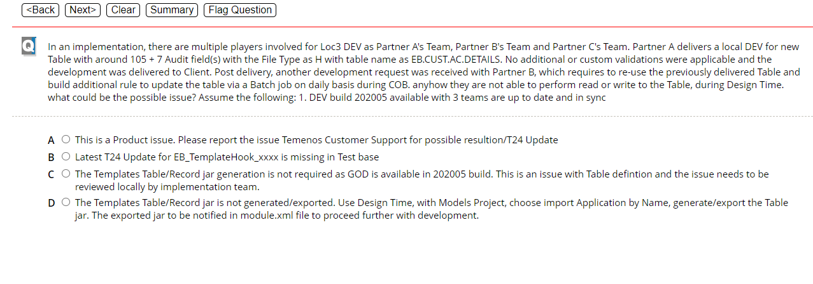

D)

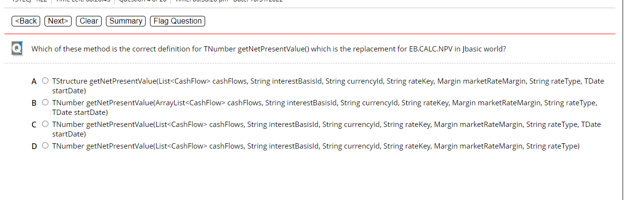

C com.temenos.api.accounting.IFSRValution

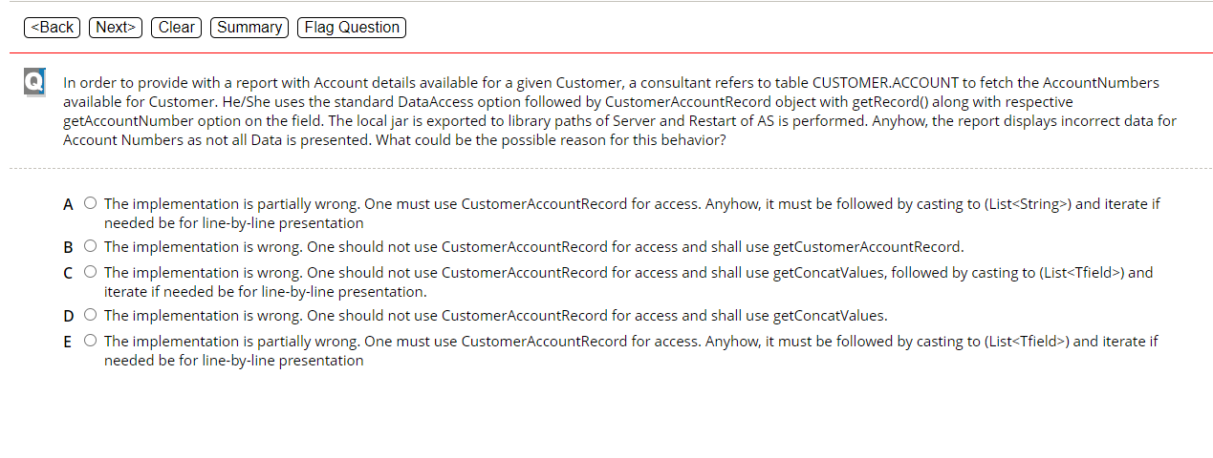

D)

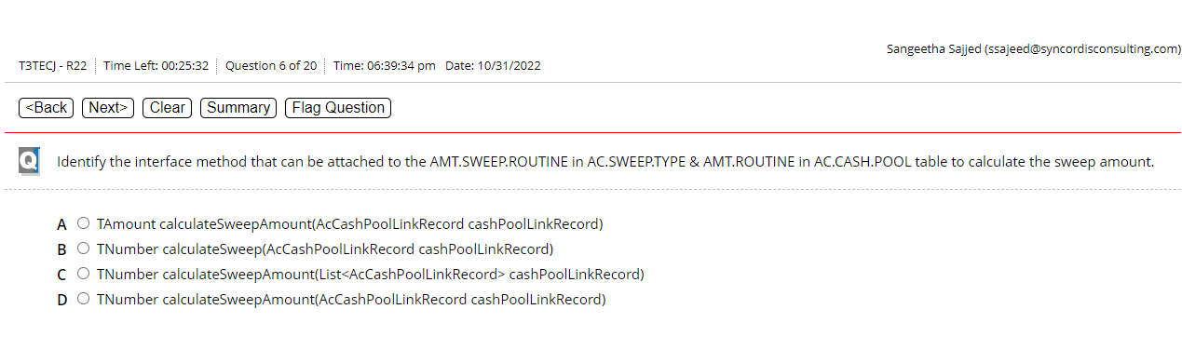

This you can search from notepad

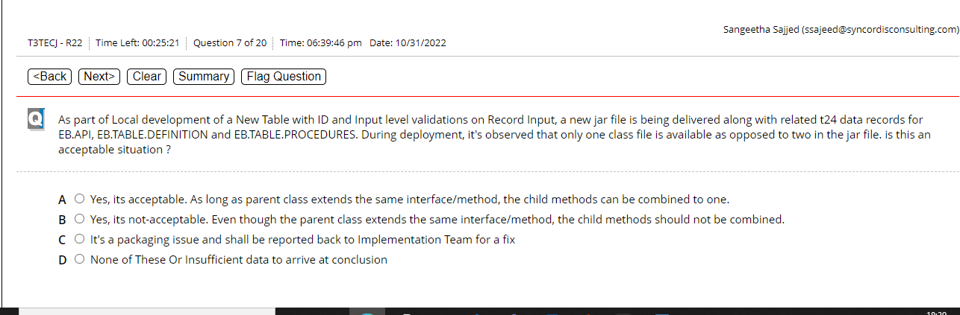

C/A-doubt A is the correct answer you can create two method in one class

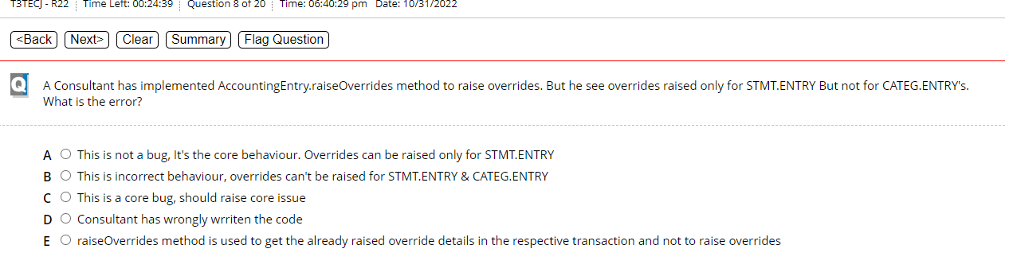

Leave this question Not Sure

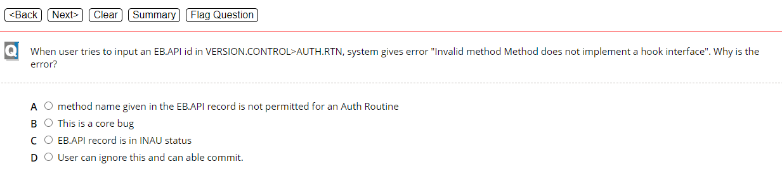

A)

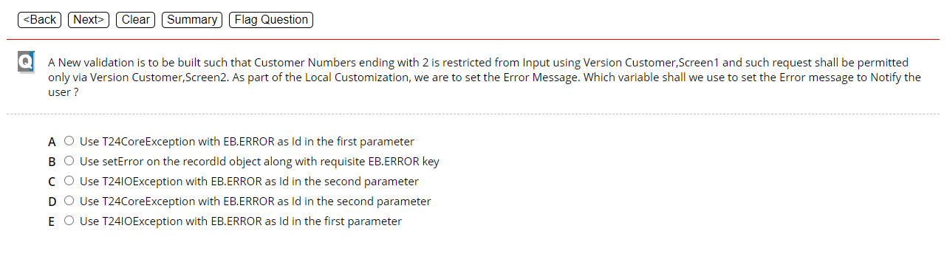

D-excel

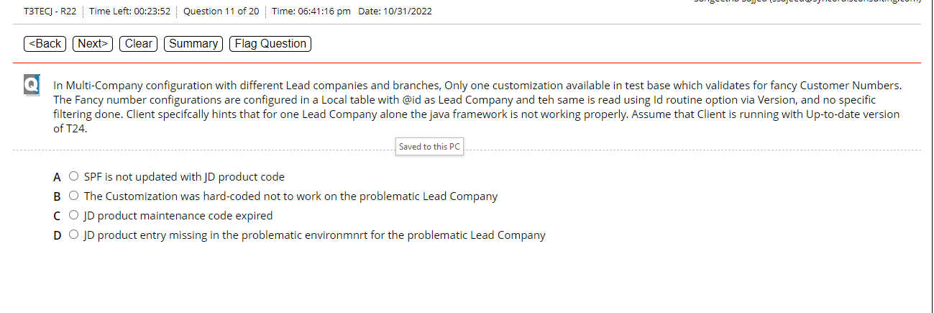

D/B-doubt Not Sure Leave it

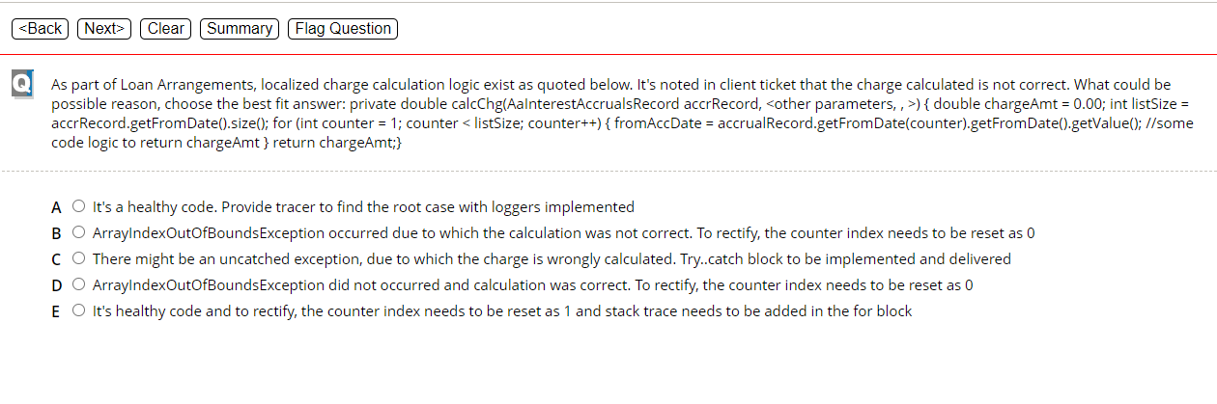

Implement this code to get the answer we can be 100% sure for this quesiton

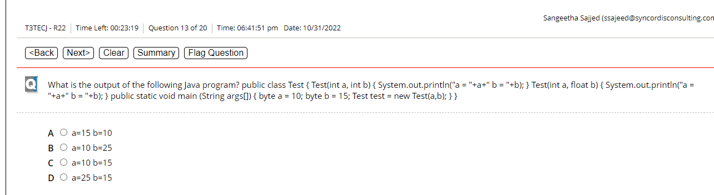

C)-excel you can write the code and get the answer but it is correct

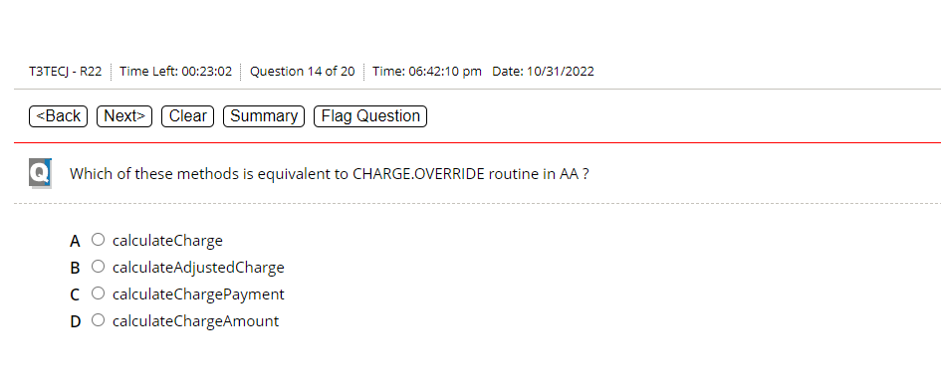

B) C:\Users\10694870\OneDrive - LTI\Documents\Javadevupdatedocs\Javadocs\JavaDevelopmentDocument\T24.javadoc\com\temenos\t24\api\hook\arrangement

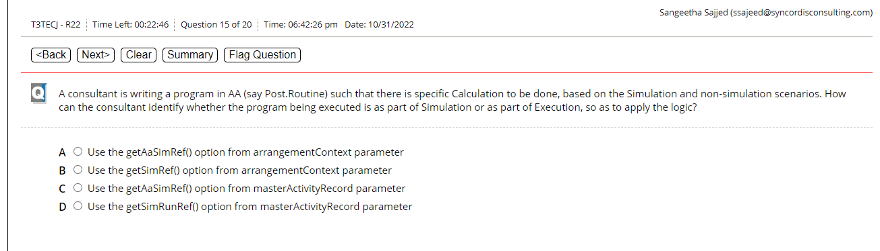

D)-Excel Search in notepad++ using javadoc

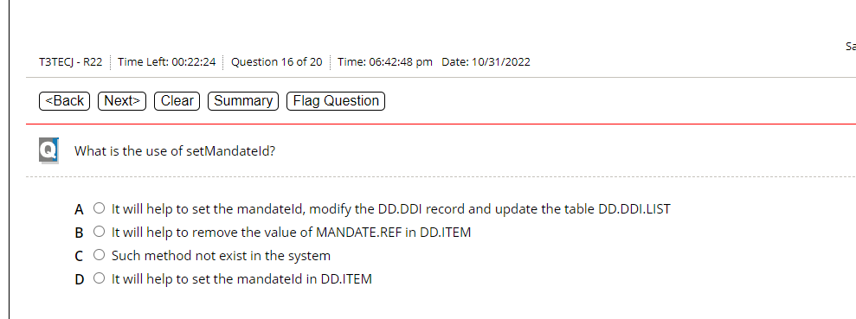

D)-doubt-C:\Users\10694870\OneDrive - LTI\Documents\Javadevupdatedocs\Javadocs\JavaDevelopmentDocument\T24.javadoc\com\temenos\t24\api\records\sepaoutward

Answer is A

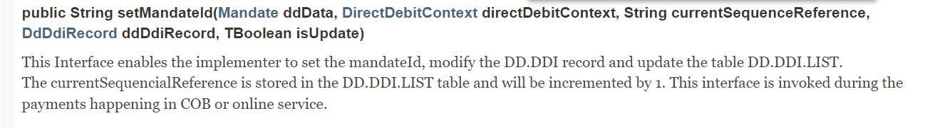

Com.temenos.t24.api.hook.contract.DriectDebit

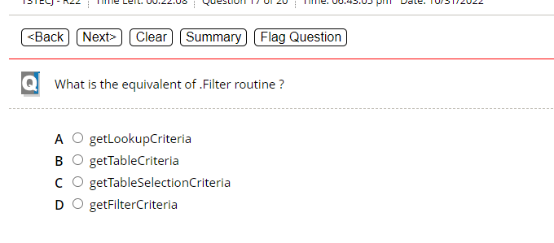

We can search it in java doc

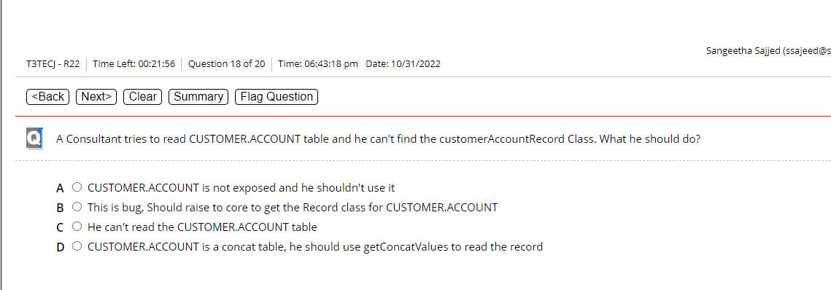

D)

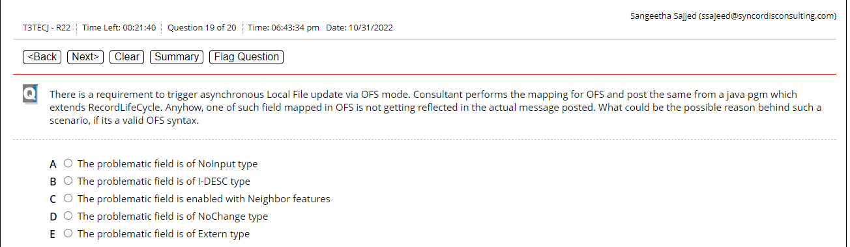

A

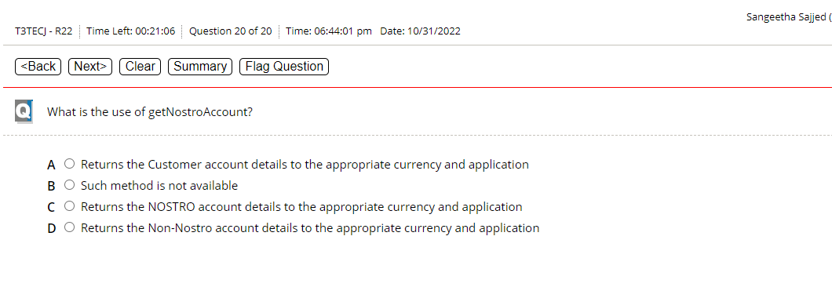

C) Search from JavaDoc