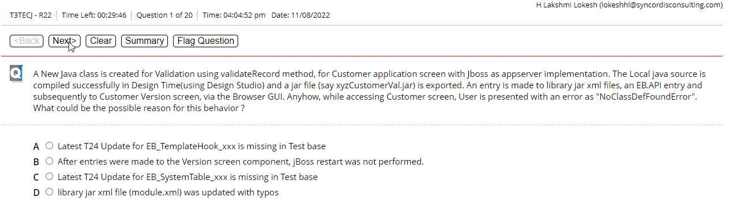

AnsC) from kumar answers

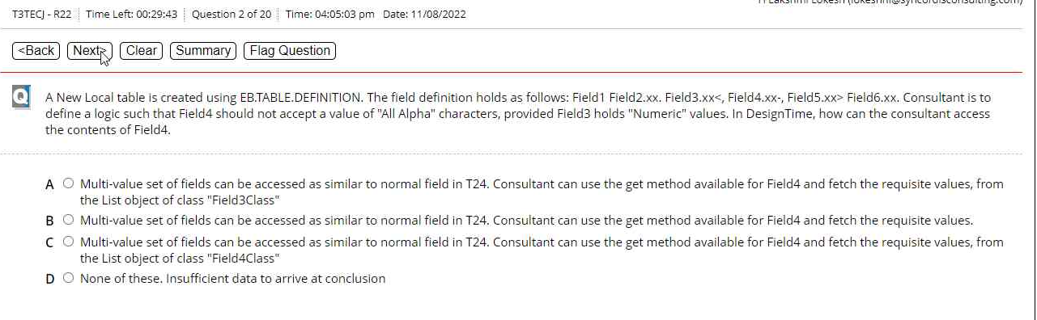

AnsA – from DS and understanding to get associated mv’s from the 1st field of multi value class object.

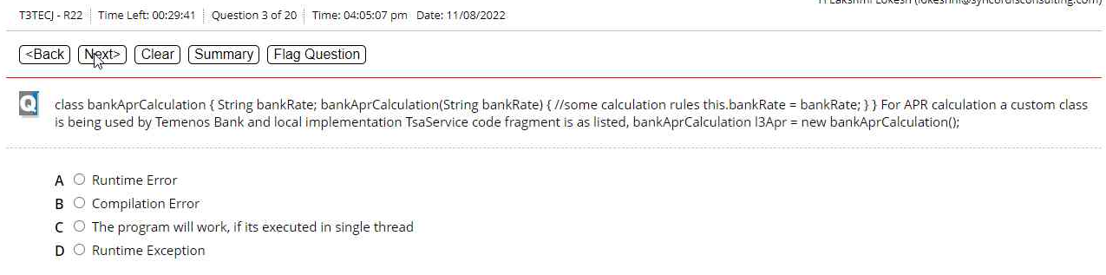

AnsB Compilation error – noticed from DS

**In multi-Company configuration…..Up-to-date version of T24**.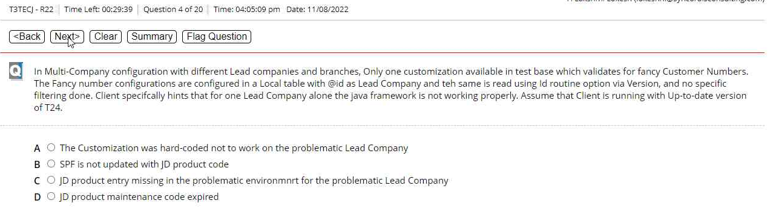

Ansered = C : JD product is missing in the problematic env<from EF doc> [doubt]

AnsD) getHistoryRecord – got it from DS

**A consultant opts for a multi-thread COB job….R20 AMR….initialise() method…..Fatal error… Jars are done whenever required)**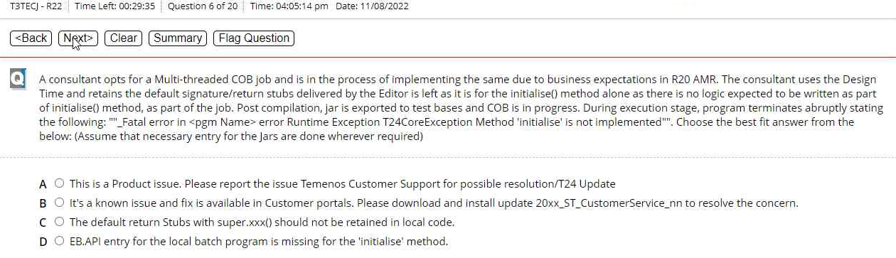

AnsC – From Jeevan excel - C is correct Answer Ankur  
MyAns=D – EB.API missing as the code still works with no issues having default return stubs with super.xxx() (to recheck)

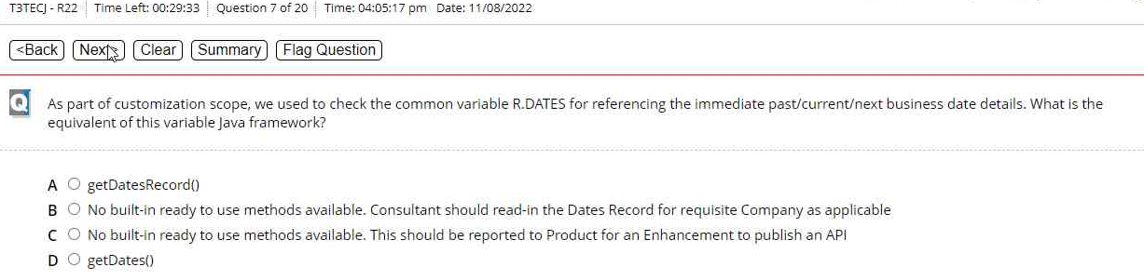

AnsD) getDates() – got it from DS

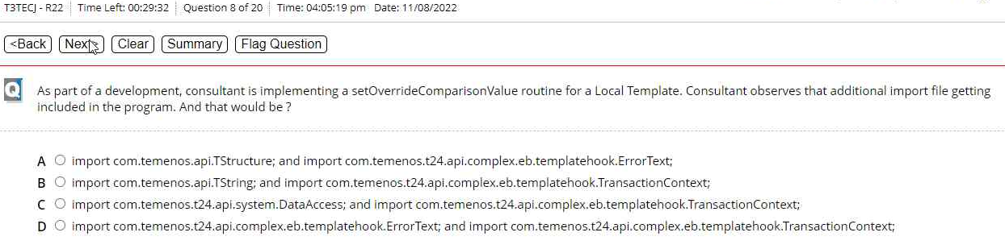

AnsB – got it from DS

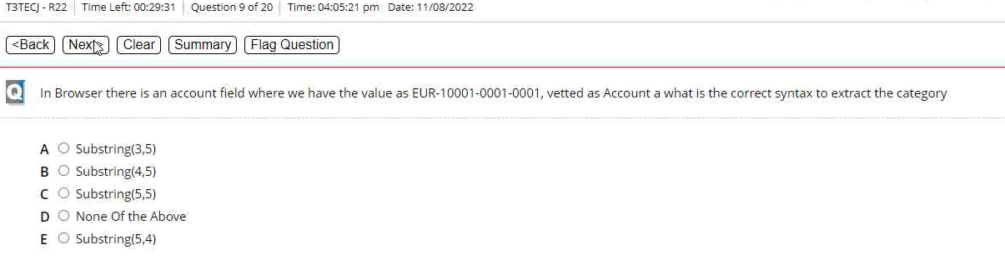

AnsD) None of the above. – executed in DS. Correct ans is Substring(3,8) to extract 10001 from the mentioned string

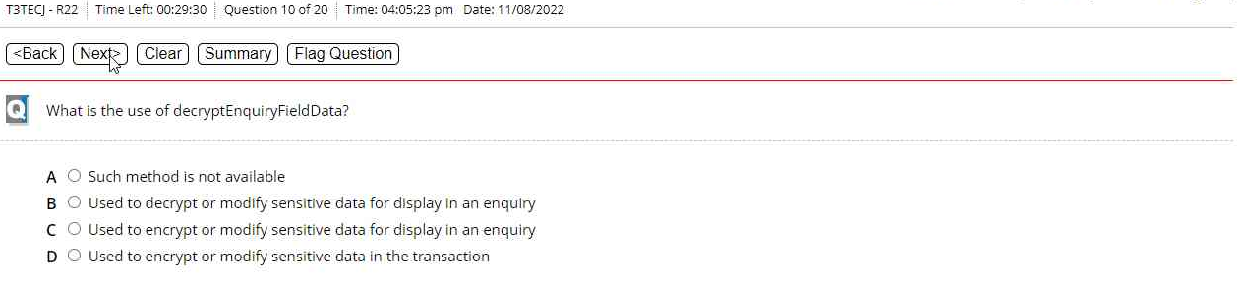

AnsB – from javadoc

**Bank BenBank is performing Local customization with in-house candidate…… achieve the expectation.**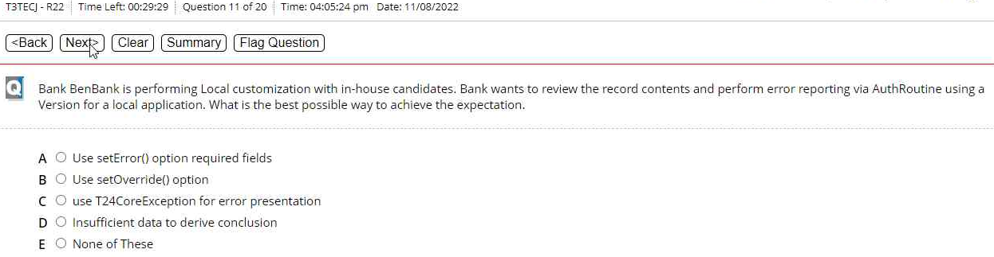

Ans A) setError() seems to be the answer. To recheck

Ankur As per my understanding it should be C but even if you want to validate or review you can do it at input level why you want to do during auth .

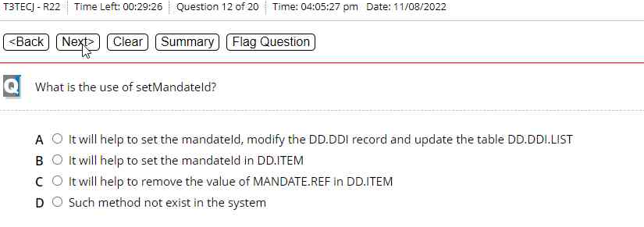

AnsA – from Javadoc

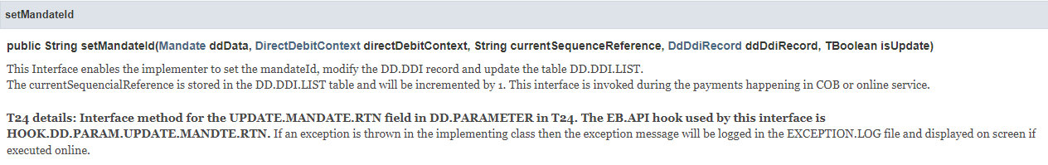

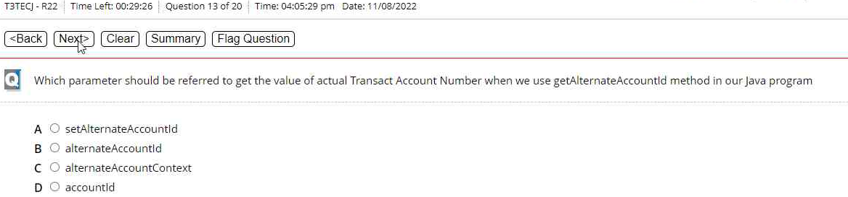

AnsD) – from Javadoc

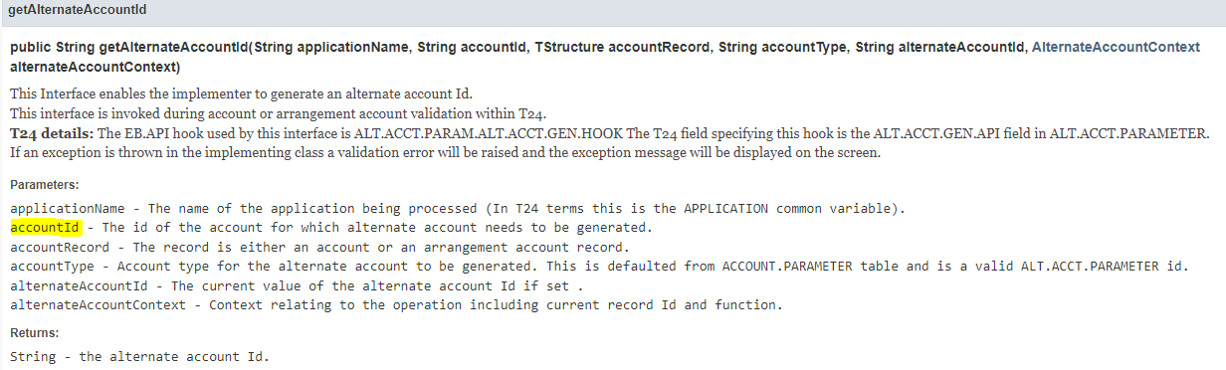

**In a Batch program, consultant implemented a collection to handle Days 1 to 31….. }}**

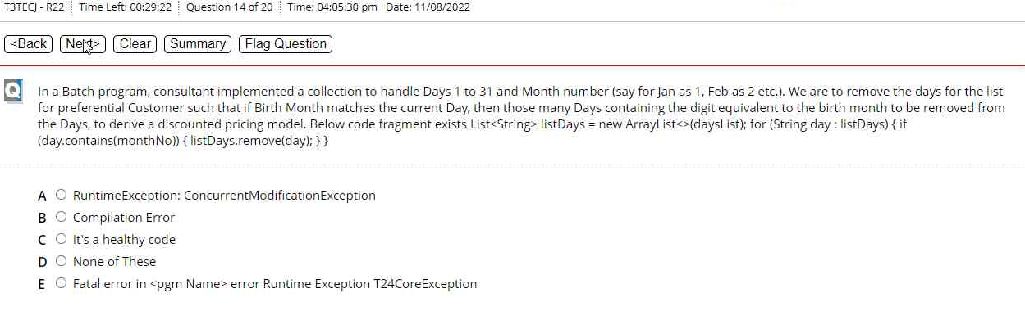

AnsC) It’s a healthy code is correct:code looks fine if executed from DS. Not sure of the collection ArrayList<>(**dayList**) removing dayList and adding few values and executing, its working fine. Below is the code tested:

String monthNo = "7";

List<String> listDays = **new** ArrayList<>();

listDays.add("1");

listDays.add("5");

listDays.add("7");

listDays.add("11");

System.***out***.println("before:" + listDays);

**for** (String day : listDays) {

**if** (day.contains(monthNo)) {

listDays.remove(day);

System.***out***.println("after remove:" + listDays);

}

}

**Results:**

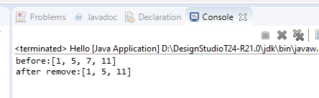

**Throwable class extends ___?**

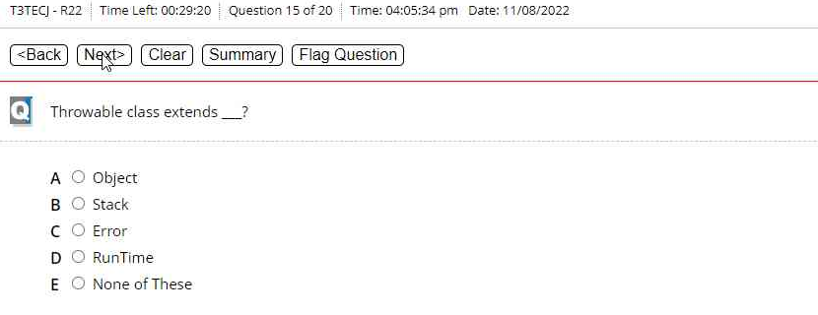

AnsA) from google

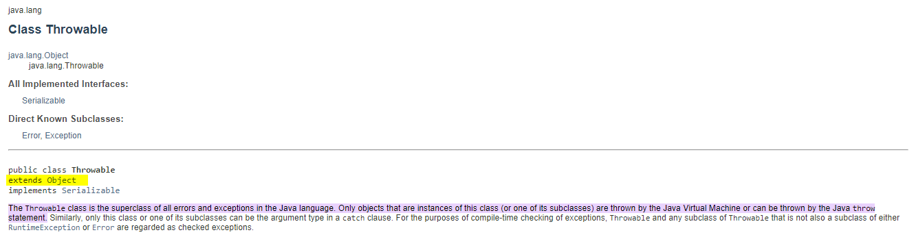

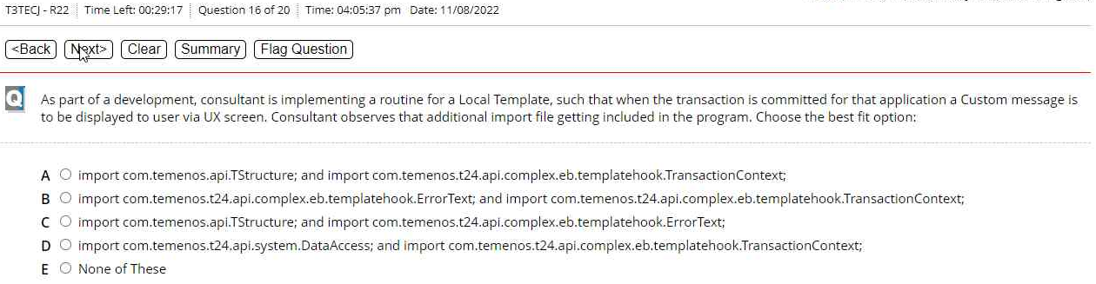

AnsA) import com.temenos.api.TStructure; and import com.temenos.t24.api.complex.eb.templatehook.TransactionContext; - from DS

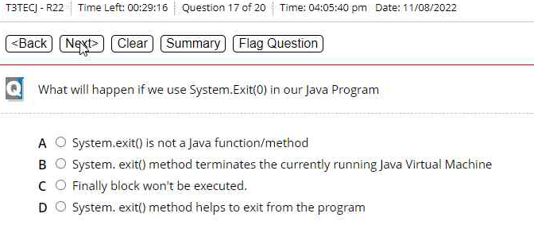

AnsB) from google

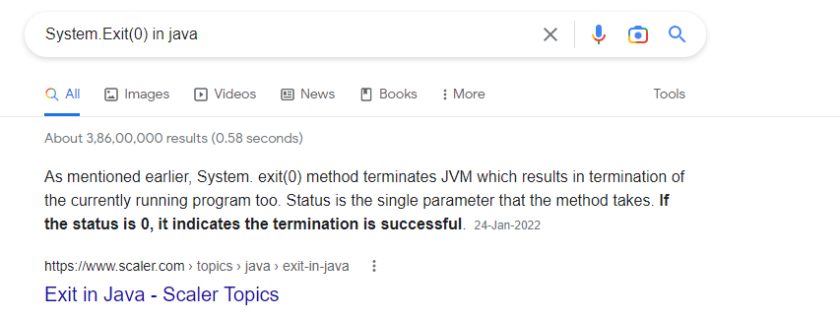

Ans C) Date.getDayType – from DS

**A client implementation is underway in R20AMR, with multiple branches….FT module…..How will you frame the solution such that the table is filled Branch wise?**

AnsC) OPM seems to be right 1. To recheck Leave it

AnsC – From DS

