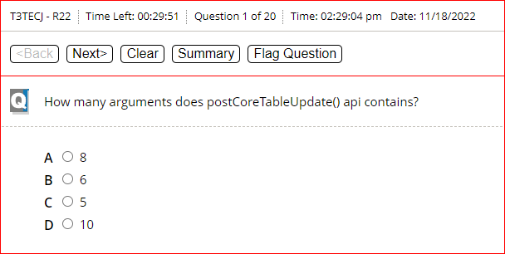

D

D

D

c

B

B

D

A

D

D

B

C

D

A

B

C

D

A

