<https://cloud.mongodb.com/user#/atlas/register/accountProfile>

select AWS, free tier

empower18-ws1

security/add user

ews1-user

ews1-user1

add ip address (http://myipaddress.com)

copy connection string

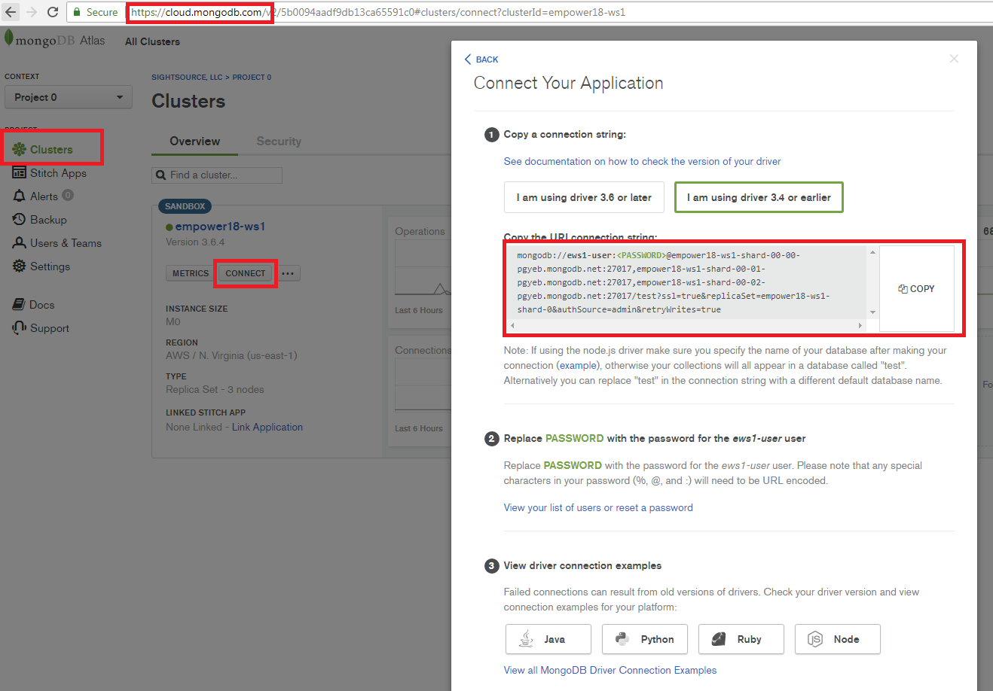

install mongodb compass

install robo 3t, configure like so:

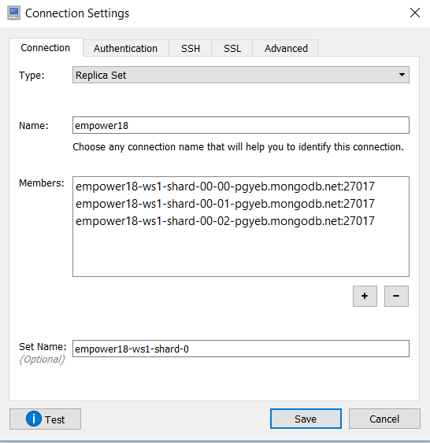

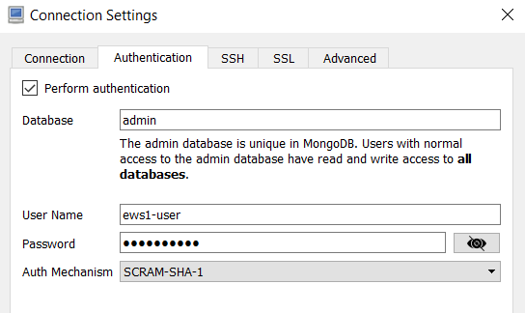

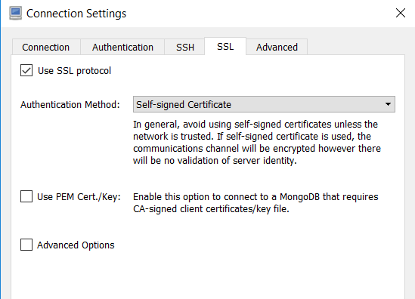

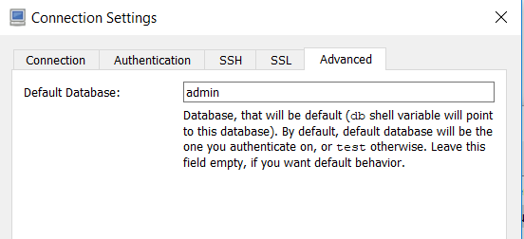

create /models/beverage.js

var mongoose = require('mongoose');

var Schema = mongoose.Schema;

var Beverage = new Schema({

name : String,

description : String

}, { collection: 'beverage' });

module.exports = mongoose.model('Beverage', Beverage);