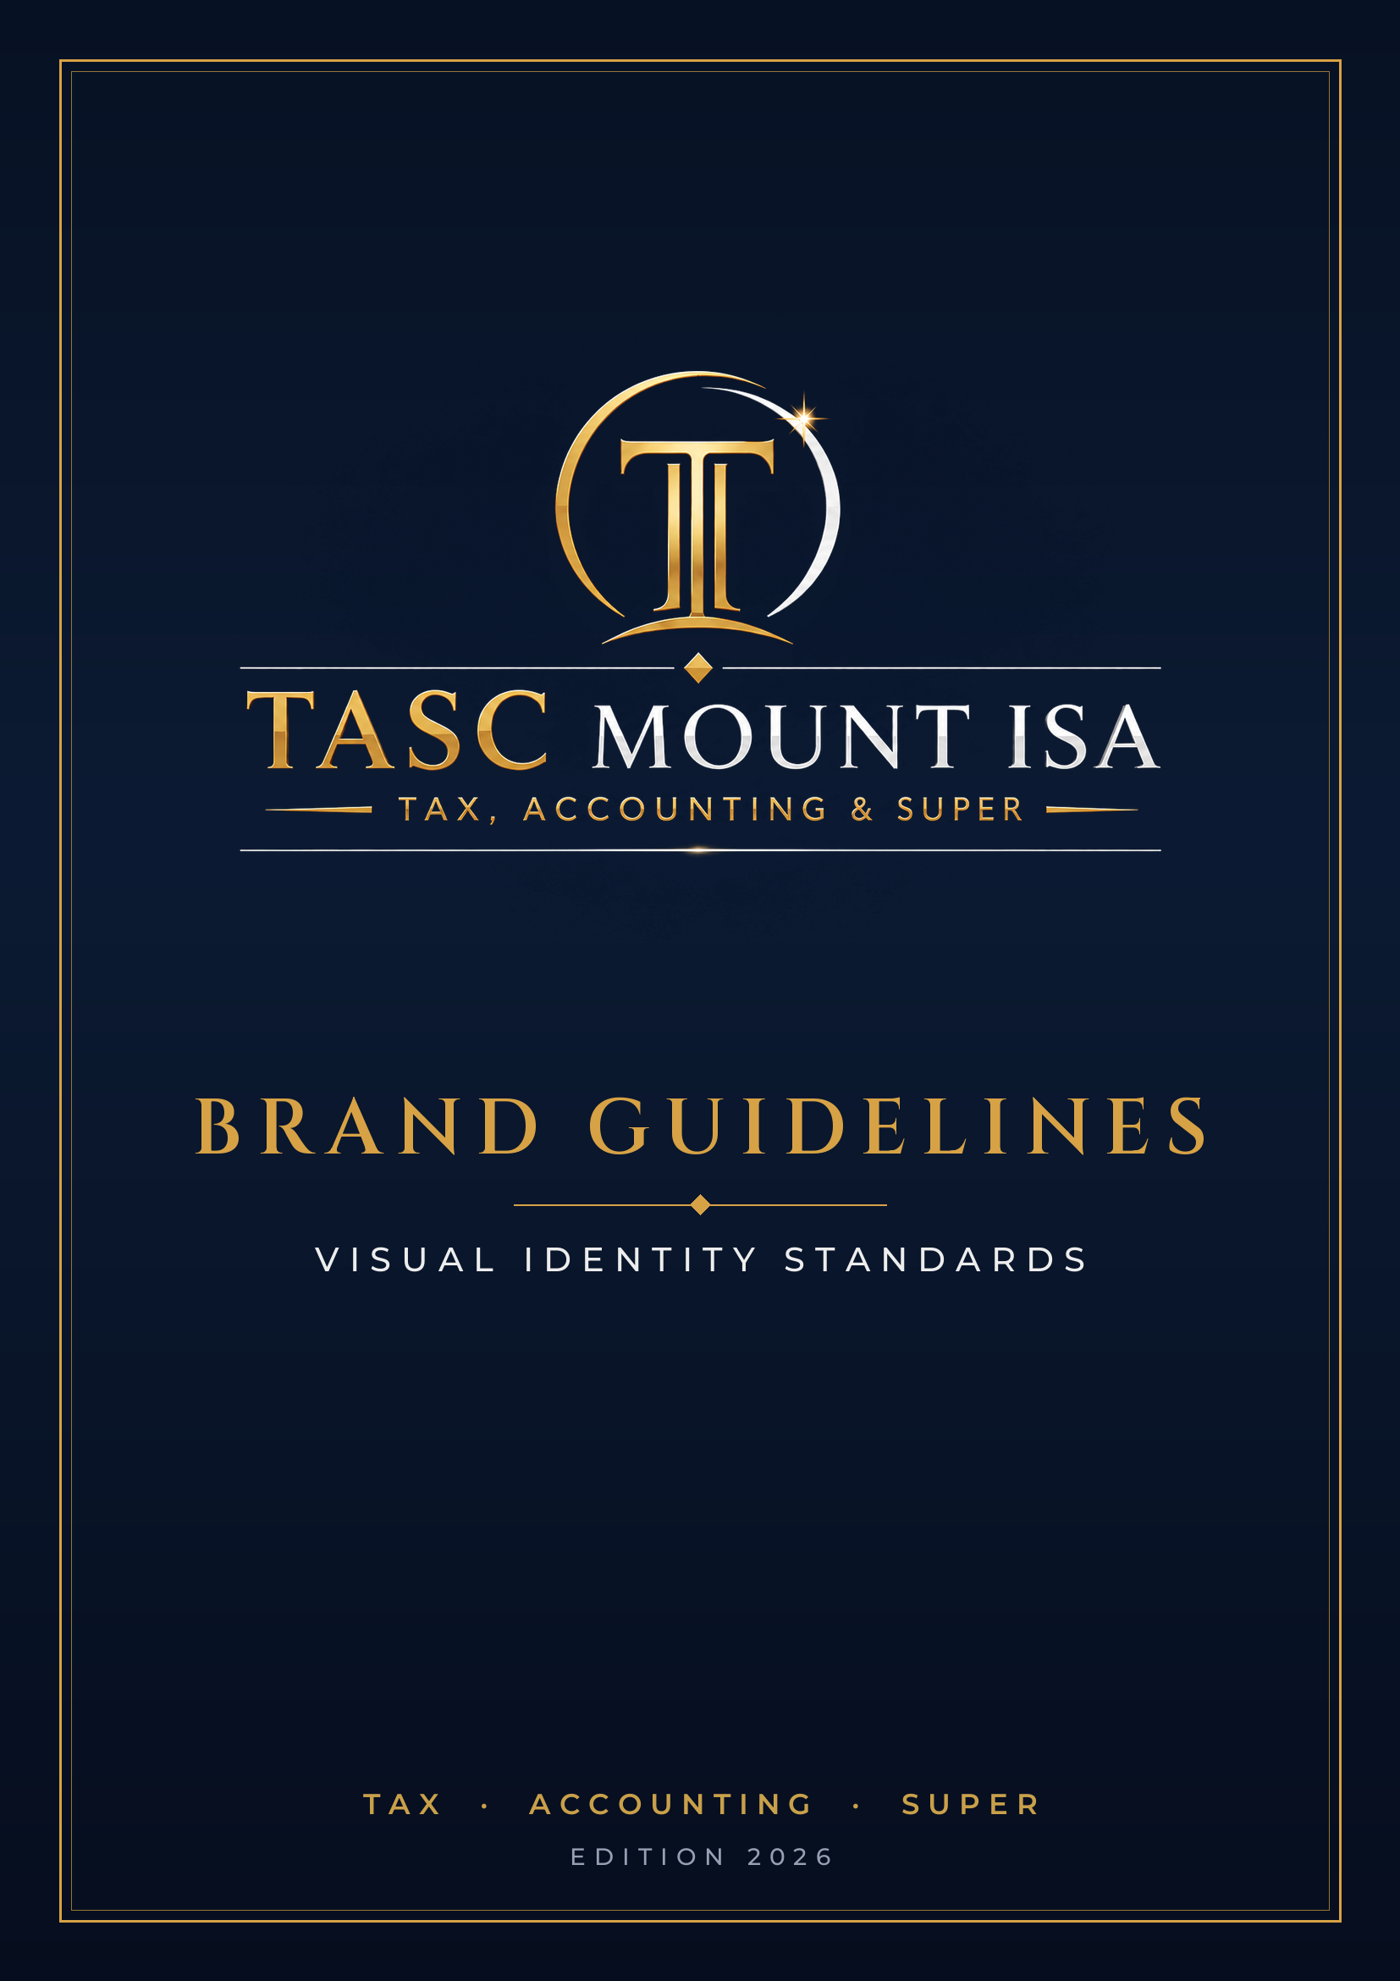

01 THE LOGO
The TASC Mount Isa identity pairs a gold monogram emblem — the interlocked “T” framed by a crescent and starburst — with a high-contrast serif wordmark. It is a reversed (light-on-dark) mark and must always sit on the brand navy or an equivalently dark ground.

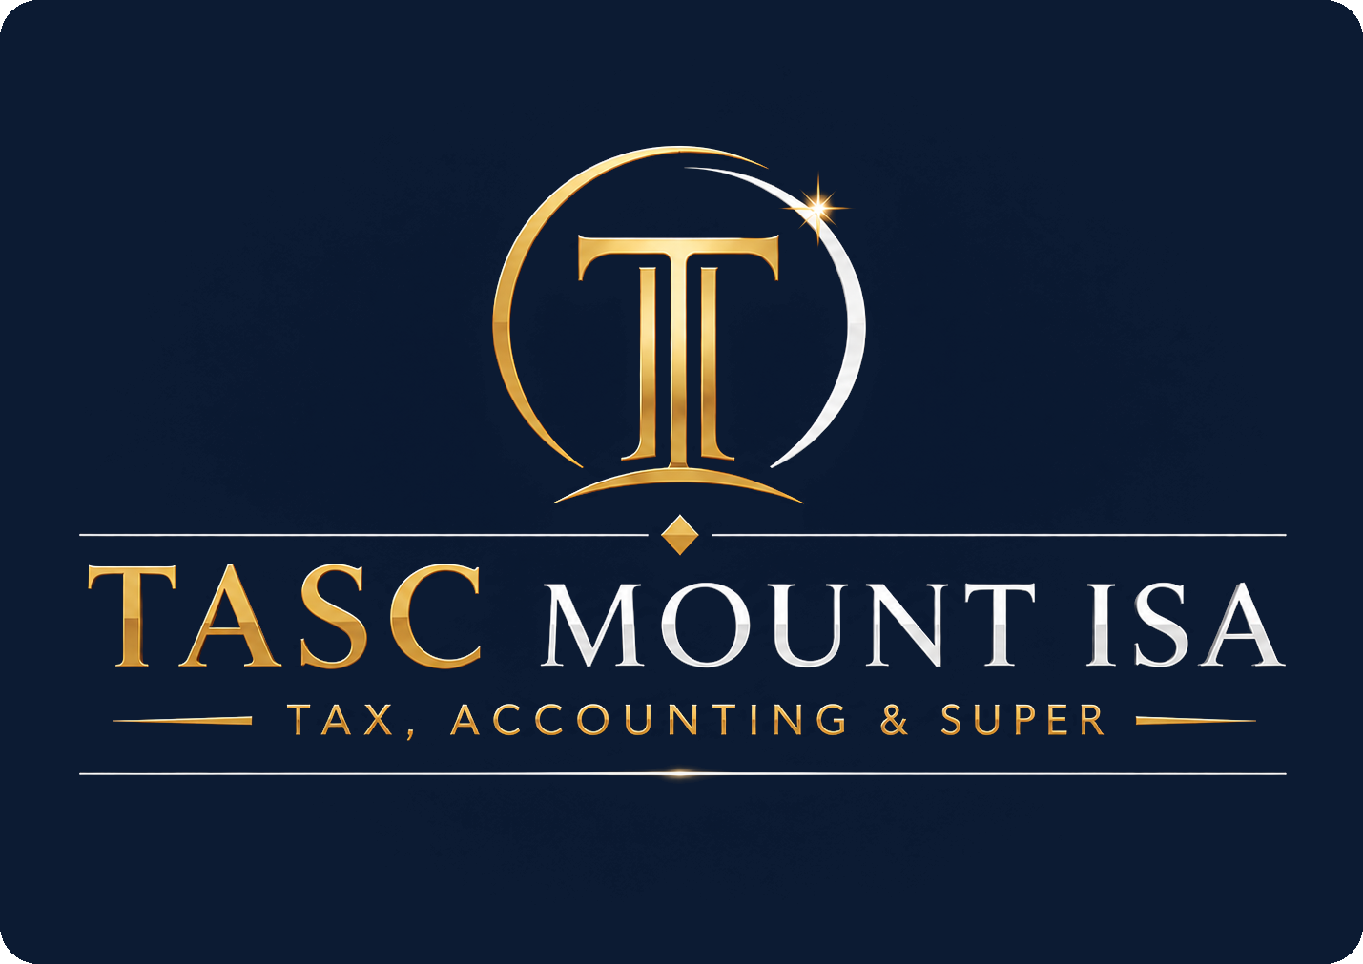
Primary lockup — stacked
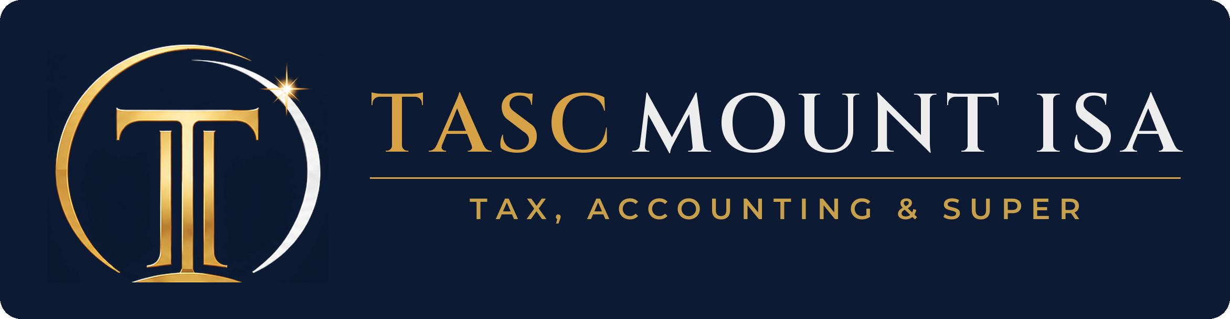  Horizontal lockup |   Emblem / app icon

Clear space & minimum size
- Keep clear space equal to the height of the monogram “T” on every side. Nothing — type, rules or imagery — may intrude.
- Minimum width: 30 mm in print / 150 px on screen for the full lockup; 12 mm / 60 px for the emblem alone.

Correct usage
- Always reverse the logo onto Primary Navy, Midnight, or a dark photographic ground with sufficient contrast.
- On unavoidable light backgrounds, use the navy “logo chip” (the lockup inside a rounded navy panel).
Avoid
- Don’t place the light wordmark on white or pale colours — the silver and white elements disappear.
- Don’t recolour, stretch, rotate, add shadows, or rebuild the mark in a different typeface.
- Don’t crop the emblem or separate the wordmark from its tagline rule in formal applications.

02 COLOUR
Navy and gold carry the brand. Navy dominates as the ground; gold is the accent for the mark, rules and key highlights. Platinum supplies the cool, premium counterpoint seen in “MOUNT ISA.” Use bronze gold for depth and for gold-coloured text on light backgrounds where the lighter golds would fail contrast.

Primary Navy
HEX #0C1B33 RGB 12 · 27 · 51 CMYK 77 · 47 · 0 · 80
Midnight (deep ground)
HEX #050B1A RGB 5 · 11 · 26 CMYK 81 · 58 · 0 · 90
Antique Gold (signature)
HEX #D7A245 RGB 215 · 162 · 69 CMYK 0 · 25 · 68 · 16
Champagne Gold (highlight)
HEX #FBCD68 RGB 251 · 205 · 104 CMYK 0 · 18 · 59 · 2
Bronze Gold (depth)
HEX #9B501D RGB 155 · 80 · 29 CMYK 0 · 48 · 81 · 39
Platinum
HEX #EDEDED RGB 237 · 237 · 237 CMYK 0 · 0 · 0 · 7

Print note: for foil or premium stock, specify a metallic gold (Pantone 871 C is a close match) and a deep navy such as Pantone 282 C / 2767 C. CMYK values above are process approximations — always proof on stock before a run.

03 TYPOGRAPHY
Cinzel — a classical, inscriptional serif — is the display face and echoes the wordmark. Montserrat handles body copy, labels and interface text. Where Cinzel and Montserrat aren’t installed (everyday Word, email, shared files), fall back to Georgia and Arial so documents stay consistent on any machine.

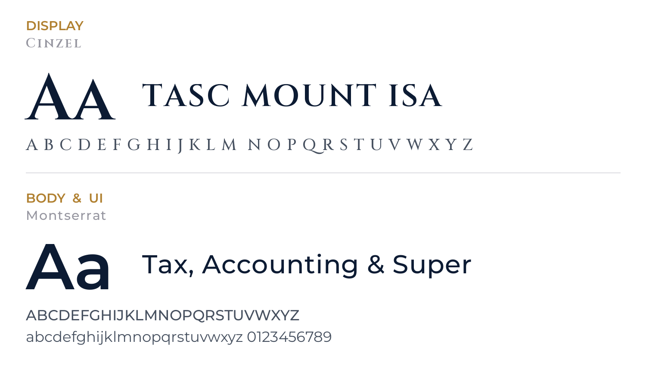

ROLE | BRAND FONT | EVERYDAY / OFFICE
Display / Headings | Cinzel — SemiBold, all caps | Georgia (or Times New Roman)
Body / UI / Tagline | Montserrat — Regular / Medium | Arial (or Calibri)
Fine print / Labels | Montserrat — Medium, tracked | Arial — 8–9pt, letter-spaced

04 VOICE & APPLICATIONS
Tagline
Tax, Accounting & Super — set in tracked capitals beneath the wordmark, or as a standalone descriptor. Keep the spacing generous; never abbreviate to “TAS.”
Tone of voice
- Assured and professional — the steady hand a regional client trusts with tax, books and super.
- Plain-spoken, not jargon-heavy. Explain, don’t lecture.
- Warm and local. TASC Mount Isa is part of the community it serves.
Applications
This suite ships with matching business cards, letterhead and an email signature, all drawn from the colours, type and logo rules above. Extend the same system to invoices, proposals, social profiles and signage — navy ground, gold accent, generous space.

05 PRACTICE DETAILS
The current, approved practice details for use across the website, stationery and all client-facing materials. Please replace any superseded details wherever they appear, and use these exact spellings and formats.

Practice name | TASC Mount Isa
Tagline | Tax, Accounting & Super
Phone | 07 4743 6342
Email | tasc@arnfin.net.au
Website | www.tascentre.com.au
Postal address | PO Box 929 Southport BC QLD 4215
ABN | 87 061 179 440
Registered Tax Agent No. (TPB) | [to be confirmed]

TASC MOUNT ISA
TAX · ACCOUNTING · SUPER

