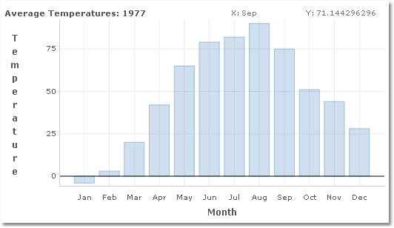
Chart Title
Cursor Position
Title Bar
Y Axis
X Axis
Y Axis Label
X Axis Label
Grid Lines
Ticks

