MDROUT=T2+T4·(LOAD+ADD)

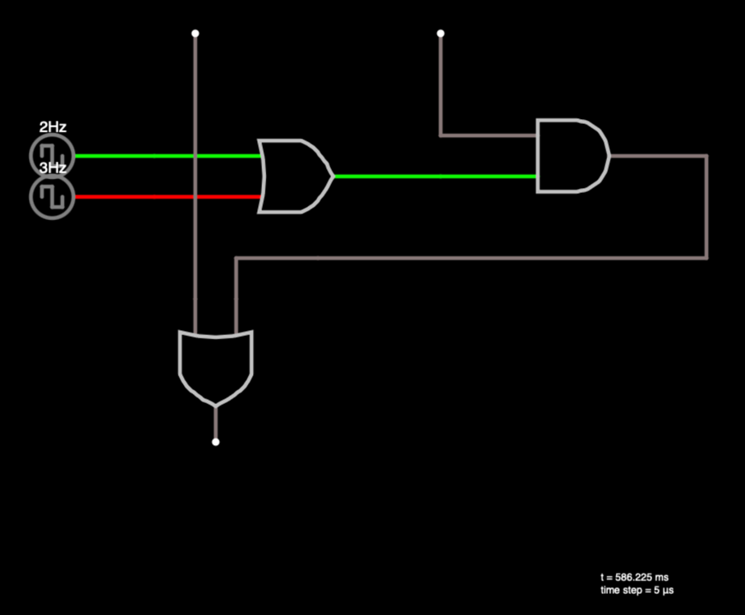

<http://scratch.trtos.com/circuitjs.html?cct=$+1+0.000005+10.20027730826997+50+5+43%0A152+48+144+272+144+0+2+5+5%0AR+48+128+-32+128+0+2+2+5+0+0+0.5%0AR+48+160+-32+160+0+2+3+5+0+0+0.5%0A150+272+128+480+128+0+2+0+5%0Aw+272+32+272+112+0%0Aw+80+32+80+240+0%0Aw+480+128+480+208+0%0Aw+176+208+480+208+0%0Aw+176+208+112+208+0%0Aw+112+208+112+240+0%0A152+96+240+96+352+0+2+0+5%0A>

R1IN=T4·LOAD+T6·ADD

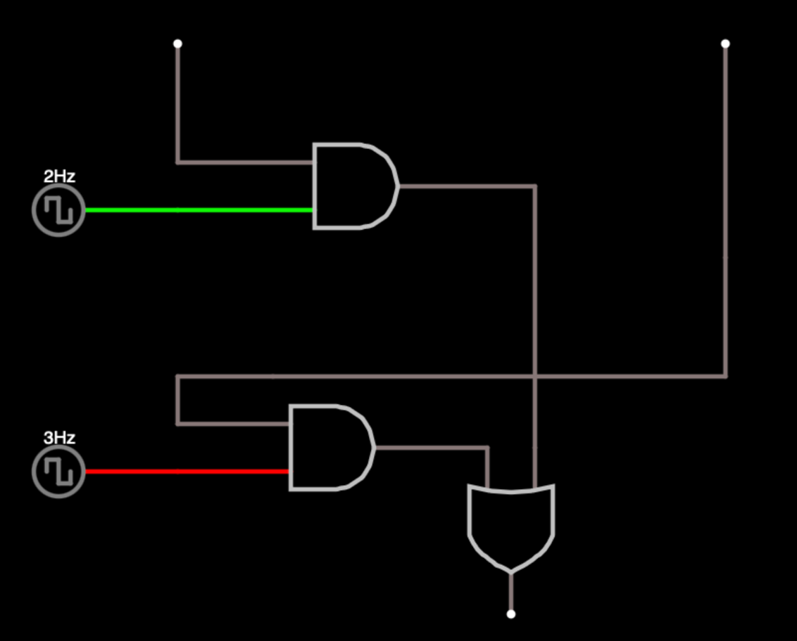

http://scratch.trtos.com/circuitjs.html?cct=$+1+0.000005+10.20027730826997+50+5+43%0AR+128+144+48+144+0+2+2+5+0+0+0.5%0A150+128+128+368+128+0+2+0+5%0Aw+128+32+128+112+0%0Aw+496+176+496+256+0%0Aw+192+256+496+256+0%0Aw+192+256+128+256+0%0Aw+128+256+128+288+0%0A152+352+304+352+416+0+2+0+5%0Aw+496+32+496+176+0%0A150+128+304+336+304+0+2+0+5%0AR+128+320+48+320+0+2+3+5+0+0+0.5%0Aw+368+128+368+304+0%0A