或门

<http://scratch.trtos.com/circuitjs.html?cct=$+1+0.000005+382.76258214399064+99+5+43%0Af+48+288+128+288+32+1.5+0.02%0Af+240+288+320+288+32+1.5+0.02%0Af+240+192+320+192+33+1.5+0.02%0Af+240+96+320+96+33+1.5+0.02%0AR+320+80+320+0+0+0+40+5+0+0+0.5%0Aw+320+208+320+240+0%0Aw+320+272+320+240+0%0Aw+128+272+128+240+0%0Aw+128+240+320+240+0%0Aw+240+192+240+288+0%0Aw+320+112+320+176+0%0Aw+320+240+416+240+0%0Aw+240+192+-16+192+0%0Aw+48+288+-16+288+0%0Aw+48+288+48+96+0%0Aw+48+96+240+96+0%0Ag+320+304+320+384+0%0Ag+128+304+128+384+0%0Af+464+288+528+288+32+1.5+0.02%0Af+464+192+528+192+33+1.5+0.02%0Aw+464+192+464+240+0%0Aw+464+240+464+288+0%0Aw+464+240+416+240+0%0AR+528+176+528+0+0+0+40+5+0+0+0.5%0Ag+528+304+528+384+0%0Aw+528+208+528+240+0%0Aw+528+240+528+272+0%0Aw+528+240+672+240+0%0A>

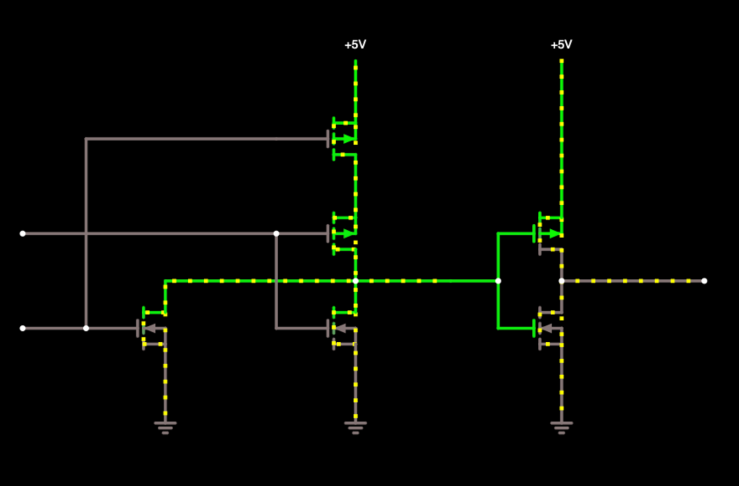

D Latch

<http://scratch.trtos.com/circuitjs.html?cct=$+1+0.000005+382.76258214399064+99+5+43%0AR+48+272+-16+272+0+2+3+5+0+0+0.5%0AR+48+64+-16+64+0+2+2+5+0+0+0.5%0Aw+848+80+896+80+0%0Aw+848+256+896+256+0%0Aw+512+96+848+256+0%0Aw+848+80+512+240+0%0Aw+400+80+512+64+0%0Aw+400+256+512+272+0%0Aw+144+272+48+272+0%0Aw+96+64+48+64+0%0Aw+96+240+208+240+0%0Aw+96+64+96+240+0%0Aw+144+272+208+272+0%0Aw+144+96+144+272+0%0Aw+208+64+96+64+0%0AI+144+96+208+96+0+0.5+5%0AI+752+80+848+80+0+0.5+5%0AI+752+256+848+256+0+0.5+5%0A152+512+256+752+256+0+2+5+5%0A152+512+80+752+80+0+2+0+5%0A150+208+256+400+256+0+2+0+5%0A150+208+80+400+80+0+2+0+5%0A>

