**Week 1**

**练习题：**

1. 假设未来的某一天你去美国X州工作和生活。你在X州要交4%的个人收入给州政府，并根据下表向联邦政府上缴部分的个人收入，且联邦政府规定薪酬税为15.3%。请问：
   1. 假如你的税前年收入是3万美元，那么你的各类税费是多少？
   2. 考虑所有类型的税，你的平均税率是多少？边际税率是多少？
   3. 如果你的税前年收入是6万美元，那么你对a)和b)的回答将有何不同？
   4. 建议各位助教自由发挥，增加一问。

|  |  |
| --- | --- |
| **应纳税个人所得额** | **税率（%）** |
| 不超过9325美元 | 10 |
| 9326-37950美元 | 15 |
| 37951-91900美元 | 25 |
| 91901-191650美元 | 28 |
| 191651-416700美元 | 33 |
| 416701-418400美元 | 35 |
| 418401美元及以上 | 39.6 |

参考答案：

1. If you earn $30,000 a year, then you pay federal income taxes in two parts: 10% on the first $9,325 of income and 15% on the amount above $9,325. Thus, your federal income taxes are

($9,325*0.10) + ($20,675*0.15) = $932.50 + $3,101.25 = $4,033.75.

You also pay $30,000*0.153 = $4,590 in federal payroll taxes and $30,000*0.04 = $1,200 in state income taxes, for a total tax bill of $9,823.75.

1. Your average tax rate is $9,823.75/$30,000 = 0.327 = 32.7%.

Your marginal tax rate is 0.15 + 0.153 + 0.04 = 0.343 = 34.3%.

1. If you earn $60,000 a year, then you pay federal income taxes in three parts: 10% on the first $9,325 of income, 15% for additional income up to $37,950, and 25% for the remaining $22,050 of income. Thus, your federal income taxes are

($9,325*0.10) + ($28,625*0.15) + ($22,050*0.25)

= $932.50 + $4,293.75 + $5,512.50 = $10,738.75.

You also pay $60,000*0.153 = $9,180 in federal payroll taxes, and $60,000*0.04 = $2,400 in state income taxes. Your total tax bill is $22,318.75.

Your average tax rate is $22,318.75/$60,000 = 0.372 = 37.2%.

Your marginal tax rate is 0.25 + 0.153 + 0.04 = 0.443 = 44.3%.

1. 以下各种情况符合受益原则还是支付能力原则？为什么？
   1. 北京许多公园对游客收取门票。
   2. 北京征收房产税，并利用该税收收入资助小学和中学的建设。
   3. 建议各位助教自由发挥，增加一种情况。

参考答案：

1. The fact that visitors to many parks pay an entrance fee is an example of the benefits principle, because people are paying for the benefits they receive.
2. The fact that local property taxes support elementary and secondary schools is an example of the ability-to-pay principle, because you must pay more tax if you own more expensive property.
3. 假设海南打算提高公共教育的预算，并考虑以下四种不同的税收方式来支持这项计划：
   * 对食品征收销售税（或产品和服务税）
   * 对有学龄儿童的家庭额外收税
   * 对度假型住房征收房产税
   * 对珠宝征收销售税（或产品和服务税）

假设这些方式最终都会带来相同的税收收入。请依次与同学们讨论（必要时请一些同学回答）以下问题：

* 1. 请用受益原则分析这些征税方案。
  2. 请用横向公平原则分析这些征税方案。
  3. 它们更可能是累进、比例还是累退的？
  4. 你更倾向于建议海南政府采用哪种税？为什么？（以讨论为主）

参考答案：

1. Are these taxes related to the benefits received?

* The sales tax on food: This broad-based tax would be appropriate if citizens, as a whole receive benefits from education. To the extent that education provides positive externalities, this tax could be justified on the benefits principle.
* The tax on families with school-age children: This tax burden would be borne mainly by those who have the highest benefits. Note that, the exceptions would be families who choose private schools or home schooling; these households would pay the taxes but not receive the benefits.
* The property tax on vacation homes: This is probably the worst from a benefits perspective. Many vacation homeowners may be from other provinces outside Hainan and receive minimal, if any, benefits from supporting education.
* A tax on jewelry: This is also weak from the benefits perspective. There is little reason to think jewelry buyers would disproportionately benefit from better public education.

1. Are taxes the same for households earning the same income? None of these taxes is horizontally equitable. They fall disproportionately on households who buy more food, have school-age children, own vacation homes, and buy jewelry. The food tax might be the best from this perspective.
2. This question is about vertical equity.
   * The sales tax on food: Regressive—lower income households spend a larger portion of their income on food.
   * The tax on families with school-age children: Regressive—lump-sum taxes have a bigger percentage impact on low incomes.
   * The property tax on vacation homes: Progressive—higher income households are more likely to own vacation homes, and to own more expensive vacation properties.
   * A tax on jewelry: Progressive—higher income households will typically buy more expensive jewelry.
3. No single tax satisfies all equity concerns. If market distortions are also considered, the decision becomes more complex. This question can generate good discussion about the trade-offs between different taxes. Many times, students will volunteer additional tax options—income taxes are a common suggestion.

**如果还有时间，可以讲课件中“北大老师个税”的题或如下附加题：**

如何看待部分经济学家取消对食品和衣物征收消费税（或产品和服务税）的建议？

参考答案（注意这三个要点）：

* Excluding food and clothing from the sales tax is justified on equity grounds because poor people spend a greater proportion of their income on those items. By exempting them from taxation, the system makes the rich bear a greater burden of taxation than the poor.
* From the point of view of efficiency, however, excluding food and clothing from the sales tax is inefficient, because the incentives to purchase food and clothing rather than other items are likely affected by this tax exemption. This leads to an inefficient allocation of resources.
* Nevertheless, because the demand for food and clothing is likely to be relatively inelastic, the deadweight loss from a tax on these goods would be relatively small (when compared with a tax on a good whose demand is relatively elastic).

Week 2

**练习题：**

1. 假设我们将目前中国的经济系统替换为一个所有人的工资都相同的体系——每个人都获得GDP/N，这里GDP是国内生产总值，N是人口。
   1. 你个人是否会倾向于生活在这样一个经济系统？为什么？
   2. 这样一个系统里可能会存在什么问题？
   3. 可以通过哪些机制克服这些问题？
   4. 谁是这样一个经济系统的受益者？
   5. 在这样一个经济系统中，什么样的工作缺少应聘者？

参考答案：

1. 大部分学生可能会反对这样一个完全平等主义的收入分布。有的学生可能会认为他们能在这个系统中获取更多收入，但其他同学可能会想到这个系统中的诸多问题——这个系统根本无法运转！还有的同学会提出平均主义是共产主义者的宣言——然而，平均主义不能代表共产主义，助教可以对此进行更深入的辨析。
2. Numerous problems exist, which can lead national income to fall if the incentives to work are changed drastically. More specifically:
   1. People may not work at all. Others may put forth less work effort.
   2. Unpleasant jobs are unlikely to be completed. Everyone would want a fun job.
   3. New inventions and technological advance could be hindered.
   4. Saving and investment and investment rates would be low.
   5. Education would become unimportant.
   6. Immigration rates could increase——助教可以与同学们讨论：到底是向外还是向内迁移（同学们可能观点不一，但只要言之成理即可）
3. 一些对策：
   1. Income could still be denied to people who did not work, and workers could still be fired for inadequate effort.
   2. Households could be required to participate in the labor force. Unpleasant jobs could be modified to improve safety, sanitation, or difficulty. Shorter hours could be assigned to those performing the least desirable work.

In short, a complete set of alternative incentives would have to be developed. These incentives become increasingly complex as more and more aspects of the price system are replaced——助教可以与同学们展开讨论激励机制

1. 当这一经济系统还没崩塌时，或通过引入新的激励机制去修正各种问题后，可能超过50%的人会收益，因为我国居民人均可支配收入中位数小于均值。具体是多少可以在国家统计局网站（人民生活部分）找到。这些收入在均值以下的人包括愚钝、懒惰的人，也包括不幸（如被歧视）的人。
2. 学生们可能会出现两个派别。一个派别认为，不被人们喜欢的工作往往是卑微的、机械的、不安全的、不干净的。常见的例子有：屠宰场、垃圾处理、生产线工人。另一个派别认为，专业性很高的工作是人们更不愿意做的，如医生、律师以及经理等等。在与同学们讨论的过程中，助教可以联系课堂上讨论的补偿性工资差别。
3. 当前，很多北大同学会选择在暑假实习，有的同学甚至在刚过去的这个寒假里就已经做了两份实习。然而，很多实习工作给同学们支付的报酬很少甚至没有。
   1. 做实习的机会成本是什么？
   2. 为什么同学们会愿意做这样的实习？
   3. 比较暑期参加无薪实习的同学以及打零工赚钱的同学，你认为他们未来的收入会有什么区别？

参考答案：

1. The opportunity cost of taking a job as a summer intern that pays little or nothing is the wage that the student could earn at an alternative job.
2. Despite the low wages, students are willing to take internships because an internship might help them land a permanent job with the firm or the government later. Also, the internship enhances the student's resume. Finally, the student may gain valuable on-the-job training.
3. You might expect that students who were interns earn higher incomes later in life，当然万事无绝对——助教可以与同学们讨论平均和异常值情况，以及为什么即使存在异常值，我们仍然考虑平均情况（这里可以联系“统计性歧视”：若没有实习经历，可能被歧视）。
4. 在过去的四十年中，中国最富有10%的收入发生了什么变化？为什么？

参考答案：

1. 该题的目的是让同学们熟悉宏观数据查找、收集和处理的过程，助教可以在习题课上演示如何访问相应网站和查找数据。
2. 首先，国家统计局只有五分位衡量，并且只有2013-2021年的数据（2014年全国层面不全）。不过，我们依然可以根据有限的数据（五分位的人均可支配年收入）去看一下过去10年的趋势：

|  |  |  |  |  |  |  |  |  |  |
| --- | --- | --- | --- | --- | --- | --- | --- | --- | --- |
| 指标\年份 | 2021 | 2020 | 2019 | 2018 | 2017 | 2016 | 2015 | 2014 | 2013 |
| Bottom 20% | 8333 | 7869 | 7380 | 6440 | 5958 | 5529 | 5221 | 4747 | 4402 |
| Second 20% | 18445 | 16443 | 15777 | 14361 | 13843 | 12899 | 11894 | 10887 | 9654 |
| Third 20% | 29053 | 26249 | 25035 | 23189 | 22495 | 20924 | 19320 | -- | 15698 |
| Fourth 20% | 44949 | 41172 | 39230 | 36471 | 34547 | 31990 | 29438 | 26937 | 24361 |
| Top 20% | 85836 | 80294 | 76401 | 70640 | 64934 | 59259 | 54544 | -- | 47457 |
| 最高20%总收入占比  （需要我们计算） | 46.0% | 46.7% | 46.6% | 46.8% | 45.8% | 45.4% | 45.3% | -- | 46.7% |

可以看出，过去10年最富有20%的收入份额一直维持在高位。

1. 其次，根据WID的估计，过去10年最富有10%的收入份额确实一直维持在高位，但1980-2010年这30年间，最富有10%的收入份额经历了高速增长。

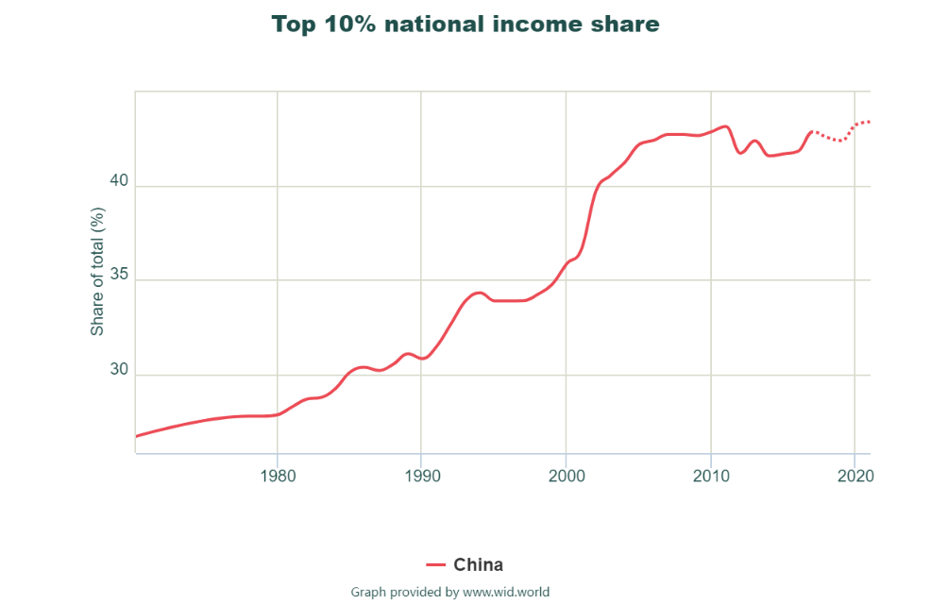

（请助教展示上面这幅图如何在网页上生成）

1. 为什么中国的财富逐渐集中在少数人手上呢？可以从以下几个方面引导同学们讨论：1）改革开放以来，随着经济的发展，中国允许超级明星存在的市场日益增多，而超级明星往往获得天文数字般的收入，因而提高了最富有10%的收入份额；2）2010年以前，腐败问题相对严重，使得财富流向少数人（不仅是官员，更是行贿者——这里可以说明一下我国财富统计存在问题，灰色收入可能缺少可靠数据，从而低估了高收入人的实际收入），这也可能导致最富有10%的收入份额不断提高；3）根据《21世纪资本论》的观点，由于资本收益率高于经济增长率（中国可能缺少可靠的数据证实这个说法），即r>g，拥有更高资本占比的富人的收入增长会快于穷人，从而进一步推动贫富分化。

**如果还有时间，可以考虑如下附加题：**

1. 假设一个经济体里只有10人。请从绝对贫困（即一般意义上的贫困）、相对贫困（即不平等）和政治哲学的角度，对以下4种不同的年收入的分配方式进行比较和点评：
   1. 5人收入10万，5人收入2万
   2. 5人收入25万，5人收入2.5万
   3. 9人收入6万，1人收入2万
   4. 10人收入5万

参考答案和讨论要点：

1. Distribution b) probably has the most unequal income distribution. In b), the rich have nearly ten times the income of the poor, while in a) the rich have only five times the income of the poor, and in c) the rich have three times the income of the only poor. However, the problem of poverty is likely to be slightly worse in a), since the poor have lower income and the rich are likely to pay less in taxes than the rich in b).
2. 自由主义代表人物罗尔斯可能最偏好d)，然后到b)，因为最大最小原则指出应该最大限度改善经济体中状况最糟的人的情况。
3. Most people will prefer the income distribution of b) to that of a), since both rich and poor families are better off than their counterparts in a), even though inequality is greater.
4. 从总收入的角度看，或许有人认为b)也比d)和c)要更好。
5. 功利主义在a)和b)之间的权衡取舍取决于人们的效用有多大程度受不平等的影响：如果人们很在乎不平等，那么b)总收入的上升带来的效用上升不能够抵消其不平等带来的效用下降，从而a)的总效用可能更高；如果人们不那么在乎不平等，那么或许功利主义的边沁也会站在b)这一边。
6. 自由至上主义的诺奇克would not find either more equitable. He would think the most equitable distribution is the one in which people got what they deserved. If the rules of the game are fair, any distribution is quite acceptable.

Week 3

**练习题：**

1. 国家统计局公布的2021年全国居民五等份收入分组如下表所示：

|  |  |
| --- | --- |
| 收入阶层 | 人均可支配年收入（元） |
| 低收入组 | 8333 |
| 中间偏下收入组 | 18445 |
| 中间收入组 | 29053 |
| 中间偏上收入组 | 44949 |
| 高收入组 | 85836 |

* 1. 请基于该表，采用“中点法”绘制洛伦兹曲线（请使用Matlab、Python、R和Stata分别展示）。
  2. 基于洛伦兹曲线计算基尼系数，并与官方数据进行比较。解释异同。

参考答案：

1. 首先，制作下表：

|  |  |  |  |
| --- | --- | --- | --- |
| 收入份额 | 收入份额中点 | 人口累积份额 | 收入累积份额 |
| 0 | 0 | 0 | 0 |
| 0.044653 | 0.02232660 | 0.1 | 0.02232660 |
| 0.098839 | 0.04941966 | 0.3 | 0.09407286 |
| 0.155683 | 0.07784166 | 0.5 | 0.22133418 |
| 0.240864 | 0.12043180 | 0.7 | 0.41960764 |
| 0.459961 | 0.22998028 | 0.9 | 0.77001972 |
| 0 | 0 | 1 | 1 |

第一列是根据人均可支配年收入计算的：因为每组人数相同，所以收入份额就是各组收入均值占均值之和的比例。注意，这里虚构了0%收入组和100%收入组，目的是使得洛伦兹曲线从原点出发，并与45度线相交于(1, 1)这一点。第二列就是收入份额的1/2（假设每组人口累积份额中点的实际收入累积份额是该组收入份额的1/2），为计算新的人口累积份额做准备。第三列是各个收入组的人口占比中点。第四列是收入累积份额，即前面完整的组的收入份额之和加上当前组收入份额的1/2。

有了上表以后，就可以绘制连线散点图：

1. 基于上图，我们实际上就是要先计算若干梯形的面积之和，得到洛伦兹曲线下方的面积。

|  |  |  |  |
| --- | --- | --- | --- |
| 人口累积比例 | 收入累积比例 | 此前梯形的高 | 此前梯形面积 |
| 0 | 0 |  |  |
| 0.1 | 0.02232660 | 0.1 | 0.0011163 |
| 0.3 | 0.09407286 | 0.2 | 0.0116399 |
| 0.5 | 0.22133418 | 0.2 | 0.0315407 |
| 0.7 | 0.41960764 | 0.2 | 0.0640942 |
| 0.9 | 0.77001972 | 0.2 | 0.1189627 |
| 1 | 1 | 0.1 | 0.0885010 |
| **求和** | | | **0.3158549** |

基尼系数 = (0.5-0.3158549)/0.5 = 0.368，远低于官方数字0.468。原因可能是官方数据采用更多的分组，而我们使用的分组太少。收入分布往往是正偏（positively skewed）的，也就均值高于中位数，更高于众数。那么，每个组收入累积份额的“线性中点”就都高于人口累积份额中点的实际收入累积份额，从而造成对洛伦兹曲线下方面积的高估，进而造成对基尼系数的低估。如果我们假设每个组人口累积份额中点的实际收入累积份额不是该组收入份额的1/2，而是1/3，那么收入累积比例就会下降：

|  |  |  |  |
| --- | --- | --- | --- |
| 收入比例 | 收入比例1/3 | 人口累积比例 | 收入累积比例 |
| 0 | 0 | 0 | 0 |
| 0.044653 | 0.01488440 | 0.1 | 0.02232660 |
| 0.098839 | 0.03294644 | 0.3 | 0.07759963 |
| 0.155683 | 0.05189444 | 0.5 | 0.19538696 |
| 0.240864 | 0.08028786 | 0.7 | 0.37946371 |
| 0.459961 | 0.15332019 | 0.9 | 0.69335963 |
| 0 | 0 | 1 | 1 |

|  |  |  |  |
| --- | --- | --- | --- |
| 人口累积比例 | 收入累积比例 | 此前梯形的高 | 此前梯形面积 |
| 0 | 0 |  |  |
| 0.1 | 0.02232660 | 0.1 | 0.0011163 |
| 0.3 | 0.07759963 | 0.2 | 0.0099926 |
| 0.5 | 0.19538696 | 0.2 | 0.0272987 |
| 0.7 | 0.37946371 | 0.2 | 0.0574851 |
| 0.9 | 0.69335963 | 0.2 | 0.1072823 |
| 1 | 1 | 0.1 | 0.0846680 |
| **求和** | | | **0.2878430** |

基尼系数 = (0.5-0.2878430)/0.5 = 0.424，略低于官方数字0.468。看来，即使假设1/3也保守了。可能在高收入组中，人口中点的实际收入份额要比1/3再小一些。这也体现出我们课上讲的最高20%收入组的财富主要集中在最高5%甚至1%。

1. 下面各个情况分别是支出法GDP的哪个组成部分（如果是的话）？分别有何影响？请解释。
   1. Uncle Fester buys a new refrigerator from a domestic manufacturer.
   2. Aunt Dolly hires a local contractor to build her a new house.
   3. The Huang family buys an old Victorian house from the Ellis family in Shanghai.
   4. You pay a hairdresser for a haircut.
   5. NIO sells an ES8 from its inventory to the Martinez family.
   6. NIO manufactures an ET5 and sells it to CAR, a Chinese car rental company in Beijing.
   7. Your parents buy a bottle of French wine.
   8. GWM (Great Wall Motor) expands its factory in Shandong.
   9. Hainan hires workers to repave a highway.

参考答案：

1. **Consumption (C) increases** as a refrigerator is a good purchased by a household.
2. **Investment (I) increases** because a house is an investment good.
3. **GDP is not affected** because nothing new is produced.
4. **Consumption (C) increases** since a haircut is a service purchased by a household.
5. **Consumption (C) increases** because a car is a good purchased by a household, but **investment (I) decreases** because the car in Ford’s inventory had been counted as an investment good until it was sold.
6. **Investment (I)** increases as a car is an investment good to the car rental company.
7. **Consumption (C) increases** because the bottle is a good purchased by a household, but **net exports (NX) decrease** because the bottle was **imported (M)**.
8. **Investment (I)** increases because new structures and equipment were built.
9. **Government purchases (G) increase** because the government spent money to provide a good to the public.
10. 下表是来自美国经济的数据：

|  |  |  |
| --- | --- | --- |
| **年份** | **名义GDP（单位：十亿）** | **GDP平减指数（基期：2012）** |
| 2018 | $20,501 | 110.4 |
| 1998 | $9,063 | 75.3 |

* 1. 名义GDP在1998-2018年的年化增长率是多少？
  2. GDP平减指数在1998-2018年的年化增长率是多少？
  3. 用2012年的价格，1998年的真实GDP是多少？
  4. 用2012年的价格，2018年的真实GDP是多少？
  5. 基于c)和d)，真实GDP在1998-2018年的年化增长率是多少？
  6. 是真实GDP还是名义GDP的年化增长率更高？为什么？

提示：对于某个变量在年内的“年化增长率”（annualized growth rate），我们通常用公式：计算。注意，到过去了年，但有年的数据。

参考答案：

1. The annualized growth rate of nominal GDP = 100*[($20,501/$9,063)0.05 - 1] = 4.2%
2. The annualized growth rate of the deflator = 100*[(110.4/75.3)0.05 - 1] = 1.9%
3. Real GDP in 1998 (in 2012 prices) is $9,063/(75.3/100) = $12035.86 billion
4. Real GDP in 2018 (in 2012 prices) is $20,501/(108.3/100) = $18,929.82 billion
5. The annualized growth rate of real GDP = 100*[($18,929.82/$12,035.86)0.05 - 1] = 2.3%
6. The annualized growth rate of nominal GDP was higher than the annualized growth rate of real GDP because of inflation
7. 一个小人国崇拜中国好声音这档节目。他们只生产和消费两种商品：

|  |  |  |  |  |
| --- | --- | --- | --- | --- |
|  | 卡拉OK机 | | 激光唱片 | |
| 价格 | 数量 | 价格 | 数量 |
| 2020年 | $40 | 10 | $10 | 30 |
| 2021年 | $60 | 12 | $12 | 50 |

* 1. 利用CPI的方法，以2020年为基期，并将商品篮子固定为1个卡拉OK机加上3个激光唱片，计算物价的变化比例。
  2. 利用GDP平减指数的办法，以2020年为基期，计算物价的变化比例。
  3. 两种方法计算出的变化比例相同吗？为什么？

参考答案：

1. The cost of the market basket in 2020 is (1 × $40) + (3 × $10) = $70.

The cost of the market basket in 2021 is (1 × $60) + (3 × $12) = $96.

Using 2020 as the base year, we can compute the CPI in each year:

2020: $70/$70 × 100 = 100

2021: $96/$70 × 100 = 137.14

We can use the CPI to compute the inflation rate for 2021:

(137.14 – 100)/100 × 100 = 37.14%

1. Nominal GDP for 2020 = (10 × $40) + (30 × $10) = $400 + $300 = $700.

Nominal GDP for 2021 = (12 × $60) + (50 × $12) = $720 + $600 = $1,320.

Real GDP for 2020 = (10 × $40) + (30 × $10) = $400 + $300 = $700.

Real GDP for 2021 = (12 × $40) + (50 × $10) = $480 + $500 = $980.

The GDP deflator for 2020 = ($700/$700) × 100 = 100.

The GDP deflator for 2021 = ($1,320/$980) × 100 = 134.69.

The rate of inflation for 2021 = (134.69 – 100)/100 × 100 = 34.69%.

1. No, it is not the same. The rate of inflation calculated by the CPI holds the basket of goods and services constant, while the GDP deflator allows it to change and holds the prices constant.

**如果还有时间，可以考虑如下附加题：**

1. 社保福利一般会随着CPI等比例增长，但经济学家们认为CPI高估了实际的通胀率。
   1. 如果老人们消费的商品篮子与其他人无异，这样的社保提高老人每年的福利了吗？请解释。
   2. 事实上，老人们消费的医疗服务比年轻人多，而医疗成本的上升往往比其它商品的物价上涨要快。这样一来，老年人每年的福利都在提升吗？

参考答案：

1. If the elderly consume the same market basket as other people, Social Security would provide the elderly with an improvement in their standard of living each year because the CPI overstates inflation and Social Security payments are tied to the CPI.
2. Because the elderly consume more health care than younger people do, and because health care costs have risen faster than overall inflation, it is possible that the elderly are worse off. To investigate this, you would need to put together a market basket for the elderly, which would have a higher weight on health care. You would then compare the rise in the cost of the "elderly" basket with that of the general basket for CPI.
3. 建国后，我国妇女劳动力的参与率不断上升。
   1. 你认为这如何影响我国GDP？
   2. 现在，假设我们衡量人们的福利时考虑做家务和休息的时间，你认为该福利指标的变化和GDP的变化有什么差异？
   3. 请试着讨论女性劳动参与率提高对其它方面福利的影响。构建一个包含这些方面的指标现实（可行）吗？

参考答案：

1. The increased labor-force participation of women has increased GDP in China, because it means more people are working and production has increased.
2. If our measure of well-being included time spent working in the home and taking leisure, it would not rise as much as GDP, because the rise in women’s labor-force participation has reduced time spent work ing in the home and taking leisure.
3. Other aspects of well-being that are associated with the rise in women’s increased labor-force participation include increased self-esteem and prestige for women in the workforce, especially at managerial levels, but decreased quality time spent with children, whose parents have less time to spend with them. Such aspects would be quite difficult to measure.

Week 4

**练习题：**

1. 国家A和B的生产函数都是。
   1. 请问，这个生产函数规模报酬不变吗？请解释。
   2. 每个工人的生产函数是什么？
   3. 假设两个国家都没有人口增长或技术进步。国家A每年存10%的产出，而国家B每年存30%的产出。使用你在b问的回答，让投资等于折旧，找到稳态均衡水平的资本密度、人均收入和人均消费。
   4. 假设两个国家初始状态（）时的资本密度是1，那么，人均收入和人均消费是多少？
   5. 资本存量的变化量是投资减去折旧。你可以用Excel来展示资本存量在两个国家会如何随时间变化吗？请在每一年展示人均收入和人均消费。多少年后，国家B的消费会高于国家A的消费？

参考答案：

1. A production function has constant returns to scale if increasing all factors of production by an equal percentage causes output to increase by the same percentage—for example, if the factors of production are doubled, then output also doubles. Mathematically, a production function has constant returns to scale if zY = F(zK, zL) for any positive number z. The production function Y = F(K, L) = K1/3L2/3 has constant returns to scale because

F(zK, zL) = (zK)1/3(zL)2/3 = zK1/3L2/3 = zY.

1. To find the per-worker production function, we divide Y = F(K, L) = K1/3L2/3 by L:

.

Since the production function has constant returns to scale,

.

If we define y = Y/L, k = K/L, and f(k) = F(k, 1), then the per-worker production function can be expressed as

y = f(k) = k1/3.

1. The steady-state condition on capital per worker is sf(k) = δk. Here f(k) = k1/3. We can plug this into the steady-state condition and solve for k:

（注意，这里储蓄率s就是上课说的1-β；δ是折旧率；在课上我们假设投资等于人口增长率n并令折旧为δ=0，这里我们则假设投资等于折旧并令人口增长率n=0）

sk1/3 = δk,

k2/3 = s/δ,

k = (s/δ)3/2.

Here the depreciation rate is δ = 0.2 and the saving rate is sA = 0.1 for country A and sB = 0.3 for country B. The steady-state levels of capital per worker are

kA = (sA/δ)3/2 = (0.1/0.2)3/2 = 0.35,

kB = (sB/δ)3/2 = (0.3/0.2)3/2 = 1.84.

Since y = k1/3 = (s/δ)1/2, the steady-state levels of income are

yA = (sA/δ)1/2 = 0.351/2 = 0.59,

yB = (sB/δ)1/2 = 1.841/2 = 1.36.

Workers save fraction s of each unit of income, so consumption per worker is c = (1 – s)y. The steady-state levels of consumption per worker are

cA = (1 - sA)y = 0.9 × 0.59 = 0.53,

cB = (1 - sB)y = 0.7 × 1.36 = 0.95.

1. If capital per worker is 1 in both countries, income per worker and consumption per worker are

yA = yB = 1,

cA = 0.9,

cB = 0.7.

1. Using a spreadsheet, we obtain the following:

（上课的时候我已经展示过Excel的做法，这里可以让同学们回去自己练习，习题课上只要给同学们展示思路即可；类似的题目可能会出现在第二次作业或考试中，而且是用科学计算器就可以算的难度）

Country A:

|  |  |  |  |  |  |  |
| --- | --- | --- | --- | --- | --- | --- |
| Year | *k* | *y* = *k*1/3 | *c* = (1 – *s*A)*y* | *i* = *s*A*y* | δ*k* | Δ*k* = *i* - δ*k* |
| 0 | 1.00 | 1.00 | 0.90 | 0.10 | 0.20 | -0.10 |
| 1 | 0.90 | 0.97 | 0.87 | 0.10 | 0.18 | -0.08 |
| 2 | 0.82 | 0.93 | 0.84 | 0.09 | 0.16 | -0.07 |
| 3 | 0.75 | 0.91 | 0.82 | 0.09 | 0.15 | -0.06 |
| 4 | 0.69 | 0.88 | 0.79 | 0.09 | 0.14 | -0.05 |
| 5 | 0.64 | 0.86 | 0.78 | 0.09 | 0.13 | -0.04 |
| 6 | 0.60 | 0.84 | 0.76 | 0.08 | 0.12 | -0.04 |

Country B:

|  |  |  |  |  |  |  |
| --- | --- | --- | --- | --- | --- | --- |
| Year | *k* | *y* = *k*1/3 | *c* = (1 – *s*A)*y* | *i* = *s*A*y* | δ*k* | Δ*k* = *i* - δ*k* |
| 0 | 1.00 | 1.00 | 0.70 | 0.30 | 0.20 | 0.10 |
| 1 | 1.10 | 1.03 | 0.72 | 0.31 | 0.22 | 0.09 |
| 2 | 1.19 | 1.06 | 0.74 | 0.32 | 0.24 | 0.08 |
| 3 | 1.27 | 1.08 | 0.76 | 0.32 | 0.25 | 0.07 |
| 4 | 1.34 | 1.10 | 0.77 | 0.33 | 0.27 | 0.06 |
| 5 | 1.40 | 1.12 | 0.78 | 0.34 | 0.28 | 0.06 |
| 6 | 1.46 | 1.13 | 0.79 | 0.34 | 0.29 | 0.05 |

After five years (in year 5), consumption per worker is higher in country B (0.784) than in country A (0.775).

1. 1990年代和过去的20几年，亚洲国家（如中国和日本）对美国进行了可观的直接和证券投资。与此同时，许多美国人对这些投资感到不爽。
   1. 从什么角度看，这些投资让美国变得更好？
   2. 从什么角度看，美国人自己做出这些投资更好？

参考答案：

1. 美国受益于中国和日本的投资，因为它们让美国的资本存量更大了，从而对经济增长有促进作用。
2. 美国人自己做出这些投资，就能获得所有的资本回报，而无需与中国和日本分一杯羹。然而，资源是稀缺的，美国人自己做出这些投资就意味着需要从另外一个地方挪用资金，所以也未必能够更好。

**如果还有时间，可以考虑如下附加题（也可以留到第5周习题课）：**

1. 古典经济学家亚当·斯密曾说过：“Little else is requisite to carry a state to the highest degree of opulence from the lowest barbarism but **peace**, **easy taxes**, and a **tolerable administration of justice**: all the rest being brought about by the natural course of things.”请解释他所提到的三个条件如何促进经济增长。

参考答案：

* **Peace** would promote economic growth because it is an indication that property rights will be respected in the future. Armed conflict and the threat of a revolutionary government reduce domestic residents’ incentive to save, invest, and start new businesses. Moreover, foreigners have less incentive to invest in the country.
* **Easy taxes** would promote economic growth because they result in citizens and businesses retaining a greater share of the income they earn and, thus, being able to save and invest a greater portion of that income.
* **A tolerable administration of justice** would promote economic growth because it would ensure the maintenance of property rights, which encourages domestic saving and investment from abroad.

1. 国际产权指数IPRI（International Property Right Index）给每个国家的法律和政治环境以及它们保护产权的程度进行综合打分。
   1. 访问<https://www.internationalpropertyrightsindex.org/>（即Property Rights Alliance的官网），找到最新年度的排名，并选择分数最高的3个国家、分数最低的3个国家和中国（在中间的位置）。
   2. 请从世界银行找到这7个国家的人均GDP，进行比较。你发现了什么？请对你的发现给出至少2点解释。

参考答案：

1. 分数最高的3个国家：

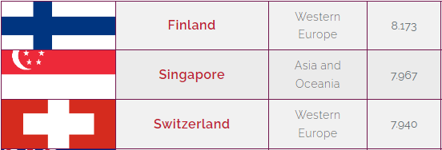

分数最低的3个国家：

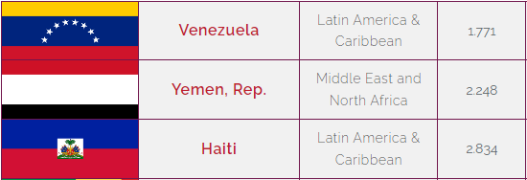

中国：

5.594分

1. 根据世界银行，这7个国家的人均GDP如下图所示：

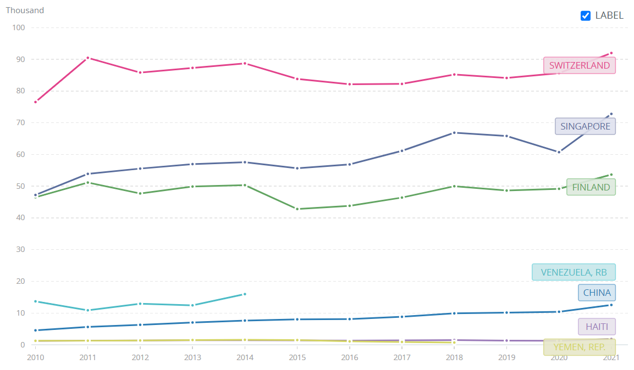

The pattern is quite clear. Countries with high IPRI scores tend to have high GDP per capita and countries with low IPRI scores tend to have low GDP per capita.

Explanations:

* Property rights allow people to exercise authority over the resources they own.
* With well-defined and enforced property rights, markets coordinate efficiently with prices.
* Also, domestic saving and investment from abroad are lower with poorly-defined or enforced property rights.

Week 5

**练习题：**

1. 某个国家的生产函数是。存在折旧率。外生的当期储蓄率为。的增长率是，人口增长率是。
   1. 稳态时，单位效率劳动的资本、产出和资本-产出比是什么？
   2. 假如我国的索罗余项是10%，，储蓄率是45%，人口在增长率是0%，折旧率是5%，你能估算出根据该模型的我国的资本-产出比吗？你觉得符合中国的事实吗？为什么？
   3. 假设该国家的经济达到了稳态下的平衡增长路径。什么因素会影响这些变量的增长率：单位效率劳动的产出、单位效率劳动的资本、人均产出、人均资本？
   4. 折旧率的下降如何影响均衡？直观是什么？请用图像模型阐释。

参考答案：

1. 稳态时，我们需要，这也就是储蓄曲线和OS线的交点。可以得到

，

，

。

1. 首先要计算，然后套用a中的结论

。

这里得到的资本系数与其他经济学家的估计相比偏低，可能是由于我们高估了（劳动增进型）技术进步的速度（或索罗余项），高估了，低估了储蓄率；也可能是模型的形式不正确导致的低估；还有可能中国并不在稳态状态下。学界普遍认为中国的资本系数在4左右。

1. 稳态状态下，单位效率劳动的产出和资本增长率为0，所以没有什么因素会影响它们。和的增长率等于技术进步率，所以受此影响。
2. 见下图：

、、、

O

折旧下降导致均衡的单位效率劳动的产出和资本上升，而人均产出和资本的增长率不变。直观很好理解，折旧下降说明损耗下降，储蓄转化为资本效率更高，单位效率劳动分得的资本也就更高，从而单位效率劳动的产出也更高。使用效率的提升与维持单位效率劳动的资本不变所需投资的下降相互抵消，故在稳态情况下，人均（或总）产出和资本的增长率不变。

1. 为了判断一个国家的经济是否有高于或低于黄金规则的资本，我们需要什么数据？

参考答案：

To determine whether an economy has more or less capital than in the Golden Rule steady state, we need to compare the marginal product of capital net of depreciation (*MPK* – *δ*) with the growth rate of total output (*n + g*)——注意这里*g*是技术进步率. If *MPK* – *δ* > *n + g*, then the economy has less capital than in the Golden Rule steady state; if *MPK* – *δ* < *n + g*, then the economy has more capital than in the Golden Rule steady state. The growth rates of population and real GDP per capita are readily available. Estimating the net marginal product of capital requires a little more work but can be backed out of available data on the capital stock relative to GDP, the total amount of depreciation relative to GDP, and capital’s share of income.

1. 制度差异如何解释各国人均收入的差别？举一个例子。

参考答案（不唯一，请发散）：

The legal system is an example of an institutional difference between countries that might explain differences in income per person. Countries that have adopted the English-style common law system tend to have better-developed capital markets, and this leads to more rapid growth through more efficient financing of investment projects. The quality of government is also important. Countries with more government corruption tend to have lower levels of income per person.

1. 内生增长理论如何在不假定外生技术进步的情况下解释经济持续的增长？这与索罗增长模型有什么不同？

参考答案：

第一，Endogenous growth theories attempt to explain the rate of technological progress by **modeling the decisions that determine the creation of knowledge** through research and development. This differs from the Solow model, which takes the rate of technological progress as given.

第二，In the Solow model, the saving rate affects growth temporarily, but diminishing returns to capital eventually force the economy to approach a steady state in which growth depends only on exogenous technological progress. By contrast, many endogenous growth models assume that there are **constant (rather than diminishing) returns to capital**, which can be interpreted as including both physical and human capital. Hence, changes in the saving rate can lead to sustained growth.

**如果还有时间，可以考虑如下附加题：**

5、选择两个你感兴趣的国家，一个富有、一个贫穷。这两个国家的人均收入是多少？找一些可能解释这个差异的国家层面的特征，比如投资率、人口增长率、教育程度等等。你如何判断哪个特征最能解释人均收入的差异？你认为索罗模型在分析这两个国家的差异时有多么有用？

参考答案：

On the World Bank website ([www.worldbank.org](http://www.worldbank.org)), you can browse data based on a wide variety of indicators related to economic growth and development. To explain differences in income per person across countries, you might look at gross saving as a percentage of GDP, gross capital formation as a percentage of GDP, the literacy rate, life expectancy, and the population growth rate. From the Solow model, we learned that, all else equal, a higher rate of saving, a lower population growth rate, a higher level of capital per worker, and more efficient or productive labor all lead to higher income per person. The selected data indicators offer explanations as to why one country might have a higher level of income per person. We can speculate about which factor is most responsible for the difference in income per person across countries, but it is not possible to say for certain given the large number of other variables that also affect income per person. For example, some countries may have more developed capital markets, less government corruption, and better legal systems. The Solow model allows us to understand some of the reasons income per person differs across countries, but such a simple model cannot explain all the reasons income per person may differ.

Week 6

**练习题：**

1. 假设一个消费者只能活两期，并在当期消费和末期消费之前做决策。假设该消费者只有末期有收入，利率是（折现率）。
   1. 请写出该消费者的预算约束。
   2. 的提升如何影响当期储蓄（负的借贷）？请尝试用无差异曲线模型解释最优消费组合的变化。
   3. 请改写AK模型，令，，证明。

参考答案：

1. 或。
2. 当提升时，相当于的价格（机会成本）变高了，因此，相对更便宜了，替代效益告诉我们要更多消费，但收入效应告诉我们要更少消费和。

由此，当期的消费下降，借贷也就下降，（负）储蓄上升。这说明，储蓄曲线（可贷资金供给曲线）是斜率为正的。

1. 不难得出新的欧拉方程

因此上升将导致相对于下降，因此期的储蓄提高。实际上，对于一个无法直接投资的消费者而言，视为回报率更为合理。

1. 下面的两两对比中，哪一个债券的利率会更高？为什么？
   1. 一个美国政府债券和一个东欧政府债券。
   2. 一个2020年支付票面价值的债券和一个2040年支付（同样）票面价值的债券。
   3. 一个可口可乐公司的债券和一个你停车房用的软件公司的债券。
   4. 一个国家财政部发行的债券和一个国家开发银行发行的债券。

参考答案：

1. The bond of an eastern European government would pay a higher interest rate than the bond of the U.S. government because there would be a greater risk of default.
2. A bond that repays the principal in 2040 would pay a higher interest rate than a bond that repays the principal in 2020 because it has a longer term to maturity, so there is more risk to the principal.
3. A bond from a software company you run in your garage would pay a higher interest rate than a bond from Coca-Cola because your software company has more credit risk.
4. 整体上看，国债和国开收益率差异的主要的原因是税收差异，但是实际影响两种债券利差的因素还有很多，比如流动性差异、息票效应等等。目前我国税法规定企业投资国债的利息收入免征企业所得税，但国开债没有相关规定。由于利息收入不免税，因此投资者投资国开势必较投资同期限国债要求更高回报。

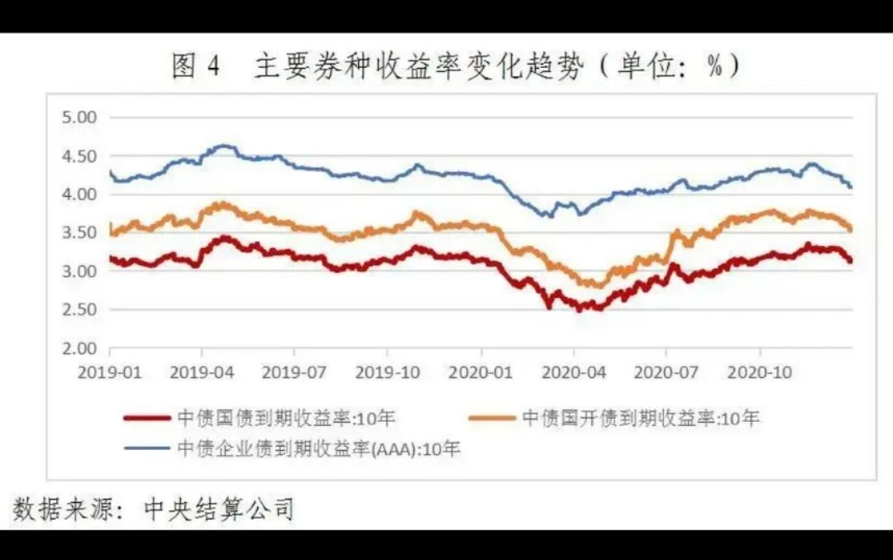

目前企业所得税的税率是25%。所以理论上两种债券的理论点差大约是25%。但实际上，两类债券的收益率差还会受到其他因素的影响，影响最大的或许是流动性差异。国开行自从2014年改变其发行方式之后，国开债的二级市场流动性出现了非常明显的好转，其1、3、5、7、10这五个关键期限的新发券（on-the-run bond）几乎是市场上流动性最好的品种，其中尤以10年期最具代表性。国开10是市场上当之无愧的“神券”，做市商对其的做市意愿以及该券的换手率都非常之高。这只券的收益率已经成为不少交易员对市场利率判断的风向标。在这种情况下，国开10这只券就会出现一定的流动性溢价，从而影响国债和国开债的相对点差。根据中债登公布的数据，国债和国开债在10年期的相对点差就只有13%，几乎将税收的影响抵消掉一半。

1. 在一个封闭国内，经济学家搜集到如下数据。

Y = 10,000

C = 6,000

T = 1,500

G = 1,700

经济学家还估计了投资函数：，其中是该国的真实利率，单位是%。请计算私人储蓄、公共储蓄、国内储蓄、投资和均衡的真实利率。

参考答案：

Private saving is equal to (Y - T - C) = 10,000 - 1,500 - 6,000 = 2,500.

Public saving is equal to (T - G) = 1,500 - 1,700 = -200.

National saving is equal to (Y - C - G) = 10,000 - 6,000- 1,700 = 2,300.

Investment is equal to national saving = 2,300.

The equilibrium interest rate is found by setting investment equal to 2,300 and solving for r:

3,300 - 100r = 2,300.

100r = 1,000.

r = 10%.

**如果还有时间，可以考虑如下附加题（也可以留到第7周习题课）：**

1. 政府可以通过减少私人储蓄的税收或减少预算赤字来提升投资水平。
   1. 请问，为什么同时实施这两类政策有困难？
   2. 为了判断哪一个政策可以更有效地提高投资，你需要知道什么？

参考答案：

1. Investment can be increased by reducing taxes on private saving or by reducing the government budget deficit. But reducing taxes on private saving has the effect of increasing the government budget deficit, unless some other taxes are increased or government spending is reduced. So it is difficult to engage in both policies at the same time.
2. To know which of these policies would be a more effective way to raise investment, you would need to know: (1) what the elasticity of private saving is with respect to the after-tax real interest rate, because that would determine how much private saving would increase if you reduced taxes on saving; (2) how private saving responds to changes in the government budget deficit, because the decline in the government budget deficit could be matched by an equal decline in private saving, so national saving would not increase at all; and (3) how elastic investment is with respect to the interest rate, because if investment is quite inelastic, neither policy will have much of an impact on investment.
3. 请通过回顾2007年中国股市的行情，解释为什么课件第29页中国国内上市公司股票市值突然超越日本并直逼美国和加拿大，并超过实体经济体量。

参考答案：

<https://zhuanlan.zhihu.com/p/347305364>

midterm之后

**练习题（如果上面的时间缩短了，则可以考虑给同学们做下面的练习题，否则将题目留到第10周）：**

1. 请解释下列每一种情况如何影响失业率和劳动参与率。
   1. 经过一个长时间的搜寻，Jon找到了工作。
   2. 一个全日制大学生Tyrion毕业了，并立马加入了某华尔街投行。
   3. 经历了一系列不成功的面试，Arya放弃了找工作，并在朋友圈宣告自己“退休”了。
   4. Daenerys辞职了，并成为了一位全职妈妈。
   5. Sansa刚过生日，成为了“成人”，但对工作毫无兴趣。
   6. Jaime刚过生日，成为了“成人”，并开始搜寻工作。
   7. Cersei在享受退休的时光中安详地离开了人世间。
   8. Jorah由于休息不足，不幸在工作岗位上突发心梗离世。

参考答案：

1. When Jon finds a job after a long search, the **unemployment rate decreases** and there is **no effect on the labor-force participation rate** because Jon was and continues to be part of the labor force and the adult population.
2. When Tyrion graduates and is immediately employed, the **unemployment rate decreases** because the labor force increases, and the **labor-force participation rate increases** because Tyrion was part of the adult population and is now part of the labor force.
3. When Arya gives up looking for a job, the **unemployment rate decreases** because Arya is no longer considered unemployed and has left the labor force and the **labor-force participation rate decreases**.
4. When Daenerys quits her job to be a stay-at-home mom, the **unemployment rate increases** because the labor force decreases, and the **labor-force participation rate decreases** because Daenerys is still part of the adult population but is no longer part of the labor force.
5. When Sansa becomes an adult but does not look for work, there is **no effect on the unemployment rate**. The **labor-force participation rate decreases** because Sansa is now part of the adult population but is not part of the labor force.
6. When Jaime becomes an adult and begins looking for work, the **unemployment rate increases** and the **labor-force participation rate increases** because the labor force and the adult population both increased by one.
7. When Cersei dies while enjoying retirement, there is **no effect on the unemployment rate**. The **labor-force participation rate increases** because the adult population decreases.
8. When Jorah dies working long hours at the office, the **unemployment rate increases** because the labor force decreases, and the **labor-force participation rate decreases** because the labor force and the adult population both decreased by one.
9. 下面这些工人更容易经历短时间失业还是长时间失业？为什么？
   1. 一个建筑工人因为当地恶劣天气被开除了。
   2. 一个制造业工人在一个闭塞的地区失去了工作。
   3. 一个驿站马车产业的工人因当地铁路的发展而被开除。
   4. 一个快餐师傅因为马路对面开了一家新的餐厅而被开除。
   5. 一个接受过较少正规教育但能熟练操作的焊接工人失去了工作，只因为公司采用了自动焊接机。

参考答案：

1. A construction worker who is laid off because of bad weather is likely to experience **short-term unemployment**, because the worker will be back to work as soon as the weather clears up.
2. A manufacturing worker who loses his job at a plant in an isolated area is likely to experience **long-term unemployment**, because there are probably few other employment opportunities in the area. He may need to move somewhere else to find a suitable job, which means he will be out of work for some time.
3. A worker in the stagecoach industry who was laid off because of the growth of railroads is likely to be **unemployed for a long time**. The worker will have a lot of trouble finding another job because his entire industry is shrinking. He will probably need to gain additional training or skills to get a job in a different industry.
4. A short-order cook who loses his job when a new restaurant opens is likely to find another job fairly quickly, perhaps even at the new restaurant, and thus will probably have only a **short spell of unemployment**.
5. An expert welder with little education who loses his job when the company installs automatic welding machinery is likely to be **without a job for a long time**, because he lacks the technological skills to keep up with the latest equipment. To remain in the welding industry, he may need to go back to school and learn the newest techniques.
6. 在一个经济体中有两个劳动力市场——制造业和服务业的劳动力市场。假设最开始没有工会。
   1. 如果制造业工人组成了一个工会，那么制造业的劳动力市场会发生什么变化？请从工资和就业人数的角度分析。
   2. 制造业这样的变化会如何影响服务业的劳动供给？服务业的劳动力市场又会发生什么变化？

参考答案：

1. The figure below illustrates the effects of a union being established in the manufacturing labor market. In the manufacturing labor market (figure on the left), the wage rises from the non-union wage, wNU, to the union wage, wU, and the quantity of labor demanded declines from the non-union quantity of labor, LNU, to the union quantity of labor demanded, LUD. Because the wage is higher, the quantity supplied of labor increases to the union quantity of labor supplied LUS, so there are (LUS - LUD) unemployed workers in the unionized manufacturing sector.
2. When those workers who become unemployed in the manufacturing sector seek employment in the service labor market, shown in the figure on the right, the supply of labor shifts to the right from S1 to S2. The result is a decline in the wage in the nonunionized service sector from w1 to w2 and an increase in employment in the nonunionized service sector from L1 to L2.

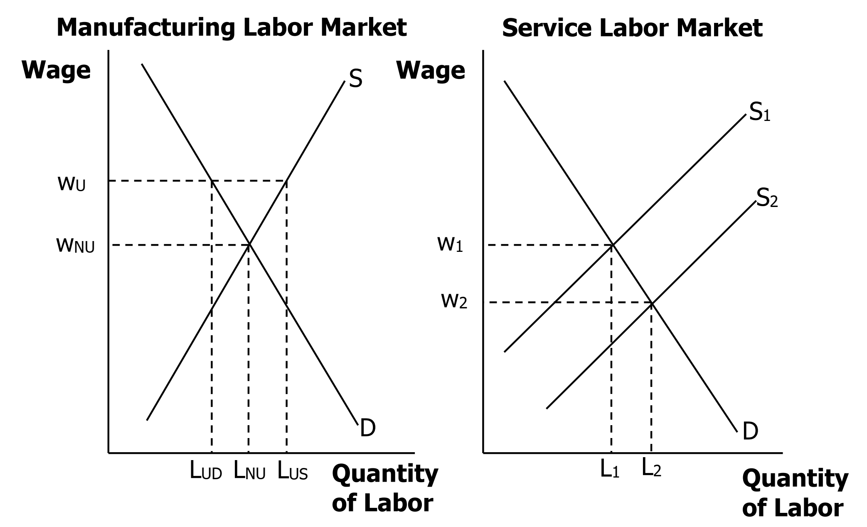

Week 10

**练习题（可以调整顺序）：**

1. 现代货币的三个主要的功能是价值贮藏、交易媒介和计量单位。下列物品能满足现代货币的哪些功能？不能满足现代货币的哪些功能？
   1. 信用卡
   2. 老王的画作
   3. A城地铁代用币

**参考答案：**

1. 信用卡可以作为交易媒介；但其是负的价值贮藏，因为使用它会增加债务；它不是计量单位，因为产品和服务的价格并不是以“多少个信用卡”来衡量的。
2. 老王的画作最多算是价值贮藏，也可能什么都不是，除非老王成为著名画家。
3. 在A城地铁系统内部，代用币满足所有三种功能；在A城地铁系统外部，它不是货币。
4. 请解释以下事件如何影响基础货币，货币乘数以及货币供给。
   1. 央行在公开操作中购买了债券
   2. 央行提高了其支付给持有准备金的银行的利率
   3. 央行通过定期拍卖工具TAF减少了给银行的贷款
   4. 有传言某种电脑病毒正在不断攻击ATM机器，人们因而从活期账户里提取了更多的现金在手中
   5. 央行开着直升飞机在中关村大街撒下一张张新打印的百元大钞

**参考答案：**

**复习：**，而。注意这里的货币供应量是在乘数效应发挥后的货币供应量，而准备金也是乘数效应发挥后的准备金，若记乘数效应发挥后的货币供应量为，其中为通货，为乘数效应发挥后的存款，则乘数效应发挥后的准备金就等于。注意课件里的定义为乘数效应发挥之前（第一个银行）的存款的变化量，因此乘数效应发挥后的存款变化量为（在没有漏损的情况下）。抛开课件中的表示方式，使用这里的表示方式，。货币供应量，其中，就是基础货币。

**接下来，让我们逐一回答问题：**

1. 当央行购买债券时，其用于支付公众的现金就增加了基础货币；若假设通货存款比不变，准备金率也不变，则货币乘数不改变，从而增加了货币供应量（等于货币乘数基础货币）；*若*假设通货存款比增加，则货币乘数下降，而货币供应量的增加没有那么多（甚至可能不增加）——*但是*，我们没有理由假设通货存款比增加，因为央行支付公众的现金可以以通货的形式存在，也可以以活期存款的形式存在。
2. 当央行给持有准备金的银行提供更高的利率时，银行就更愿意在央行存超额准备金，从而提高了基础货币（假设通货不变）；准备金率一般也会提高的，进而降低了货币乘数（若通货存款比不变）；货币供应量不变，因为在前面我们假设不变、不变，这就意味着也不变——基础货币的提升与货币乘数的下降对货币供应量的影响恰好抵消了。*当然，*我们也有理由假设存款下降而通货存款比不变，这样也会下降，这样货币乘数依然下降，但基础货币（）的变化是不确定的——可以肯定的是，基础货币的变化无法抵消货币乘数下降对货币供应量变化的负面影响，因为货币供应量下降了。
3. 基础货币（准备金）会下降；若假设通货存款比、准备金率都不变，则货币供给会下降，因为货币乘数不变。这里TAF的作用是控制央行向银行系统和经济中注水的程度。*当然*，如果假设准备金率下降，则货币供给的下降不会那么多（甚至不下降）。*但是*，我们没有理由假设准备金率发生变化，因为，银行可以通过减少存款来满足准备金率的要求。
4. 如果人们对ATM机器失去了信心，则上升，从而在准备金率不变的情况下，降低了货币乘数；由于人们提款的缘故，银行为了满足准备金率的要求，则只能减少贷款，这样货币供给量也会下降。基础货币会怎么变呢？上升，但下降（从而准备金下降），的变化取决于两者谁的变化更大一些。若在银行体系中的高能货币没有漏损，则下降1个单位就下降个单位，这样两者的变化就抵消了，从而基础货币不变。
5. 若央行撒钱，基础货币会因为通货的增加而增加；若民众捡到任何钱并存入银行，货币供给会进一步增加；若人们将捡到的钱更多地以通货的形式持有而不是存入银行，则上升，在准备金率不变的情况下，货币乘数下降。
6. 对于下面每一项交易，其最初对M1和M2的影响是什么？
   1. 小王卖了一些股票，并将收益存入定期储蓄账户中。
   2. 小李卖了一些股票，并将收益转入支付宝荷包。
   3. 在美国留学的小张将其美国银行中的钱从savings（储蓄）账户里转到了checking（支票）账户里。
   4. 小美在宿舍地毯下面找到了100元大钞，并将其存入农行的活期账户中。

**参考答案：**

1. 股票既不在M1中，也不在M2中，因而卖掉股票对M1和M2无影响；但是定期储蓄账户中的余额属于M2，将收益存入定期储蓄账户中增加了M2；M1不受影响，因为定期储蓄账户中的余额不包含M1中。
2. 支付宝荷包中的余额包含在M1中，自然也包含在M2中，因而M1和M2都增加了。
3. 现在savings和checking账户中的余额在美国都算作M1了，那么自然也都在M2中，在它们之间的转账既不影响M1也不影响M2。
4. 地毯下的100元大钞属于通货M0，自然包含在M1和M2中，而活期账户中的余额也包含在M1和M2中，在它们之间的转移对M1和M2都无影响。
5. 上课提到三种类型的货币：商品货币、商品支持货币和法币。请问下列例子分别属于哪种货币？
   1. 在殖民地时期的澳大利亚，一些产品和服务的费用可以用几瓶朗姆酒来结清。
   2. 在许多欧洲国家，盐可以作为交易媒介。
   3. 在一段短暂的时光中，德国用一种可以自由兑换黑麦的券作为纸币。
   4. 在纽约州的伊萨卡小镇，有一种叫“伊萨卡时间币”的货币可以在当地用于购买产品和服务。

**参考答案：**

1. 商品货币
2. 商品货币
3. 商品支持货币
4. 法币——其价值完全来源于它能用于支付伊萨卡当地产品和服务的功能，而非内在价值
5. 请对比中、美央行，并发现区别与联系。

**参考答案：**

<https://zhuanlan.zhihu.com/p/509195221>

<https://www.zhihu.com/question/26788422/answer/2788874864>

Week 12

**练习题（可以调整顺序）：**

1. 最近某新闻标题写道：“美国每年在和中国的贸易中损失5000亿美元”。这个数额会包含在美国国际收支平衡表“经常账户”的赤字中。你认为这个新闻标题是否存在对民众的误导？这些交易如何影响可贷资金市场？

**参考答案：**

首先，虽然美国与中国的确存在贸易逆差，但是贸易逆差不能说成是一个国家的“损失”。理由有两点：其一，作为交换，美国获得了中国的产品和服务；其二，“经常账户”和“资本和金融账户”（加上误差项后）的和为零——美国“经常账户”的赤字应该要被其“资本和金融账户”的盈余抵消。换句话说，当美国与中国存在贸易逆差时，中国通过购买美国的资产将额外的资本返还给美国。

其次，在可贷资金的供求模型图中，“资本和金融账户”的盈余将使可贷资金的供给曲线向右移动，从而导致利率下降。（可以在黑板上画图）

1. 在特朗普任职美国总统期间，他试图减少美国与中国的贸易逆差，因此他对中国的出口品施加了一系列新关税政策。在特朗普之前，美国对中国出口品的关税平均为3.1%，但到了2020年2月，美国对中国出口品的平均关税达到19.3%。与此同时，美元对人民币升职，汇率从6.27升到7.10（站在美国角度，这是第二种表达方式，即单位本国货币能兑换的外国货币量）。请试图用外汇市场解释关税如何影响美元的第二种汇率。理论与我们观察到的数据一致吗？

**参考答案：**

施加在中国出口品上的关税会使得美国消费者购买中国产品的价格提高，从而使美国消费者减少对这些产品（和服务）的购买。由于美国消费者减少对中国产品的购买，美国对人民币的需求会下降。如果我们用第二种汇率的表达方式，站在美国的角度：

第二种名义汇率

（单位：人民币/美元）

人民币数量

（百亿元）

可以看出，人民币对美元会贬值，这就意味着美元对人民币升值，该理论与我们观测到的数据的方向是一致的。值得一提的是，关税提高了大约16.2个百分点（绝对变化），而人民币贬值了大约12%（相对变化）。

1. 下面这些交易将如何被加入到中国的国际收支平衡表？它们会加入到“经常项目”的“贷方”还是“借方”或“金融账户”的“负债”还是“资产”？“经常项目”和“金融项目”的收支平衡将如何变化？
   1. 一个法国进口商买了中国的一瓶茅台，并支付了$500。
   2. 一个在一家美国公司工作的中国人将该公司从美国银行打来的工资存入她的中国银行卡里。
   3. 一个中国人从一个日本公司买了$10,000的债券。
   4. 一个中国慈善机构向非洲捐赠了$100,000，以帮助遭受自然灾害和粮食减产的当地百姓购买食物和生活用品。

**参考答案：**

1. 记在“经常项目”的“贷方”，因为是我国实物资产（茅台）的减少，或法国金融负债（法国欠条，即欧元）的增加，是我们“贷”了茅台给法国，需要得到法国的支付。“经常项目”的盈余会增加$500。
2. 当一个中国人得到一个美国公司的工资支付，她收到的是她“出口”的劳动要素的租金，这笔初次收入视同出口，记入“贷方”，“经常项目”的盈余会增加。
3. 记入“金融账户”的“资产”，赤字增加$10,000（负值的绝对值）。这个资产类似于“借方”，是我们暂时将钱借给了日本公司，是外汇的流出。
4. 这是“二次转移”，是外汇的流出，所以记入“借方”，“经常项目”的赤字会增加$100,000（负值的绝对值）。
5. 假设Northlandia和Southlandia是世界上唯一进行国际贸易的国家，且经常项目和金融账户各自都达到收支平衡（没有赤字也没有盈余），并且两个国家互相视对方的资产为同质资产。如果国际资本流动不受限制，请基于下图，解释两国的可贷资金市场需求、供给和利率如何变化，经常项目和金融账户的收支平衡又如何变化？

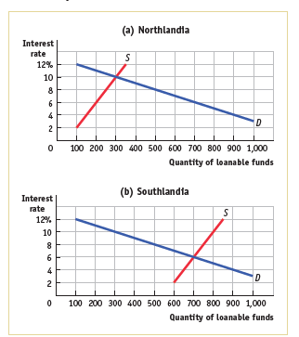

**参考答案：**

当前Northlandia的利率是10%，Southlandia只有6%，因此Northlandia的投资者希望从Southlandia借钱，而Southlandia的可贷资金供给者也希望贷款给Northlandia以获得更高的回报率。Southlandia可贷资金供给下降（或者用课件的规范，可贷资金的需求上升）导致Southlandia利率上升，而Northlandia的可贷资金供给上升导致Northlandia利率下降。两国的利差会缩小。由于两国不区分资产的性质，利差会缩小至0为止。

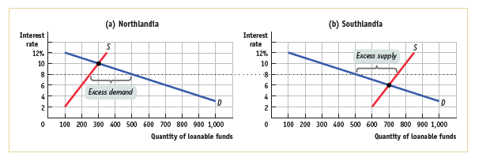

上图是一个可能性，两国利率均衡时为8%，此时Northlandia有超额的可贷资金需求，恰好由NCI填补；Southlandia有超额的可贷资金供给，恰好由NCO带走。NCI和NCO的规模（绝对值）都是250。Northlandia的“金融账户”会有250的盈余（负债），而Southlandia的“金融账户”会有250的赤字（资产）；相应地，Northlandia的“经常项目”将有250赤字（借方），Southlandia的“经常项目”将有250盈余（贷方）。

1. 假设Albernia（一个虚构的国家）的央行实行固定汇率，将其货币“the bern”盯住美元，使得1单位bern可以兑换US$1.50。最开始，外汇市场处于均衡状态（如下图）。然而，Albernia人和美国人都开始相信，持有Albernia资产的风险增大。结果是，他们开始不愿意持有Albernia的资产（除非利率相对美国提高一些）。这将如何影响下图？如果Albernia央行用货币政策盯住1:1.5（bern兑美元）的汇率，Albernia的经济会如何变化？

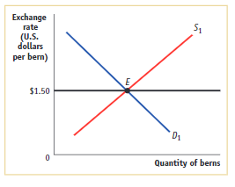

**参考答案：**

注意上图若站在Albernia的视角则是第二种汇率的表示方式（可以想象若bern是人民币的），外国对bern的需求会下降（从*D*1到*D*2），因为美国人更不愿意买Albernia的资产，对bern的供给会提高（从*S*1到*S*2），因为Albernia人更愿意买美国的资产。这样一来，均衡的汇率会下降到比如1单位bern换$1.00的地步（如下图）。若Albernia央行坚持固定汇率，那么货币政策就需要让Albernia的资产更有吸引力，则Albernia需要提高利率（比如通过减少货币供给），而这将对Albernia的经济在短期内产生紧缩性的影响（减少投资）。

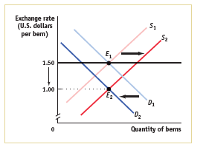

1. 一个案例分析用麦当劳巨无霸汉堡在不同国家的价格来分析购买力平价，而下表是某年的数据：

|  |  |  |  |
| --- | --- | --- | --- |
| 国家 | 巨无霸汉堡单价 | 预测汇率 | 实际汇率 |
| 智利 | 2,640 pesos |  | 679 pesos/$ |
| 匈牙利 | 850 forints |  | 280 forints/$ |
| 捷克共和国 | 85 korunas |  | 22.3 korunas/$ |
| 巴西 | 16.9 real |  | 3.72 real/$ |
| 加拿大 | 6.77 C$ |  | 1.33 C$/$ |

* 1. 请将上表补充完整：对于每一个国家，预测站在美国视角的第二种汇率表示方式（一单位美元能兑换的外币数量），$5.58是麦当劳巨无霸汉堡在美国的单价。
  2. 根据购买力平价理论，智利比索和加拿大元之间的汇率是多少？实际上（名义）汇率是多少？
  3. 请评价购买力平价理论的预测能力如何？

**参考答案：**

1. 计算如下：

Chile: 2,640 pesos/$5.58 = 473 pesos/$

Hungary: 850 forints/$5.58 = 152 forints/$

Czech Republic: 85 korunas/$5.58 = 15.2 korunas/$

Brazil: 16.9 reales/$5.58 = 3.01 reales/$

Canada: 6.77C$/$5.58 = 1.21C$/$

1. 在PPP理论下，1加拿大元可以兑换2640/6.77 = 390智利比索。实际汇率则是679/1.33 = 510智利比索/加拿大元。
2. 预测能力到底好不好是“仁者见仁、智者见智”的事情。其实差距不是很大，但也不小。

Week 13

**练习题：**

1. 下图是总支出函数的三个状态。请使用支出乘数，找到该经济体的MPC。

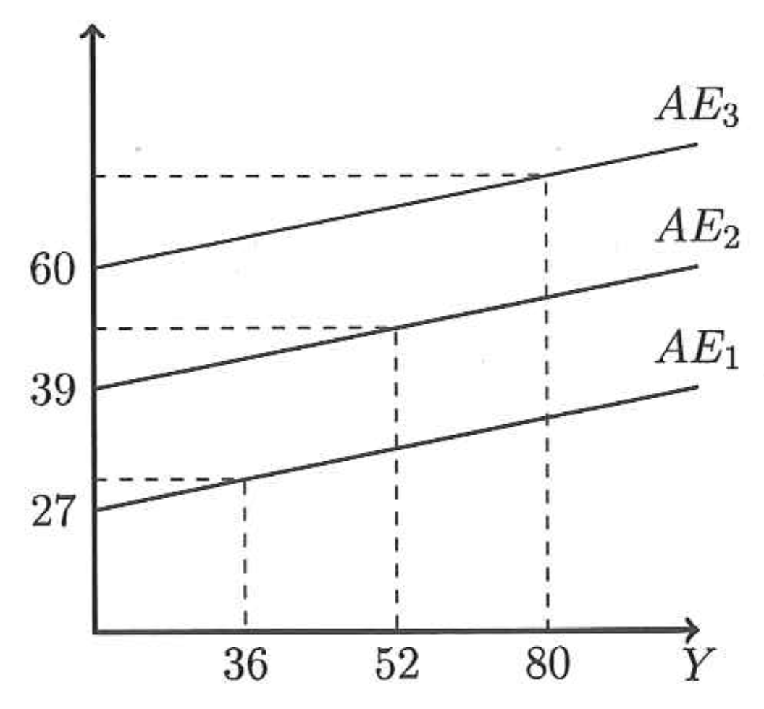

**参考答案：**

我们知道，其中是自主总支出（autonomous aggregate expenditure）的变化。图中，存在这样的关系（注意图中隐含了45度线）：

无论使用哪一个关系，都可以得到

也就是说，。

1. 上题的图中，计划总支出是。假设股市出现了持续的牛市，导致许多股民账面收益大幅提高。请问会朝着还是的方向移动呢？为什么？

**参考答案：**

财富提高，消费函数提高，因此计划总支出函数上移（朝着的方向）。

1. 有经济学家指出，美国1980年代贸易逆差的增加与政府预算赤字增加有关。与此同时，受众较广的媒体有时称美国的贸易逆差来自于美国相对其它国家产品质量的下降。
   1. 假设1980年代美国产品的相对质量确实有所下降，这将如何影响美国的“净进口”（在任意给定的汇率水平下）？（假设美国净出口一直为负，即净进口一直为正，下同。）
   2. 请使用调整的“可贷资金市场-净资本流入-汇率市场”三面板图，展示该净出口的移动如何影响真实汇率和贸易平衡。
   3. 受众较广的媒体的言论与模型一致吗？美国产品相对质量的下降对美国人的生活标准有影响吗？（提示：当美国人卖产品给其它国家的人时，他们得到了什么？）

**参考答案：**

1. 在给定汇率下，美国的“净进口”增加，即净出口降低。
2. 由于NX<0，NCO<0，NCI>0，我们使用调整后的三面板图。给定汇率下，“净进口”的增加导致美国对美元的“净供给”增加（因为美国要用美元换外币来支付），从而美元的供给曲线向右移动。请注意，我们对曼昆教材中的模型进行了调整，当NCO<0时，我们采用NCI曲线来决定美元的净需求，这个与汇率无关，而与利率有关。美元的净供给取决于RER，因为其越高，美国产品的国际竞争力越低（注意这里采用第二种汇率，所以与课上讨论相反），因此美国要更多地进口，也即要更多地用美元兑换其它国家的货币（对其它国家的货币的需求量就是美元的供给量），所以供给曲线斜率为正。

可贷资金

0

净资本流入

0

第二种真实汇率

美元量

0

对美元的净供给

对美元的净需求

1. 受众较广的媒体的言论与模型不一致。美国产品质量的下降只是导致美元的供给增加，从而导致均衡真实汇率下降，从而抵消了质量下降对出口的负面影响（因为第二种真实汇率下降代表美国产品的国际竞争力提高）。可以看到，NCI是给定的，由于净进口M-X = NCI，所以净进口也是给定的。

然而，美国的生活水平可能会下降，因为RER的下降相当于一单位美国产品能兑换的外国产品数量下降。

对于为什么产品质量下降不会影响净进口的更直观的理解：产品质量下降的同时真实汇率也相应地调整了，这不是PPP理论中的“一物一价”，而是不同物不同价。试想，一些国家的产品质量虽差，但它便宜啊，所以我们也还是会买，这就是这道题中的思想——通过调整真实汇率，我们维持住了净进口，但是第二种真实汇率的下降是美国人生活水平的损失。

Week 14

**练习题：**

1. 若我们将收入-支出模型拓展为如下模型，请问支出乘数是多少？

**参考答案：**

将、、、、全部代入的表达式即可求出支出乘数——事实上是否代入无所谓，因为与无关，所以是“自主”的：

当时，有

也就是说，就是支出乘数。

这个支出乘数有什么含义呢？当、和时，支出乘数是，且越小，支出乘数越小。显然，削弱了支出乘数，也削弱了支出乘数，则增大了支出乘数（政府支出与消费的作用是类似的，这里假设政府不管赤字是多少，只要提高，支出就提高）。

1. Consider an economy, with no government spending or international trade, where households have the following consumption function

𝐶=1200+0.60𝑌

Planned investment is 300.

1. Graph aggregate expenditure, and depict the equilibrium graphically.
2. Find the equilibrium level of income.
3. What is the level of unplanned inventories when income is 2000?
4. What is the equilibrium consumption and savings when the planned investment becomes 600?

**参考答案：**

* 1. 见下图

45-degree line

(Ensuring )

*C +*

= 1200 + 0.6Y +300

= 1500 + 0.6Y

1500=1200+300

Y*=3750

Planned AE

Y

* 1. Let AEplanned = Y, then 1500 + 0.6Y = Y, so 0.4Y = 1500, and Y = 3750.
  2. When Y = 2000, AEplanned = 1500 + 0.6×2000 = 2700.

Since Y = AEplanned + Iunplanned (the gap between actual output and planned aggregate expenditure is unplanned investment spending),

Iunplanned = Y – AE = 2000 – 2700 = –700

The negative unplanned investment means firms (i) involuntarily decrease their inventory, (ii) underestimate sales and (iii) produce too little than the equilibrium output.

* 1. When Iplanned = 600, AEplanned = 1800 + 0.6Y, equilibrium Y* = 4500.

In the equilibrium, Iunplanned = 0

The equilibrium savings = 600.

The equilibrium consumption = AEplanned − Iplanned = Y* − I* =4500 – 600 = 3900.

1. The Conference Board (美国谘商会) publishes the Consumer Confidence Index (CCI) every month based on a survey of 5,000 representative U.S. households. It is used by many economists to track the state of the economy. A press release by the Board on March 31, 2020, stated: “The Conference Board Consumer Confidence Index declined sharply in March, following an increase in February. The Index now stands at 120.0 (1985 = 100), down from 132.6 in February.”
   1. As an economist, is this news encouraging for economic growth?
   2. Explain your answer to part a with the help of the AD-AS model. Draw a typical diagram showing two equilibrium points (*E*1) and (*E*2). Label the vertical axis “Aggregate price level” and the horizontal axis “Real GDP.” Assume that all other major macroeconomic factors remain unchanged.
   3. How should the government respond to this news if the economy is below potential output? If it is above potential output?

**参考答案：**

1. No, consumers base their spending on how confident they are about the income they will have in the future. Likewise, firms base their investment spending on what they expect conditions to be like in the future. If consumers become more pessimistic, spending will fall. A decrease in the CCI indicated that consumers were more pessimistic in March 2020 than they had been in February 2020. They were also more pessimistic in February 2020 than they had been in January 2020. 可以结合中国的CCI来讨论，数据见课件。
2. A decrease in consumer confidence leads to a leftward shift of the aggregate demand curve. As shown in the accompanying diagram, other things equal, this will decrease real GDP from *Y*1 to *Y*2 and will decrease the aggregate price level from *P*1 to *P*2.（下面这个图画反了，请重新绘制）

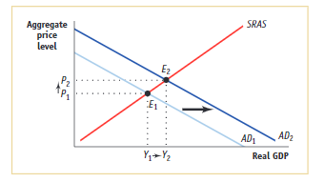

1. As seen in part b, the increase in consumer confidence will cause a leftward shift in the aggregate demand curve. If this puts the economy in a recessionary gap, the government could use expansionary monetary policy or fiscal policy to close the recessionary gap. If the leftward shift of the aggregate demand curve leaves the economy above potential output, then the government could respond with contractionary monetary policy or fiscal policy, although this is highly unlikely.
2. Explain whether the following government policies affect the aggregate demand curve or the short-run aggregate supply curve and how.
   1. The government reduces the minimum nominal wage.
   2. The government increases Temporary Assistance for Needy Families (TANF) payments, government transfers to families with dependent children.
   3. To reduce the budget deficit, the government announces that households will pay much higher taxes beginning next year.
   4. The government reduces military spending.
   5. 可以适当增加一些情况。

**参考答案：**

1. 这与名义工资下降的效果类似，AS会提高，SRAS曲线右移。
2. 消费支出会提高（因为可支配收入Y-T+TR提高），AD会提高，AD曲线右移。
3. 今年消费支出就会降低，因为消费者预期到可支配收入会下降，AD降低、曲线左移。
4. G下降，AE下降，AD下降，AD曲线左移。

Week 15

**练习题：**

1. Explain how each of the following developments would affect the supply of money, the demand for money, and the interest rate. Use diagrams to illustrate your answers.
   1. The Fed’s bond traders buy bonds in open-market operations.
   2. An increase in credit-card availability reduces the amount of cash people want to hold.
   3. The Fed reduces the interest rate it pays on reserves.
   4. Households decide to hold more money to use for holiday shopping.
   5. A wave of optimism boosts business investment.

**参考答案：**

1. When the Fed’s bond traders buy bonds in open-market operations, the money-supply curve shifts to the right from *MS*1 to *MS*2, as shown in Figure 1. The result is a decline in the interest rate.

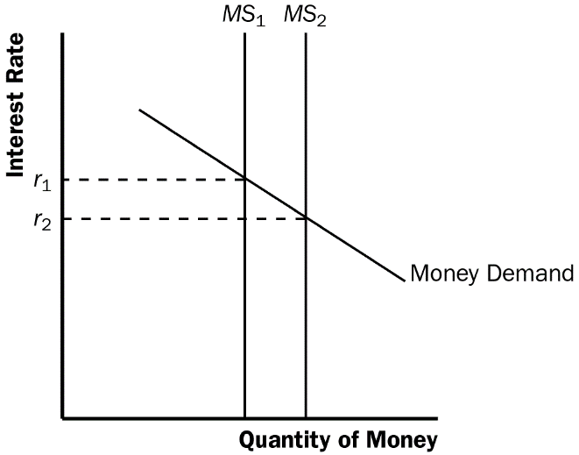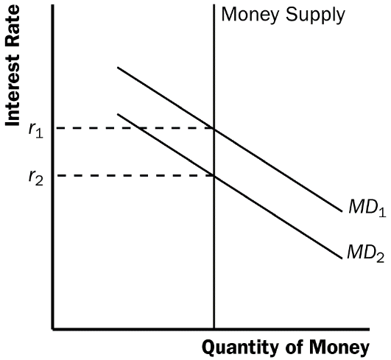

**Figure 1 Figure 2**

1. When an increase in credit card availability reduces the cash people hold, the money-demand curve shifts to the left from *MD*1 to *MD*2, as shown in Figure 2. The result is a decline in the interest rate.
2. When the Fed reduces the interest rate it pays on reserves, the money supply increases, so the money-supply curve shifts to the right from *MS*1 to *MS*2, as shown in Figure 1. The result is a decline in the interest rate.
3. When households decide to hold more money to use for holiday shopping, the money-demand curve shifts to the right from *MD*1 to *MD*2, as shown in Figure 3. The result is a rise in the interest rate.

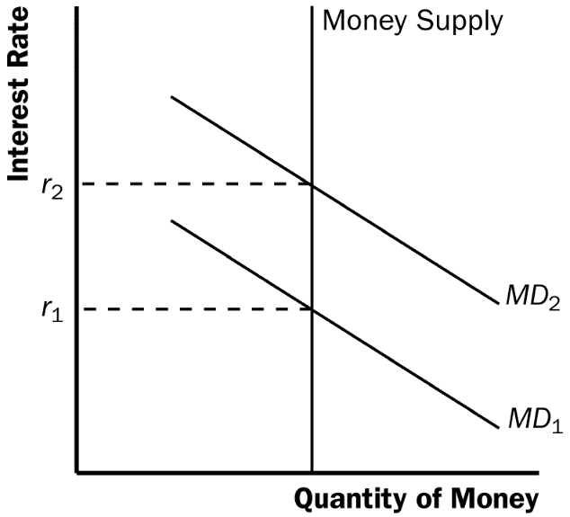

**Figure 3**

1. When a wave of optimism boosts business investment and expands aggregate demand, money demand increases from *MD*1 to *MD*2 in Figure 3. The increase in money demand increases the interest rate.
2. The Fed expands the money supply by 5 percent.
   1. Use the theory of liquidity preference to illustrate in a graph the impact of this policy on the interest rate.
   2. Use the model of aggregate demand and aggregate supply to illustrate the impact of this change in the interest rate on output and the price level in the short run.
   3. When the economy makes the transition from its short-run equilibrium to its new long-run equilibrium, what happens to the price level?
   4. How does this change in the price level affect the demand for money and the equilibrium interest rate?
   5. Is this analysis consistent with the proposition that money has real effects in the short run but is neutral in the long run?

**参考答案：**

1. The increase in the money supply will cause the equilibrium interest rate to decline, as shown in Figure 4. Households will increase spending and will invest in more new housing. Firms too will increase investment spending. This will cause the aggregate demand curve to shift to the right as shown in Figure 5.

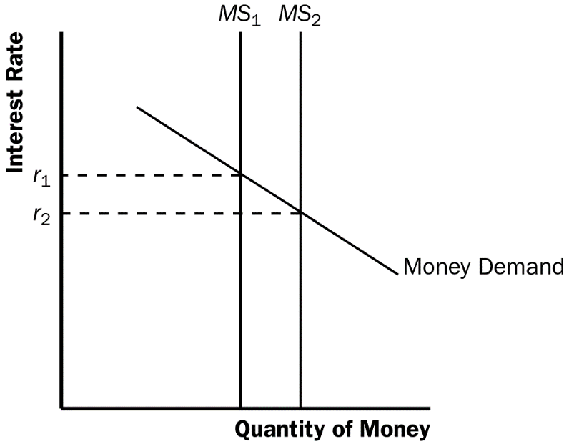

**Figure 4**

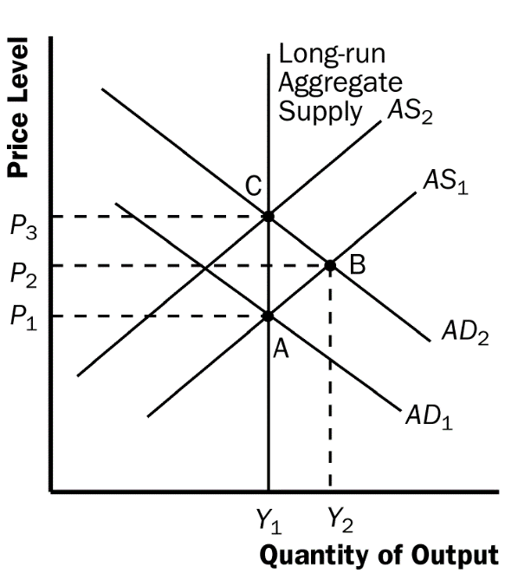

**Figure 5**

1. As shown in Figure 5, the increase in aggregate demand will cause an increase in both output and the price level in the short run (point B).
2. When the economy makes the transition from its short-run equilibrium to its new long-run equilibrium, short-run aggregate supply will decline, causing the price level to rise even further (point C).
3. The increase in the price level will cause an increase in the demand for money, raising the equilibrium interest rate.
4. Yes. While output initially rises because of the increase in aggregate demand, it will fall once short-run aggregate supply declines. Thus, there is no long-run effect of the increase in the money supply on real output.
5. Consider an economy described by the following equations:

where Y is GDP, C is consumption, I is investment, G is government purchases, T is taxes, and r is the interest rate. If the economy were at full employment (that is, at its natural level of output), GDP would be 2,000.

1. Explain the meaning of each of these equations.
2. What is the marginal propensity to consume in this economy?
3. Suppose the central bank adjusts the money supply to maintain the interest rate at 4 percent, so r = 4. Solve for GDP. How does it compare to the full-employment level?
4. Assuming no change in monetary policy, what change in government purchases would restore full employment?
5. Assuming no change in fiscal policy, what change in the interest rate would restore full employment?

**参考答案：**

1. *Y=C+I+G* is the equilibrium condition for GDP in a closed economy (output equals the sum of consumption, investment, and government spending); *C=100+.75(Y-T)* is the equation for consumption which depends on disposable income; *I=500*–*50r* is the equation for investment which depends on the interest rate; *G=125* means that government spending is fixed at 125; *T=100* means that taxes are fixed at 100.
2. The marginal propensity to consume is 0.75.
3. When the interest rate, *r*, is 4 percent,  
   *Y* = 100 + .75(*Y* – 100) + 500 – 50(4) + 125  
   *Y* = 100 + .75*Y* – 75 + 500 – 200 + 125  
   *Y* = 450 + .75*Y*  
   .25*Y* = 450  
   *Y* = 1800, which is less than the full employment level.
4. Assuming no change in monetary policy, an increase in government purchases of 50 (to 175) would restore full employment. Because the marginal propensity to consume is .75, the multiplier is 1/(1–.75) or 4. To increase GDP from 1800 to 2000, or by 200, government spending would need to increase by 200/4 = 50.

需要和同学们强调的是，这里假设AS曲线为水平线，因为Y与P无关；若Y与P有关，即AS曲线不为水平线，则无法使用乘数来简单计算。第五次作业第3题可以用这道题的思路解答，但是第4题不能。

1. Assuming no change in fiscal policy, a decrease of 1 percent (from 4 percent to 3 percent) in the interest rate would restore full employment.

2000 = 100 + .75(2000 – 100) + 500 – 50*r* + 125

2000 = 2150 – 50*r*

50*r* = 150

*r* = 3

1. Explain whether each of the following events shifts the short-run aggregate-supply curve, the aggregate-demand curve, both, or neither. For each event that does shift a curve, draw a diagram to illustrate the effect on the economy.
   1. Households decide to save a larger share of their income.
   2. Florida orange groves suffer a prolonged period of below-freezing temperatures.
   3. Increased job opportunities overseas cause many people to leave the country.

**参考答案：**

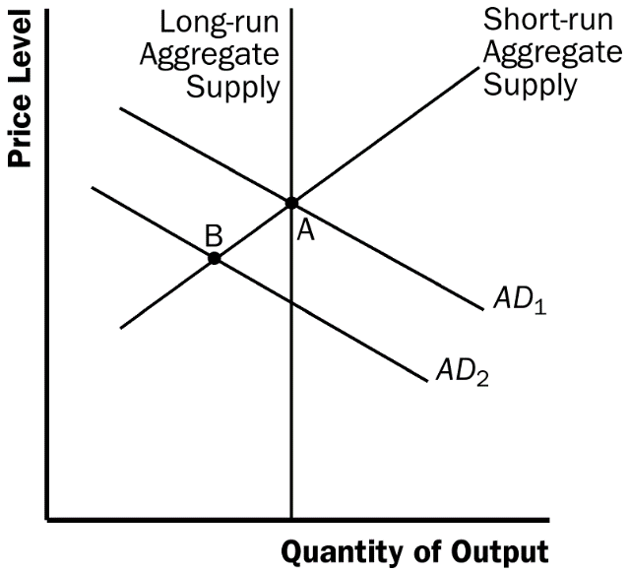

**Figure 6**

1. If households decide to save a larger share of their income, they must spend less on consumer goods, so the aggregate-demand curve shifts to the left, as shown in Figure 6 The equilibrium changes from point A to point B, so the price level declines and output declines.
2. If Florida orange groves suffer a prolonged period of below-freezing temperatures, the orange harvest will be reduced. This decline in the natural level of output is represented in Figure 7 by a shift to the left in both the short-run and long-run aggregate-supply curves. The equilibrium changes from point A to point B, so the price level rises and output declines.

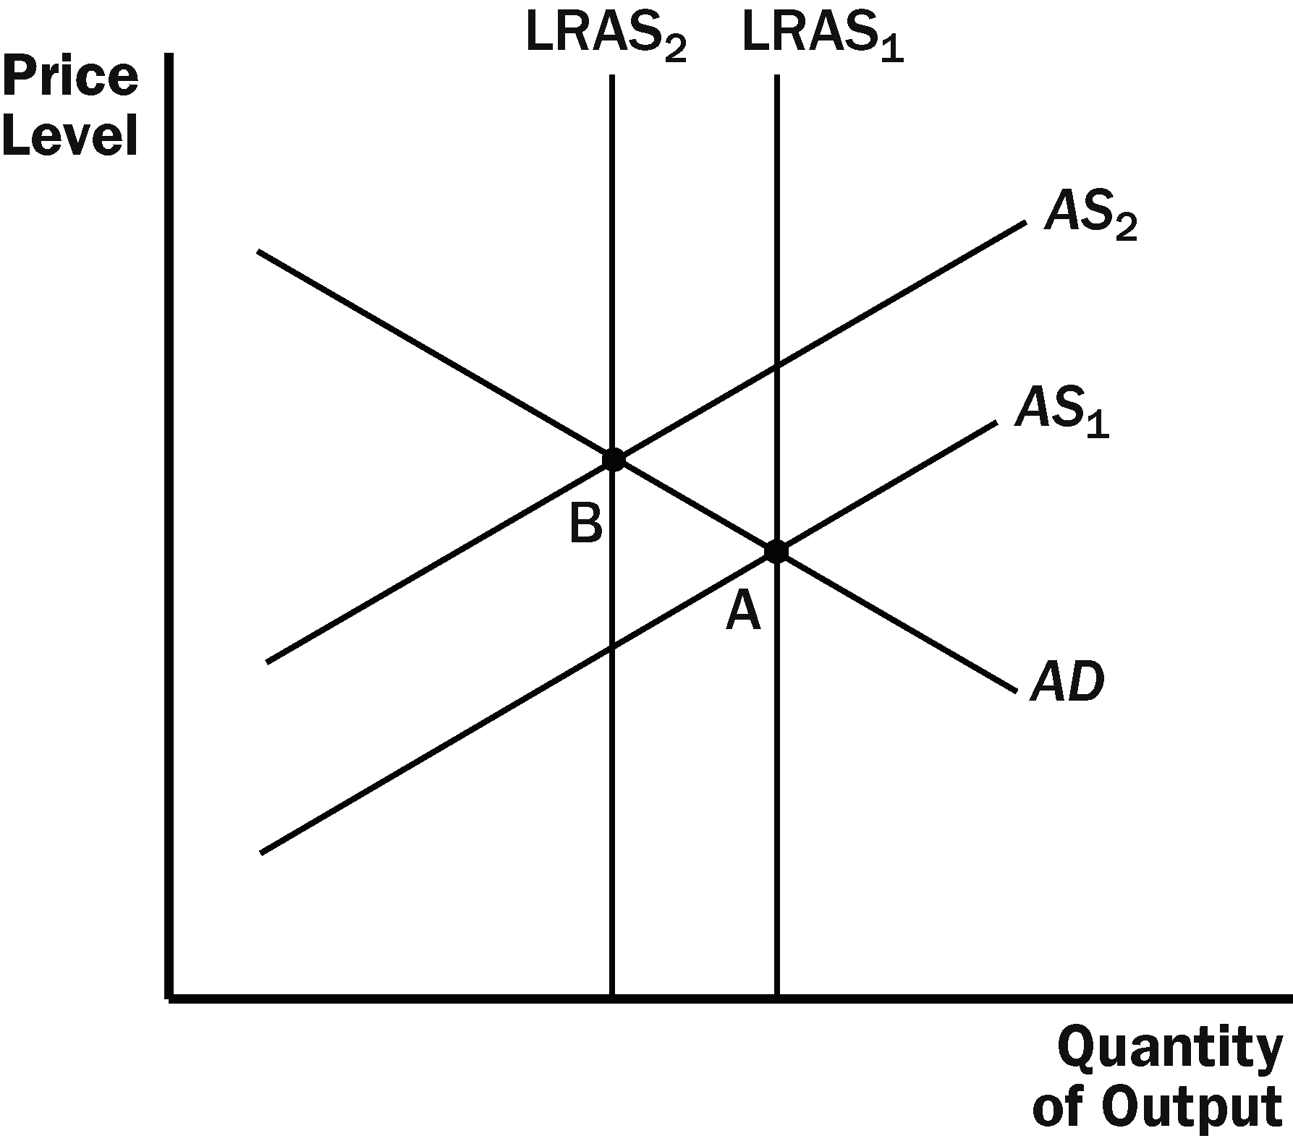

**Figure 7**

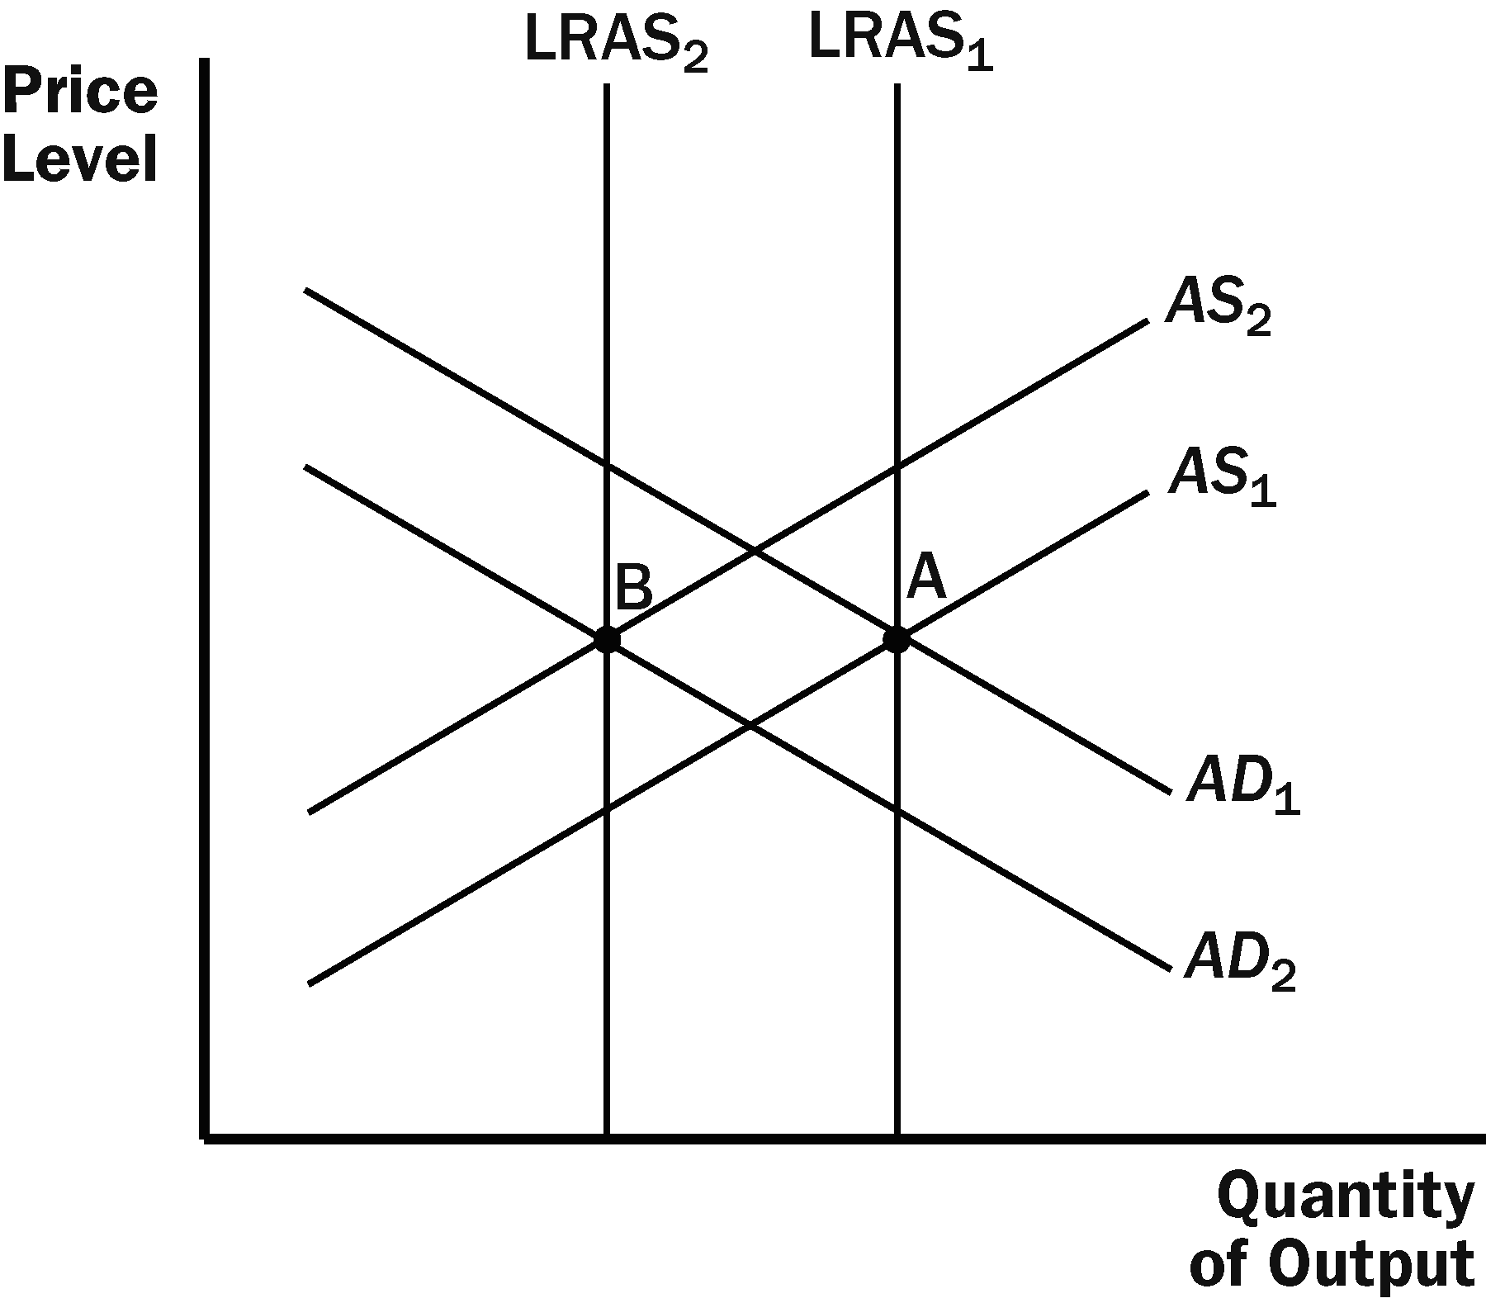

**Figure 8**

1. If increased job opportunities cause people to leave the country, the long-run and short-run aggregate-supply curves will shift to the left because there are fewer people producing output. The aggregate-demand curve will also shift to the left because there are fewer people consuming goods and services. The result is a decline in the quantity of output, as Figure 8 shows. Whether the price level rises or declines depends on the relative sizes of the shifts in the aggregate-demand curve and the aggregate-supply curves.
2. Suppose the natural rate of unemployment is 6 percent. On one graph, draw two Phillips curves that describe the four situations listed here. Label the point that shows the position of the economy in each case.
   1. Actual inflation is 5 percent, and expected inflation is 3 percent.
   2. Actual inflation is 3 percent, and expected inflation is 5 percent.
   3. Actual inflation is 5 percent, and expected inflation is 5 percent.
   4. Actual inflation is 3 percent, and expected inflation is 3 percent.

**参考答案：**

Figure 9 shows two different short-run Phillips curves depicting these four points. Points aand d are on *SRPC*1 because both have expected inflation of 3%. Points b and c are on *SRPC*2 because both have expected inflation of 5%.

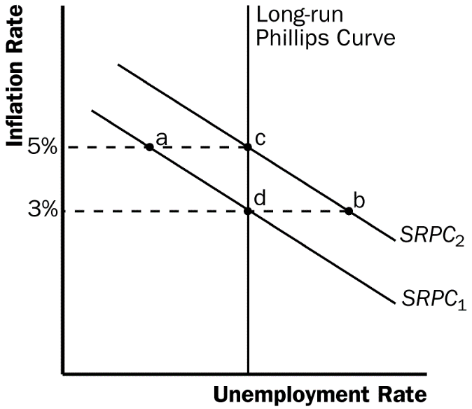

**Figure 9**

1. In 2008, the Federal Reserve faced a decrease in aggregate demand caused by the housing and financial crises and a decrease in short-run aggregate supply caused by rising commodity prices.
   1. Starting from a long-run equilibrium, illustrate the effects of these two changes using both an aggregate-supply/aggregate-demand diagram and a Phillips-curve diagram. On both diagrams, label the initial long-run equilibrium as point A and the resulting short-run equilibrium as point B. For each of the following variables, state whether it rises or falls or whether the impact is ambiguous: output, unemployment, the price level, the inflation rate.
   2. Suppose the Fed responds quickly to these shocks and adjusts monetary policy to keep unemployment and output at their natural rates. What action would it take? On the same set of graphs from part (a), show the results. Label the new equilibrium as point C.
   3. Why might the Fed choose not to pursue the course of action described in part b)?

**参考答案：**

1. As shown in the left diagram of Figure 10, equilibrium output and employment will fall. However, the effects on the price level and inflation rate will be ambiguous. The fall in aggregate demand puts downward pressure on prices, while the decline in short-run aggregate supply pushes prices up. The diagram on the right side of Figure 10 assumes that the inflation rate rises.
2. The Fed would have to use expansionary monetary policy to keep output and employment at their natural rates. Aggregate demand would have to shift to *AD*3.
3. The Fed may not want to pursue this action because it will lead to a rise in the inflation rate as shown by point *C*.

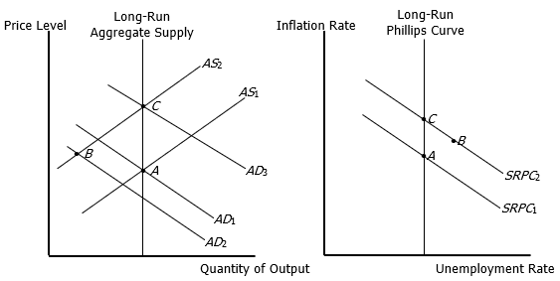

**Figure 17**

**附加题：**

Suppose the Federal Reserve’s policy is to maintain low and stable inflation by keeping unemployment at its natural rate. However, the Fed believes that the natural rate of unemployment is 4 percent when the actual natural rate is 5 percent. If the Fed based its policy decisions on its belief, what would happen to the economy? How might the Fed come to realize that its belief about the natural rate was mistaken?

**参考答案：**

If the Fed acts on its belief that the natural rate of unemployment is 4%, when the natural rate is in fact 5%, the result will be a spiraling up of the inflation rate, as shown in Figure 11. Starting from a point on the long-run Phillips curve, with an unemployment rate of 5%, the Fed will believe that the economy is in a recession, because the unemployment rate is greater than its estimate of the natural rate. Therefore, the Fed will increase the money supply, moving the economy along the short-run Phillips curve *SRPC*1. The inflation rate will rise and the unemployment rate will fall to 4%. As the inflation rate rises over time, expectations of inflation will rise, and the short-run Phillips curve will shift to the right to *SRPC*2. This process will continue, and the inflation rate will spiral upwards.

The Fed may eventually realize that its estimate of the natural rate of unemployment is wrong by examining the rising trend in the inflation rate.

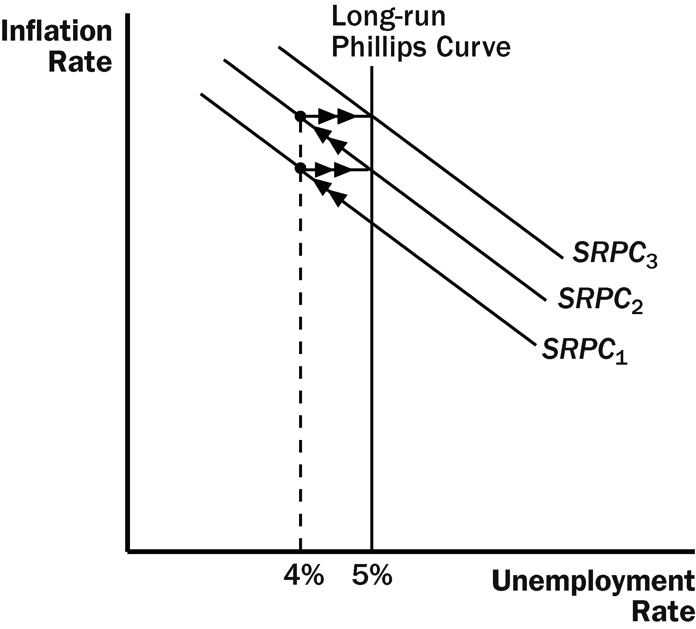

**Figure 11**