Plunder: A Pirate’s Life – Expansion Rules
Plundering – Plundering an enemy ship can only be done if:
- Your ship is fully upgraded.
- You must successfully attack an enemy ship without sinking it.
- After combat, roll against the defending player to resolve the Plunder attempt.
The defending player chooses one of two roll methods:
- A single 1 out of 1 roll-off, or
- A 2 out of 3 showdown – best of three rolls wins.
If you win the roll, perform one of the following Plundering actions:
- Steal a held item from the defending ship.
- Take two random resource cards from the defending player.
If you lose the roll, your attacking ship loses a life point, and no Plundering takes place.
Each ship may Plunder only once per turn. However, you may attempt to Plunder again using a different ship against a different enemy vessel.

Obtainable Items:
Cthulhu Idol - Relic of the Deep
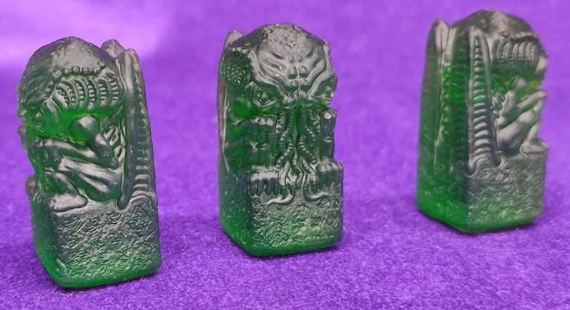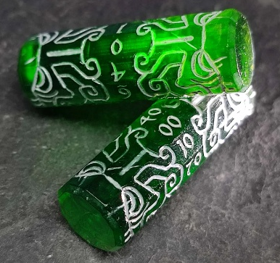

Kraken’s Rum & Kraken’s Die (D6)
Setup - At the start of the game, spin the compasses to determine the location of the Kraken’s Rum.
Retrieval - Sail over the space containing the Kraken’s Rum to collect it. If the Kraken’s Rum is located on land, your ship must reach an adjoining ocean space to claim it – it cannot be collected through land barriers or across the storm’s boundary. Once collected, the Kraken’s Rum is bound to the ship that obtained it. Use a ship marker to track ownership, or simply keep the Kraken’s Rum near the claiming ship during gameplay.
Losing the Kraken’s Rum - You may lose possession of the Kraken’s Rum under one of the following conditions:
- If the claiming ship is lost in battle, the Kraken’s Rum is placed at the location where the ship sank. Any player may collect it by sailing over that space.
- If your ship is successfully Plundered by an attacker (see Plundering rules), the Kraken’s Rum transfers to the attacking ship.
Kraken’s Rum Effects
Passive Effect – The Kraken’s Spirits
- The holder gains +1 Rum at the start of each turn.
Active Effect – Kraken’s Draft
- Before your movement roll, roll the Kraken’s Die and resolve its effect.
- Then, draw a number of Treasure Cards equal to your roll — all at once. Do not resolve any cards until the full set is drawn. If any of the following cards appear — The Kraken, Drink Up, or Blackout — read them aloud, but do not trigger their effects immediately.
  - If only one of the mentioned cards is drawn, resolve it normally.
  - If more than one appears, the next Pirate in turn randomly selects one for you to resolve. Ignore the others.
    - If the card Blackout is selected, the ship carrying the Kraken’s Rum is the one that is relocated.
- After resolving the selected effect, place all drawn Treasure Cards at the bottom of the Treasure Deck.
- Optional Mechanic – If the card The Kraken is drawn, move the Kraken token from its current location and place it in front of your nearest ship. That ship must battle the Kraken to claim the card’s resources.
  - Bonus Effect – If you rolled a 6 with the Kraken’s Die, gain +1 Attack during the battle. Attack resets to normal after combat.

Roll | Effect Name | Outcome
1 | Blackout Brew | Lose all Rum this turn. Discard 1 additional resource card or skip movement.
2 | Sea Sickness | -1 Rum. Nearest opponent gains +1 rum.
3 | Scallywag’s Swill | +1 attack for all owned ships but also -1 defense until your next turn.
4 | Fortune’s Froth | +1 Rum and +1 Gold!
5 | Saboteur’s Cask | +1 Rum. Choose one Pirate to skip their next Movement Roll.
6 | Kraken’s Favor | +2 Rum and immunity from any negative Rum-related effects this round.

- Card Effects
  - The Kraken – Description: Ye fashion harpoons ta kill the monster guardin this treasure.
    - -1 Wood, -2 Iron, +4 Gold
  - Drink Up – Description: Ye find barrels of booze floating adrift. Waste not a drop nor a stave.
    - +1Wood, +1 Rum
  - Blackout – Description: This haul be barrels of liquid goodness. Ye celebrate too hard and fall asleep at the helm.
    - +3 Rum – Use the compass to relocate your ship. Your turn is now over.

A Jar of Dirt & Pirate’s Coin
Setup - At the start of the game, spin the compasses to determine the location of the Jar of Dirt.
Retrieval - Sail over the space containing the Jar of Dirt to collect it. If the Jar of Dirt is located on land, your ship must reach an adjoining ocean space to claim it – it cannot be collected through land barriers or across the storm’s boundary. Once collected, the Jar of Dirt is bound to the ship that obtained it. Use a ship marker to track ownership, or simply keep the Jar of Dirt near the claiming ship during gameplay.
Losing the Jar of Dirt - You may lose possession of the Jar of Dirt under one of the following conditions:
- If the claiming ship is lost in battle, the Jar of Dirt is placed at the location where the ship sank. Any player may collect it by sailing over that space.
- If your ship is successfully Plundered by an attacker (see Plundering rules), the Jar of Dirt transfers to the attacking ship.
Jar of Dirt’s Effects
Passive Effects:
- Earthen Fortune – At the start of your turn, flip the Pirate’s Coin.
  - Heads: Gain +1 Iron.
  - Tails: Gain +1 Wood.
Active Effects:
- Land Crossing – To move across land spaces, flip the Pirate’s Coin once per land grid tile. Your ship must end its movement on an ocean tile within your movement roll allowance.
  - Heads: You may cross.
  - Tails: Movement fails and may not cross land. Your ship may continue to move on other ocean tiles if there are movements left in your turn.
- Dirt Defense – When attacked, flip the Pirate’s Coin three times.
  - If two out of three flips land on Heads, your ship is defended from the attack.
  - If two out of three flips land on Tails, the attack on your ship is successful.
