These are all the files included in the project.
Before running the application, execute the following command:
python3 init_data.py

This script populates the database with predefined sample data, which helps simplify testing..

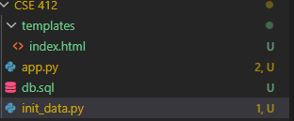
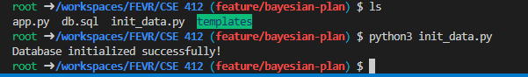
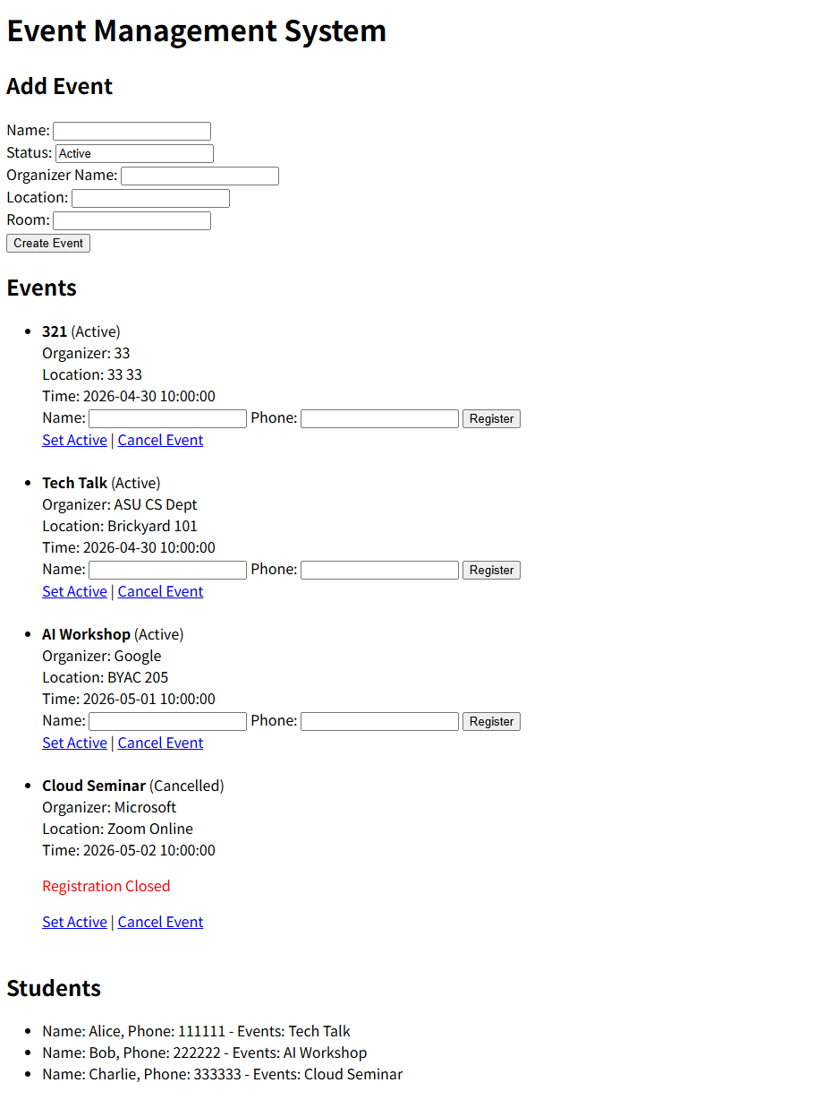
You need to configure the database connection in your app.py file:
conn = psycopg2.connect(
dbname="cse412",
user="postgres",
password="1234",
host="localhost"
)
Replace the username and password with your own PostgreSQL credentials.
If you forget your password, you can reset it by switching to root and running:
sudo su
sudo -u postgres psql

Then execute:
ALTER USER postgres WITH PASSWORD 'newpassword';

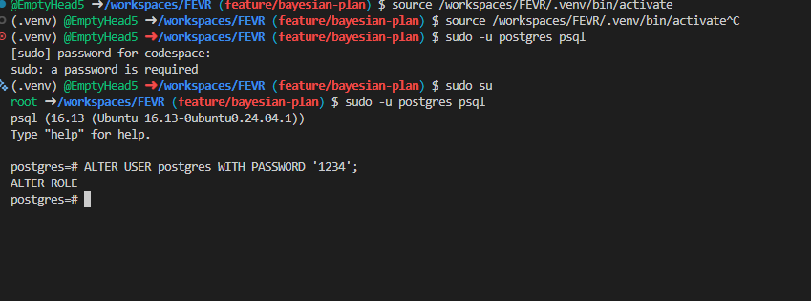

Next, import the database schema:
sudo -u postgres psql -d cse412 -f db.sql
If you see messages like CREATE TABLE, it means the tables were created successfully.

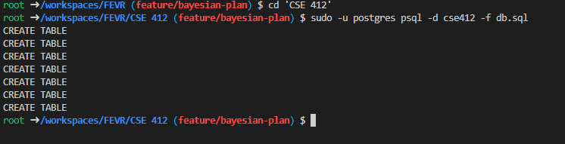
After that, start the PostgreSQL service:
sudo service postgresql start

Make sure the status shows [OK].

Finally, run your application and open it in your browser at:

http://127.0.0.1:5000

Note: The local address may vary depending on the user’s environment. The screenshots in this report were captured using the address shown above.

