Labyrinth, a modern adaption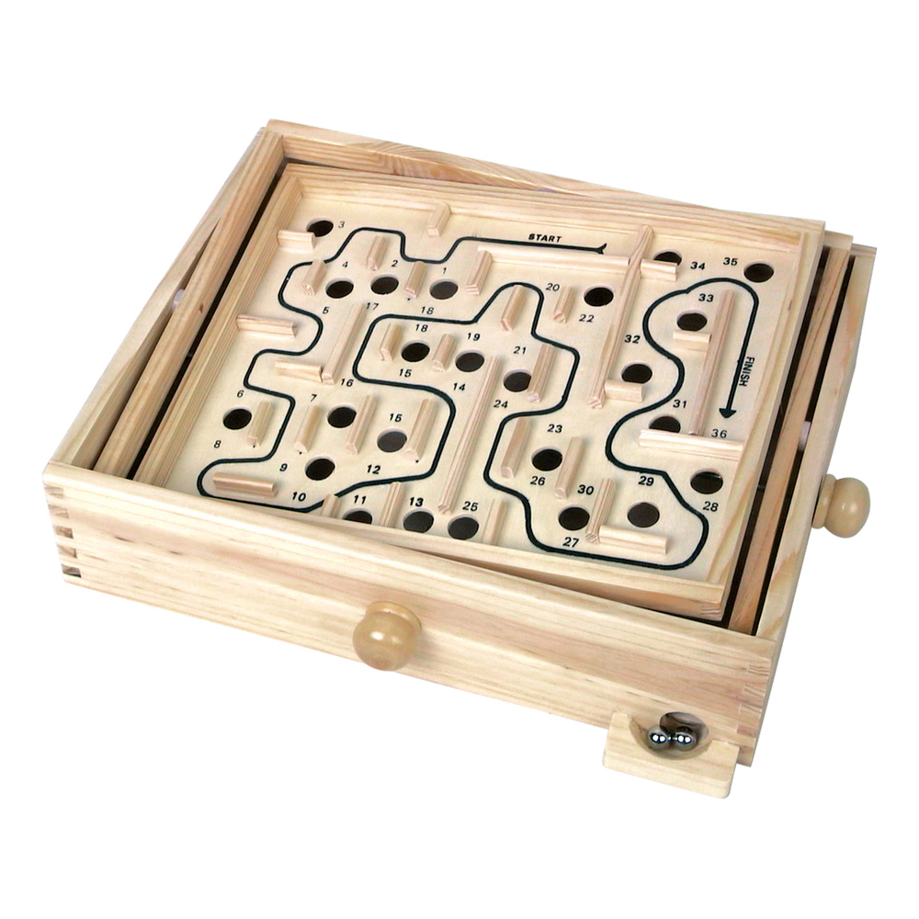

A game by:

Marlo Ploemen

Ajdin Husic

Luuk de Niet

# The gameplay

In the vintage game Labyrinth, it is the objective to move the ball through the level without falling through the holes. It is clearly a game of skill that requires a steady hand. In our game this is also the case. The finish is also a hole in the game. When you fall through the wrong hole, the level will start again. But if you fall through the finish, you completed the level.

The game can be played on a PC or on your mobile phone or tablet. When the game is played on a PC, the controls are the arrow keys or the WASD keys. But when you play on a phone or tablet, the original feel of the game returns. The gyroscope in your device will make it feel like you are really playing the wooden real life game.

In the main menu there are two options: tutorial and campaign. In the tutorial you will learn the controls and get to know the powerups we added. Even for the most inexperienced gamer, this shouldn’t take more than a few minutes. In the campaign the levels will get increasingly difficult. Only when a level is completed, will the next one be unlocked. So the highest level you have unlocked is your highscore.

# The modifications

To adapt the game to the present, we introduced some new elements to spice up the game. First we added a canon to increase the difficulty. The canon shoots cannonballs through the level. When the player is hit, the level restarts. So be careful to avoid the cannonballs.

Furthermore we added three special powerups. These powerups are cubes floating in space that influence the game when hit. First we have the spring. This powerup pushes the ball back. Just like a real spring, the force on the ball is dependent of the speed at which you hit the spring. So if you lightly touch the spring, not much will happen, but when you crash into it, you will be fired in the other direction. After a collision, the cube doesn’t disappear.

The other two powerups do disappear when hit, but effect the gameplay from that point. One of them inverts the controls. And the other doubles the speed of the ball.

We believe that these extra components make this game a vivid adaption of the old labyrinth game.