Applied Microsystems Corporation

Xbox™ Video Game Console
Optical Drive Emulation System
Software Users Manual

June 2001
Table of Contents
Welcome
Guided Tour
Overview
Preparing for emulation
Notes
Selecting the files in the image
Notes
Mapping files to disc
Notes
Enabling and controlling emulation
Pre-mastering tapes
Note
Selecting files for emulation
DVD Layout Tool
Version 1.x Note
DVD Layout controls and menus
Context menu
DVD Root
Folder and file panels
Saving and reopening layout files
To create and prepare DVD Root
To change DVD Root
To open an existing configuration file
Notes
To select folders or files
Selection indicators
Notes
To build an image
Remapping files to improve performance
DVD Geography Editor
Buttons and controls
Display columns
Context menu options
Not Placed tab

Default automatic file placement
Manual placement
Grouping files
Note
Placement tips
When all files won't fit
To load files into the Geography Editor
To create a placement mapping
Notes
File placement scenario
Automatic placement
Manual placement
Manual and automatic placement
Notes about usage
Placement tips
To adjust security placeholders
To group a set of files
To resequence files or groups
To delete a group
Note
To find a file or group
To save the file mapping
Notes
Starting and controlling emulation
Emulation Control Panel
Enable/Disable
Activity LED
Exit
Open/close tray
Select DVD image
Emulation mode
Reboot
Recent DVDs
Status
To start the Emulation Control Panel
To enable/Disable emulation
Notes
To change the emulation mode
To select and run the game
Version 1.0 Note
Notes
To emulate images from tape masters
Notes
To run actual game discs in Xbox
Generating and reloading master tapes
Tape Pre-Mastering Tool
Controls
Dialogs
To start the Tape Pre-Mastering Tool
Note
To write a tape set
Note
To abort a read or write
To read a tape set
Note
To locate tape drive properties
Using the Command Line
Command Line Tools
XbDvdImg
Usage
Notes
XbDvdEmu
Usage
Notes

Welcome
The Applied Microsystems Xbox™ Video Game Console Emulation System provides easy-to-use tools for generating game images and running them in the emulator. The toolset uses smart-switch technology to allow you switch seamlessly from running physical discs to using host-based files. You are freed from the need to burn new discs each time you modify your game. Instead you define and run a virtual DVD image using the files on your host system. You have the choice of command-driven operation or graphical user interfaces.
- Using the layout tools, you quickly select and deselect files to include in the emulation image, map their location on a virtual disc, and build the image.
- Using the emulation control panel, you load the "disc" into the emulator and select one of three emulation modes:
- Turbo
- Thomson emulation
- Philips emulation
- Using the tape tool, you create master tapes for Microsoft or unload master tapes onto your development system host.
- A guided tour is provided to get you started.

Guided Tour

Overview
This simple demonstration uses the sample program Dolphin.XBE and its media files to introduce you to the Applied Microsystems Xbox™ Video Game Console DVD emulation tools. The sample files are included in the Xbox SDK. Using them, you
Prepare for emulation
Select files to include and exclude
Map files to the disc
Build the emulation image
Enable and control all modes of emulation
Pre-master and verify a set of tapes
The demonstration uses the graphical user interfaces because they provide the most effective means of showing how to use the tools. Once you are confident of your understanding of the features available, you can choose to switch to command-driven operation.
The demonstration is best performed in sequence.

Preparing for emulation
Once you have application and data files that should work together, you can begin testing them using the emulation system.
This module shows how to
- Prepare the emulation root directory.
- Copy files onto the emulation drive.
- Change the game executable name

- Create Demo and Demo\dolphin directories on the emulation drive.
- Using the SDK console, change directories to
- <install dir>\Microsoft Xbox SDK\Samples\Xbox\Graphics\Dolphin
- Following Microsoft instructions, build the Dolphin game.
- Copy the dolphin.xbe and entire Media subdirectory structure to Demo\dolphin on the emulation drive.
- In Demo\dolphin, rename the dolphin.xbe file as default.xbe.
Default.XBE is the required filename for the application when it is run from media.

Notes
In actual practice, you may find it simpler to have your build routine automatically copy files to the emulation drive whenever you build your project. For example, you could add the following lines to the "Post-build step" of the dolphin project settings:
copy Debug\Dolphin.xbe <emulation_drive>:\Demo\dolphin\default.xbe
xcopy /E /D /Y media <emulation_drive>:\Demo\dolphin\media\
This is also a very good place to add XbDvdImg commands that automatically create the DVD image after an application build. More about that later.

Selecting the files in the image
Once the files are on the emulation drive, you can choose to build images that include all or only a subset of the files that reside in DVD Root. This can be a very powerful feature if you want to test alternatives quickly. Simply enable one alternative file or folder and disable the other. Then rebuild the image and emulate.
The DVD Layout Tool provides a simple interface for making file selections. It also serves as the launch platform for the other tools in the Xbox emulation toolbox: the Geography Editor, the DVD Image Builder, the Emulation Control Panel, and the tape Pre-Mastering Tool.
This module introduces you to
- Starting the DVD Layout Tool
- Setting DVD Root
- Selecting and deselecting folders and files
- Generating a configuration file
- Modifying and reloading a configuration file
- Building an image with default file mapping

- From a command prompt or the SDK console, start the Disk Layout Tool:
- >>XbDvdImg.exe
- You may find it useful to create a shortcut or batch file to simplify opening this GUI.
- 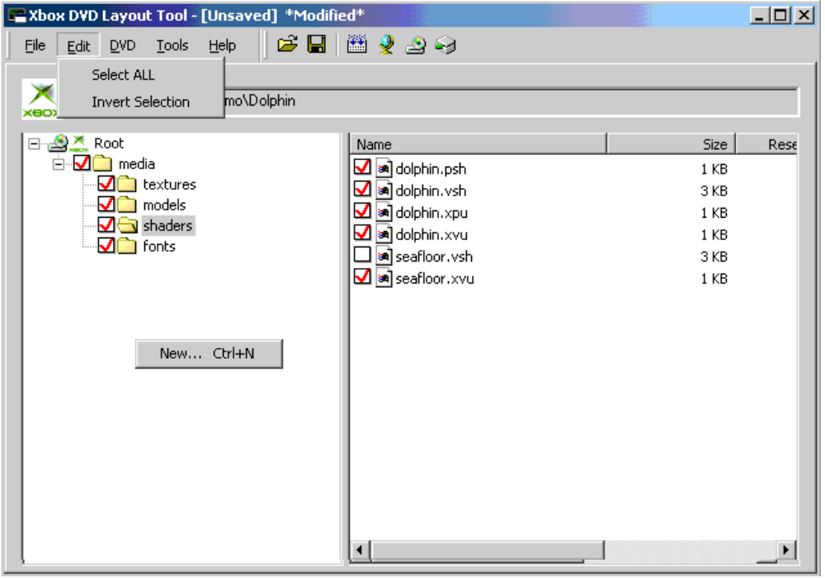
- Click the 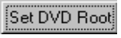 button, enable Directory and Content, and click Select.
- The two radio buttons let you select whether all files in and below DVD Root are initially selected or only the directory itself.
- In the navigation dialog, set DVD Root to Demo\dolphin, and click OK.
- The parent directory for the game image is called DVD Root. Only files located in or below the directory identified as DVD Root can be used when generating the emulation image. And only those selected (checked) are used when building the image. The DVD Root directory should be located on the emulation drive.
- Use File | Save As to save the file as dolphin.
- Notice that the window titlebar reports the name and location of the file, which now has an FLD extension. This stands for File Layout Desciption.
- In the folder pane (left), click Media to expand it.
- Uncheck (deselect) Media.
- Notice that all check boxes are empty.
- Reselect some files and folders by clicking the check boxes in both the folder and file panels (right).
- Notice that Ctrl-A performs a "select all" operation on all files in the active directory. If you then change the selection state of one file, all other selected files received the same setting.
- Notice that when you select a file in a subfolder, all folders between it and DVD Root are automatically selected. Likewise, selecting a folder selects all files within that folder. However, unchecking a file in a subfolder does not automatically uncheck the parent directory, as long as checked files remain in the subfolder.
- When you are through experimenting, use File | Save As, and change the name of the emulation configuration file to mytest.
- Make some changes to that file, and click File | Save.
- Use File | Open to reopen the original configuration file: dolphin.FLD.
- Make some changes to that file, but don't save them.
- Use File | Revert to discard those changes and reload the original FLD.
- Ensure that all folders and files are selected for inclusion in the image.
- Build an emulation image by clicking the  icon on the toolbar.
Although we won't actually run the game yet, this demonstrates just how quick and simple image creation and emulation can be.

Notes
When you build or rebuild the emulation image, three files are created and placed in the _amc subdirectory of DVD Root:
dvd_root_name.fld The file layout and disc geography configuration file.
dvd_root_name.fst The game image file system table.
xdfs.bin The Microsoft XDFS-format binary
Notice that even though you have saved the FLD under another name and in another location, this build's FLD is also saved under the DVD Root name "dolphin.".

Mapping files to disc
By default, files are placed on the DVD in descending size order (largest to smallest). For performance, placement begins from the outer edge of Layer 0 and, if space requires, continues from the outer edge of Layer 1. Customizing file location becomes necessary only when you are ready to optimize for performance or if all files cannot be placed automatically.
This module introduces you to
- Default file order
- Changing file order
- Grouping and ungrouping files for easy handling
- Finding files and folders
- Building the image

- Examine default file placement
- If it is not still open, use File | Open to reopen the dolphin.FLD file.
- Click the  icon on the toolbar to switch to the Geography Editor.
- Examine the default file placement in Layer 0.
- 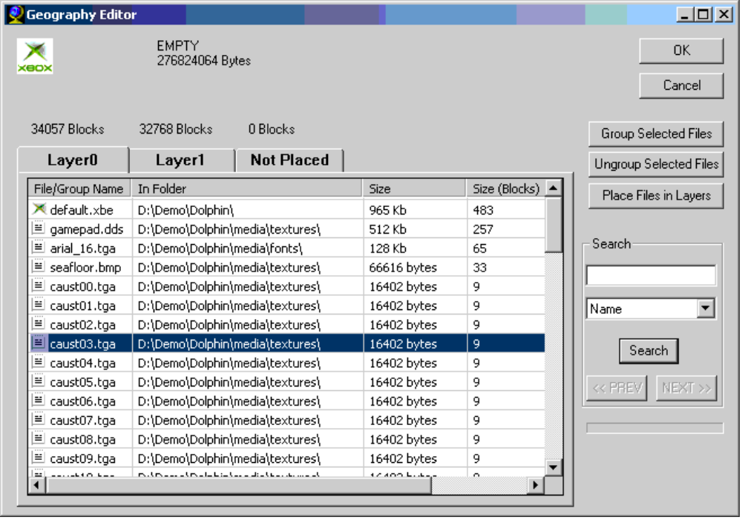
- Experiment with new file placement
- Click the button, enable Directory and Content, and click Select.
- In the navigation dialog, set DVD Root to Demo\dolphin, and click OK.
- Click to open the Geography Editor, and click the red Not Placed tab.
- Notice that all files are listed in defaultdescending size order. Until you save the FLD file or build the image, files remian unplaced and are listed on the Not Placed tab.
- Click the column heading to rearranged them by name, size, etc.
- Experiment with grouping and ordering files within the Not Placed tab.
- Select several files using ctrl-click or shift-click.
- Using the context menu, select Group.
- Using the context menu Rename function, rename the group.
- Using drag-and-drop, add another file to the group.
- Using drag-and-drop, drag other files to new locations on either side of the group.
- Experiment with sorting the remaining files by clicking the Name, Size, or Folder column headers.
- Experiment with moving files to layers:
- Using the context menu Move to Layer x options, move some individual files to other layers.
- Using arrow keys move among the layer tabs.
- Click the Place Files in Layers button. Notice that this moves the remaining unplaced files to Layer 0. It maintains both the placement of the files moved earlier to other layers, and the order of files as they were on the Not Placed tab before you clicked the button.
- Experiment with the Search feature:
- With Name selected in the search type, find default.xbe.
- With Folder selected as the search type, find an instances of the "shaders" folder.
- Using Next and Prev, move through all the instances of "shaders".
- Click OK to accept the current file order.
- Note: If any files remain in the Not Placed tab, you are warned and must acknowledge before saving. When you build the image, these files will be appended in the mappings you have already specified. The order in effect on the Not Placed tab determines the order that they are moved individually to the next available space on the layers.
- In the DVD Layout toolbar, click the to build the DVD image.
When you build or rebuild the emulation image, three files are created and placed in the _amc subdirectory of DVD Root:
dvd_root_name.fld The file layout and disc geography configuration file.
dvd_root_name.fst The game image file system table.
xdfs.bin The Microsoft XDFS-format binary
Notice that even though you may have saved the FLD under another name and in another location, this build's FLD is also saved under the DVD Root name "dolphin."

Notes
The Dolphin sample is extemely small and fits easily in the first empty space on Layer 0. In real practice, it is possible to arrange files such that they don't fit on the layers. See "File placement scenario" for a representitive situation.

Enabling and controlling emulation
Once the required files are present in DVD Root\_amc, you can run the game in the emulator.
This module demonstrates
- How to start the Emulation Control Panel.
- How to select the emulation mode
- How to enable and disable emulation
- How to load the disc image into the game console
- How to start the game in the Xbox console
- How to monitor emulation status
- How to exit emulation
- Click the Emulate icon  in the DVD Layout Tool to start the Emulation Control Panel.
- Notice that a COM service starts in the system tray. As long as this service persists, emulation may be active. Whe emulation is active, the icon in the system tray rotates.
- If necessary, toggle the Enable button on the controller  to its disabled state. Status should display "Drive Disabled."
- Press the secondary mouse key to bring up the context menu, and select Turbo mode. Device should display "Turbo."
- When you select an emulation mode, you determine how the emulator responds to console accesses. Three modes are available:
- Turbo: The default mode. Provides responses at HDD speeds, which usually exceed DVD access times. No effort is made to mimic DVD seek times or other characteristics.
- Thomson: Emulates the drive characteristics and timing of the Thomson TGM600 DVD drive.
- Philips: Emulates the drive characteristics and timing of the Philips VAD6011/21 DVD drive
- Emulation defaults to Turbo mode initially, but remembers the most recent setting for all subsequent sessions.
- Click the Enable button to re-enable emulation. Status should display "Drive Enabled."
- Click the "DVD Tray" button  to eject the tray.
- Click the "Select DVD Image" button , and select DVD Root\_amc\dolphin.FST. Tray should display "<drive>:\Demo\Dolphin\_amc\Dolphin.FST."
- Click the "DVD Tray" button to close the tray.
- Click the Reboot button .
- This executes a soft reboot (xbreboot), Xbox should begin running the application selected. Notice the DVD access LED indicating drive accesses .
- When you are ready to try another mode, click Enable button and disable emulation. Status should display "Drive Disabled."
- Repeat steps 2 & 3 to choose Philips mode and restart emulation. You should see a marked difference in performance as the emulator applies timing constraints specific to the Philips DVD drive.
- Click the Enable button to disable emulation.
- Click the Exit button  to exit the controller.
Important: Simply exiting the Control Panel does not stop emulation. You must use the Enable/Disable button  to change the Status to "Drive Disabled" to stop the emulator. Likewise, if Xbox is reboot during emulation, the game that was active is reloaded and emulaiton resumes.

Pre-mastering tapes
Someday in the not-too-distant future, you and your team will be ready to transmit a final version of your game to Microsoft for encryption, mastering, and disc production. The Pre-Mastering Tool is designed to assist you with that happy event.
This module demonstrates
- How to start the Pre-Mastering Tool
- How to set parameters for tape production
- How to generate tapes for both layers of the disc
- What to do if you must abort the process
- How to verify that the tape images actually run

Note
These procedures require up to two hours to perform. However, we recommend that one or more team members run through this module. This ensures that they are familiar with the process and that this critical phase works. You don't want to reach deadline day and then find out that your tape drive doesn't work!
- Connect the tape drive to a SCSI port on your host or server, and power it on.
- Locate two tapes, and label them Tape0 and Tape1.
- A separate tape is generated for each layer.
- In the DVD Layout Tool, click the  icon to start the Pre-Mastering Tool.
- Set the SCSI ID and LUN to correspond to your tape drive.
- Need to find the SCSI ID and LUN? See page 38.
- Click Write Tape.
- In the Parameters dialog, set the following values, and click OK.
- The path and name of the dolphin.fst file
- The path and name of the dolphin.fld file
- Insert Tape0, and wait while Tape0 is written, rewinds, and ejects.
- When prompted, insert Tape1, and wait while Tape1 is written, rewinds, and ejects.
- To verify the tape images, click Read Tape.
- When prompted, supply parameters, and specify the path and directory in which to write the images.
- Note: There must be 7 GB of free space on the drive to hold the images.
- When prompted, insert the tapes in order, click OK, and wait for each to write, rewind and eject.
- Verify that the appropriate directories and files have been created.
- The read operation generates an FST and extracts the game XBE file within the directory specified. It also creates two subdirectories (Layer0 and Layer1). Each of these contains three files (DX2ML.XML, XCONTROL.DAT, XDATA.DAT).
- Follow the procedures above to select and run the FST in the emulator.
Once you are satisfied that the program runs correctly, store the images on an archive, and send the tapes to Microsoft.

Selecting files for emulation

DVD Layout Tool
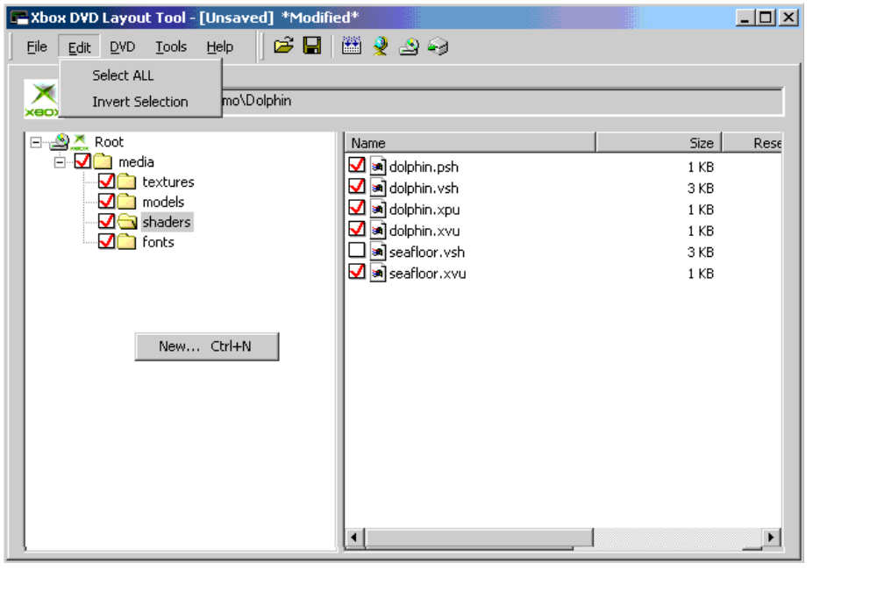
The Applied Microsystems Xbox™ Video Game Console DVD Layout Tool serves as the platform for game image creation and emulation. It gives you access to all the tools you'll need for image generation, turbo or timing-based emulation, and creation of the mastering tapes:
- Disc layout: Automated or selective file identification.
- Disc geography: Automated or manual file mapping to the two layers of the optical disc.
- Emulation control: Point-and-click access to all emulation controls, as well as display of the system's current status. (Can be launched independently.)
- Pre-mastering: Write-to-tape for Microsoft reproduction, and read-from-tape for emulation of previously pre-mastered games. (Can be launched independently.)

Version 1.x Note
You should not attempt to access the DVD emulation drive while emulation is in progress. Doing so can cause the host computer and the XBox to lock up. It may also be necessary to wait a few seconds after writes to the drive before enabling emulation. This allows Windows to finish flushing any cached data from the recent accesses. Having a Microsoft Explorer window open with the emulation drive visible should not be a problem as long the emulation drive is not being accessed by Explorer.

DVD Layout controls and menus
Menu/Option |  | Tool Icon |  | Description
File | New |  |  | Clears the current layout and DVD Root, prompts for new root, and opens new layout file.
 | Open |  |  | Loads an existing DVD file layout description (FLD).
 | Save |  |  | Saves the current file selection and mapping to the currently open .FLD file.
 | Save As |  |  | Saves the current file selection mapping as a new .FLD file. There is no restriction on where this file may reside.
 | Revert |  |  | Discards unsaved changes and reloads the most recently saved layout file.
Edit | Select All |  |  | Highlights all files in the current directory (Ctrl-A). Checking or unchecking is applied to all highlighted files.
 | Invert Selection |  |  | Inverts the current highlight mode of all files in the active directory.
DVD | Build  Image |  |  | Saves the current file selection and mapping, and builds the DVD file system information and binary.
 | Map Disc Geography |  |  | Launches the DVD Geography Editor and loads it with the currently selected layout file.
Tools | Pre-Master Tape |  |  | Launches the Tape Pre-Mastering Tool which creates or reads images suitable for mastering. Tape system must be connected and powered on.
 | Emulate |  |  | Launches the Emulation Control Panel.
Help | Contents |  |  | Launches this Help system.
 | About |  |  | Displays version information.
Set DVD Root |  |  |  | DVD Root is the parent directory for DVD image generation. Only files located in or below the directory identified as DVD Root can be used when generating the image.

Context menu
New | Clears the current layout and DVD Root, prompts for new root, and opens new layout file.

DVD Root
DVD Root is the parent directory for the game's DVD image. Only files located in or below the directory identified as DVD Root can be used when generating the image. For emulation performance reasons, the directory selected as DVD Root should be located on the emulation drive. The read-only field in the DVD Layout Tool displays the directory that is currently selected as DVD Root.

Folder and file panels
The two panels of the DVD Layout Tool serve as an enhanced Explorer-style folder and file navigator. Contents are relative to DVD Root. Check boxes indicate whether a folder or file is selected for inclusion in the DVD image.

Saving and reopening layout files
Each time you save the file layout and mapping or build an image, a File Location Descriptor file (*.fld) is created or regenerated from the current settings in the DVD Layout Tool. A copy of this file is always placed in DVD_Root\_amc when you build an image, but can reside anywhere on your local or network filesystem.

To create and prepare DVD Root
- On the emulation drive, create a root directory to use as DVD Root.
- Modify your game make file to copy the .XBE To DVD Root and rename it default.xbe.
- Copy game media resource subdirectories and data files to DVD Root.

To change DVD Root
- Click the selection button .
- Note: Any current contents of the layout Tool will be discarded when you select a new root. Be sure to save your FLD file before starting a new one.
- Choose how the initial selection should occur:
- Directory and content: Select all directories and files in or below DVD Root for inclusion in the game image.
- Directory only: Select the DVD Root directory, but leave all subdirectories and files deselected. Useful when you intend to use only a subset of the files in DVD Root in the generated image.
- Security: A group of LSNs is set aside for security placeholders. Surrounding them are empty areas of disc space of differing sizes. You can change the settings; however, you will need assistance from Microsoft to do so.
- Use the selection dialog to navigate to the correct directory.
- Click OK.

To open an existing configuration file
- Click the File icon , and navigate to the FLD file that you want.
- The navigator will default to the most recently open FLD.
- Click OK.

Notes
If a files or directories listed in an existing FLD file is no longer in the same location, a listing of those files is displayed. If you choose to proceed, those files/directories are deleted from the FLD when you click Save.

To select folders or files
- Click a folder in the folder pane to expand or collapse it.
- Click the folder check box to select that folder and all its constituent files and subfolders for inclusion in the DVD emulation image.
—Or—
Click the check boxes of individual files in the file pane to select only those files.

Selection indicators
 A red check indicates that the file or folder is selected for inclusion in the image.
 An empty block indicates that the file or folder is not to be included in the image.

Notes
- When you select a file or directory, all directories in the path between it and DVD Root are automatically selected. However, once you have begun customizing selection, a red check at the directory level indicates only that one or more files in the directory or subdirectory has been selected. The may also be unselected files in those directories.
- If you change the selection state of a folder, it files and folders are also changed to that state.

To build an image
When you are ready to build an image for emulation or pre-mastering, you simply click the Build button . A progress dialog reports the build actions and results:
- If necessary, an _amc directory is created below DVD Root.
- If _amc already exists, its contents are discarded.
- The current FLD file is saved to that directory.
- The FST file is generated and saved to that directory. This is the file you load into the emulator.
- If you have used the DVD Geography Editor to map file placement, that mapping is applied. If not, default file placement is used: all selected files, and any remaining unplaced files, are mapped in size order beginning with the outer sector of Layer 0 and carrying over from the outer sector of Layer 1, if necessary.
- A GDFX binary is created (xdfs.bin).

Remapping files to improve performance

DVD Geography Editor
The Xbox™ Video Game Console DVD Geography Editor simplifies mapping files to the DVD disc for optimum performance. It arranges the files selected with the DVD Layout tool and produces output suitable for building the emulation or physical disc image.
Mapping is an optional process unless default placement results in unplaced files. Whenever you save the layout file (*.FLD) or build the DVD image, the system automatically places selected files on the layers of the disc. By default it uses largest-to-smallest size order and automatic placement to optimize use of space on the disc. Files (and groups) must fit within contiguous disc space; they cannot span security placeholders. For performance, it begins placement from the outer edge of Layer 0 and, if space requires, continues from the outer edge of Layer 1.

Buttons and controls
Name | Description
OK | Accepts and saves current file placement.
Cancel | Discards unsaved modifications to placement.
Group Selected Files | Creates group from highlighted file(s).
Ungroup Selected Files | Removes highlighted file(s) from group and places them before group on same layer in descending size order.
Place Files in Layers | Moves all unplaced files from Not Placed tab and places them in unused areas of the disc according to the order in the Not Placed tab. Does not modify any existing file placement on the two layers.
Search | Performs file name or folder name search using specified string.

Display columns
Name | Description
File / Group Name | The name of the group or the file.
In Folder | Location of the files on the local file system.
Size | Size of the file in bytes.
Size (Blocks) | Number of 2048-byte sectors reserved on the disc for this file.
Logical Sector | Logical Sector Number. Identifies where on the DVD the file will be placed.

Context menu options
Command | Description
Move to Layer 0/1 | Moves selected file or group to layer specified.
Unplace Files/Group | Moves selected files or group to the Not Placed tab.
Group | Creates a new group from the files selected.
Move out of Group | Removes selected file(s) from the group.
Collapse/Expand | Toggles group listing. Same as double-clicking the group name.
Rename | Assigns the specified name to the highlighted group.
Ungroup | Moves all files from within the selected group, and deletes group name from list.
Delete Group | Removes empty group from listing.

Not Placed tab
Initially and anytime files remain unmapped, all unmapped files are listed on the Not Placed tab, and the tab header is colored red. The Not Placed tab functions as a scratch area for you and the system. Initially the system lists all files in default size order. Once you begin customizing this order, the order in this tab becomes the order which will be applied if you choose to have the system automatically place the files. If you attempt to exit the editor without placing all files, you are warned, and must acknowledge before proceeding.

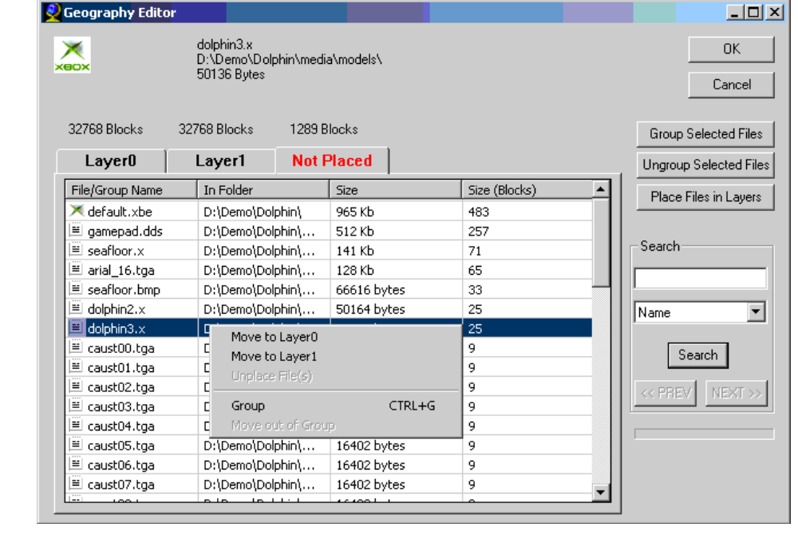

Default automatic file placement
Xbox™ Video Game Console discs use Opposite Track Path (OTP) sequencing of two layers: Layer 0 and Layer 1. Logical Sector Numbers (LSN) ascend from the inside of the disc to the outside (Layer 0) and from the outside to the inside (Layer 1). The outside edge represents the transition between layers.
On each layer, eight security placeholders define areas of empty disc space. These areas are of differing size, typically with the largest empty areas closest to the outer edges. By default, files are placed individually, in size order, largest to smallest. Each file (or an entire group) is moved individually to the first contiguous empty space large enough to hold the file/group. For performance, placement begins from the outer edge of Layer 0 and, if space requires, continues from the outer edge of Layer 1.
- Auto placement attempts to place ALL unplaced files one at a time based on the sort order of the Not Placed tab. Groups are treated for individual placement, not each file in the group. The first available space is used (starting with the outside tracks moving inward, Layer 0 first, then Layer 1).
- Auto placement of files is most efficient when files are sorted by size (largest to smallest).
- Files can be moved after auto placement using drag and drop functions.
- Auto placement does not move files that have previously been placed on a layer.

Manual placement
You can manually place some or all of the files in specific areas on a layer. You can also drag-and-drop to adjust sequencing within a layer. If you choose to place only some files manually, you can use the Place Files on Layers button to apply automatic placement to the files remaining on the Not Placed tab.

Grouping files
Files can be grouped together within named folders. Folder contents display as an indented list below the folder. Groups can be collapsed or expanded. Only one level of grouping is possible. You cannot nest groups within groups. Files in Groups are placed together. Enough contiguous space for the entire group must be available before the group can be placed. Groups can be broken to place files individually.

Note
When a group is moved to a different layer, the file sequence within the group is maintained. Consequently, if a group moves from one layer to the other, the order is inverted. This occurs because the files are arranged according to OTP to be read sequentially on one layer and must remain sequential when moved to the other.
For example, if on Layer 0 you have sequenced three files,
Group
a.txt
b.txt
c.txt
and you move the group to Layer 1, the sequencing is reversed:
Group
c.txt
b.txt
a.txt

Placement tips
- Place performance-critical files first.
- Place very large files early.
- Group files that should remain close together physically on the DVD
- Use auto placement on files sorted from largest to smallest
- Auto-place files. and then move them manually.
- Un-group groups that are too large to place.
- Don’t create many large groups. This will limit placement options.

When all files won't fit
For a variety of reasons, you can encounter a situation where the system reports that all files have not been placed and that remaining files will not fit on the disc. For a representative scenario and suggested solutions, see "File placement scenario" on page 24.

To load files into the Geography Editor
- Select the directories or files using the DVD Layout Tool.
—Or—
- In the DVD Layout Tool's File menu, load an existing FLD file.

To create a placement mapping
- Select the directories and files in the DVD Layout Tool
- Open the DVD Geography Editor
- Click the Not Placed tab.
- Highlight critical file(s) and use the context menu options to move them to a layer.
- Within layers, use drag and drop on files and groups to fine-tune placement.
- Once critical files are mapped, click Place Files in Layers to apply automatic placement to all remaining files.

Notes
- Shift-Click and Alt-Click and Ctrl-A can be used for multiple selection.
- Arrow keys navigate among the tabs.
- Grouping can be useful for file order and easy movement.

File placement scenario
Andrew would like to use the Xbox DVD Emulation tools to prepare his game files for emulation and, eventually, tape pre-mastering. His game software consists of the following files:
Type | Number | Size
Default.xbe | 1 | 100 MB | Game executable
Movie1.vid | 1 | 500 MB | Introduction video clip
Movie2.vid | 1 | 500 MB | End-game video clip
Level*.lvl | 39 | 100 MB | Level Models
Texture*.txt | 1000 | 1 MB | Texture maps
Total | 1042 | 5.1 GB
Andrew decides to use the default Security Placeholders settings, which provide for a large contiguous space at the outermost tracks on both layers of the DVD. He plans on placing his two movie files near the outermost tracks to gain the fastest read performance, one on each layer. Each of his 39 level files is associated with several texture files. Because of the way Andrew has written his game, he would like for levels and their associated textures to be placed together on the DVD. This would eliminate large seek movements in the DVD during game play, improving performance.
His "release" development directory looks like this:
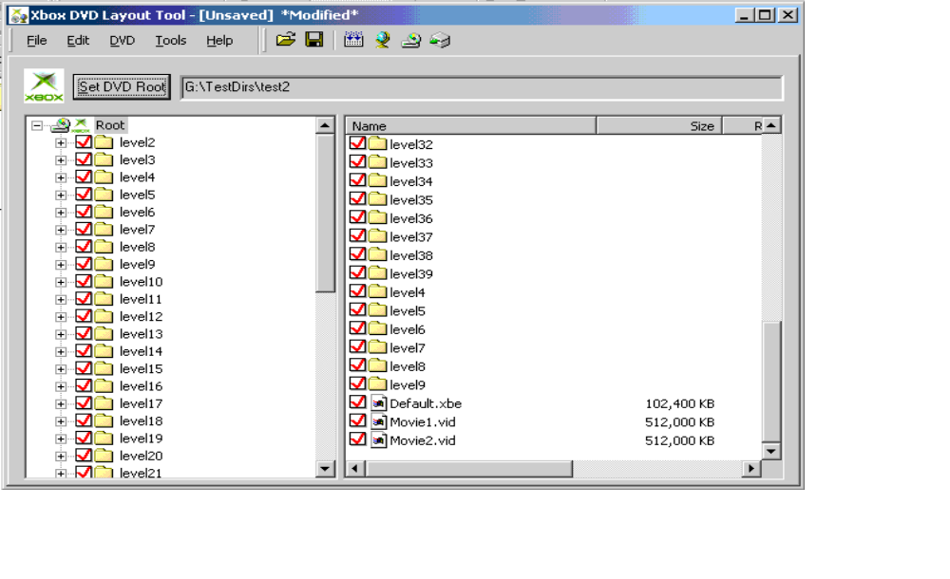
Movies and XBE file in the main directory. Each Level is in a subdirectory with its associated texture files, 10 texture files to each level, with the remaining textures stored in a "Common" directory.
Andrew starts the Xbox DVD Disc Layout Tool. He starts a new FLD project by selecting his release directory as the DVD Root. He scans over his files to ensure that they are all checked. Those that are checked will be placed on the DVD; those that are not checked will be omitted. They are all checked.
He now starts the DVD Geography Editor. All of his files are listed under the Not Placed tab. He has a few options here. He can allow the Geography Editor to place his files automatically, he can place them manually, or he can use a combination of both methods.

Automatic placement
To automatically place files, Andrew merely has to sort the files on the Not Placed tab in the order he wants them placed, and press the Place Files in Layers button. This places each file (starting with the first in the grid control) onto the layers (starting with the outermost tracks of Layer 0, proceeding inward toward the center of the DVD and then similarly on Layer 1).
If Andrew sorts the list by size so that the smallest files are placed first, he will notice that all files cannot be placed on the DVD.
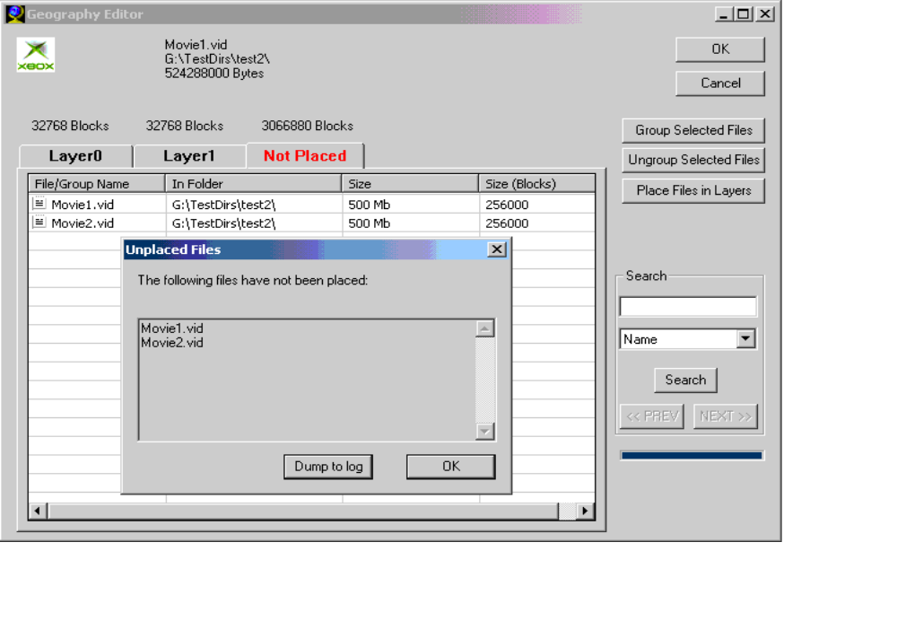
What happens, is that the smaller files (in Andrew’s case, the 1 MB texture files) are placed in the very large spaces in the outermost tracks first. By the time the largest files (the 500 MB video clip files) are to be placed, there is no contiguous empty space on any layer large enough to accommodate them.
If he sorts the list by size, largest to smallest, then the automatic placement method easily places all files.
If Andrew inspects the files that have been placed, he notices that texture files are not grouped with their associated layers.
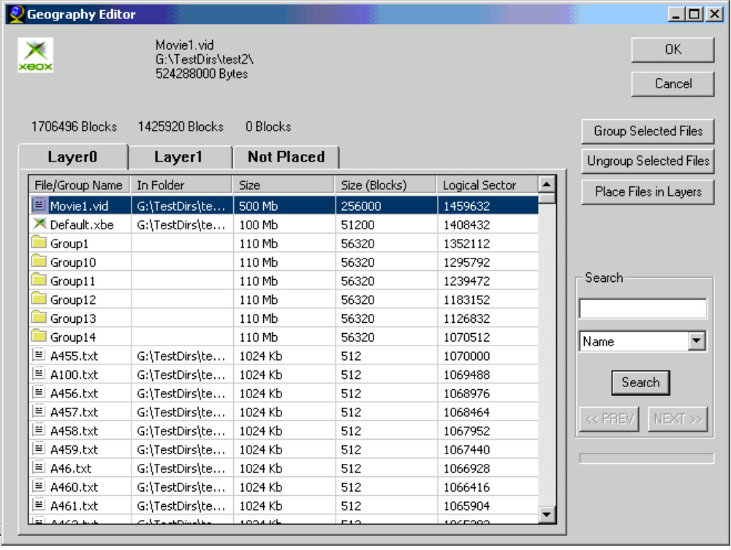
One way he may prevent this fragmentation of files that should be logically grouped is to group them. Since each is located in the same subdirectory, he can sort by folder, select files in the same subdirectories, and group them using the Group Selected Files button. This ensures that files that are grouped are placed together and that sorting will not separate them. However, a contiguous space large enough to hold the entire group must be available for placement. Andrew can see available spaces and their sizes by looking for the "Empty" placeholders in each layer tab. He can also see that if he groups all textures and all level files into one group, he will not be able to place that group at all.

Manual placement
Because Andrew has a good idea of where he would like to place some of his files, he can place them manually. He uses the drag-and-drop function to move Movie1.vid to the first layer. He moves Movie2.vid to the second layer. He moves the XBE file to the first layer. He can drag and drop this file to be before (closest to the outside track of the DVD) or after the Movie1.vid file. [Note: He will probably emulate in both configurations to find out which is best for his needs]. He then sorts the levels and texture files by folder, groups them and then manually places them wherever they fit. This method is slow, but gives a very good idea of where everything is placed.
Of course, he can end up placing files in such a way as to cause problems. For example:
Andrew starts by placing the level/texture groups. He places 10 of these groups (110 Mbytes each) into the outermost space on each layer (10 in the first empty space on Layer 0 and 10 in the first empty space on Layer 0). He has now created a situation where there is not enough contiguous space to place any of the Movie*.vid files (500 Mbytes each). The largest space remaining on either layer is 264 Mbytes.

Manual and automatic placement
The most efficient placement scenario will probably involve using both placement methods.
First, Andrew would place large and/or important files. These are files that he knows need to be placed for reasons of performance and/or because he needs to place very large files before they squeezed out by other placements. In this case, he would place the .vid files and the application .XBE first. He would use drag-and-drop to order them to his liking.
Next he would organize files that needed to be together. In this case, he would use the "Not Placed" tab to sort by folder and group Level files to their respective texture files. Once this is done, he could manually place these grouped files or automatically place them using "move to layer" functionality.
His final step would be to automatically place all remaining files. In the event that something couldn’t be placed, an error message would appear, and Andrew would see that files had not managed to be placed. In such an event, he would need to analyze space usage, move files manually and/or break up groups. He would be able to drop files back onto the "not placed" tab and use that tab as a staging area or scratch area.

Notes about usage
- Auto placement attempts to place ALL unplaced files one at a time based on the sort order of the "Not Placed" tab. Groups are treated for individual placement, not each file in the group. The first available space is utilized (starting with the outside tracks moving inward, layer0 first, then layer1)
- Files in Groups are placed together. Enough contiguous space for the entire group must be made available before the group can be placed.
- Groups can be broken to place files individually.
- Auto placement of files is most efficient when files are sorted by size (largest to smallest).
- Files can be moved after auto placement using drag and drop functions.
- Auto placement does not move previously placed files.
- Files cannot span security placeholders

Placement tips
- Place performance critical files first.
- Place very large files early
- Group files that should remain close together physically on the DVD
- Use auto placement on files sorted from largest to smallest
- Auto place files and then manually move them.
- Un-group groups that are too large to place.
- Don’t create many large groups. This will limit placement options.

To adjust security placeholders
Security placeholders can sometimes make placement of all files impossible. Placeholders can be moved, but typically you cannot adjust them by trial and error. You will need assistance from Microsoft.
- Contact technical support.
- In the DVD Layout Tool, click DVD Root to begin a new layout file.
- Click Security
- Following the guidance of technical support to enter new values in the placeholder fields.
- Click Verify to confirm that the new values meet the internal requirements.
- Click OK to apply the new values.
- Proceed with file layout and mapping.

To group a set of files
- Use Shift-click or Ctrl-click to highlight a set of files.
- Click the Group Selected Files button.
- (Optional) Click to select the resulting group folder in the Group/Name column.
- (Optional) In the context menu, select Rename, and supply a name.
- Click OK.

To resequence files or groups
- Use the primary mouse button to select the file or group.
- Drag-and-drop the selection to the new location.
Note: LSN numbers automatically recalculated once the selection is in its new location.

To delete a group
- Select the group name in the list.
- In the context menu, select Ungroup.

Note
Only the group and group label are deleted. Files are unaffected. If possible, files are placed on the same layer in the same order as when grouped. Otherwise they are returned to the Not Placed tab.

To find a file or group
- In the Search section of the window, use the dropdown list to select the type of search: file Name or Folder name.
- Enter a name or unique string characters in the Search entry field.
- Click the Search button, and use the Next and Prev buttons to navigate among multiple hits.
Search scans sequentially Layer 0, Layer 1, and Not Placed. Next (Ctrl-N) scans from the current position until it reaches the end of Not Placed. Prev (Ctrl-P) scans from the current position to the beginning of Layer 0. Once all layers have been searched, it stops.

To save the file mapping
- Click the Editor's OK button.
- In File menu of the DVD Layout Tool, click Save or Save As.
- Navigate to the directory in which to locate the FLD file.
- Provide a name for the file.
- Click OK.

Notes
All files selected in the Layout Tool must be mapped (placed) on the disc. Unplaced files are listed in the Not Placed tab, and the tab label is red. If you attempt to exit the editor without placing all files, you are warned, and must acknowledge before proceeding. Unplaced files are then appended to the end of any existing mapping using automatic placement.

Starting and controlling emulation

Emulation Control Panel
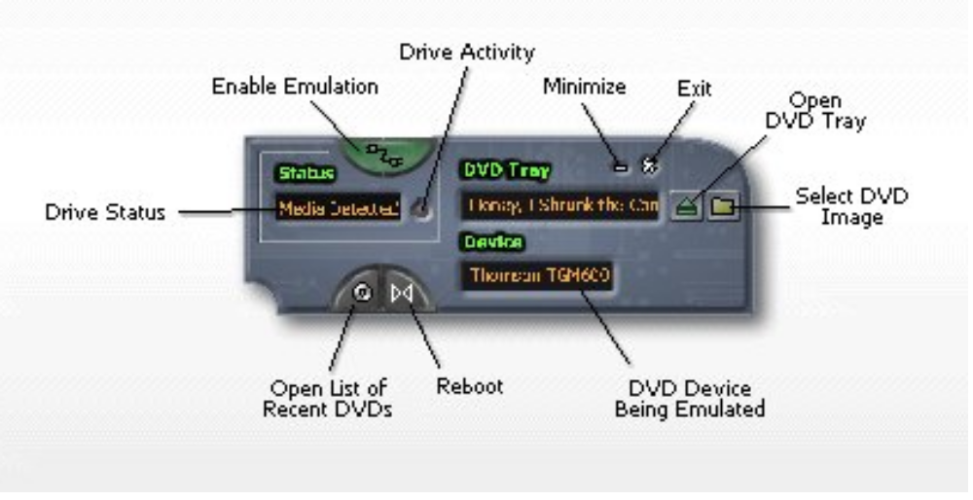
The Applied Microsystems DVD Emulation Control Panel enables you to
- Simulate user actions
- Set emulation modes and start and stop emulation
- Monitor emulation states
Emulation mode selection can be very useful. The system supports three modes:
Thomson mode Emulates the drive characteristics and timing of the Thomson TGM600 DVD drive.
Philips mode Emulates the drive characteristics and timing of the Philips VAD6011/21 DVD drive.
Turbo mode Dispenses with timing emulation and allows HDD-speed.
You can start the controller from the Disc Layout Tool window or directly from the command line.

Enable/Disable
Use this button to enable or disable the emulation system. The drive must be enabled before you can emulate.

Activity LED
This indicator is lit when the game console is accessing the emulation drive. While emulation is in progress, you should not attempt to move or change any file located on the emulation drive.

Exit
- Click this button to close the Emulator Control Panel GUI. Closing the Emulation Control Panel interface does not stop emulation. Notice that the COM server is still present in the tray on the desktop.
- If the Xbox is rebooted during emulation, emulation restarts and loads the game that was running before the reboot.

Open/close tray
Like an actual game console, you must open the tray before selecting a game. To start the game, click the Reboot button.

Select DVD image
Clicking this button raises a file navigator that allows you to select the game to emulate. Choose the FST file.

Emulation mode
This display indicates whether you are in one of three emulation modes:
- Philips: emulates the timing of a Philips drive
- Thomson: emulates the timing of a Thomson drive
- Turbo: injects no timing controls. Uses emulation HHD speed..

Reboot
Executes a soft reboot of Xbox and begins running the game.

Recent DVDs
Lists the most recently used programs. Click one for rapid selection.

Status
Reports the two emulation states controlled by the Enable/Disable button:
Drive Disabled Emulation is disabled.
Drive Enabled: Emulation is enabled.

To start the Emulation Control Panel

Launching the controller from the command line
- Create a shortcut to install-dir\xbdvdemupanel.exe.
- Double-click the shortcut to launch the controller.

Launching the control panel from the Disc Layout Tool
- Click the Emulation Control Panel icon in the toolbar.
—Or—
- Select Emulate in the Tools menu.

To enable/Disable emulation
- Press the Enable button to toggle the emulation state. Status displays the current state:
Drive Enabled: Emulation is enabled.
Drive Disabled: Emulation disabled.

Notes
- Emulation must be disabled if you want to use the actual DVD drive.
- Closing the Emulation Control Panel interface does not stop emulation. Notice that the COM server is still present in the tray on the desktop. As long as emulation is enabled, the icon in the tray rotates.
- If the Xbox is rebooted during emulation, emulation restarts and loads the game that was running before the reboot.
- Anytime you open the DVD tray, the system automatically enables emulation, if it is not already enabled.
- If you cycle power on the Xbox, emulation is no longer enabled.
- Version 1.x: You should not attempt to access the DVD emulation drive while emulation is in progress. Doing so may cause the host computer and the XBox to lock up. It may also be necessary to wait a few seconds after writes to the drive before enabling emulation. This allows Windows to finish flushing any cached data from the recent accesses. Having a Microsoft Explorer window open with the emulation drive visible should not be a problem as long it is not the drive being accessed in Explorer.

To change the emulation mode
The emulation mode defaults to Turbo mode initially, but remembers the most recent setting for all subsequent sessions.
- Toggle the Enable button on the controller to its disabled state.
- Status should display "Drive Disabled."
- Use the context menu "Set Emulation Mode " option to choose Turbo, Thomson, or Philips emulation.
- Click the Enable button to re-enable emulation.

To select and run the game
The DVD Emulator is capable of running either freshly generated images or images extracted from master tapes. To extract images stored on tape, see the Tape Pre-Mastering section.
- If necessary, copy the game files to DVD Root on the emulation drive and build the image.
- Eject the tray with the green "DVD Tray" button .
- Click the "Select DVD Image" button to begin "inserting" a new game into the player.
- In the resulting file selection dialog, select the <project>.fst file.
- Typically this file resides in the _amc subdirectory of DVD Root unless you have extracted the files from tape.
- Close the tray by clicking the "DVD Tray" button .
- Click the Reboot button .
This executes a soft reboot (xbreboot): Xbox should begin running the application selected.

Version 1.0 Note
You should not attempt to access the DVD emulation drive while emulation is in progress. Doing so may cause the host computer and the XBox to lock up. It may also be necessary to wait a few seconds after writes to the drive before enabling emulation. This allows Windows to finish flushing any cached data from the recent accesses. Having a Microsoft Explorer window open with the emulation drive visible should not be a problem as long it is not the drive being accessed in Explorer.

Notes
- The game file in DVD Root must be named default.xbe.
- When you open the tray and select a file, the system automatically enables emulation. This is indicated in the Status field by "Drive Enabled."
- Emulation must be disabled if you want to use the actual DVD drive.
- Closing the Emulation Control Panel interface does not stop emulation. Notice that the COM server is still present in the tray on the desktop.
- If the Xbox is rebooted during emulation, emulation restarts and loads the game that was running before the reboot.

To emulate images from tape masters
This is a useful method of verifying the integrity of images that have been written to tape.
- Use the Pre-mastering tool to read the images from Tape0 and Tape1.
- Verify that the following files are generated at the destination:
- <game_name>.FST
DX2ML.XML
XCONTROL.DAT
XDATA.DAT
- If necessary, start the Emulation Control Panel.
- Open the tray, and select the FST file in the directory where the images reside.
- Close the tray.
If the game does not begin to run, execute xbreboot from the command console.

Notes
- You can choose any of the three emulation modes.
- You cannot alter the file makeup or disk geography of a from-tape image.

To run actual game discs in Xbox
- Start the Emulation Control Panel
- If necessary, toggle the Enable button until Status reads "Emulation Disabled."
- Place the disc in the player and close the tray.
- Click the Control Panel Reboot button .
The game should begin running.

Generating and reloading master tapes

Tape Pre-Mastering Tool
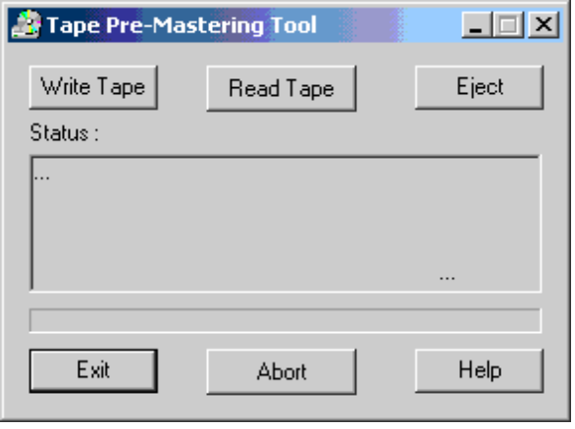
The Applied Microsystems Xbox™ Video Game Console Tape Pre-Mastering Tool enables you to generate a set of game tapes or to extract files from an existing tape. Tapes are generated in the required format which Microsoft can use for encryption and mass production.
A tape drive must be connected and powered up in order to proceed. The Read and Write operations are sequential. Tape0/Layer 0 is processed first, followed by Tape1/Layer1. If you abort an operation, it must be repeated in sequence.

Controls
Name | Description
Write Tape | Prompts for parameters, then writes the selected image to the tape.
Read Tape | Prompts for parameters, then writes the contents of the selected tape to the specified directory.
Status | Reports the current process and status.
Eject | Ejects the tape from drive.
Exit | Closes the tool.
Abort | Stops active portion of write or read operation.

Dialogs
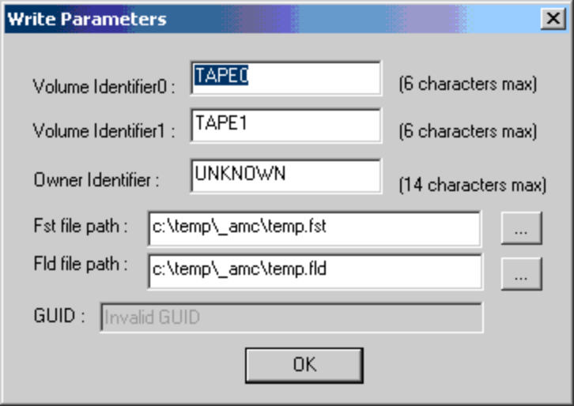
The Write Parameters dialog defines the identifiers for the two tapes and specifies the location of the image source configuration files.
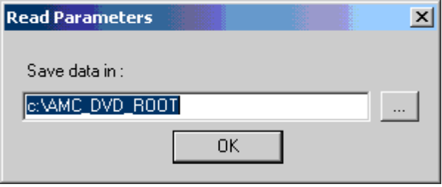
The Read Parameters dialog specifies the destination folder on the host or network drive. There must be at least 8 GB of storage available.
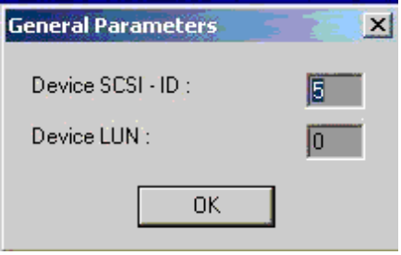
The General Parameters dialog prompts for the SCSI ID number and Logical Unit Number of the tape drive. These are reported in the Device Manager dialog of My Computer.

To start the Tape Pre-Mastering Tool

- From the DVD Layout window Tools menu, select Pre-Mastering Tape Tool.
—Or—
- From the SDK command console, execute <path>\AmcPreMasteringTool.exe.

Note
Unless a tape drive is properly connected and powered up, you will be unable to proceed.

To write a tape set
- Ensure the tape mastering console is properly connected and powered on.
- Start the Tape Pre-Mastering Tool.
- If prompted, provide the SCSI ID and LUN of the tape drive.
- Click Write Tape, and provide the following parameters.
Name | Description
Volume Identifier 0 | Identified for Tape 0. Can use up to six alphanumeric characters.
Volume Identifier 1 | Identified for Tape 1. Can use up to six alphanumeric characters.
Owner Identifier | Can use up to 14 alphanumeric characters.
FST file Path | Full path and filename of the FST file used to build the game.
FLD file path | Full path and filename of the FLD file used to build the game.
GUID  (read only) | 128-bit Global Unique Identifier provided by Microsoft. At installation it is placed in  HKEY_LOCAL_MACHINE\Software\Microsoft\XboxSDK\TapeMastering. The pre-mastering tool retrieves it from the registry.
5 Click OK to validate the parameter information. Resolve any reported errors.
- 6 Insert Tape 0 when prompted.
- 7 Following the write operation, remove Tape 0 when ejected.
- 8 During the write operation, a progress bar indicates the percentage of completion and time remaining. The tape automatically rewinds before ejection.
- 9 When prompted, insert Tape 1, and remove it when it is ejected.

Note
If you abort a write operation, you must begin with Tape 0 and repeat the entire operation.

To abort a read or write
- Click the Abort button.
- Wait until the tape rewinds and ejects before removing it.
- Repeat the read or write operation from Tape 0.

To read a tape set
- Ensure the tape mastering console is properly connected and powered on.
- Start the Pre-Mastering Tool.
- Click Read Tape, and supply the path to the destination directory.
- Insert Tape 0 when prompted.
- In the Parameters dialog, provide the following parameter:
Name | Description
Save data in | Directory in which to write the game files extracted from the tape. You will need at least 7 GB of storage space on the drive.
6 Click OK to validate this information, and respond to any reported errors.
7 Following the read operation, remove Tape 0 when ejected.
During the read operation, a progress bar indicates the percentage of completion and time remaining. The tape automatically rewinds before ejection.
8 When prompted, insert Tape 1, and remove it when it is ejected.
The read operation generates an FST and extracts the game XBE file within the directory specified. It also creates two subdirectories (Layer0 and Layer1). Each of these contains three files (DX2ML.XML, XCONTROL.DAT, XDATA.DAT).

Note
If you abort a read operation, you must begin with Tape 0 and repeat the entire operation.

To locate tape drive properties
- Highlight "My Computer," and press the secondary mouse key.
- Select "Manage."
- Select "Device Manager" in left panel.
- Select the tape drive in the right panel.
- Right-click on the tape you want to identify.
- Select "Properties."

Using the Command Line

Command Line Tools
If you prefer script-driven operation, you can use two commands: XbDvdImg and XbDvdEmu. With them you can perform most image definition, build, and emulation operations.

XbDvdImg
Performs most of the essential operations provided in the DVD Layout Tool:
- Uses the defined DVD Root to create a default layout file (.fld).
- Applies default file sequencing within the disc image.
- Builds the DVD image.

Usage
xbdvdimg [options] [[arguments] "dvd_root"]
Options
-g[ui] | Starts the DVD Layout GUI.
-?|h[elp] | Launches help screen
Arguments
-dr | dvdroot "<DVD_ROOT>" |  | Creates or clears <DVD_ROOT>/_amc.  (Re-)Generates dvdroot.fst, dvdroot.fld, and xdfs.bin in <DVD_ROOT>/_amc.

Notes
Paths or filenames with embedded spaces must be enclosed in quotations.

XbDvdEmu
Performs most of the operations possible using the Emulation Control Panel GUI:
- Manipulates tray.
- Selects game file.
- Enables and disables emulation.
- Selects emulation mode.

Usage
xbdvdemu [options] [imagefile]

Options
-g[ui] | Starts up the GUI
-s[tatus] | Displays the emulation mode: Philips, Thomson, or Turbo.
-v[ersion] | Displays version of the control software
[-i[magefile] <imagefile> |  | Starts up emulation with the given image file. <imagefile> is the pathname of the image file (*.fst).  Note: If there are spaces embedded in the pathname, double quotes (")must be used.
-o[pentray] | Opens the tray
-c[losetray] | Closes the tray
-e[nable] [tu[rbo] | ph[lips] | th[ompson]] |  |  |  | Selects emulation mode and enables emulation.
 | tu[rbo] | turbo mode (default)
 | th[omson | thomson mode
 | ph[ilips] | philips mode
-d[isable] | Disables emulation
-?|h[elp] | Launches help system

Notes
- When you execute a closetray, the Xbox should automatically reboot itself and the game should begin to run. In some cases, you may need to issue xbreboot from the command console.
- Paths or filenames with embedded spaces must be enclosed in quotations
- If you want to use the actual DVD drive, you must disable emulation.

Index
A
Aborting a tape read or write 38
Adjust ingsecurity placeholders 29
B
Building an image 8, 10, 19
C
Changing DVD Root 18
Changing the emulation mode 33
Command Line Tools 40
Commands 40
XbDvdemu 40
XbDvdImage 40
Creating a placement mapping 24
Creating and preparing DVD Root 18
D
Default file mapping 41
Deleting a group 29
DVD Layout Tool 16, 18, 19
panels of 18
reopening a file 19
reopening files 18
saving files 18
selecting folders or files 19
DVD Root 18
changing 18
creating 18
E
Emulating images from tape masters 34
Emulation 31, 32, 33, 34
changing mode 33
controlling 31
enabling/disabling 33
selecting the game 33
starting controller 32
Emulator Controller 31
Enabling and controling emulation 13
Enabling/Disabling emulation 33
F
Finding a file or group 30
Folder and file panels 18
G
Geography Editor 11, 21, 24, 29, 30
deleting a group 29
finding folders and files 30
grouping files 29
loading files into 24
resequencing files or groups 29
saving mapping 30
Grouping a set of files 29
Guided Tour 7, 8, 10, 13, 14
drive preparation 7
enabling and controling emulation 13
file selection 8
improving performance 10
mapping disc geography 10
pre-mastering tapes 14
L
Loading files into the Geography Editor 24
Locating tape drive properties 39
M
Mapping files 21, 24, 29, 30
creating a placement mapping 24
deleting a group 29
finding a folder or file 30
grouping files 29
moving security placeholders 29
saving map 30
O
Opening an existing configuration file 19
P
Pre-Mastering Tool 36, 37, 38, 39
aborting read/write 38
locating tape drive properties 39
reading a tape set 39
starting 37
writing tape set 38
R
Reading a tape set 39
Resequencing files or groups 29
Revert 17
Running actual game discs in Xbox player 35
S
Saving and reopening layout files 18
Saving the file mapping 30
Security placeholders 29
Selecting folders or files 19
Selecting the game to run 33
Starting the Emulation Controller 32
Starting the Pre-Mastering Tool 37
T
Tape mastering 36
W
Walk Through 6
Welcome 5
Writing a tape set 38
X
Xbdvdemu 40
XbDvdImage 40

