CS490 Windows Internals Labs
Oct 9th, 2011

- Viewing DLL Usage
To diagnose DLL conflicts, you need to know which DLLs were loaded and from where
  - Pviewer & pview & tlist lists the loaded DLLs, but not the path (e.g. type “tlist explorer”)
  - Dependency Walker can trace DLL loads
  - Process Explorer or listdlls from www.sysinternals.com lists full path
First of all, we use listdlls to view dlls loaded by a process with the following command:
Listdlls [processname|PID]
We can see dlls loaded by Microsoft Office Word in the following picture.
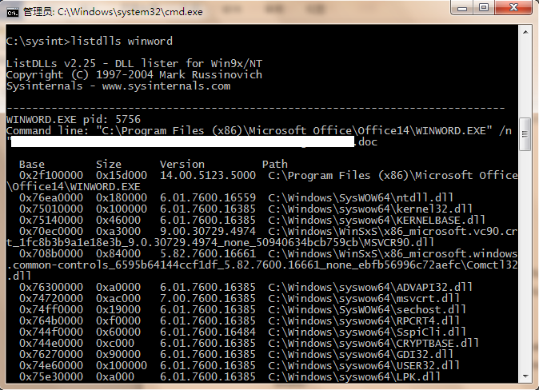

In the following step, we use Process Explorer to view dlls loaded.
  - Run Process Explorer.
  - Select View, Lower Pane View and then select DLLs.
  - Select Show Lower Pane in the View menu.
  - Select Columns for your DLLs pane in DLL tab in the Select Columns dialog window.
  - Choose any columns that you want to view (E.g. Path), then press OK.
  - Click on a process that you want to view, for example POWERPNT.exe (Microsoft Office PowerPoint). Then you will see the loaded DLLs information in the lower pane.
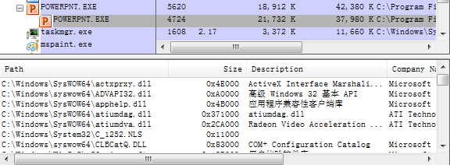

- Viewing the Working Set
Vadump (Resource Kit) can dump the breakdown of private, shareable, and shared pages. Run your Vadump on command prompt. (The Vadump is in CRK-Tools\reskit\) Use this command:
Vadump –o –p [PID]
If you want to view Working Set information for Microsoft Office PowerPoint, find the corresponding process identifier by using Process Explorer. For example the PowerPoint’s PID is 7424, run vadump –o –p 7424, then you can find the working set information in the result.
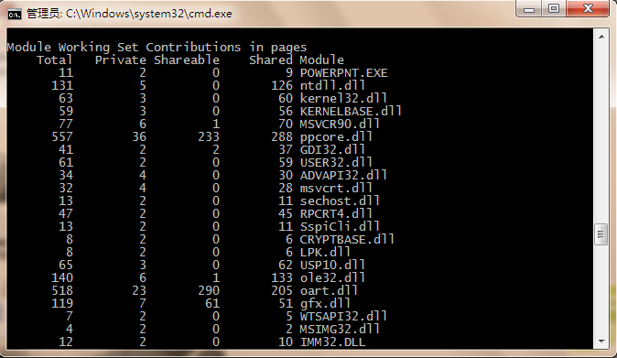

You can also use the Performance Monitor to examine process working set sizes by looking at the following performance counters:
Counter Description
Process: Working Set Current size of the selected process’s working set in bytes
Process: Working Set Peak Peak size of the selected process’s working set in bytes
Process: Page Faults/Sec Number of page faults for the process that occur each second
In order to view PowerPoint’s working set, run Performance Monitor and add the above counters for Process Powerpnt.exe. Change the Vertical Scale Maximum to be 600 or larger.
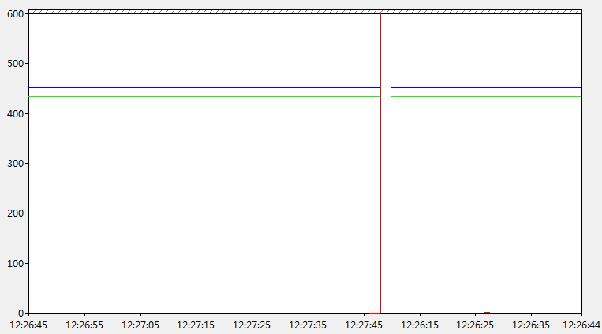
Notice that, the blue line is the working set peak counter and the green line is current working set counter. In this case, the peak number of working set is around 45MB, and the current working set is around 43MB. If page fault happens, the working set will become a little larger, but not above 45MB. Then the page fault will decrease and the working set size will decay to 43MB again.

You can also get the total of all the process working sets by selecting the _Total process in the instance box in the Performance tool. This process isn’t real—it’s simply a total of the process-specific counters for all processes currently running on the system. The total you see is misleading, however, because the size of each process working set includes pages being shared by other processes. Thus, if two or more processes share a page, the page is counted in each process’s working set.

- PFN Database
You can examine individual PFN entries with the kernel debugger !pfn command. You first need to supply the PFN as an argument. (For example, !pfn 0 shows the first entry, !pfn 1 shows the second, and so on.) In the following example, the PTE for virtual address 0x50000 is displayed, followed by the PFN that contains the page directory, and then the actual page:
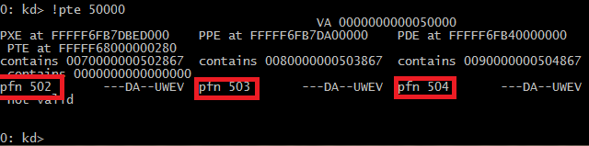
Then, for example we can see the PFN entry with number 502:
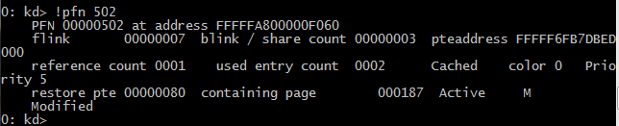

Using the kernel debugger !memusage command, you can dump the size of the various
paging lists. The following is example output from this command:
