CS490 Windows Internals Labs
Oct 14th, 2012

- Viewing the Installed Driver List
In Windows XP/2003/vista/7, you can obtain the driver information by executing the Msinfo32.exe utility from the Run dialog box of the Start menu. Select the System Drivers entry under Software Environment to see the list of drivers configured on the system. Those that are loaded have the text “Yes” in the Started column.

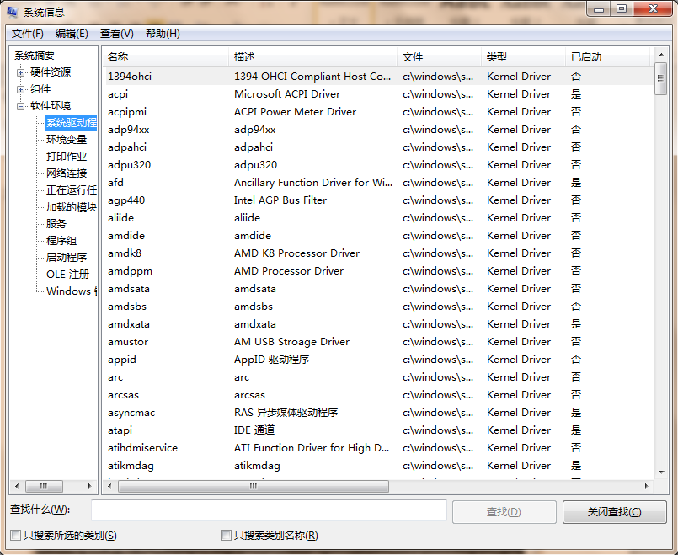

You can also view the list of loaded kernel-mode drivers with Process Explorer from www.sysinternals.com. Run Process Explorer, select the System process, and select DLLs from the Lower Pane menu entry in the View menu. Process Explorer lists the loaded drivers, their names, version information including company and description, and load address (assuming you have configured Process Explorer to display the corresponding columns).
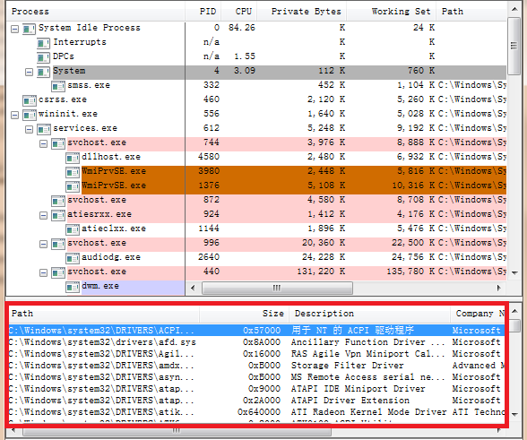

To view loaded driver, you can get a similar display with the kernel debugger lm kv command: kd>lm kv

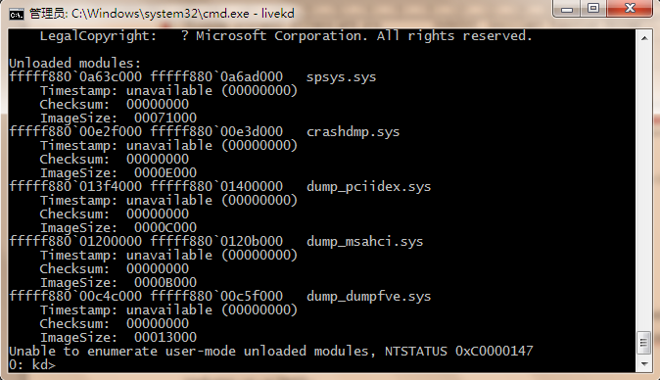

- Viewing \Device Directory
You can use the Winobj tool from www.sysinternals.com or the !object kernel debugger command to view the device names under \Device in the object manager namespace. The following screen shot shows an I/O manager–assigned symbolic link that points to a device object in \Device with an auto-generated name.
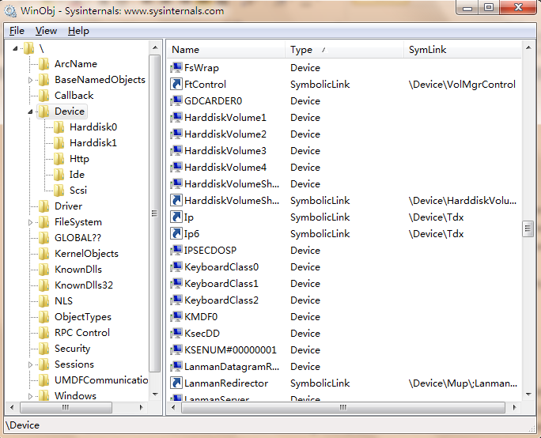
When you run the !object kernel debugger command and specify the \Device directory, you should see output similar to the following:
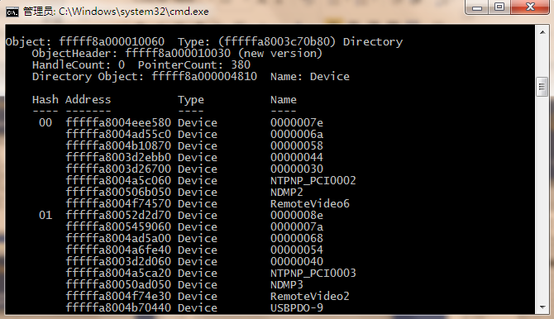
- Device Name Mappings
You can examine the symbolic links that define the Windows device namespace with the Winobj utility from www.sysinternals.com. Run Winobj, and click on the \Global?? on Windows XP or later version. Notice the symbolic links on the right. Try double-clicking on the device C:. C: is a symbolic link to the internal device named \Device\HarddiskVolume1, or the first volume on the first hard drive in the system.
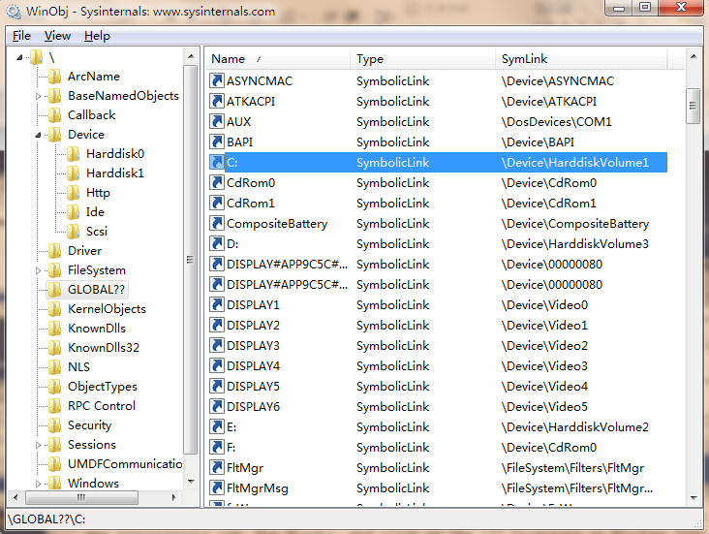

- Viewing the TCP/IP Driver Object and its Device Objects
Using the kernel debugger to look at a live system, you can examine TCP/IP’s device objects. After performing the !drvobj command to see the addresses of each of the driver’s device objects, execute !devobj tcpip 7 to view the name and other details about the device object.
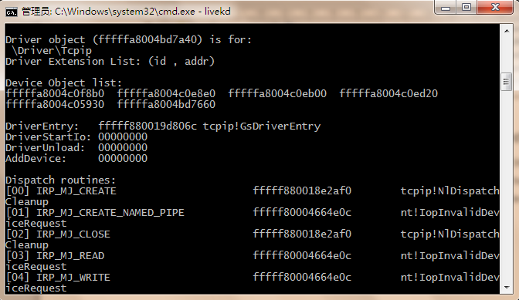
- Looking at Driver’s Dispatch Routines
You can obtain a listing of the functions a driver has defined for its dispatch routines by entering a 7 after the driver object’s name (or address) in the !drvobj kernel debugger command. The following output shows that drivers support 28 IRP types.
Kd>!drvobj kbdclass 7

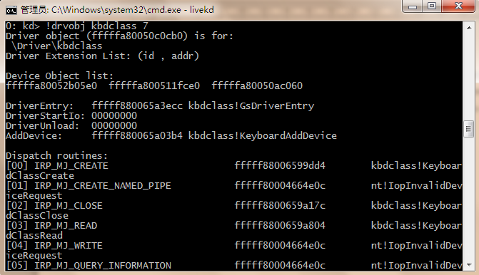

- Find an IRP
In this experiment, you’ll find an uncompleted IRP on the system, and you’ll determine the IRP type, the device at which it’s directed, the driver that manages the device, the thread that issued the IRP, and what process the thread belongs to. At any point in time, there are at least a few uncompleted IRPs on a system. This is because there are many devices to which applications can issue IRPs that a driver will only complete when a particular event occurs, such as data becoming available. One example is a blocking read from a network endpoint. You can see the outstanding IRPs on a system with the !irpfind kernel debugger command:
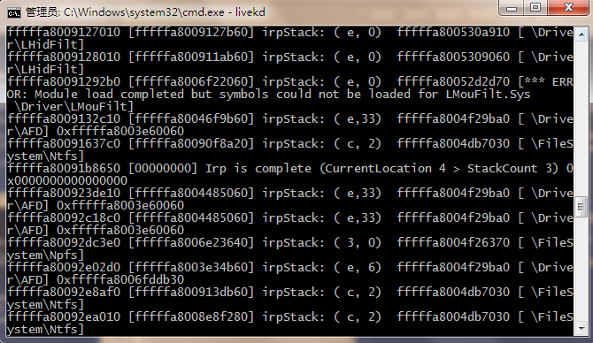

When you use the !thread command, it prints any IRPs associated with the thread.

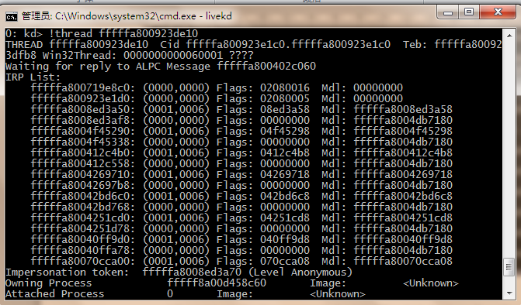

If you want to see the current IRP, use !irp after you scan the IRPs by using !irpfind. You can get result similar to the following screenshot.
