CS490 Windows Internals Labs
Dec 22th, 2010

- Viewing the Device Tree
In Windows, you can check the device tree on your computer very easily by using Device Manager. To bring up the device manager, you can access the Hardware tab of the System application in Control Panel.

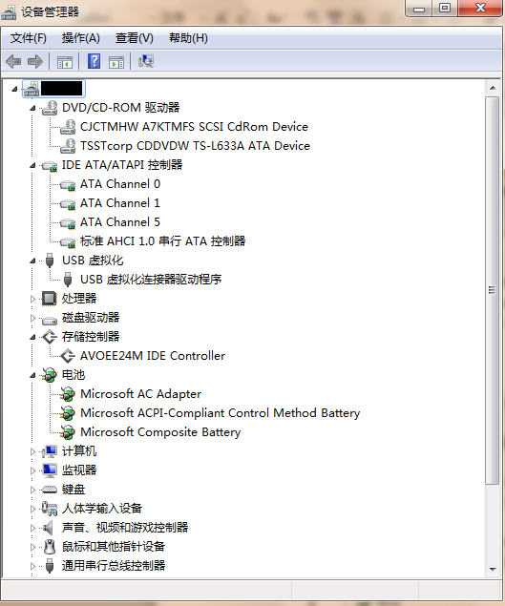

In Windows Vista/7 you can find the Details tab after you double-clicked a device in device manager. (In Windows XP/2003, you must set devmgr_show_details environment variable to a value of 1 to enable the Details tab). The tab allows you to view an assortment of fields including the devnode’s device instance ID, hardware ID, service name, filters, and power capabilities.

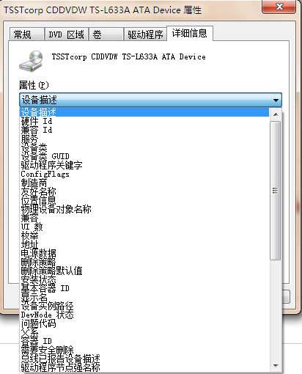

You can also view the device tree by using the !devnode kernel debugger command. Specifying 0 1 as command options dumps the internal device tree devnode structures, indenting entries to show their hierarchical relationships. (For more details, please check the help file for debugging tools for windows)
Kd>!devnode 0 1
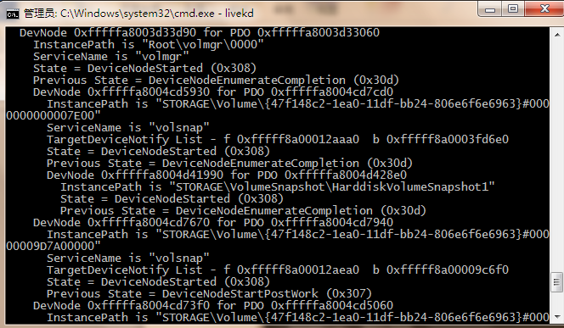

- Viewing a Driver’s Power Mappings
In Windows, you can see a driver’s system power state to driver power state mappings with Device Manager. Open the Properties dialog box for a device, and choose the Power Data entry in the drop-down list of the Details tab to see the mappings.
The dialog box also displays the current power state of the device, the device-specific power capabilities that it provides, and the power states from which it is able to wake the system.
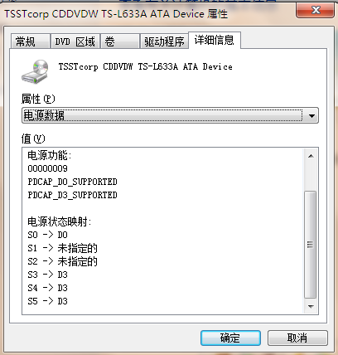
- Viewing the System Power Capabilities and Policy
You can view a computer’s system power capabilities by using the !pocaps kernel debugger command. Here’s the output of the command when run on an ACPI-compliant laptop running Windows 7:

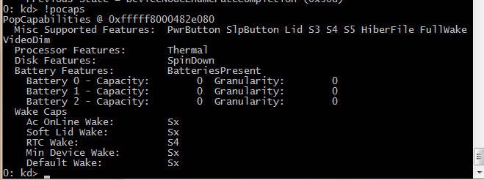

The Misc Supported Features line reports that, in addition to S0 (fully on), the system supports system power states S1, S3, S4, S5 (it doesn’t implement S2) and has a valid hibernation file to which it can save system memory when it hibernates (state S4).
You can change the system’s power policy in Power Options page which can be accessed from Control Panel. The exact properties you can configure depend on the system’s power capabilities.

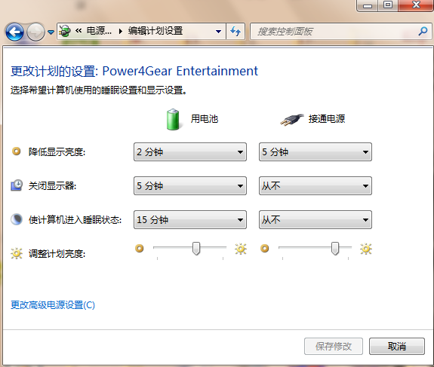
You can display the system’s power policy by using !popolicy debugger command. Here’s an output of the command on the same system.
Kd>!popolicy
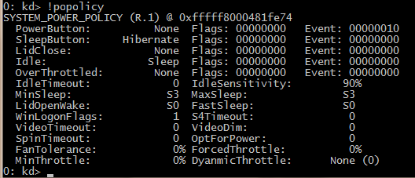

The first lines of the display correspond to the button behaviors sepcified on the Advanced Settings tab of Power Options. In this system, the PowerButton do nothing and SleepButton do Hibernate.
The timeout values correspond to the settings you can see configured on the Power Options page. In this system, the video timeout is 0 which means never turn off the monitor.

