CS490 Windows Internals Labs
Oct 26th, 2012

- NTFS Streams
Most Windows applications aren’t designed to work with alternate named streams, but both the echo and more commands are. Thus, a simple way to view streams in action is to create a named stream using echo and then display it using more. The following command sequence creates a file named test with a stream named stream:


If you perform a directory listing, test’s file size doesn’t reflect the data stored in the alternate stream because NTFS returns the size of only the unnamed data stream for file query operations, including directory listings.

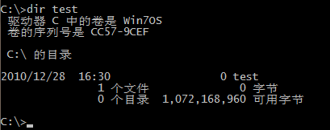

You can determine what files and directories on your system have alternative data streams with the Streams utility from Sysinternals (see the following output) or by using the /r switch in the dir command.

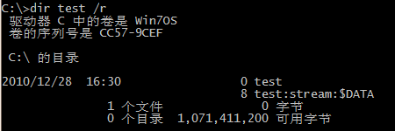

- Hard Links and Symbolic Links
Creating a Hard Link
There are two ways you can create a hard link: the fsutil hardlink create command or the mklink utility with the /H option. In this experiment we’ll use mklink because we’ll use this utility later to create a symbolic link as well. First, create a file called text.txt and add some text to it, as shown here
Now create a hard link called hard.txt as shown here:
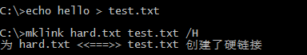
If you list the directory’s contents, you’ll notice that the two files will be identical in every way, with the same creation date, permissions, and file size; only the file names differ.
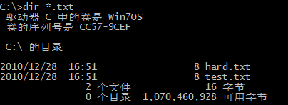

Creating a Symbolic Link
This experiment shows you the main difference between a symbolic link and a hard link, even when dealing with files on the same volume. Create a symbolic link called soft.txt as shown here, pointing to the test.txt file created in the previous experiment:
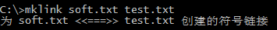
If you list the directory’s contents, you’ll notice that the symbolic link doesn’t have a file size and is identified by the <SYMLINK> type. Furthermore, you’ll note that the creation time is that of the symbolic link, not of the target file. The symbolic link can also have security permissions that are different from the permissions on the target file.
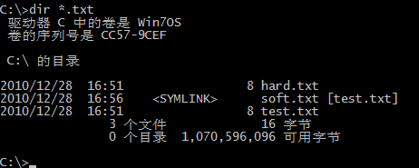
Finally, if you delete the original test.txt file, you can verify that both the hard link and symbolic link still exist but that the symbolic link does not point to a valid file anymore, while the hard link references the file data.
The hard link:
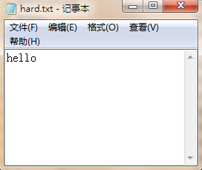
The symbolic link:
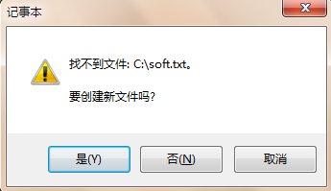

- Viewing the NTFS Information
You can use the built-in fsutil.exe command-line program to view information about an NTFS volume, including the placement and size of the MFT and MFT zone:
