Multiprocessor Considerations for Kernel-Mode Drivers
Preliminary Version - October 28, 2004
Abstract
Hyper-threading and future technologies mean that all new machines will eventually support more than one processor. Therefore, every Windows driver must be designed to handle the concurrency and synchronization requirements that multiprocessor systems impose and must be thoroughly tested on both single-processor and multiprocessor systems.
This paper is for developers of kernel-mode drivers for the Microsoft® Windows® family of operating systems.
This information applies for the following operating systems:
Microsoft Windows 2000
Microsoft Windows XP
Microsoft Windows Server™ 2003
Microsoft Windows Vista™
The current version of this paper is maintained on the Web at:
http://www.microsoft.com/whdc/driver/kernel/MP_issues.mspx
References and resources discussed here are listed at the end of this paper.
Contents
1 Introduction 3
2 Multiprocessor Support in Windows 3
3 Simultaneous Thread Execution 5
4 Reentrant and Concurrent Routines 7
4.1 Reentrancy 7
4.2 Concurrency 7
5 Synchronizing Access and Enforcing Program Order 13
5.1 The volatile Keyword 13
5.2 Windows Synchronization Mechanisms 16
6 Memory Barriers and Hardware Reordering 17
6.1 Memory Barrier Semantics 17
6.2 Windows Kernel-Mode Memory Barrier Routines 19
6.3 Hardware Reordering on x86, x64, and Itanium Architectures 19
7 Performance and Scalability 22
7.1 Locking Issues 22
7.2 Caching Issues 24
8 Testing 25
8.1 Driver Verifier 26
8.2 Call Usage Verifier 26
8.3 Kernrate and KrView 26
8.4 DevCon 26
9 About NUMA Architectures 27
10 Best Practices for Drivers 28
11 Resources 28

Disclaimer
This is a preliminary document and may be changed substantially prior to final commercial release of the software described herein.

The information contained in this document represents the current view of Microsoft Corporation on the issues discussed as of the date of publication. Because Microsoft must respond to changing market conditions, it should not be interpreted to be a commitment on the part of Microsoft, and Microsoft cannot guarantee the accuracy of any information presented after the date of publication.

This White Paper is for informational purposes only. MICROSOFT MAKES NO WARRANTIES, EXPRESS, IMPLIED OR STATUTORY, AS TO THE INFORMATION IN THIS DOCUMENT.

Complying with all applicable copyright laws is the responsibility of the user. Without limiting the rights under copyright, no part of this document may be reproduced, stored in or introduced into a retrieval system, or transmitted in any form or by any means (electronic, mechanical, photocopying, recording, or otherwise), or for any purpose, without the express written permission of Microsoft Corporation.

Microsoft may have patents, patent applications, trademarks, copyrights, or other intellectual property rights covering subject matter in this document. Except as expressly provided in any written license agreement from Microsoft, the furnishing of this document does not give you any license to these patents, trademarks, copyrights, or other intellectual property.

Unless otherwise noted, the example companies, organizations, products, domain names, e-mail addresses, logos, people, places and events depicted herein are fictitious, and no association with any real company, organization, product, domain name, email address, logo, person, place or event is intended or should be inferred.

© 2004 Microsoft Corporation. All rights reserved.

Microsoft, Windows, Windows Server, and Windows Vista are either registered trademarks or trademarks of Microsoft Corporation in the United States and/or other countries.

The names of actual companies and products mentioned herein may be the trademarks of their respective owners.

Introduction
In the past, the typical Microsoft® Windows® computer had only a single processor. Multiprocessor configurations could be found in high-end servers and computing-intensive labs, but such systems were the exception rather than the rule. As technology improves and prices decrease, desktop applications are becoming more CPU intensive, requiring processing power that only a few years ago was found mainly on servers and in labs.
Hyper-threaded processors, which Windows treats as two CPUs, are already becoming common in machines for home and desktop environments. Soon, most new computers will be multiprocessor systems. All new drivers must be designed and tested for such systems.
Because the Windows kernel is fully preemptible, writing drivers to run on multiprocessor systems is no different from writing drivers to run on single-processor systems. However, errors in synchronization and locking are more likely to occur on multiprocessor systems because code from a single driver can run simultaneously on more than one processor. A driver that has been tested and debugged on single-processor systems may fail when run on a multiple-processor system because of previously undetected bugs.
To write drivers that operate correctly on all Windows platforms, you should be familiar with the following:
- Multiprocessor architectures that Windows supports
- Simultaneous thread execution
- Reentrancy and concurrency of standard driver routines
- Driver synchronization requirements
- Performance and scalability issues
- Tools for testing on multiprocessor hardware

In addition, Microsoft Windows Server™ 2003 includes limited support for cache-coherent non-uniform memory access (ccNUMA) architectures; expanded support is planned for the next client version of Windows, Microsoft Windows Vista™. This paper includes a brief discussion of driver issues for such architectures.

Multiprocessor Support in Windows
Windows supports symmetric multiprocessor (SMP) architectures. In SMP architectures, all CPUs are identical and have uniform access to memory and I/O control registers. Windows treats hyper-threaded architectures as two-CPU multiprocessors.
Figure 1 shows how CPUs, memory, and devices might be configured on an SMP system.
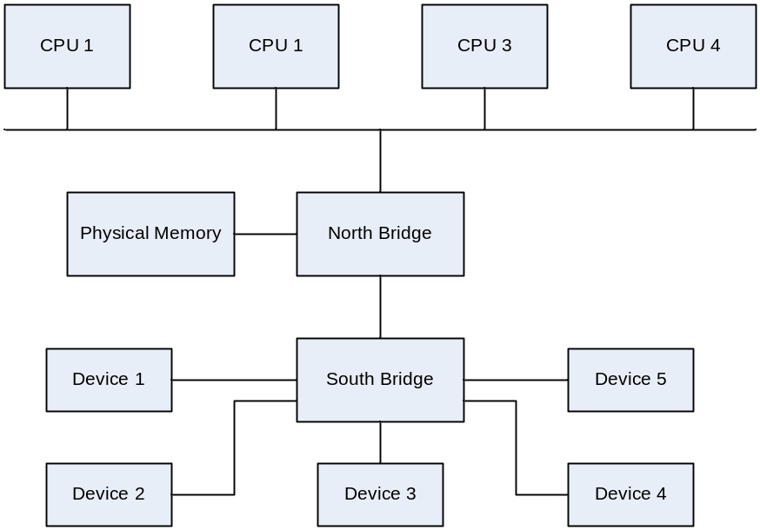

Figure 1. Organization of Traditional SMP System
On SMP architectures, each CPU has uniform access to memory, so that operations have the same effect regardless of which CPU issues them. Each CPU has its own cache.
By default, Windows assumes that any device can interrupt on any processor, although some chip sets might favor one CPU over another. When the device interrupts, its InterruptService routine runs immediately on the same processor that the device interrupted, and its DpcForIsr routine subsequently runs on the same processor also.
Microsoft provides separate executable images of the Windows kernel and several other system files for single-processor and multiprocessor machines. During installation, the correct files are loaded onto the hardware.
The number of processors supported depends on the edition of Windows, as summarized in Table 1. These numbers represent physical processors, not logical processors. Therefore, a hyper-threaded processor counts as only one processor for licensing purposes, even though the operating system treats it as two processors.
Table 1. Number of Processors Licensed for Windows Editions
Operating System Version | Edition | Number of processors
Windows Server 2003 | Web | 2
Windows Server 2003 | Enterprise | 8
Windows Server 2003 | Standard | 4
Windows Server 2003 | Datacenter | 32 (32-bit architectures)  64 (64-bit architectures)  128 (in 2 partitions)
Windows XP | Home | 1
Windows XP | Professional | 2
Windows 2000 | Professional | 2
Windows 2000 | Server | 4
Windows 2000 | Advanced Server | 8
Windows 2000 | Datacenter Server | 32

Simultaneous Thread Execution
In most ways, the single-processor and multiprocessor versions of Windows are identical. The major difference of interest to driver writers involves thread scheduling and execution.
By default, Windows schedules all threads—including user-mode and kernel-mode threads—across all processors; no processors are reserved for system use. The highest-priority ready thread on the system is guaranteed to be running at all times. On multiprocessor systems, Windows tries to schedule the next-highest priority ready threads on additional processors, but does not guarantee such scheduling. For example, on a four-processor system, at any given time one processor will be running the highest priority thread, but the other three processors will not necessarily be running the next three highest-priority threads. For more detailed information about the thread scheduling algorithm for multiprocessor systems, see Inside Microsoft Windows 2000, Third Edition, as listed in the Resources section.
Because more than one thread runs at the same time, more than one driver routine can run at the same time. Thus, it is possible—even likely—that code from a single driver will be running in two or more different thread contexts, on different processors, simultaneously.
Figure 2 shows a simplified example of how two different processors run different threads simultaneously.
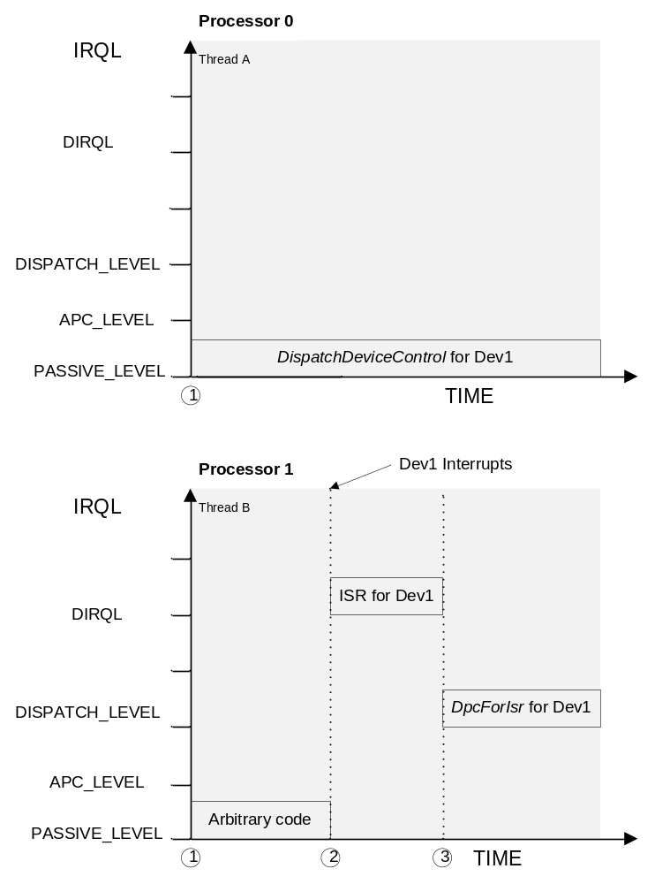
Figure 2. Simultaneous Threads on Multiprocessor Systems
In Figure 2, the following operations occur in sequence:
1. At the start, Thread A is running on Processor 0 and Thread B is running on Processor 1. In Thread A the DispatchDeviceControl routine for Device 1 (Dev1) is running at IRQL PASSIVE_LEVEL. In Thread B, arbitrary code for some process is running, also at PASSIVE_LEVEL.
2. Device 1 interrupts on Processor 1, indicating that it has finished an earlier I/O request. Processor 1 raises IRQL to DIRQL to run the InterruptService routine (ISR). The InterruptService routine stops the device from interrupting and queues a DpcForIsr routine. Meanwhile, the DispatchDeviceControl routine continues running on Processor 0 at PASSIVE_LEVEL.
3. The InterruptService routine completes on Processor 1, which then lowers IRQL to DISPATCH_LEVEL and runs the DpcForIsr previously queued by the InterruptService routine for Device 1. The DispatchDeviceControl routine continues running on Processor 0 at PASSIVE_LEVEL.

Because the IRQL is associated with an individual CPU, the hardware interrupt on Processor 1 has no effect on Processor 0. Therefore, the DispatchDeviceControl routine continues running on Processor 0 while the device interrupts on Processor 1 and the InterruptService and DpcForIsr routines run. The DispatchDeviceControl routine thus runs concurrently with the InterruptService routine and with the DpcForIsr routine. If DispatchDeviceControl shares writable data with either of the other two routines, the driver must use locks to ensure that only one routine accesses the shared data at a time.
The need for locks in such situations is not limited to multiprocessor systems. For example, assume that the DispatchDeviceControl routine (which runs at PASSIVE_LEVEL) shares writable data with the DpcForIsr routine (which runs at DISPATCH_LEVEL). The DispatchDeviceControl routine must acquire a lock that raises IRQL to DISPATCH_LEVEL or higher before accessing the shared data. On single-processor systems, Windows implements spin locks by raising IRQL to DISPATCH_LEVEL, thus preventing preemption while the lock is held. ExInterlockedXxx and InterlockedXxx routines also prevent preemption at DISPATCH_LEVEL.

Reentrant and Concurrent Routines
To correctly implement synchronization in your driver, you need to know which driver routines are reentrant and which can run concurrently. Most standard driver routines are both reentrant and concurrent.

Reentrancy
A routine is reentrant if the same copy in memory can be shared by more than one user. Reentrant routines do not maintain static data between calls; all data is provided by the caller of the function. Any caller-specific data that the routine maintains must be stored in an area specific to that call.
Most standard driver routines are designed to be reentrant. For example, in a driver’s I/O dispatch routines, call-specific data is maintained in each individual IRP and passed from one driver to the next. Each driver must either complete the IRP or mark the IRP pending before passing it to the next driver on the stack. Only the DriverEntry and Unload routines are not reentrant.

Concurrency
Two routines that can run at the same time are said to be concurrent. For a driver, concurrency generally means that the operating system (usually the I/O or PnP manager) might call one routine before a previously called routine has completed. For example, the system could call a driver’s Cancel routine while its DispatchRead routine is running.
When two routines can run concurrently, you must ensure that any shared, writable data is accessed by only one routine at a time unless all such accesses are read-only. The data might be in a shared memory buffer, in the device extension, or in a global variable. This means you must use locks, interlocked routines, or some other synchronization technique to prevent conflicts.
Some drivers manage more than one device; others can perform I/O on more than one file at a time. Windows typically calls the standard driver routines to perform a specific task on behalf of a particular driver object, device object, or file object. Whether Windows calls two routines concurrently thus depends on the driver, device, or file objects that each such routine uses. For example, the system might call a driver’s DispatchPnp routine to handle an IRP_MN_REMOVE_DEVICE request for one device while the same routine is handling an IRP_MN_START_DEVICE request on behalf of another device, because the two requests affect different device objects. However, the system would not call these routines concurrently if the two requests were targeted at the same device.
Tables 2, 3, and 4 in the following sections list the concurrency of standard driver routines with respect to driver objects, device objects, and file objects. Refer to the tables to find out whether the operating system calls two routines concurrently with the same object. In the tables:
- Yes means that the system might call the routine listed at the top while the routine at the left is running.
- No means that the system does not call the routine listed at the top while the routine at the left is running.
- Maybe means that whether the routines can run concurrently depends on how the driver is implemented. For example, whether a particular worker thread routine can be called concurrently depends on what the worker thread does.

For example, in a driver that manages two or more devices, the StartIo routine for one device can run concurrently with the DispatchRead routine for another device. However, if the two requests target the same device, these two routines cannot run concurrently. Thus, the StartIo and DispatchRead routines are concurrent with respect to the driver object, but not with respect to the device object.

Concurrency with Respect to Driver Object
Table 2 lists the concurrency of standard driver routines with respect to the driver object.
Table 2. Concurrency of Driver Functions per Driver Object
Routine to be called |  | AddDevice | Cancel | DispatchPnp | DispatchPower |  | DispatchXxx | DPC | ISR | StartIo | Unload | Worker Thread Routine
Routine currently running |  | AddDevice | Cancel | DispatchPnp | System | Device
AddDevice |  | Yes | Yes | Yes | Yes | Yes | Yes | Yes | Yes | Yes | No | Maybe
Cancel (if set) |  | Yes | Yes | Yes | Yes | Yes | Yes | Yes | Yes | Yes | No | Yes
DispatchPnP | Start device | Yes | Yes | Yes | Yes | Yes | Yes | Yes | Yes | YesError: Reference source not found | No | Maybe
DispatchPnP | Other | Yes | Yes | Yes | Yes | Yes | Yes | Yes | Yes | Yes | No | Maybe
DispatchPower | SystemError: Reference source not found | Yes | Yes | Yes | Yes | Yes | Yes | Yes | Yes | Yes | No | Maybe
DispatchPower | DeviceError: Reference source not found | Yes | Yes | Yes | Yes | Yes | Yes | Yes | Yes | Yes | No | Maybe
DispatchXxxError: Reference source not found |  | Yes | Yes | Yes | Yes | Yes | Yes | Yes | Yes | Yes | No | Maybe
DPC |  | Yes | Yes | Yes | Yes | Yes | Yes | Yes | Yes | Maybe | Maybe | Maybe
ISR |  | Yes | Yes | Yes | Yes | Yes | Yes | Yes | Yes | Maybe | Maybe | Maybe
StartIo |  | Yes | Yes | Yes | Yes | Yes | Yes | Maybe | Maybe | Maybe | No | Maybe
Unload |  | No | No | No | No | No | No | Maybe | Maybe | No | No | Maybe
Worker Thread Routine |  | Maybe | Yes | Maybe | Maybe | Maybe | Maybe | Maybe | Maybe | Maybe | Maybe | Maybe

Most driver routines are concurrent with respect to the driver object because most driver tasks are performed on behalf of a file or device object, rather than the driver itself. Driver routines that perform driver-wide activities, such as adding a device, are typically not concurrent. For example, in Table 2, a driver’s Unload routine for a given driver object cannot be called while the driver’s AddDevice routine is running.

Concurrency with Respect to Device Object
Table 3 lists the concurrency of standard driver routines with respect to the device object.
Driver routines that communicate with or change the state of the physical device are typically not concurrent with respect to the device object. For example, as Table 3 shows, a driver’s StartIo routine cannot be called while the DispatchPnP routine is handling a Plug and Play state change IRP for the same device object. The converse is also true. Plug and Play state-change IRPs include the following minor IRP codes:
IRP_MN_CANCEL_REMOVE_DEVICE
IRP_MN_CANCEL_STOP_DEVICE
IRP_MN_QUERY_REMOVE_DEVICE
IRP_MN_QUERY_STOP_DEVICE
IRP_MN_REMOVE_DEVICE
IRP_MN_START_DEVICE
IRP_MN_STOP_DEVICE
IRP_MN_SURPRISE_REMOVAL

Concurrency with Respect to File Object
Table 4 lists the concurrency of standard driver routines with respect to a file object.
For a file object, concurrency of standard driver routines is typically related to the state of the file object. For example, a driver’s DispatchCleanup routine is not called until the handle to the specified file object has been closed. Therefore, it cannot be called for a given file object while the DispatchClose or DispatchCreate routine is running for that same file object, and vice versa, as Table 4 shows.

Table 3. Concurrency of Driver Functions per Device Object
Routine to be called |  |  | Cancel | DispatchPnp |  | DispatchPower |  | DispatchXxx | DPC | ISR | StartIo | Unload | Worker Thread Routine
Routine currently running |  |  | Cancel | State change | Other | System | Device
AddDevice |  |  | No | No | No | No | No | No | No | No | No | No | Maybe
Cancel (if set) |  |  | Yes | Yes | Yes | Yes | Yes | Yes | Yes | Yes | No | No | Yes
DispatchPnP |  | State-changeError: Reference source not found | No | No | No | No | Yes | No | Yes | Yes | No | No | Maybe
 |  | Other | Yes | Yes | Yes | Yes | Yes | Yes | Yes | Yes | Yes | No | Maybe
DispatchPower |  | SystemError: Reference source not found | Yes | No | Yes | No | No | Yes | Yes | Yes | Yes | No | Maybe
 |  | DeviceError: Reference source not found | Yes | Yes | No | No | No | Yes | Yes | Yes | No | No | Maybe
DispatchXxxError: Reference source not found |  |  | Yes | Yes | Yes | Yes | Yes | Yes | Yes | Yes | No | No | Maybe
DPC |  |  | Yes | Yes | Yes | Yes | Yes | Yes | Yes | Yes | Maybe | Yes | Maybe
ISR |  |  | Yes | YesError: Reference source not found | Yes | Yes | Yes | Yes | Yes | No | Maybe | MaybeError: Reference source not found | Maybe
StartIo | Cancelable |  | Yes | No | Yes | Yes | Yes | No | Maybe | Maybe | No | No | Maybe
StartIo | Noncancelable |  | No | No | Yes | Yes | Yes | No | Maybe | Maybe | No | No | Maybe
Unload |  |  | No | No | No | No | No | No | Yes | Maybe | No | No | Maybe
Worker Thread Routine |  |  | Yes | Maybe | Maybe | Maybe | Maybe | Maybe | Maybe | Maybe | Maybe | Maybe | Maybe

Table 4. Concurrency of Driver Functions per File Object
Routine to be called |  | Cancel | Dispatch Routines |  |  | DPC | ISR | StartIo | Unload | Worker Thread Routine
Routine currently running |  | Cancel | Cleanup | Create, Close | Other dispatch
Cancel (if set) |  | Yes | Yes | No | Yes | Yes | Yes | Yes | Yes | Maybe
Dispatch Routines | Cleanup | Yes | No | No | Yes | Yes | Yes | Yes | No | Maybe
Dispatch Routines | Close, Create | No | No | No | No | Yes | Yes | No | No | Maybe
Dispatch Routines | Other dispatchError: Reference source not found | Yes | Yes | No | Yes | Yes | Yes | Yes | No | Maybe
DPC |  | Yes | Yes | Yes | Yes | Yes | Yes | Maybe | Yes | Maybe
ISR |  | Yes | Yes | Yes | Yes | Yes | Yes | Maybe | Yes | Maybe
StartIo |  | Yes | Yes | Yes | Yes | Maybe | Maybe | No | No | Maybe
Unload |  | No | No | No | No | Maybe | Maybe | No | No | Maybe
Worker thread routine |  | Yes | Maybe | Maybe | Maybe | Maybe | Maybe | Maybe | Maybe | Maybe

Synchronizing Access and Enforcing Program Order
Maintaining correct data within a driver involves two factors:
- Synchronizing access to data
- Enforcing program order of execution

Synchronizing access to data means ensuring that only one thread at a time can access the data, and that operations on the data are performed in the correct order. In general, drivers require synchronization in the following situations:
- Shared data might be accessed concurrently by multiple driver routines, unless all such code accesses it in a read-only manner.
- A set of operations must be performed as a single unit (atomically).

Without synchronization, read or write operations performed by driver routines running concurrently in two different thread contexts might be interleaved or might appear in the wrong order, or a multistep operation might not be completed as an atomic unit. (One common multistep operation is adding an entry to a doubly-linked list and updating the pointer to the next entry in the list.) Either can cause a driver to use stale or incorrect data, which could result in a driver or system crash.
In a poorly written driver, such problems could easily occur on multiprocessor systems, where multiple threads execute simultaneously. They can also occur on single-processor systems if the thread in which the driver code is running is pre-empted. Drivers should use the volatile keyword in C and the standard Windows synchronization mechanisms to prevent these problems.
Enforcing program order of execution means ensuring that your code executes in the sequence you intended. Keep in mind that the code you write is not necessarily executed in the order in which the instructions appear in the source.
Optimizing compilers, such as the Microsoft C compiler, sometimes eliminate or reorder read and write instructions if the optimizations do not break the logic of the routine being compiled. For example, if routine A performs two successive reads from the same variable without changing its value in the interim, the compiler might eliminate one of the read instructions as redundant. Such an optimization is consistent with the logic of routine A. However, if routine B, which shares the data, writes the variable in the meantime, the optimization can result in routine A using stale or incorrect data. Furthermore, certain hardware architectures sometimes reorder read and write instructions to improve performance.
Most of the time, reordering by the compiler or the hardware is completely invisible to the programmer and has no effect on results other than generating them more efficiently. However, in a few situations, you must prevent or control reordering.
The volatile keyword in C and the Windows synchronization mechanisms can also enforce program order of execution in nearly all situations.

The volatile Keyword
The volatile keyword in C indicates that the value associated with a variable can be changed by something outside the control of the current thread.
The compiler reads the value of a volatile variable from memory each time the variable is referenced and writes the value of the variable to memory each time it is assigned. Without the volatile keyword, the compiler might optimize access to the variable by combining read or write operations or by reordering references to the variable in code.
Consider the following code snippet:
int Var1, Var2;

Var1=0;
Var2=1;
/* more code intervenes
.
.
.
Var1=Var1+Var2;

In the example, neither Var1 nor Var2 is declared as volatile. Therefore, after the compiler writes these variables according to the first two assignment statements, it might not read them again before it performs the addition in the last statement. If neither value changes in the meantime, this optimization works without error. However, if the value of either Var1 or Var2 is modified elsewhere in the driver after the current code assigns a value, the addition might be performed with stale or incorrect data.
Assume that Var2 is changed by another driver routine that is running concurrently. The following snippet would then ensure that the compiler reads the current value of Var2 before adding it to Var1:
int Var1;
volatile int Var2;

Var1=0;
Var2=1;
/* more code intervenes
.
.
.
Var1=Var1+Var2;

In addition, declaring a variable as volatile prevents the compiler from reordering references to that variable relative to any other volatile variables. However, it does not prevent the reordering of references to nonvolatile variables relative to the volatile variable. Consider the following example:
volatile ULONG Vol1, Vol2;
ULONG NonVol;

Vol1 = 1;
NonVol = 2;
Vol2 = 3;

Vol1 and Vol2 are declared volatile, and NonVol is not. Given these declarations, the compiler could generate code that performs the assignments in the following order:
NonVol = 2;
Vol1 = 1;
Vol2 = 3;

In this case, the compiler has reordered the assignment to NonVol so that it precedes the assignments to Vol1 and Vol2. The assignments to Vol1 and Vol2 remain in the same relative positions; that is, the assignment to Vol1 still precedes the assignment to Vol2. The following order is also valid:
Vol1 = 1;
Vol2 = 3;
NonVol = 2;

Here the compiler has reordered the assignment to NonVol so that it follows the assignments to Vol1 and Vol2. As in the preceding example, the assignments to Vol1 and Vol2 remain in the same relative positions; that is, the assignment to Vol1 still precedes the assignment to Vol2. The compiler would not, however, reorder the assignments as follows:
NonVol = 2;
Vol2 = 3;
Vol1 = 1;

This ordering is not valid because the assignment to Vol2 now precedes the assignment to Vol1. The compiler always keeps references to volatile variables in the same relative order.
Details of how to implement the volatile keyword are not specified in the ANSI language standards, but are left to compiler developers. Therefore, implementations may vary from compiler to compiler. Never assume that every C compiler—or even every version of a single manufacturer’s C compiler—implements volatile in the same way.
The Microsoft C compiler generates code for each assignment to or reference of a volatile variable, even if the code appears to have no effect. If you declare a variable as volatile, the compiler considers it volatile for the lifetime of the variable. You can also cast a single reference as volatile; in this case, the compiler is guaranteed to generate code for that reference only.
Consider the following example, which defines a queue of items:
typedef struct GENERIC_QUEUE {
struct GENERIC_QUEUE * volatile Next;
PQUEUE_ITEM volatile QueueItem;
} MY_QUEUE, *PMY_QUEUE;

In this structure, Next points to the next item in the queue, so its value changes whenever an item is added or deleted from the queue. Next is declared volatile because concurrent driver routines may read or write the value. The QueueItem field, which is a pointer to the current item, is declared volatile for the same reason. The volatile keyword ensures that the compiler generates a read or write instruction, as appropriate, each time the field is read or written.
However, declaring these fields as volatile is not sufficient to ensure proper driver operation in all situations. For example, if the driver adds an item to the queue and increments the Next pointer, it must lock the queue to ensure that both pointers are updated together, in a single, atomic operation.
In drivers, the volatile keyword is most useful in the following situations:
- A single variable of the native machine size (32 bits wide on 32-bit hardware or 64 bits wide on 64-bit hardware) has one writer and multiple readers. Because the variable is the native machine size, the processor reads and writes it in an atomic operation; such reads and writes do not require synchronization. However, because the writer and one or more readers can run concurrently, it must nevertheless be read every time it is used.
- Instead of using the READ_REGISTER_* and WRITE_REGISTER_* macros, some drivers create a structure that mimics the layout of the device’s hardware registers and call MmMapIoSpace to map the structure on top of the registers themselves. To read and write the device registers, the driver simply reads and writes the members of the structure. However, this technique does not work correctly on hardware that reorders memory accesses. To ensure working code, the driver must declare each member of the structure as volatile (to prevent compiler reordering) and use KeMemoryBarrier (to prevent hardware reordering) between any two accesses that must occur in program order. See “Windows Kernel-Mode Memory Barrier Routines” for details.

If you look at the sample drivers shipped with the Windows DDK, you will see that volatile appears infrequently. In general, volatile is of limited use in driver code for the following reasons:
- Using volatile prevents optimization only of the volatile variables themselves. It does not prevent optimizations of nonvolatile variables relative to volatile variables. For example, a write to a nonvolatile variable that precedes a read from a volatile variable in the source code might be moved to execute after the read.
- Using volatile does not prevent the reordering of instructions by the processor hardware.
- Using volatile correctly is not enough on a multiprocessor system to guarantee that all CPUs see memory accesses in the same order.
Windows synchronization mechanisms are more useful in preventing all these potential problems.

Windows Synchronization Mechanisms
Windows synchronization mechanisms synchronize access, enable atomic operations, and protect against compiler reordering. They include interlocked operations (InterlockedXxx and ExInterlockedXxx routines) and various types of locks.
The appropriate mechanism to use depends on the type of data, how the driver is using the data, and the highest IRQL at which any thread might access the data. If any of the driver code that accesses the data can run at DISPATCH_LEVEL or higher, every access must either occur in an interlocked operation or be enclosed in a spin lock. The following list summarizes these mechanisms:
- The InterlockedXxx routines perform common arithmetic and logical operations atomically, ensuring correct results on multiprocessor systems. Whenever possible, drivers should use these routines because they are fast. Most of them are native processor instructions that are implemented inline by the compiler and can be called at any IRQL.
- The ExInterlockedXxx routines perform arithmetic and manipulate lists. To ensure atomic operation, they disable interrupts on the current processor and use a spin lock to protect the data from access by code running in a thread running on another processor.
- Spin locks protect operations at IRQL DISPATCH_LEVEL or higher. (Keep in mind that any data that can be accessed at DISPATCH_LEVEL must be in nonpaged memory.) In addition, you should consider using a spin lock if your driver requires synchronization at a lower IRQL but few other threads are likely to contend for the lock. In such situations, spin locks can be less expensive to acquire and release than mutexes, fast mutexes, or executive resources.
- Mutexes, fast mutexes, and executive resources are blocking primitives used to protect data that is accessed at lower IRQLs. Mutexes allow mutually exclusive access, one thread at a time. Executive resources provide read/write locks, which allow one thread to have write access or allow many threads to have read access.

For more details about using any of these mechanisms, see “Locks, Deadlocks, and Synchronization,” listed in the Resources section at the end of this article.

Memory Barriers and Hardware Reordering
In certain situations on some hardware architectures, the processor can reorder read and write instructions. Furthermore, on multiprocessor architectures, the sequence in which read and write operations are executed can appear different from the perspective of different processors. To prevent hardware reordering, the executable code must contain memory barriers.
If your driver uses only the standard Windows locking mechanisms, you don’t need to be concerned about hardware reordering or memory barriers. All of the standard Windows locking mechanisms (spin locks, mutexes, kernel events, and resources managed by the executive resource package) protect against processor reordering by inserting memory barriers where required in executable code. So do the InterlockedXxx and ExInterlockedXxx functions.
This feature is an important reason to use the Windows mechanisms and to avoid creating your own locks. As a general rule, a driver should never create its own locks except in the rare situations where it has special requirements that make using the Windows mechanisms impractical or undesirable. Driver-created locks must insert memory barriers to prevent hardware reordering in certain conditions. These conditions can be difficult to detect and the problems resulting from them can be extremely tricky to debug.
However, if you choose not to use the standard mechanisms, you need to understand what memory barriers are, what they do, and how, why, and where to use them.

Memory Barrier Semantics
A memory barrier is a processor instruction that preserves the ordering of read and/or write operations from the perspective of any other processor. Memory barriers include processor instructions with acquire, release, and fence semantics. These semantics describe the order in which results of an operation become visible.
- Acquire semantics mean that the results of the operation are visible before the results of any operation that appears after it in code.
- Release semantics mean that the results of the operation are visible after the results of any operation that appears before it in code.
- Fence semantics combine acquire and release semantics. The results of an operation with fence semantics are visible before those of any operation that appears after it in code and after those of any operation that appears before it.

Figures 3, 4, and 5 show how acquire, release, and fence semantics affect the order in which the results of operations are visible.
In Figure 3, Operation 3 has acquire semantics. This means that the results of Operation 3 are visible before the results of Operations 4, 5, and any other operation that follows it in code. The acquire semantics do not, however, affect the order in which the results of Operations 1 and 2 are visible. These results might appear before or after those of Operations 3, 4, or 5.
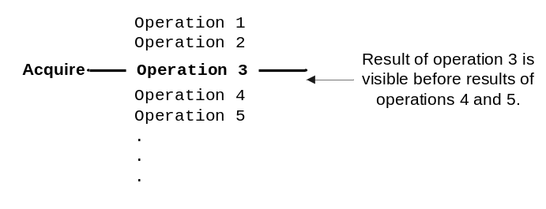
Figure 3. Acquire Semantics
In the next figure (Figure 4), Operation 3 has release semantics. Therefore, the results of Operations 1 and 2, which precede it, are visible before the results of Operation 3 are visible. However, the order in which the results of Operation 3 are visible with respect to Operations 4 and 5 is not specified. The results of these operations, which follow the release instruction, might be visible before or after those of Operation 3.
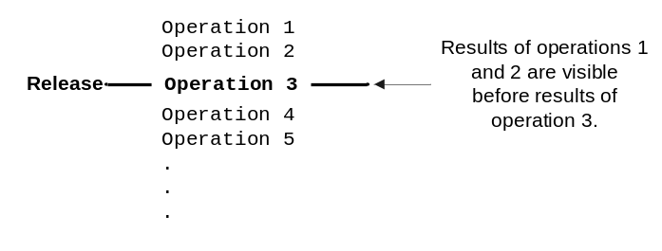
Figure 4. Release Semantics
Finally, in Figure 5, Operation 3 has fence semantics. This means that the results of Operations 1 and 2 are visible before the result of Operation 3, and that the result of Operation 3 is visible before the results of Operations 4 and 5.
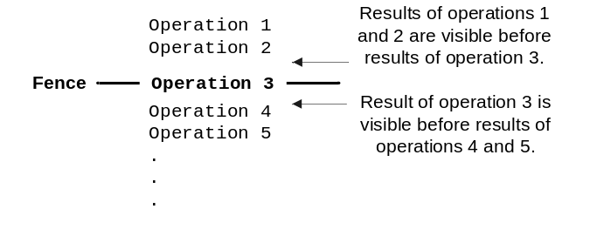
Figure 5. Fence Semantics
On x86 and x64-based hardware (including AMD64 and the Intel Extended Memory 64 Technology), the InterlockedXxx and ExInterlockedXxx functions have both acquire and release semantics by default. The Intel Itanium architecture, however, can execute operations that have either acquire or release semantics (and not both) faster than those that have both. On Windows Vista, Microsoft plans to provide versions of the InterlockedXxx and ExInterlockedXxx functions that support either acquire or release semantics.
In addition, Microsoft CL 14.0.0 and later versions tighten the restrictions on the types of reordering that can occur around volatile variables. In these compilers, reads from volatile locations are treated as acquires and writes to volatile locations are treated as releases on hardware architectures that support these semantics.

Windows Kernel-Mode Memory Barrier Routines
The KeMemoryBarrier and KeMemoryBarrierWithoutFence routines explicitly insert memory barriers in kernel-mode code. These routines were first released in the DDK for Windows Server 2003. They are declared in Ntddk.h and Wdm.h.
The following is the syntax for these routines:
VOID KeMemoryBarrier (
VOID
);

VOID KeMemoryBarrierWithoutFence (
VOID
);

KeMemoryBarrier inserts a fence instruction at the current position in the executable code on hardware that supports this instruction. Thus it preserves the visibility order of subsequent operations for all processors in the machine. Specifically, this routine requires that all read and write operations that precede it in code must appear complete before any operations that follow it are executed, from the perspective of any processor in the machine.
KeMemoryBarrierWithoutFence prevents only the compiler from reordering. The compiler does not move any instructions that precede the call to occur after the call to the routine. However, this routine does not prevent reordering by the hardware.

Hardware Reordering on x86, x64, and Itanium Architectures
The x86-based, x64-based (AMD64 and Intel Extended Memory 64 Technology), and Itanium-based architectures all reorder instructions in some situations. Reordering is a feature of the chip itself; therefore, NUMA architectures are subject to the same reordering scenarios as the underlying processor.
Important All driver code should be platform-independent. Instead of including platform-specific code paths to handle processor reordering, code your driver to operate on all possible platforms. By using the standard Windows synchronization mechanisms and if necessary, the kernel-mode memory barrier routines, you can avoid the need for any special-case code.
On x86-based, x64-based and Itanium-based hardware, reordering might take place when a write operation for one location precedes a read operation for a different location. Processor reordering might move the read operation ahead of the write operation on the same CPU, thus effectively reversing their order in code. These architectures do not reorder read operations followed by read operations or write operations followed by write operations.
The following code sequence shows a situation where this sort of processor reordering might cause problems in a driver. The code is oversimplified to demonstrate the issue and ignores the possibility of compiler rearrangement.
The source code declares a and b and initializes both to 0, as follows:
LONG a = 0;
LONG b = 0;

The following code sequence executes in Thread 1:
{
a = 1;
b = 2;
}

The following code sequence executes in Thread 2:
{
LONG c;

b = 0;
c = a;
}

If the instructions are executed in program order, you could expect the final results to be any of the following:
Results | How Obtained
a = 1, b = 0, c = 1 | All code in Thread 1 executes before any code in Thread 2.
a = 1, b = 2, c = 0 | All code in Thread 2 executes before any code in Thread 1.
a = 1, b = 2, c = 1 | Code in Threads 1 and 2 execute in an interleaved order.

However, processor reordering could result in the following sequence of operations:
Thread | Operation | Resulting Value
2 | Read a | a = 0
1 | Write a | a = 1
1 | Write b | b = 2
2 | Write b | b = 0
2 | Write c | c = 0

If instructions are executed in this order, the final result in memory would be a=1, b=0, and c=0.
To prevent this problem, the code should either assign 0 to b in an interlocked sequence or call KeMemoryBarrier immediately before assigning the value of a to c. The following example uses an interlocked sequence:
{
LONG c;

InterlockedExchange (&b, 0);
c = a;
}

The call to InterlockedExchange is an implicit memory barrier. It ensures that the result of the assignment to b is visible before the processor reads the value of a.
The following example shows how to use KeMemoryBarrier to solve the same problem:
{
LONG c;

b = 0;
KeMemoryBarrier();
c = a;
}

KeMemoryBarrier inserts a memory barrier instruction in the generated code. The memory barrier ensures that the result of assigning 0 to b is visible before the processor reads a.

Additional Hardware Reordering on the Intel Itanium Architecture
In addition to the reordering scenario described in the preceding section, shared memory access is subject to the following rules on Itanium-based architecture:
- Multiple write operations can be combined so that they appear as a single operation, thus preventing a processor from reading an interim value.
- The order of reads and writes to different locations is not preserved when seen from the perspectives of different processors. In this case, Processor 1 might write a new value to location x and then read a new value from location y, but Processor 2 sees the result of the read operation before it sees the result of the write operation.

The following example shows a situation in which read and write operations to shared memory might be reordered. The example includes a driver-created lock and illustrates one of the problems such locks might encounter. The standard Windows locking mechanisms are not subject to this problem.
In the example, the AcquireLock routine acquires a lock on an object. The ReleaseLock routine, in turn, releases the lock.
static LONG Lock = 0;
static LONG Total = 0;

void AcquireLock (PLONG pLock)
{
while (1) {
if (InterlockedCompareExchange (pLock, 1, 0) == 0) {
break;
}
}
//
// Lock is acquired.
//
}

void ReleaseLock (PLONG pLock)
{
*pLock = 0;
}

Consider the following code sequence, which uses these locking routines:
AcquireLock (&Lock);
Total++;
ReleaseLock (&Lock);

AcquireLock correctly uses InterlockedCompareExchange to lock the object. However, ReleaseLock does not use an interlocked exchange or a memory barrier. Consequently, either the compiler or the hardware could reorder the instruction that increments Total so that it occurs outside the locked code region, thus causing errors on multiprocessor systems.
The following code corrects this problem:
void ReleaseLock (LONG VOLATILE *pLock)
{
KeMemoryBarrierWithoutFence ();
*pLock=0;
}

The corrected code declares pLock as a volatile parameter, which ensures that the compiler generates code for the assignment to *pLock. The memory barrier prevents the compiler from reordering the statement that increments Total to occur after the assignment to *pLock. Using a standard Windows locking mechanism, such as an InterlockedXxx or ExInterlockedXxx routine, would also prevent this problem.

Performance and Scalability
A driver’s performance and scalability on multiprocessor hardware depend to a great extent on its use of locks and cache. Addressing performance and scalability can be difficult, particularly if you are developing a single driver that must perform well on a wide variety of hardware configurations. In some cases, optimal tuning for single-processor or dual-processor machines conflicts with that for high-end hardware with many processors. You should consider your primary market and the life cycle of your device and driver in determining the best design.

Locking Issues
Some performance problems related to locks are more likely to appear on multiprocessor machines than on single-processor machines. The material here summarizes the major issues facing driver writers. For more detailed information, see “Locks, Deadlocks, and Synchronization,” listed in the Resources section at the end of this article.

Frequently Used Locks
The types of locks your driver uses are an important and easily controllable factor in ensuring good performance. The InterlockedXxx and ExInterlockedXxx routines are designed for speed and should be used whenever possible.
On a multiprocessor system, heavy use of system-wide locks, such as the kernel dispatcher lock or the cancel spin lock, can slow system performance. If many threads that use such locks are running simultaneously, performance slows while threads spin, waiting for the lock. A driver that creates a single lock and uses it often or for several purposes can have similar performance problems, especially if the device controlled by that driver is used heavily.
Waiting threads acquire in-stack queued spin locks in first-come, first-served order, making acquisition of these locks fairer than acquisition of traditional spin locks. In-stack queued spin locks are often faster, as well. However, they are held at a higher IRQL than traditional spin locks. For this reason, they can actually degrade performance if held for a long time. Queued spin locks are most appropriate for use in high-contention situations in which they are held briefly. Traditional spin locks are preferable in low-contention situations.
Follow these guidelines when choosing and using locks:
- Keep in mind that single references to variables of the native machine size are always atomic. That is, on 32-bit hardware, 32-bit variables are accessed in a single machine instruction, and similarly for 64-bit variables on 64-bit hardware. You don’t need to lock such references unless they are part of an operation that requires strong ordering or must be performed atomically.
- Use cancel-safe IRP queues to avoid use of the system-wide cancel spin lock.
- Use InterlockedXxx and ExInterlockedXxx functions to perform simple logical, arithmetical, and list operations atomically.
- Use spin locks only when required. Use in-stack queued spin locks when lock contention is high and the hold time is very brief. Use traditional spin locks when lock contention is low.
- Minimize lock hold times by eliminating all unnecessary code from locked regions.

Deadlocks
A deadlock occurs when code running in Thread A holds a lock that code running in Thread B is trying to acquire while the code in Thread B holds a lock that code in Thread A is trying to acquire. Neither thread can progress until the other releases its lock.
To prevent deadlocks in your driver, define a locking hierarchy that specifies the order in which locks will be acquired. Code that conforms to a locking hierarchy always acquires locks in hierarchical order. For example, a driver that requires two locks, A and B, would always acquire lock A before acquiring lock B. If your driver consistently follows these rules, deadlocks cannot occur.
In addition, drivers can cause system deadlocks—and eventual crashes—by calling system routines that use locks from too high an IRQL. For example, driver code that runs at DISPATCH_LEVEL or higher can cause a deadlock by calling a system routine that waits for a mutex. The mutex is a kernel-dispatcher object, and code that waits for such objects must run at PASSIVE_LEVEL or APC_LEVEL. (For details, see “Locks, Deadlocks, and Synchronization,” which is listed in the Resources section.) For similar reasons, a driver that tries to acquire a spin lock from its InterruptService or SynchCritSection routine can cause a deadlock, because these routines run at DIRQL, and spin locks operate at the lower DISPATCH_LEVEL. Before attempting to call a system routine from driver code that runs at IRQL>PASSIVE_LEVEL, check the Windows DDK to determine the IRQLs at which the system routine can be called.

Live Locks
Live locks are another problem that appears more often on multiprocessor systems than on single-processor systems. In a live lock situation, code running in two or more threads tries to acquire the same lock at the same time, but the threads keep blocking each other. This problem can occur when two driver routines try to acquire a lock in the same kind of loop. For example:
void AcquireLock (PLONG pLock)
{
while (1) {
InterlockedIncrement (pLock);
if (*pLock == 1) {
break;
}
InterlockedDecrement (pLock);
}
}

This example shows a lock acquisition routine. If this routine executes in two threads simultaneously, a live lock can occur. Each thread increments pLock, determines that pLock equals 2 instead of 1, then decrements the value and repeats. Although both threads are “live” (not blocked), neither can acquire the lock.

Caching Issues
Optimizing drivers for caching can be difficult and time-consuming. Consider such optimizations only after you have thoroughly debugged and tested your driver and after you have resolved any locking problems or other performance bottlenecks.
Drivers typically allocate nonpaged, cached memory to hold frequently accessed driver data, such as the device extension. When it updates the cache, the hardware always reads an entire cache line, rather than individual data items. If you think of the cache as an array, a cache line is simply a row in that array: a consecutive block of memory that is read and cached in a single operation. The size of a cache line is generally from 16 to 128 bytes, depending on the hardware; KeGetRecommendedSharedDataAlignment returns the size of the largest cache line in the system.
Each cache line has one of the following states:
- Exclusive, meaning that this data does not appear in any other processor’s cache. When a cache line enters the Exclusive state, the data is purged from any other processor’s cache.
- Shared, meaning that another cache line has requested the same data.
- Invalid, meaning that another processor has changed the data in the line.
- Modified, meaning that the current processor has changed the data in this line.

All architectures on which Windows runs guarantee that every processor in a multiprocessor configuration will return the same value for any given memory location. This guarantee, which is called cache coherency between processors, ensures that whenever data in one processor’s cache changes, all other caches that contain the same data will be updated. On a single-processor system, whenever the required memory location is not in the cache, the hardware must reload it from memory. On a multiprocessor system, if the data is not in the current processor’s cache, the hardware can read it from main memory or request it from other processors’ caches. If the processor then writes a new value to that location, all other processors must update their caches to get the latest data.
Some data structures have a high locality of reference. This means that the structure often appears in a sequence of instructions that reference adjacent fields. If a structure has a high locality of reference and is protected by a lock, it should typically be in its own cache line.
For example, consider a large data structure that is protected by a lock and that contains both a pointer to a data item and a flag indicating the status of that data item. If the structure is laid out so that both fields are in the same cache line, any time the driver updates one variable, the other variable is already present in the cache and can be updated immediately.
In contrast, consider another scenario. What happens if two data structures in the same cache line are protected by two different locks and are accessed simultaneously from two different processors? Processor 0 updates the first structure, causing the cache line in Processor 0 to be marked Exclusive and the data in that line to be purged from other processors’ caches. Processor 1 must request the data from Processor 0 and wait until its own cache is updated before it can update the second structure. If Processor 0 again tries to write the first structure, it must request the data from Processor 1, wait until the cache is updated, and so on. However, if the structures are not on the same cache line, neither processor must wait for these cache updates. Therefore, two data structures that can be accessed simultaneously on two different processors (because they are not protected by the same lock) should be on different cache lines.
To test for cache issues, you should use tools that return information about your specific processor. A logic analyzer can help you determine which cache lines are contending. Some processor vendors make available software packages that can read performance data from their processors. Check your vendor’s Web site to find out if such a package is available.

Testing
You should always test every driver on both multiprocessor and single-processor machines. Testing on both increases the chances that you will discover problems related to timing and synchronization. In particular, testing on multiprocessor systems often reveals latent driver bugs that would eventually appear on a single-processor system, but that might not become apparent until after the driver has shipped.
As the number of processors increases, you are likely to find more bugs and more types of bugs. Unfortunately, multiprocessor hardware—especially machines with four or more processors—can be expensive. A practical solution is to use a two-processor hyper-threaded machine in testing. Such a configuration is relatively cheap, but it presents four processors to the operating system.
The Windows DDK includes numerous tools that can help you find problems in your driver. The following are especially useful in analyzing locking and performance issues:
- Driver Verifier
- Call Usage Verifier
- Kernrate and KrView
- DevCon

Driver Verifier
You can find many common driver bugs by using the Driver Verifier. The Driver Verifier is available on Windows 2000 and later versions and works with drivers for these versions. All of the Driver Verifier’s features are available to drivers for most types of devices. However, some features are not supported for graphics drivers, such as display and kernel-mode printer drivers.
By default, Driver Verifier always performs certain checks related to the use of locks. It checks to ensure that drivers acquire and release spin locks at the correct IRQL and that the driver releases each spin lock exactly once per acquisition.
In Windows XP and later systems, the Driver Verifier includes the Deadlock Detection option. Used together with the !deadlock extension to the debugger, this option can help you find potential deadlocks in your code. (This option does not work for display drivers or kernel-mode printer drivers.)
When you enable the Deadlock Detection option, Driver Verifier looks for lock hierarchy violations involving spin locks, mutexes, and fast mutexes. Most of the time, these violations identify code paths that will eventually deadlock.
Even if you believe that the conflicting code paths can never run simultaneously, you should nevertheless rewrite them. Any violation of a lock hierarchy violation can eventually cause a deadlock, especially if the code is revised, even slightly, in the future.
In addition, Driver Verifier can monitor global counters related to spin locks. The counters tell you how many times all verified drivers on the system acquired spin locks. This statistic can be useful in fine-tuning a driver to improve performance.

Call Usage Verifier
Call Usage Verifier (CUV) checks a driver’s calls to routines that use spin locks (including interlocked list routines) to ensure that the driver initializes the locks correctly and uses them consistently. For example, CUV raises an error if the driver initializes a spin lock as an in-stack queued spin lock but later uses it as a traditional executive spin lock. Using different locks to protect the same list also causes an error.

Kernrate and KrView
Kernrate is a general purpose profiler for tracking CPU utilization. It samples the CPU periodically and reports what is executing. Kernrate can do the following to help you tune your driver:
- Identify CPU usage patterns.
- Determine which routines consume the most CPU time.
- Collect data for individual processors in a multiprocessor system.

KrView is a companion tool that organizes the Kernrate data and displays it graphically in Microsoft Excel spreadsheets. For more information on these tools, see “Analyze Driver Performance,” which is listed in the Resources section at the end of this paper.

DevCon
For Windows Vista, Microsoft plans to update the DevCon utility to provide additional support for testing and fine-tuning on multiprocessor systems. In this version of DevCon, the new policy option displays and changes the interrupt affinity for a device. If your device is targeted at very specific markets, such as high-end server farms, you might find this option useful in fine-tuning performance.

About NUMA Architectures
In addition to the traditional SMP architectures described previously, Windows runs on cache-coherent NUMA architectures (ccNUMA or, more simply, NUMA). Windows Server 2003 provides limited support for such architectures; current plans for Windows Vista include additional features.
Figure 6 shows how the processors, memory, and devices might be configured in such a system.
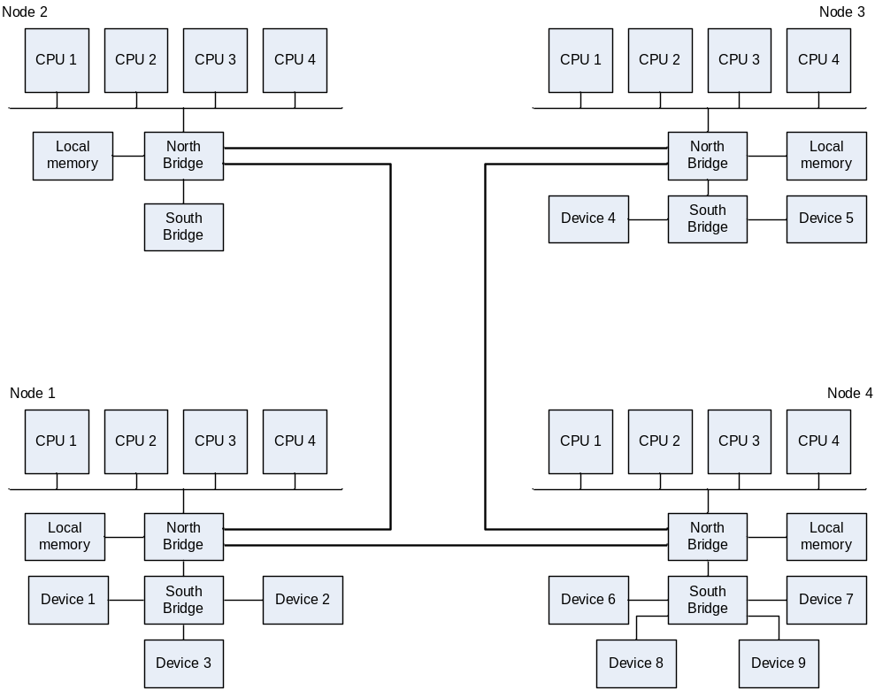
Figure 6. Hypothetical NUMA configuration
As the figure shows, the processors in a NUMA machine are organized into nodes. Each node has local memory and may also have local devices. All of the memory in the system is available to all processors on all nodes, but access times differ, depending on where the memory is located. For example, Node 1 in the figure can access its local memory the fastest, but requires additional time to access the memory attached to Nodes 2 and 4; accessing memory in Node 3 takes even longer.
The caches of all processors in all nodes are guaranteed to remain coherent; the contents of the cache on one processor will never be out of date with respect to the contents of the cache on any other processor.
On NUMA architectures, a device can interrupt on any node by default, and the ISR and DpcForIsr routines run on the same node on which the device interrupted.
Drivers that run on NUMA architectures are subject to all of the same concurrency, synchronization, and reordering issues previously described in this paper. Such architectures give the same guarantees as traditional SMPs with respect to the ordering of instructions.
However, some effects that are not often seen in traditional SMP architectures are frequently observed in NUMA architectures. Consider a traditional spin lock that is owned by a processor in Node 1. If two threads are waiting for it—one in Node 1 and one in Node 2—the waiting thread in Node 1 will probably receive many more memory cycles when trying to acquire the lock than the waiting thread in Node 2. Consequently, the waiter in Node 2 might receive fewer cycles (a situation called starvation) and consequently have a much lower chance of acquiring the lock. This is an important reason to use queued spin locks, instead of traditional spin locks, when contention is high.

Best Practices for Drivers
A properly designed and implemented driver will run correctly on both single-processor and multiprocessor systems. Because Windows is a fully preemptible operating system, most of the problems commonly observed on multiprocessor systems will eventually occur on single-processor systems, too.
Here are a few guidelines to help you develop drivers that operate properly and perform well on both single-processor and multiprocessor architectures:
- Assume that every driver will run on multiprocessor systems.
- Test every driver on as many different hardware configurations as possible. Always test drivers on multiprocessor systems to find errors that are related to locking, synchronization, and concurrency.
- Identify data and memory locations that are shared and might be accessed concurrently. Use locks to ensure that all potentially concurrent accesses occur serially.
- Use the simplest synchronization technique that meets your needs. Use interlocked operations and spin locks to perform atomic operations.
- Protect against compiler and processor reordering when required.
- Use standard Windows synchronization mechanisms whenever possible. They have implied memory barriers and are guaranteed to work on all supported hardware platforms.
- Write platform-neutral code. Do not create special cases in code for architecture-specific reordering scenarios.
- Use Driver Verifier and CUV to test for synchronization and locking problems.
- Use Kernrate, KrView, and (on Windows Vista) DevCon to collect performance data on multiprocessor systems.

Resources
General multiprocessor information:
Inside Microsoft Windows 2000, Third Edition
Solomon, David A. and Mark Russinovich. Redmond, WA: Microsoft Press, 2000.
Intel Itanium Architecture Software Developer’s Manual
http://www.intel.com/
Synchronization:
“Scheduling, Thread Context, and IRQL”
http://www.microsoft.com/whdc/driver/kernel/IRQL.mspx
“Locks, Deadlocks, and Synchronization”
http://www.microsoft.com/whdc/driver/kernel/locks.mspx
Testing:
“Analyze Driver Performance”
http://www.microsoft.com/whdc/driver/perform/drvperf.mspx
Microsoft Windows Driver Development Kit (DDK) Documentation:
Kernel-Mode Driver Architecture Design Guide
Synchronization Techniques
Kernel-Mode Driver Architecture Reference
Standard Driver Routines
Driver Support Routines
Driver Development Tools
Tools for Testing Drivers
Debugger extensions:
Debugging Tools for Windows
http://www.microsoft.com/whdc/DevTools/Debugging/default.mspx
Additional Tools:
Windows Resource Kit
http://www.microsoft.com/windows/reskits/default.asp

Called with any PnP minor IRP code.
Includes all driver dispatch routines except DispatchPower and DispatchPnP.
Called with the minor IRP code IRP_MN_SET_POWER or IRP_MN_QUERY_POWER and Parameters.Power.Type set to SystemPowerState.
Called with the minor IRP code IRP_MN_SET_POWER or IRP_MN_QUERY_POWER and Parameters.Power.Type set to DevicePowerState.
Cancel routine is set in IoSetCancelRoutine and IoStartPacket.
Called with the PnP minor IRP code IRP_MN_START_DEVICE.
Called with any PnP minor IRP code except IRP_MN_START_DEVICE.
Can be concurrent if driver supports more than one device. StartIo can be called any time after IRP_MN_START_DEVICE has completed for the target device.
Includes all Dispatch routines except DispatchPnp and DispatchPower.
Minor IRP codes IRP_MN_CANCEL_REMOVE_DEVICE, IRP_MN_CANCEL_STOP_DEVICE, IRP_MN_QUERY_REMOVE_DEVICE, IRP_MN_QUERY_STOP_DEVICE, IRP_MN_REMOVE_DEVICE, IRP_MN_START_DEVICE, IRP_MN_STOP_DEVICE, or IRP_MN_SURPRISE_REMOVAL.
Called with minor IRP code IRP_MN_SET_POWER or IRP_MN_QUERY_POWER and Parameters.Power.Type set to SystemPowerState.
Called with minor IRP code IRP_MN_SET_POWER or IRP_MN_QUERY_POWER and Parameters.Power.Type set to DevicePowerState.
Cancel routine is set by a call to IoSetCancelRoutine or IoStartPacket.
The InterruptService routine (ISR) cannot be called until IoConnectInterrupt has completed for the device, typically during processing of an IRP_MN_START_DEVICE request. The ISR can be called concurrently while the interrupt is connected.
DispatchPnP can be called with state-change IRPs until IRP_MN_REMOVE_DEVICE has been completed.
StartIo routine can be made noncancelable in a call to IoSetStartIoAttributes.
Depends on the type of driver. In a WDM driver, they cannot be concurrent because the driver disconnects interrupts before Unload is called. In a legacy driver, they can be concurrent because the driver disconnects interrupts in the Unload routine.
Includes Dispatch routines for all IRP major function codes except IRP_MJ_PNP, IRP_MJ_POWER, IRP_MJ_CREATE, IRP_MJ_CLOSE, and IRP_MJ_CLEANUP.
Cancel routine can be set by a call to IoSetCancelRoutine or IoStartPacket.
Support of cancellation of IRP_MJ_CREATE requests is planned for Windows Vista.

