3. Features
- Compatible with DFRobot FireBeetle V2 Series
- Small Size of 25.4×60 mm
- ESP32 Dual-core low power maincontroller, WiFi+BT4.0
- GDI Display Port, esay to connect
- Onboard Charging Circuit and PH2.0 li-ion Battery Port
4. Specification
- Operating Voltage: 3.3V
- Input Voltage: 3.3V-5.5V (Support USB Charging)
- Processor: Tensilica LX6 dual-core processor (One for high-speed connection; one for independent application development)
- Main Frequency: 240MHz
- SRAM: 520KB
- Flash: 32Mbit
- Wi-Fi Standard: FCC/CE/TELEC/KCC
- Wi-Fi Protocol: 802.11 b/g/n/d/e/i/k/r (802.11n，speed up to 150 Mbps), A-MPDU and A-MSDU Aggregation, support 0.4us guard interval)
- Frequency Range: 2.4-2.5 GHz
- Bluetooth Protocol: Bluetooth v4.2 BR/EDR and BLE standard compliant
- Bluetooth Audio: CVSD and SBC audio
- On-chip Clock: 40MHz crystal, 32.768KHz crystal
- Digital I/O x18
- Analog Input x11
- SPI x1
- IIC x1
- I2S x1
- RGB_LED: WS2812
- Connector: FireBeetle V2 series compatible
- Operating Temperature: -20℃ to +85℃
- Module Size: 25.4 × 60(mm)
- Mount Hole Size: M2, diameter 2.0mm
- Weight: 13g
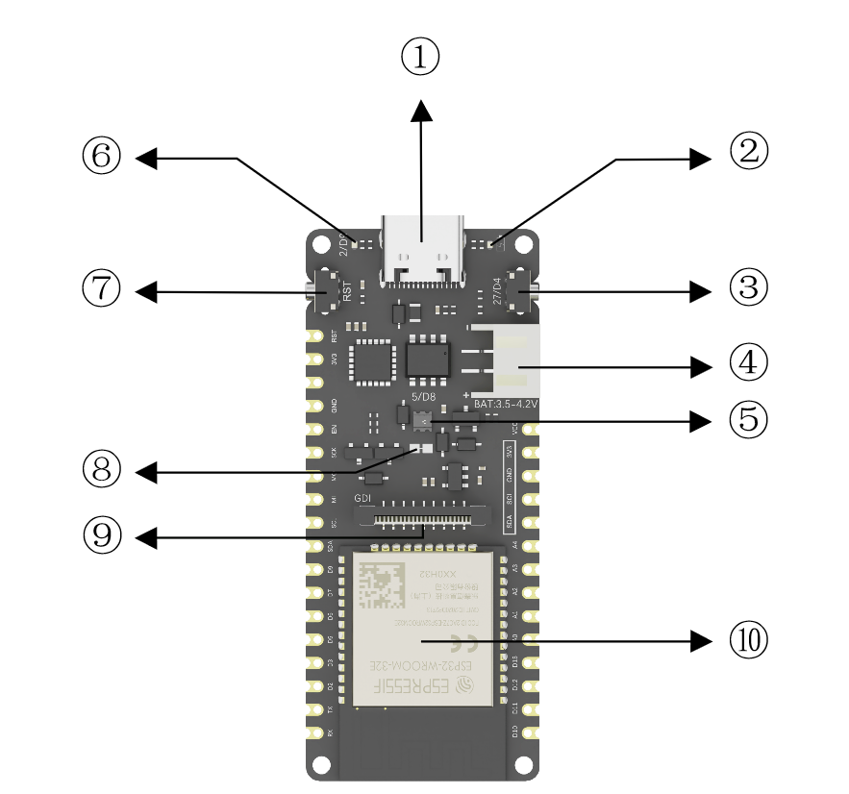

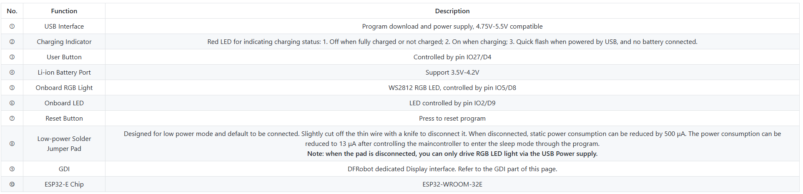

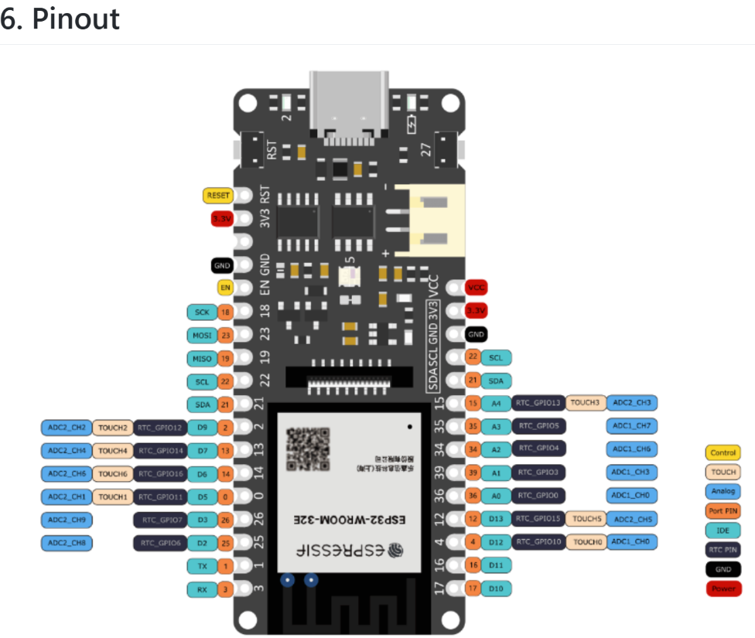
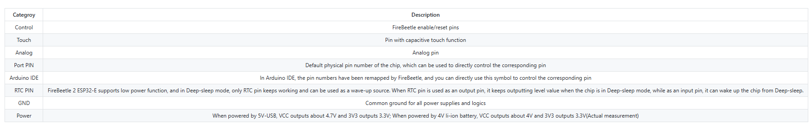

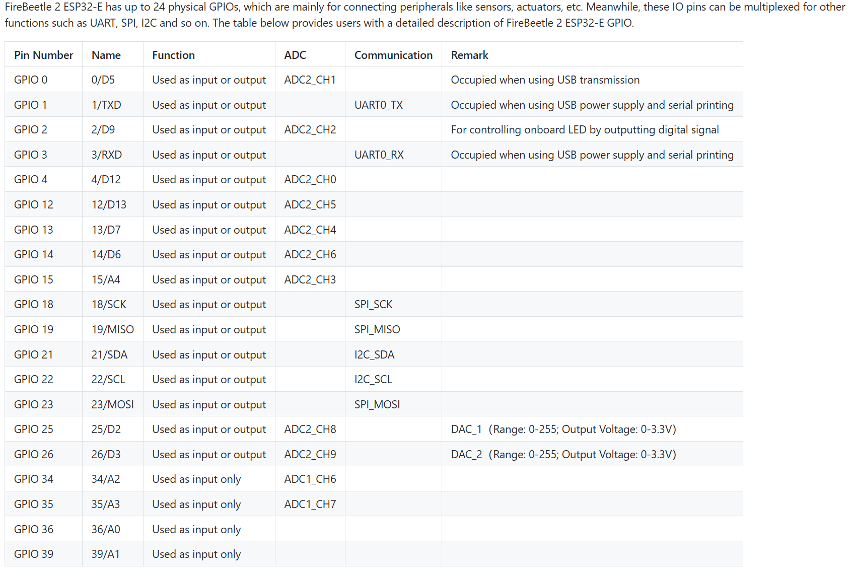

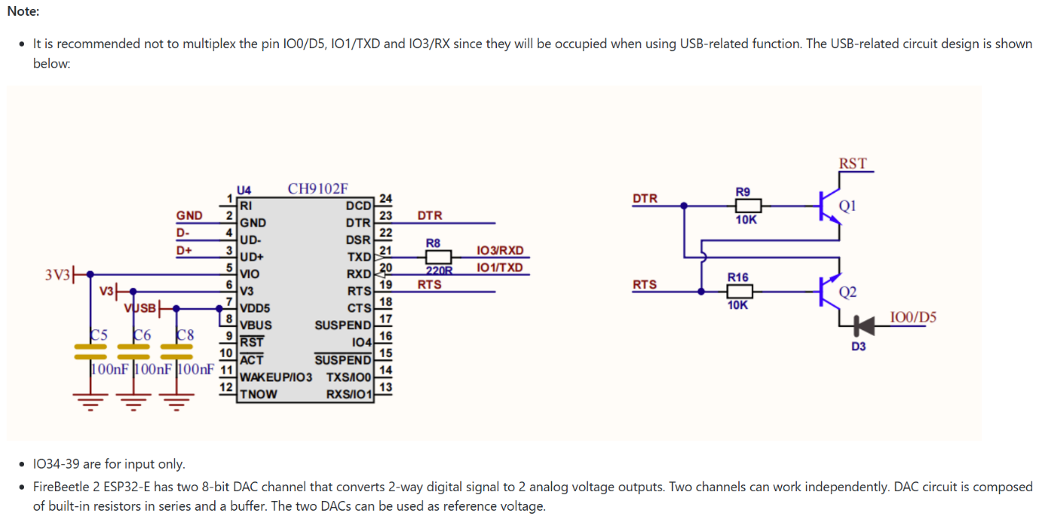

THW_1060_Regler:
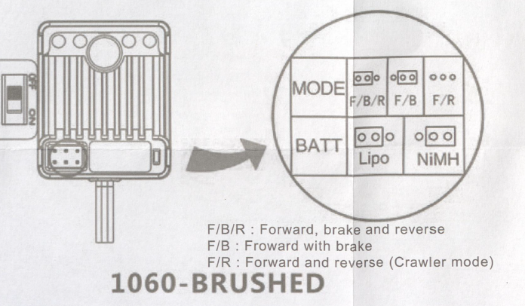
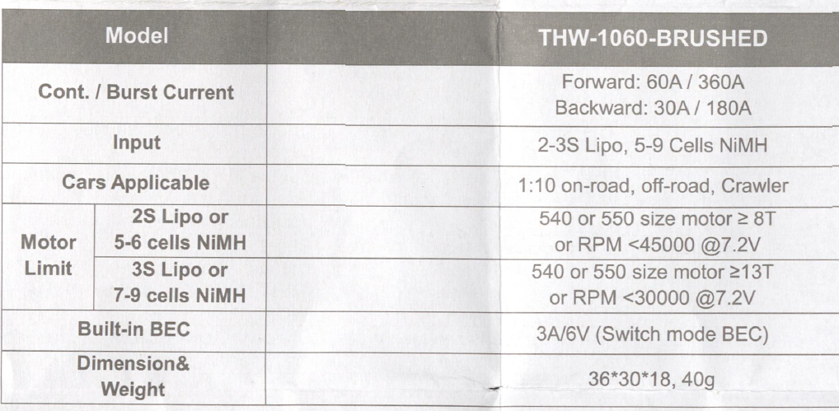

THW_1060_Regler:
Es wurde F/R Mode gewählt. Das heisst --> Vorwärts und Rückwärts ( Ohne Bremsung )
BATT: LIPO Baterie.

Motor Auswahl:
Für unsere Aufbau ist sinnvoll:
. 2S Lipo (7.4 V, 30-50C, 2200-3000 mAh)
  - passt perfekt zum Motor (Nennspannung 6-8 V )
  - Genug Spannung, um den Motor im Effizienzbereich laufen zu lassen.
  - mit 2200 mAh bei 20 A Last 6-7 min Laufzeit.

RS_540/545H:

