DeTechtive: A Bayesian Network–Based Decision Support System for Criminal Investigations
Abstract—DeTechtive (the “Batcomputer”) is a probabilistic decision-support system that assists investigators by computing posterior guilt probabilities for suspects in a criminal scenario. The system features a Python/Streamlit backend that builds a discrete Bayesian network for each case and performs exact inference, and a themed React/TypeScript frontend that serves as a secure login portal. In the Bayesian model (a naïve-Bayes topology), a GuiltyVillain node (the hypothesis) has directed edges to evidence nodes (“clues”), whose conditional probability tables (CPTs) are loaded from decoupled JSON scenario files. Users enter observed clues via a dynamic UI; the engine updates guilt probabilities in real time using the Variable Elimination algorithm. Key components include pgmpy for network construction and inference, Graphviz for DAG visualization, and Streamlit for the interactive interface. The frontend employs React 18 with TypeScript and Vite, styled by Tailwind CSS utilities and components from shadcn/ui (based on Radix) under a dark, “Gotham”-themed aesthetic. We present the system architecture, Bayesian modeling, data schema, and workflow, illustrating how evidence is integrated to rank suspects by guilt likelihood.

Introduction
Modern forensic analysis often involves reasoning under uncertainty. Bayesian networks (BNs) are a natural fit for this domain: they use directed acyclic graphs to encode variables (e.g. suspects, clues) and their conditional dependencies, and support efficient probabilistic inference. In DeTechtive, we apply this paradigm to criminal scenarios. Investigators select a case (e.g. a Gotham heist), and the system calculates the posterior probability of each suspect being the perpetrator given observed evidence. The core inference engine models the causality that the identity of the guilty villain probabilistically “causes” certain clues to appear. Using Bayes’ theorem, the system updates uniform priors on suspects with the likelihood of each clue (from the scenario’s CPTs) to obtain guilt probabilities. For example, let $S$ be a suspect and $E_{1},…,E_{n}$ be binary clues; under conditional independence, the posterior is
$$P\left(S ∣ E_{1},…,E_{n}\right) ∝ P\left(S\right) \prod{{\left(i=1\right)}^{n}P}\left(E_{i} ∣ S\right)​,$$
as in a naïve Bayes classifier. In practice, DeTechtive treats each clue as a child of the GuiltyVillain node, assuming clues are independent given the suspect. This simplifies inference and aligns with the “detection” idiom of Bayesian classifiers.
Figure 1 illustrates the overall architecture. The system has two modules: an analytical backend and a stylized frontend gateway. The backend (Python/Streamlit) loads a selected case, dynamically constructs the Bayesian network with pgmpy, renders the graph with Graphviz, and continuously updates guilt probabilities as evidence is entered. The frontend (React) provides an authentication-themed login/signup interface that leads users into the Batcomputer console (the Streamlit app). The aesthetic design (dark blue-black background #030213 with gold highlights #FACC15 in Courier Prime font) and limited routing (/login, /signup) evoke a secure, retro terminal feel. Throughout this report we detail each component’s role and how they integrate, citing relevant literature on BNs, inference, and the web technologies employed.
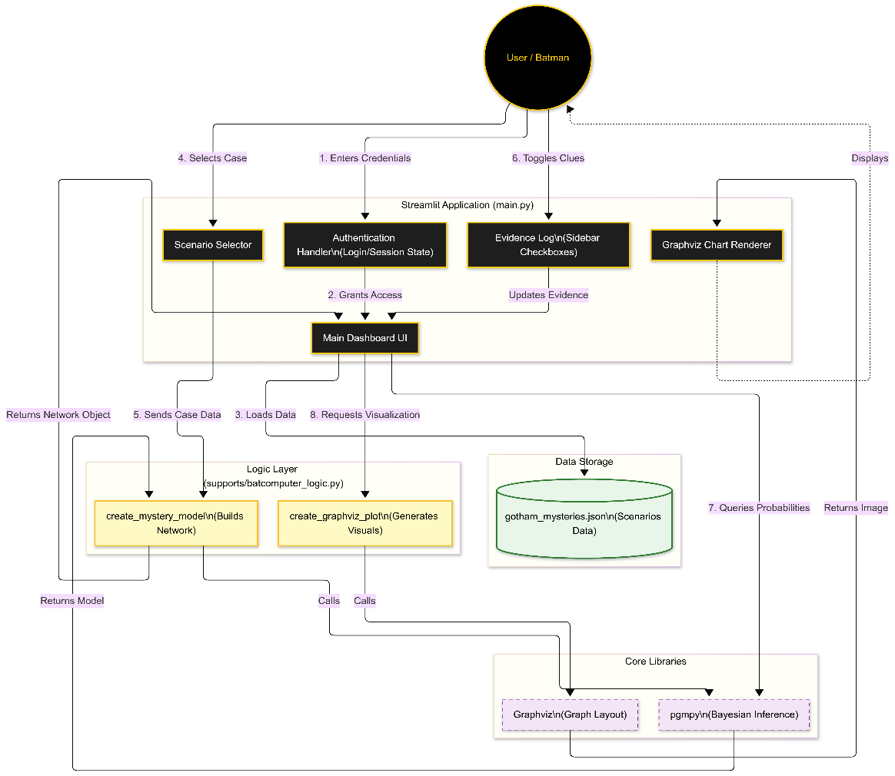
Figure 1: System architecture diagram (backend inference engine and frontend login portal).

System Architecture
The DeTechtive system is logically separated into a Backend Inference Engine and a Frontend Secure Entry, each implemented with modern frameworks.

Backend Inference Engine (Streamlit)
The core analytics are implemented in Python using Streamlit, an open-source framework for building interactive data apps. Streamlit allows rapid prototyping: minimal code is required to define UI elements and tie them to computation. The main script (e.g. main.py) handles user interaction, loads case data, builds the BN, performs inference, and displays results. Key responsibilities include: - Loading scenario data: The engine reads a JSON file describing the case (see Sec. V below).
- Constructing the Bayesian network: Using pgmpy, the code creates a DiscreteBayesianNetwork instance. The network typically has a single parent node GuiltyVillain and child nodes for each clue (a “naïve Bayes” structure). Edges are added from GuiltyVillain to each clue.
- Adding probability tables: For each node, conditional probability tables (CPTs) are instantiated (pgmpy’s TabularCPD). The GuiltyVillain node uses a uniform prior over suspects (e.g., $P\left(\text{villain}=v_{i}\right)= or N$suspects). Each clue node’s CPT $P\left(\text{clue}=\text{True} ∣ \text{villain}=v_{i}\right)$ is set from the scenario data.
- Visualization: The network’s structure is rendered to the UI via Graphviz (DOT language). Graphviz is a standard open-source graph visualization tool that takes the DAG definition and produces an image. This helps users see the logical model of the case.
- Inference: Given user-input evidence (which clues are present), the engine performs probabilistic inference using the Variable Elimination algorithm. Variable elimination is a fundamental exact inference method for Bayesian networks. The pgmpy library’s VariableElimination class is invoked to compute the posterior distribution $P\left(\text{GuiltyVillain} ∣ \text{observations}\right)$ .
- Displaying results: The posterior probabilities are displayed as a sorted table and a bar chart (using Streamlit’s plotting or pandas integration). The highest-probability suspect is highlighted as the prime suspect.
Throughout this process, the Streamlit UI is responsive: as soon as the user checks or unchecks evidence checkboxes, the posterior is recomputed and the display updates. This real-time feedback loop is enabled by Streamlit’s event handling (automatically reruns the script on widget change). The result is a single-page interface where selecting a case and entering evidence immediately yields an updated ranking of suspects. In summary, the backend tightly couples BN modeling and interactive visualization into a coherent analytic workflow.

Frontend Secure Entry (React + TypeScript)
The frontend is a separate single-page application (SPA) built with React 18 and TypeScript. Its sole purpose is to authenticate and stylize entry into the Batcomputer interface (which is actually the Streamlit app). The frontend features two routes, managed by [react-router-dom]: /login and /signup. Users must “log in” or “sign up” (the backend does not enforce credentials, but the UI simulates a secure access) to access the analytics. Key design elements include:
- Vite build tool: The project is bootstrapped with Vite for fast development. The React app is bundled using modern ES module tooling.
- Component library: It uses shadcn/ui components, a UI kit built on [Radix UI]. Radix provides unstyled, accessible React primitives; shadcn adds Tailwind CSS styling to these components. For example, buttons, inputs, and tabs are Radix-based components styled with Tailwind classes. This ensures accessibility and consistency.
- Styling (Tailwind CSS): The app employs Tailwind CSS for utility-first styling. Tailwind lets us apply design directly in markup (e.g. class="bg-[color] ..."). For instance, the entire login page uses a dark background color (#030213, a near-black-blue) with gold/yellow accents (#FACC15) to mimic Gotham’s vibe. This color scheme and the Courier Prime font evoke a monochrome terminal or typewriter aesthetic.
- Theme and Layout: The login interface is a stylized “Batcomputer” terminal. It uses large, pixelated input fields and ASCII-art style headings. Tabs or animations (via Lucide React icons) may be used, but the primary focus is a retro, dark theme. The design is fully responsive and mobile-friendly.
- Routing: Using React Router, the “Signup” and “Login” pages are separate routes. After successful form submission, the user is programmatically navigated to the main app. (In deployment, this might simply open the Streamlit URL in a new browser tab.)
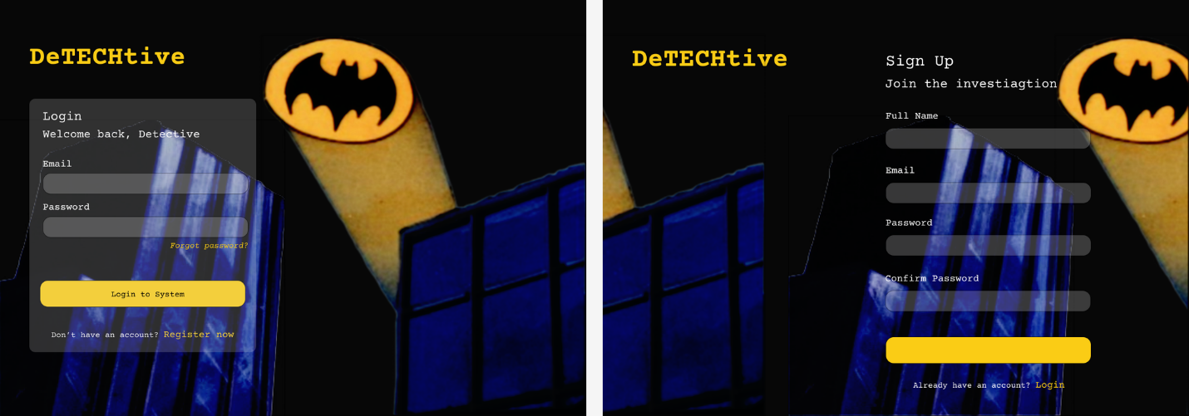
Figure 2: The themed login/signup interface (dark Gotham aesthetic).

Bayesian Model and Inference
At the mathematical core is a discrete Bayesian network that embodies the suspicion model. We adopt a naïve Bayes structure, where GuiltyVillain is the parent (root) node, and each piece of evidence is a child node conditionally dependent on the parent (Figure 3). This corresponds to the assumption that clues are independent of each other given the true culprit. Formally, if the set of suspects is $S=v_{1},…,v_{N}$ and the clues are binary variables $E_{1},…,E_{M}$, then the joint distribution factors as:
$$P\left(v,e_{1},…,e_{M}\right) = P\left(v\right)\prod{{\left(i=1\right)}^{M}P}\left(e_{i} ∣ v\right),$$
where $v∈S$ . This factorization is exactly the chain rule under the conditional independence assumptions. During inference, we want the posterior $P\left(v ∣ E\right)$ given evidence $E_{i}=\text{True}/\text{False}$. By Bayes’ theorem,
$$P\left(v ∣ E\right) ∝ P\left(v\right)\prod{{\left(i=1\right)}^{M}P}\left(E_{i} ∣ v\right).$$
Since $P\left(E_{i}=v\right)=0.5$ when no clue is observed (or equivalently not included in the product), the calculation essentially multiplies likelihoods for each positively observed clue. In practice, the code uses pgmpy’s VariableElimination to compute this posterior exactly.
Prior Distribution: We initialize $P\left(v\right)$ uniformly (every suspect is equally likely) because we have no a priori reason to favor one over another. (Uniform priors are a common default in absence of additional information.) For example, with 4 suspects, each has prior 0.25. One could imagine weighting this if external intelligence were available.
Conditional Probability Tables (CPTs): The scenario JSON provides, for each clue and each suspect, the probability that the clue is present given that suspect. For instance, in a “Gotham Bank Heist” scenario, the CPT for “RiddleLeftAtScene” might be high for the Riddler and low for others. These probabilities $P\left(\text{clue}=\text{True} ∣ \text{villain}=v_{i}\right)$ are stored as an array aligned with the suspects list. The Bayesian network node for that clue is created with a TabularCPD, specifying the probability of True/False for each parent (suspect) state. (pgmpy expects full binary distributions, so it automatically assigns $P\left(\text{clue}=\text{False} ∣ v\right)=1-P\left(\text{clue}=\text{True} ∣ v\right)$.)
Inference Algorithm: DeTechtive uses exact inference. In particular, pgmpy’s VariableElimination is used to sum out the non-query variables efficiently. Conceptually, the algorithm eliminates all evidence and hidden nodes to compute the marginal posterior of GuiltyVillain. This is efficient for the small networks in our scenarios. (More advanced networks could use approximate methods, but here the problem size is limited.) The result is a posterior probability for each suspect. These are normalized (to sum to 1) and sorted to identify the leading suspect.
Overall, this BN approach has the advantage of clear semantics: each suspect’s guilt is scored by the degree to which the evidence matches that suspect’s known signature. It also transparently shows how each clue affects the probability, which can be inspected in the visualization.

Data Structure: Scenario JSON
To enable flexibility, case definitions are stored externally in a JSON file (e.g. data/gotham_mysteries.json). This decoupling means adding a new scenario requires no code changes. The JSON schema for each scenario includes:
- Key (identifier): e.g. "gotham_bank_heist".
- title: A short name (e.g. “The Gotham Bank Heist”).
- description: Narrative context describing the crime.
- suspects: An array of strings naming the possible villains (e.g. ["The Joker", "The Riddler", ...]).
- clues: An array of clue objects. Each clue object has:
- label: A human-readable question/prompt (e.g. "Was the crime scene chaotic?").
- probabilities: An array of floats of length N (number of suspects). Entry i is $P\left(\text{clue}=\text{True} ∣ \text{villain}=suspects\left[i\right]\right)$. These values form the CPT for that clue.
For example, a scenario entry might look like:
"gotham_bank_heist": {
"title": "The Gotham Bank Heist",
"description": "A daring robbery at the Gotham National Bank...",
"suspects": ["The Joker", "The Riddler", "Harley Quinn", "Poison Ivy"],
"clues": [
{
"label": "Was the crime scene chaotic?",
"probabilities": [0.9, 0.6, 0.4, 0.2]
},
{
"label": "Is a riddle left at the scene?",
"probabilities": [0.3, 0.95, 0.1, 0.05]
},
...
]
}
This schema means, for instance, that if The Riddler is guilty, there is a 95% chance a riddle is left at the scene; if The Joker is guilty, only a 30% chance.
At app startup or when the user selects a case from the dropdown, the backend loads the chosen scenario’s JSON entry. It then builds the BN: one parent node “GuiltyVillain” with states equal to the suspect names, and one child node per clue. Each clue node’s CPT is loaded from that clue’s probabilities array. The uniform prior is added as a separate CPT for GuiltyVillain (e.g. [1/N,1/N,...,1/N]).
The decoupled JSON allows effortless expansion: to create a new mystery, one can add a JSON object with the same structure. The Python code automatically handles any number of suspects or clues by iterating over the loaded lists.

User Workflow and Interface
A typical user session proceeds as follows (see also Figure 3):
- Secure Access: The user lands on the login page, enters credentials, and is taken to the main interface.
- Select a Case: A dropdown menu on the sidebar lists available cases (keys from the JSON). The user chooses one scenario (e.g. “The Arkham Asylum Breakout”). The title and description are shown for context.
- View Model Visualization: Upon case selection, the application dynamically generates the Bayesian network. Graphviz renders this network as an image and displays it, showing GuiltyVillain at the root and arrows to each clue node. This gives the user an overview of how evidence relates to suspects.
- Enter Evidence: Below the network, the sidebar presents a checkbox for each clue (with its label). The user can check “true” for each clue observed in the investigation.
- Real-Time Inference: As the user toggles clues, Streamlit triggers a rerun. The engine adds the evidence to the inference engine (setting evidence variables in VariableElimination.query) and recomputes $P\left(\text{villain} ∣ \text{evidence}\right)$.
- Result Display: The main panel updates to show a data table and a bar chart of suspect probabilities. The table lists each suspect and its posterior probability, sorted descending. The bar chart (e.g. via Matplotlib or Streamlit’s chart) visually highlights the top suspect.
Throughout, the interface remains responsive and intuitive. Checkboxes and dropdowns are implemented with Streamlit widgets (st.checkbox, st.selectbox) styled via the chosen theme. Figure 3 shows a mockup of the main inference interface, with a network diagram, clue checkboxes, and probability output.
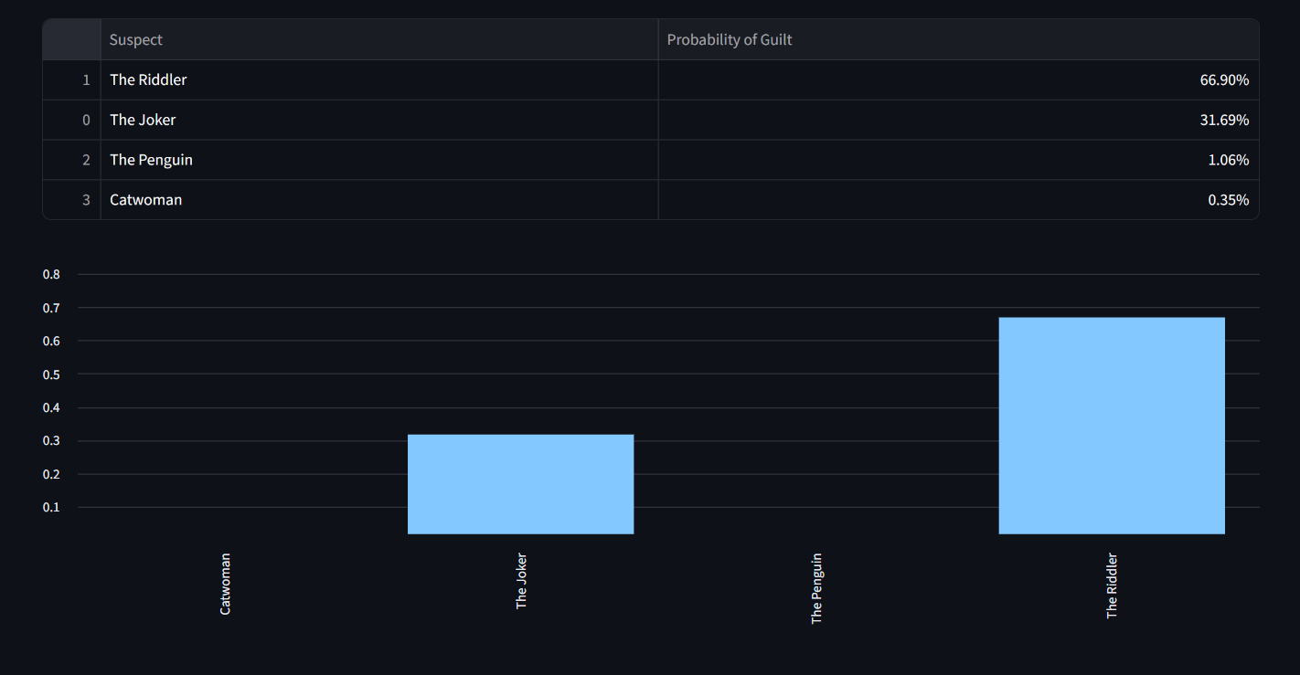
Figure 3: [Description – e.g., “User interface after entering evidence: bar chart of posterior probabilities.”]

Key Features and Technology Stack
Probabilistic Inference: The system’s intelligence lies in its Bayesian core. By applying Bayes’ theorem (and assuming clue independence), it computes exact posterior probabilities using variable elimination. The use of pgmpy provides a modular and extensible implementation.
Flexible Data-Driven Design: Cases are defined in JSON, separating data from code. This design pattern facilitates adding new mysteries without modifying the source. The Python backend simply iterates through the JSON arrays to create nodes and CPDs, demonstrating a data-driven approach.
Interactive Visualization: Graphviz (an open-source graph-drawing tool) is used to automatically layout the network structure. This visual aid helps users understand the model. The final results are presented both numerically and graphically (sorted table and bar chart) to suit different preferences.
Responsive Web Interface: Streamlit provides an automatically refreshing UI. The engineering effort is greatly reduced (no manual HTML/JS needed) because Streamlit abstracts the web server. Code in the script (with calls like st.checkbox, st.write, and charting functions) is straightforward, exemplifying Streamlit’s mantra “weave in interaction”.
Secure Login Gateway: Although the analysis is Python-based, the themed React frontend adds a gamified entry point. The use of modern frontend tools (React 18, TypeScript, Vite) ensures fast load times and maintainability. Tailwind CSS utilities allow rapid styling: for example, to set the dark background one simply adds a class like bg-[#030213]. The design system ensures consistent colors, fonts, and spacing. Shadcn UI (Radix-based) provides accessible components, reducing custom CSS work.
Extensible Architecture: The separation of frontend (authentication) and backend (analysis) allows future work, such as connecting to a real user database or expanding the analytics. The NodeJS/React app could, for example, be extended to handle role-based access, while the Python engine could incorporate learning algorithms or handle continuous evidence.

Conclusion
DeTechtive demonstrates how Bayesian networks can be harnessed in a playful yet rigorous forensic context. By encapsulating domain knowledge (suspects and their clues) in a probabilistic model, the system allows investigators (or players) to test evidence against hypotheses quantitatively. The hybrid tech stack Streamlit for the analytic core and a React/Tailwind frontend for theming delivers both computational power and a polished user experience.
Future work could involve scaling the models (allowing interdependent clues, learning CPTs from data, or adding temporal evolution) and tightening the integration (e.g. generating the UI directly in React). One could also integrate external APIs or databases for authentication, making the login truly functional.
Acknowledgments: The pgmpy toolkit and Streamlit framework greatly simplify the implementation of probabilistic models and interactive UIs.

References
- A. P. Dawid and J. Mortera, “Graphical Models for Forensic Analysis,” in Handbook of Graphical Models, M. Drton et al., Eds. Boca Raton, FL: CRC Press, 2018.
- “Bayesian network,” Wikipedia, The Free Encyclopedia, [Online]. Available: https://en.wikipedia.org/wiki/Bayesian_network.
- “Naive Bayes classifier,” Wikipedia, The Free Encyclopedia, [Online]. Available: https://en.wikipedia.org/wiki/Naive_Bayes_classifier.
- T. Gruber, “Streamlit — A faster way to build and share data apps,” Streamlit Inc. [Online]. Available: https://streamlit.io.

