Ec2-( Elastic Cloud Compute )

### Summary

In this comprehensive tutorial, Abhishek introduces the foundational concepts and practical steps related to AWS EC2 (Elastic Cloud Compute) instances, a core and widely used service within Amazon Web Services (AWS). The video begins with an explanation of what EC2 is, breaking down the terminology—elastic, cloud, and compute—and explaining how EC2 provides virtual servers on demand. Abhishek elaborates on the significance of virtualization, describing how physical servers are partitioned into multiple virtual machines, enabling efficient resource sharing.

Next, the video explores why EC2 instances are essential, especially highlighting how the cloud eliminates the need for organizations to manage physical servers, reducing maintenance overhead and cost. The elastic nature of EC2 means instances can be scaled up or down based on demand, providing flexibility and cost efficiency.

The tutorial then covers the different types of EC2 instances—general purpose, compute optimized, memory optimized, storage optimized, and accelerated computing—helping viewers understand that different workloads require different instance types. Abhishek emphasizes that for most initial learning and simple applications, general purpose instances suffice.

Abhishek also explains the AWS global infrastructure, focusing on regions and availability zones. He clarifies the importance of selecting regions close to clients for low latency and compliance reasons and how availability zones provide fault tolerance by distributing resources across physically separate data centers.

The practical part of the video walks through launching an EC2 instance on the AWS console, selecting the region, instance type (typically a free tier eligible T2 micro instance), and operating system (Ubuntu in this case). He demonstrates creating a key pair for secure access, connecting to the instance using SSH, and modifying permissions for the private key file.

After successfully logging in, Abhishek updates the instance packages and installs Jenkins, a popular DevOps tool. He shows how to start the Jenkins service and explains the necessity of adjusting security group inbound rules to open port 8080 for accessing Jenkins from outside the AWS network. Finally, he accesses Jenkins through the public IP and confirms the successful deployment of the first application on an EC2 instance.

Throughout the video, Abhishek stresses the importance of understanding AWS concepts like virtual servers, instance types, regions, availability zones, and security settings, which are critical for anyone aiming to become proficient in AWS or cloud infrastructure. The tutorial closes with encouragement for viewers to practice and explore further.

### Highlights

- 🚀 Introduction to AWS EC2 as a virtual server service in the cloud.

- ☁️ Explanation of the “Elastic Cloud Compute” terminology and virtualization basics.

- 💡 Advantages of EC2: reduced maintenance, cost efficiency, and scalability.

- 🔍 Overview of different EC2 instance types tailored for various workloads.

- 🌍 Understanding AWS global infrastructure: regions and availability zones for latency and fault tolerance.

- 🛠️ Step-by-step practical guide to launching, connecting, and managing an EC2 instance.

- 🔐 Demonstration of key pair creation and SSH access for secure instance login.

- 🧰 Deploying Jenkins on EC2 and configuring security groups for external access.

### Key Insights

- ☁️ **Elastic Cloud Compute Explained**: EC2 instances represent virtual servers provisioned on-demand in the cloud, combining CPU, RAM, and storage. This virtualization enables multiple users to share physical hardware efficiently, optimizing resource utilization and cost. Understanding this abstraction is fundamental to cloud computing.

- 💰 **Cost and Maintenance Benefits**: By leveraging EC2, organizations avoid upfront investments in physical hardware and the ongoing overhead of server maintenance, upgrades, and patch management. AWS manages the underlying infrastructure, allowing users to focus on deploying and scaling applications. This pay-as-you-go model offers flexibility and financial efficiency, especially for startups and enterprises alike.

- 🧩 **Instance Types Cater to Different Workloads**: The categorization into general purpose, compute optimized, memory optimized, storage optimized, and accelerated computing instances reflects how AWS matches server configurations to use cases. For example, compute optimized instances suit CPU-intensive tasks like gaming servers or machine learning inference, while memory optimized instances support high-performance analytics or big data workloads. Recognizing this helps architects optimize application performance and cost.

- 🌐 **Regions and Availability Zones Improve Performance and Reliability**: The physical distribution of AWS data centers into regions and multiple availability zones within each region is critical for addressing latency, data sovereignty, and fault tolerance. Deploying applications close to end users reduces latency, improving user experience, while multi-AZ deployment ensures high availability and disaster recovery capabilities, crucial for enterprise-grade applications.

- 🔑 **Security Through Key Pairs and Network Controls**: AWS EC2 instances use public-private key pairs to enforce secure SSH access, eliminating password-based vulnerabilities. Additionally, security groups act as virtual firewalls controlling inbound and outbound traffic, requiring explicit configuration (e.g., opening port 8080 for Jenkins) to expose services externally. This layered security design is vital for protecting cloud infrastructure.

- 🖥️ **Hands-On Approach Enhances Learning**: The video’s practical demonstration of launching an EC2 instance, connecting via SSH, updating packages, installing Jenkins, and configuring security highlights the importance of experiential learning. Real-world tasks deepen understanding beyond theoretical knowledge and prepare learners for operational cloud environments.

- ⚠️ **Managing Free Tier Limits and Costs**: AWS’s free tier provides a limited quota (e.g., 750 hours per month of T2 micro instances) which is sufficient for learning and basic workloads but requires careful management to avoid unexpected charges. Users should shut down instances when not in use and monitor usage, especially when experimenting with multiple or larger instances. This awareness is essential to control cloud spending.

This detailed tutorial sets a strong foundation in AWS EC2, combining conceptual clarity with practical execution, making it an excellent resource for beginners and those preparing for cloud-related roles.  
  
  
  
  
  
  
  
  
  
### Summary

In this detailed and foundational video on AWS Virtual Private Cloud (VPC), Abhishek demystifies one of the most complex AWS topics by using a relatable, real-life analogy. The core idea is to understand what a VPC is, why it is necessary, its key components, and how these components work together to provide secure, isolated cloud environments.

Abhishek starts by comparing a VPC to a gated community or a secure housing society inside a large village. This analogy helps explain why companies prefer to use VPCs instead of sharing physical servers directly—primarily for enhanced security, privacy, and management. He then transitions this analogy into the AWS context: AWS acts as a wise person who owns large data centers (akin to the village land), and companies (the lazy people) request resources (houses) without managing the underlying infrastructure.

He explains the evolution of infrastructure management from shared physical servers to isolated virtual environments created via VPCs, which prevent security breaches by isolating different tenants. Key AWS VPC components such as IP address ranges, subnets (subdivisions of IP ranges), internet gateways, load balancers, route tables, security groups, and NAT gateways are introduced and linked back to the analogy of houses, gates, guards, and pathways.

The video also touches on advanced concepts like Network Access Control Lists (NACLs) for automating security group rules and VPC flow logs for monitoring traffic within the VPC. Throughout, Abhishek emphasizes the importance of understanding foundational networking concepts before diving into practical implementations, which are planned for follow-up videos.

This video is designed to build a strong, intuitive understanding of AWS VPC, making it accessible even for beginners with little to no networking background.

### Highlights

- 🏘️ VPC explained using a real-life gated community analogy for easy understanding.

- 🔐 Importance of security and isolation in cloud infrastructure emphasized.

- 🌐 Key AWS VPC components introduced: subnets, internet gateway, load balancer, route tables, and security groups.

- 🛡️ Explanation of security groups and NACLs to protect cloud resources.

- 🛰️ NAT Gateway concept introduced for secure internet access from private subnets.

- 📊 Introduction to VPC flow logs for monitoring and debugging network traffic.

- 💡 Emphasis on building foundational knowledge before practical hands-on deployment.

### Key Insights

- 🏡 **Analogy Bridging Complex Concepts:** Abhishek’s use of a real-world example—a gated housing community inside a village—effectively simplifies the abstract and complex topic of VPCs. This approach helps beginners visualize cloud networking as familiar concepts like land, houses, gates, and security guards, aiding retention and comprehension.

- 🔒 **Security as the Primary Driver for VPCs:** The story highlights that shared resources (like houses close together) pose significant security risks without proper isolation. Similarly, in AWS, VPCs provide isolated environments to ensure that one customer’s cloud resources cannot be accessed or compromised by another, a critical requirement for multi-tenant cloud infrastructure.

- 🌍 **VPCs as Virtual Data Centers:** AWS data centers in various global regions represent the "land" where VPCs (secure gated communities) are created. This clarifies the concept that a VPC is not a separate physical entity but a logically isolated virtual network within a physical AWS region.

- 📏 **IP Addressing Defines Size and Structure:** The size of a VPC is determined by its IP address range (CIDR block). This numeric range essentially defines how many resources can be hosted. Subnets divide that range further for organization and segmentation, analogous to dividing land into plots for different houses/projects. Understanding IP ranges and subnetting is essential for designing scalable and manageable VPCs.

- 🚪 **Internet Gateway & Load Balancers Enable Controlled Access:** The internet gateway acts as the secure gate to the VPC, allowing inbound and outbound internet traffic. Load balancers inside a public subnet distribute incoming traffic to application instances residing in private subnets. This layered architecture enhances availability, scalability, and security.

- 🛣️ **Route Tables as Network Traffic Directors:** Route tables define the paths that network traffic should follow within the VPC, ensuring that requests from users or other networks reach the correct subnet or instance. This is similar to directional signs or maps guiding visitors inside the gated community to their destination.

- 🛡️ **Security Groups and NACLs Provide Granular Traffic Control:** Security groups act like security guards vetting incoming and outgoing traffic at the instance level, based on IP addresses and ports. NACLs automate and simplify security policies across multiple instances or subnets. This layered security approach is critical to protect cloud resources from unauthorized access.

- 🌐 **NAT Gateways Enable Secure Outbound Internet Access for Private Instances:** Instances in private subnets cannot directly access the internet but may need to download updates or patches. NAT gateways provide this capability by masking the private IP addresses with public IPs, maintaining internal security while enabling necessary outbound connections.

- 📈 **VPC Flow Logs for Traffic Monitoring and Troubleshooting:** VPC flow logs record all traffic flowing within the VPC, allowing administrators to monitor, audit, and debug network activity. This visibility is essential for maintaining security and optimizing network performance in complex cloud environments.

- 🎯 **Foundational Understanding Before Practical Application:** The video stresses the importance of learning and understanding VPC components conceptually before diving into hands-on labs or production deployments. This ensures better design decisions and efficient troubleshooting when working with cloud networking.

By combining real-life analogies with AWS technical terminology and architecture, this video serves as a comprehensive introductory resource for anyone seeking to grasp the fundamentals of AWS VPC. It prepares viewers for deeper dives into security, practical deployments, and advanced networking topics in subsequent lessons.  
  
***Mind-map***  
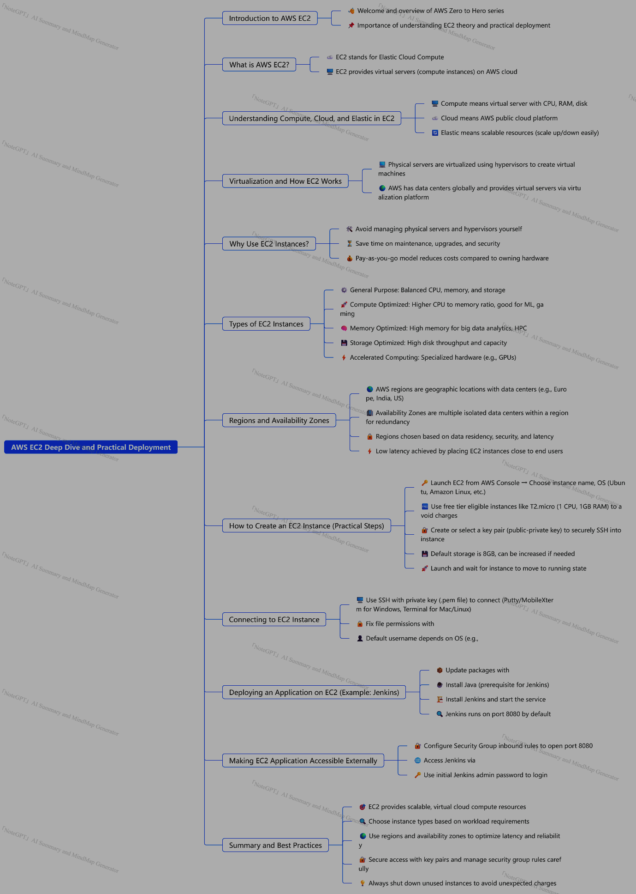

**Ec2-(Cloud-champ)**

### Summary

This comprehensive video tutorial offers an in-depth introduction to Amazon EC2 (Elastic Compute Cloud), a core and foundational service of AWS (Amazon Web Services). The instructor, an AWS Certified Solutions Architect, aims to provide viewers with a complete understanding of EC2, enabling them to confidently launch, manage, and secure virtual servers on AWS without needing further resources. The video combines theoretical explanations with practical hands-on demonstrations, covering essential topics such as setting up AWS accounts, budgeting to avoid unexpected costs, choosing instance types, launching instances, configuring security groups (firewalls), using user data scripts for bootstrapping, SSH access methods, Elastic IP addresses for static IPs, IAM roles, and various EC2 pricing and purchase options.

The tutorial starts by emphasizing the importance of setting up budgets in AWS to avoid high bills, especially for beginners. It then explains EC2 as an Infrastructure as a Service (IaaS) platform that allows users to rent virtual machines with customizable hardware and software configurations. The video details how EC2 supports different operating systems, storage options (EBS, instance storage), networking configurations, and security groups to control inbound and outbound traffic.

The instructor demonstrates launching a Linux-based EC2 instance, choosing the Amazon Machine Image (AMI), instance type (free-tier eligible t2.micro), key pairs for SSH access, and security group rules (allowing HTTP and SSH ports). The tutorial explains user data scripts to automate instance bootstrapping such as installing Apache web server and configuring a simple web page. After launching the instance, the instructor shows how to connect via EC2 Instance Connect and SSH, install software, and troubleshoot common issues related to IP changes when instances are stopped and started. The concept of Elastic IP addresses is introduced to solve the problem of dynamic IPs and ensure static IP assignment.

Further, the video explains instance types and their naming conventions, categorizing them into general-purpose, compute-optimized, memory-optimized, and storage-optimized instances. Use cases for each instance type are discussed, including web servers, gaming servers, databases, and high-performance computing workloads. Security groups are elaborated upon as virtual firewalls that regulate traffic through specific ports and protocols, with practical examples of modifying inbound rules to enable HTTP access.

The tutorial also covers how to securely connect to instances using SSH on Linux/Mac and PuTTY on Windows, emphasizing the advantage of EC2 Instance Connect for browser-based access without third-party software. It introduces IAM roles that provide secure permissions to EC2 instances for accessing AWS services without embedding credentials, demonstrated by attaching a role that allows listing IAM users directly from the instance.

Finally, the video outlines various EC2 purchasing options such as On-Demand, Reserved Instances, Savings Plans, Spot Instances, Dedicated Hosts, and Dedicated Instances. It explains the cost-benefit and use-case scenarios for each, highlighting Spot Instances as the most cost-efficient for temporary workloads and Dedicated Hosts for compliance and licensing needs. The video concludes with a summary of EC2’s capabilities and an invitation for viewers to engage by asking questions or suggesting future topics like S3, RDS, load balancers, and auto-scaling.

### Highlights

- ⚙️ Comprehensive hands-on tutorial on launching and managing AWS EC2 instances from scratch.

- 💡 Explanation of EC2 as an Infrastructure as a Service with customizable virtual machines.

- 🔐 Detailed walkthrough of security groups acting as firewalls controlling access to instances.

- 🛠 Demonstration of EC2 user data scripts to automate instance configuration and bootstrapping.

- 🌐 Introduction and practical use of Elastic IPs to maintain static IP addresses for instances.

- 🔑 Multiple secure connection methods to EC2 instances, including EC2 Instance Connect and SSH.

- 💰 Overview of EC2 pricing models: On-Demand, Reserved, Spot, Dedicated Hosts, and their use cases.

### Key Insights

- ⚠️ **Budgeting is critical to avoid unexpected AWS bills:** The tutorial starts by stressing the necessity of setting AWS budgets before launching EC2 instances. AWS charges can accrue quickly if instances are left running or misconfigured, especially for students and new users. Setting budgets and alerts helps maintain cost control and avoid surprises.

- 🖥️ **EC2 offers flexibility with OS, compute, memory, and storage options:** Users can select from various operating systems (Linux, Windows, Mac OS) and tailor the instance’s CPU, RAM, and storage types (EBS, instance store, EFS) to meet specific workload requirements. This versatility makes EC2 suitable for a wide range of applications from simple web servers to complex high-performance computing.

- 📝 **User Data scripts automate instance setup, saving time and effort:** Bootstrapping through user data allows automatic execution of commands like software installation and configuration during the initial launch of an instance. This is a powerful feature that reduces manual setup and enhances repeatability and consistency in deployments.

- 🔄 **Elastic IPs solve the problem of dynamic public IPs on EC2:** Since EC2 public IPs change every time an instance is stopped and started, Elastic IPs provide a static IP address solution. This is essential for production environments where DNS or external services depend on a fixed IP. The tutorial’s demonstration clarifies this common AWS networking challenge and its resolution.

- 🔒 **Security groups are fundamental to securing EC2 instances:** Acting as virtual firewalls, security groups regulate inbound and outbound traffic based on ports and protocols. The difference between “connection timeout” (security group blocking traffic) and “connection refused” (application issue) is an important troubleshooting insight shared in the video. Properly configuring security groups is vital for both security and accessibility.

- 🔑 **IAM roles enhance security by eliminating credential management on EC2:** Instead of embedding AWS access keys on instances, attaching IAM roles grants instances permissions securely. This approach minimizes security risks and simplifies permission management, aligning with AWS best practices for cloud security. The hands-on example of listing IAM users from the instance using the attached role provides clear understanding.

- 💸 **Understanding EC2 purchasing options is key for cost optimization:** The video explains various purchasing models from On-Demand (flexible, pay-as-you-go) to Reserved Instances (long-term discount), Spot Instances (highly cost-efficient but interruptible), and Dedicated Hosts (for compliance and licensing). Recognizing when and how to use each can lead to significant cost savings and operational efficiency.

This tutorial equips viewers not only with practical skills to launch and manage EC2 instances but also with foundational knowledge about cloud infrastructure, security, automation, and cost management, making it a valuable resource for aspiring cloud professionals.

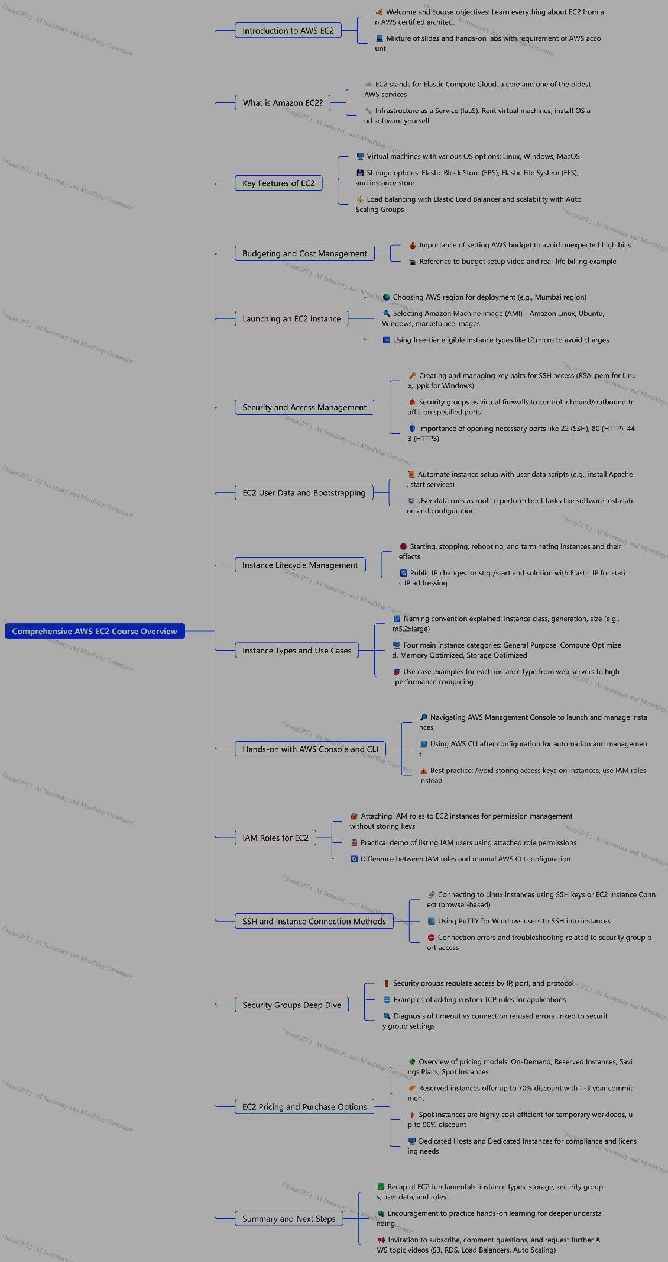

### Summary

In this detailed and foundational video on AWS Virtual Private Cloud (VPC), Abhishek demystifies one of the most complex AWS topics by using a relatable, real-life analogy. The core idea is to understand what a VPC is, why it is necessary, its key components, and how these components work together to provide secure, isolated cloud environments.

Abhishek starts by comparing a VPC to a gated community or a secure housing society inside a large village. This analogy helps explain why companies prefer to use VPCs instead of sharing physical servers directly—primarily for enhanced security, privacy, and management. He then transitions this analogy into the AWS context: AWS acts as a wise person who owns large data centers (akin to the village land), and companies (the lazy people) request resources (houses) without managing the underlying infrastructure.

He explains the evolution of infrastructure management from shared physical servers to isolated virtual environments created via VPCs, which prevent security breaches by isolating different tenants. Key AWS VPC components such as IP address ranges, subnets (subdivisions of IP ranges), internet gateways, load balancers, route tables, security groups, and NAT gateways are introduced and linked back to the analogy of houses, gates, guards, and pathways.

The video also touches on advanced concepts like Network Access Control Lists (NACLs) for automating security group rules and VPC flow logs for monitoring traffic within the VPC. Throughout, Abhishek emphasizes the importance of understanding foundational networking concepts before diving into practical implementations, which are planned for follow-up videos.

This video is designed to build a strong, intuitive understanding of AWS VPC, making it accessible even for beginners with little to no networking background.

### Highlights

- 🏘️ VPC explained using a real-life gated community analogy for easy understanding.

- 🔐 Importance of security and isolation in cloud infrastructure emphasized.

- 🌐 Key AWS VPC components introduced: subnets, internet gateway, load balancer, route tables, and security groups.

- 🛡️ Explanation of security groups and NACLs to protect cloud resources.

- 🛰️ NAT Gateway concept introduced for secure internet access from private subnets.

- 📊 Introduction to VPC flow logs for monitoring and debugging network traffic.

- 💡 Emphasis on building foundational knowledge before practical hands-on deployment.

### Key Insights

- 🏡 **Analogy Bridging Complex Concepts:** Abhishek’s use of a real-world example—a gated housing community inside a village—effectively simplifies the abstract and complex topic of VPCs. This approach helps beginners visualize cloud networking as familiar concepts like land, houses, gates, and security guards, aiding retention and comprehension.

- 🔒 **Security as the Primary Driver for VPCs:** The story highlights that shared resources (like houses close together) pose significant security risks without proper isolation. Similarly, in AWS, VPCs provide isolated environments to ensure that one customer’s cloud resources cannot be accessed or compromised by another, a critical requirement for multi-tenant cloud infrastructure.

- 🌍 **VPCs as Virtual Data Centers:** AWS data centers in various global regions represent the "land" where VPCs (secure gated communities) are created. This clarifies the concept that a VPC is not a separate physical entity but a logically isolated virtual network within a physical AWS region.

- 📏 **IP Addressing Defines Size and Structure:** The size of a VPC is determined by its IP address range (CIDR block). This numeric range essentially defines how many resources can be hosted. Subnets divide that range further for organization and segmentation, analogous to dividing land into plots for different houses/projects. Understanding IP ranges and subnetting is essential for designing scalable and manageable VPCs.

- 🚪 **Internet Gateway & Load Balancers Enable Controlled Access:** The internet gateway acts as the secure gate to the VPC, allowing inbound and outbound internet traffic. Load balancers inside a public subnet distribute incoming traffic to application instances residing in private subnets. This layered architecture enhances availability, scalability, and security.

- 🛣️ **Route Tables as Network Traffic Directors:** Route tables define the paths that network traffic should follow within the VPC, ensuring that requests from users or other networks reach the correct subnet or instance. This is similar to directional signs or maps guiding visitors inside the gated community to their destination.

- 🛡️ **Security Groups and NACLs Provide Granular Traffic Control:** Security groups act like security guards vetting incoming and outgoing traffic at the instance level, based on IP addresses and ports. NACLs automate and simplify security policies across multiple instances or subnets. This layered security approach is critical to protect cloud resources from unauthorized access.

- 🌐 **NAT Gateways Enable Secure Outbound Internet Access for Private Instances:** Instances in private subnets cannot directly access the internet but may need to download updates or patches. NAT gateways provide this capability by masking the private IP addresses with public IPs, maintaining internal security while enabling necessary outbound connections.

- 📈 **VPC Flow Logs for Traffic Monitoring and Troubleshooting:** VPC flow logs record all traffic flowing within the VPC, allowing administrators to monitor, audit, and debug network activity. This visibility is essential for maintaining security and optimizing network performance in complex cloud environments.

- 🎯 **Foundational Understanding Before Practical Application:** The video stresses the importance of learning and understanding VPC components conceptually before diving into hands-on labs or production deployments. This ensures better design decisions and efficient troubleshooting when working with cloud networking.

By combining real-life analogies with AWS technical terminology and architecture, this video serves as a comprehensive introductory resource for anyone seeking to grasp the fundamentals of AWS VPC. It prepares viewers for deeper dives into security, practical deployments, and advanced networking topics in subsequent lessons.

***Mind-map***

