Install Docker
Steps -1 we need to create ec2 instances rest the setting are some as we create the instances the only changes we need to add in security group
Configure Security Group:
  - Create a new security group
  - Add rules to allow:
    - SSH (port 22) - Your IP
    - HTTP (port 80) - Anywhere
    - HTTPS (port 443) - Anywhere
    - Custom TCP (port 8080) - Anywhere (for Jenkins)
    - Custom TCP (port 8081) - Anywhere (for Tomcat)
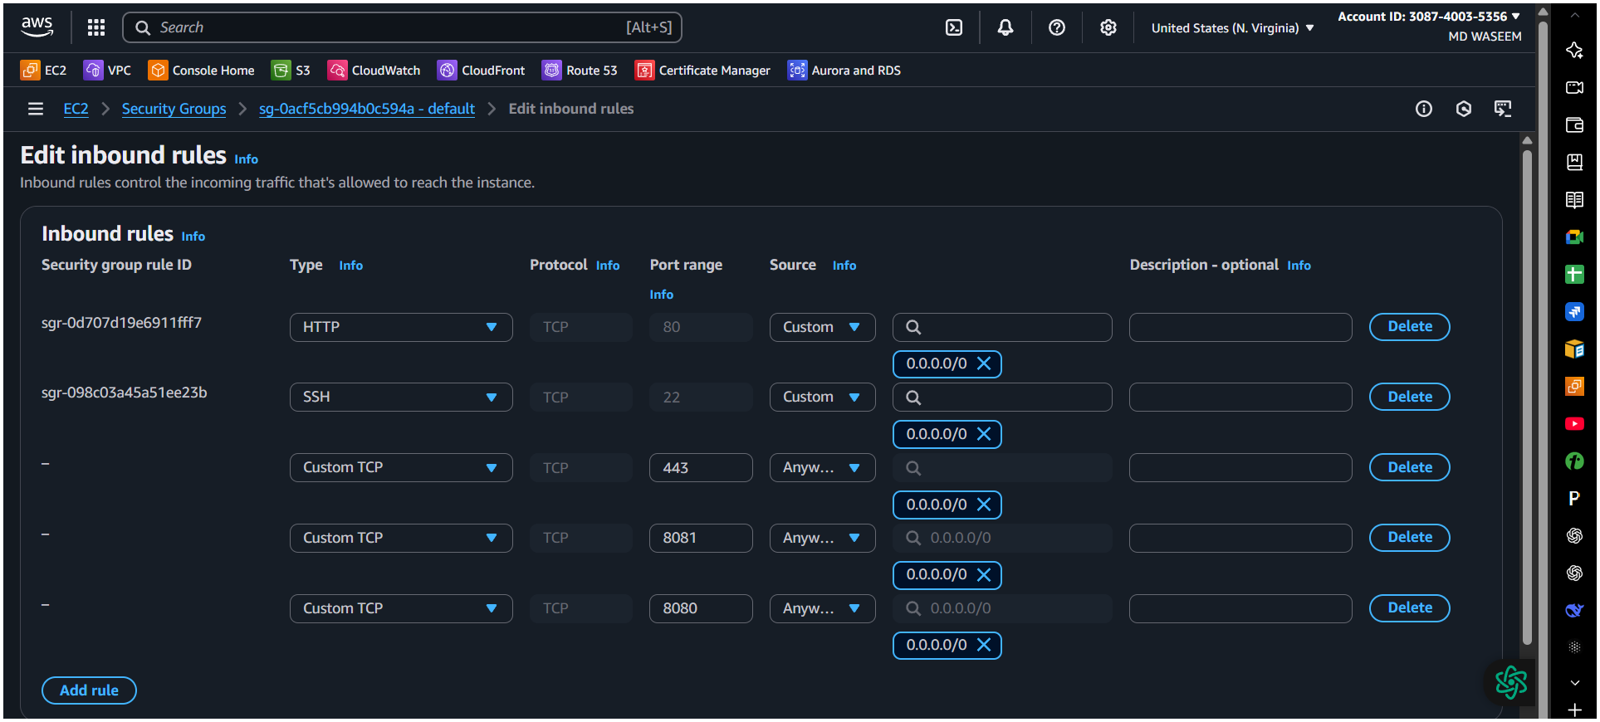

- And then switch to root user connect to shh -I pem key ec2-user@ ip addrs
- Use the git bash to execute these command’s
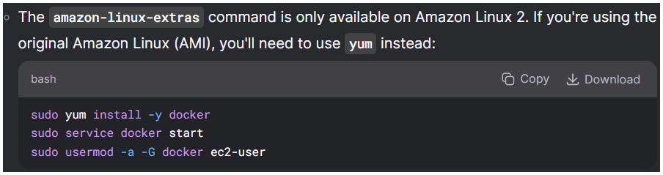
Sudo yum install -y docker
Getting started installation with Docker
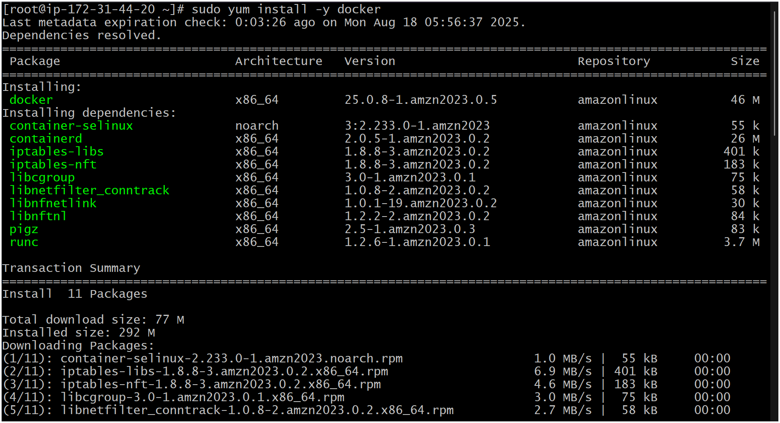

- Here we have successfully installed docker in ec2 with git bash.
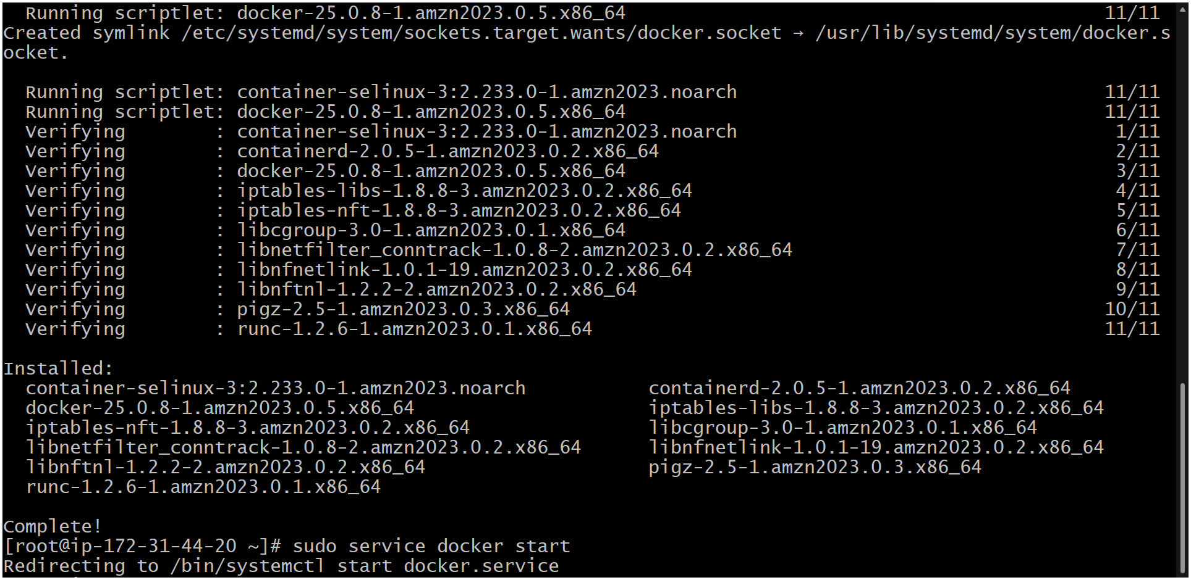
- Here we’re checking the version and running status.
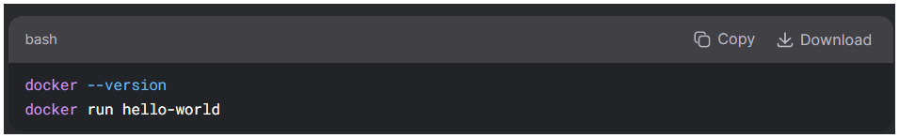
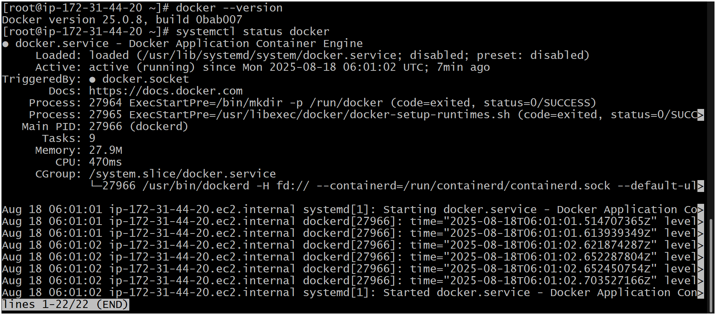

2) Install Jenkins
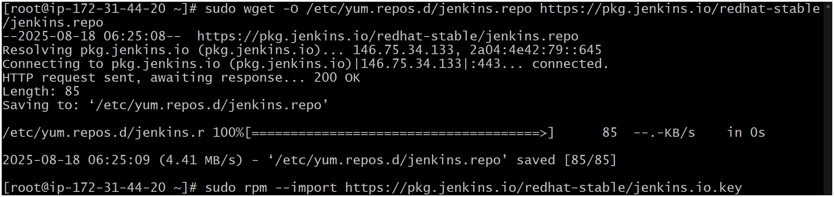
- Here I was facing error for java installation
I did some RND here is the Passover method

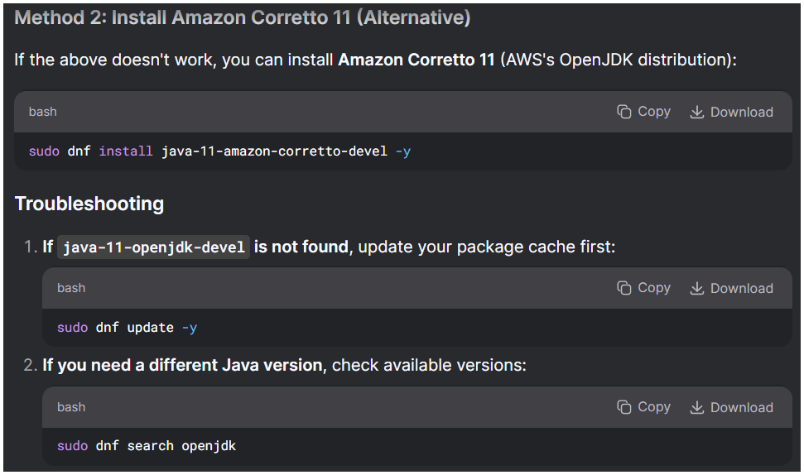
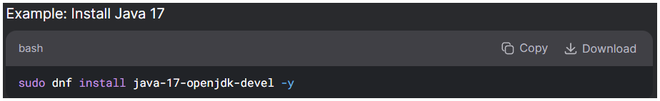

- Started installation of java
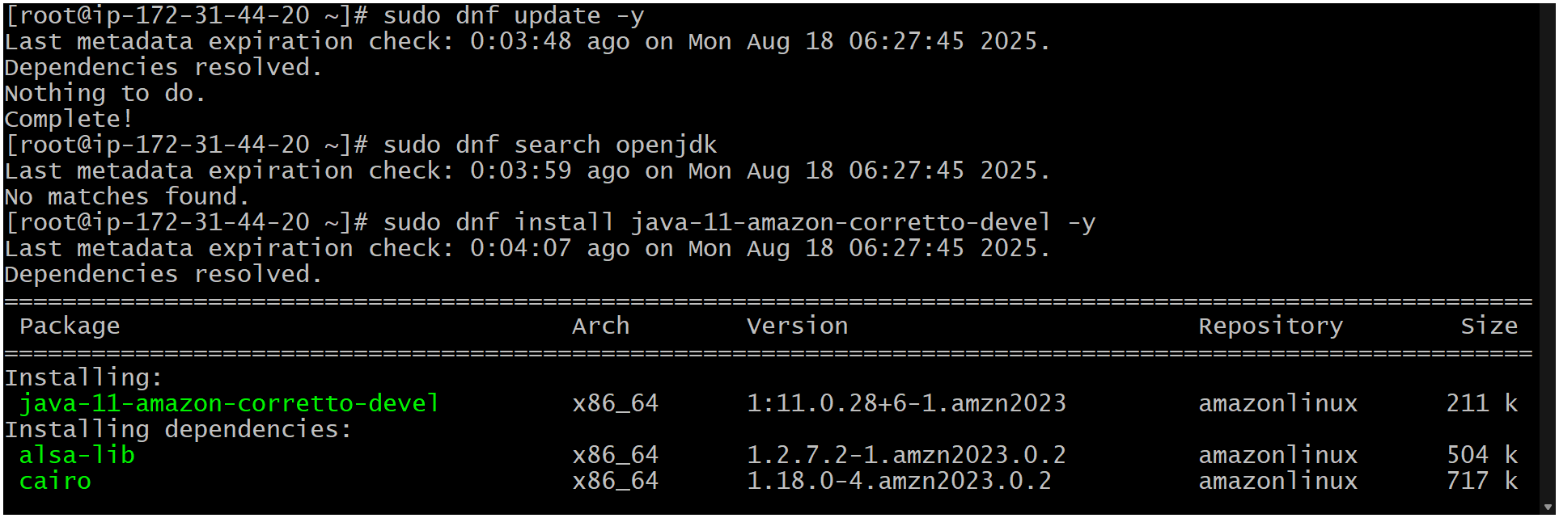
Successfully install java
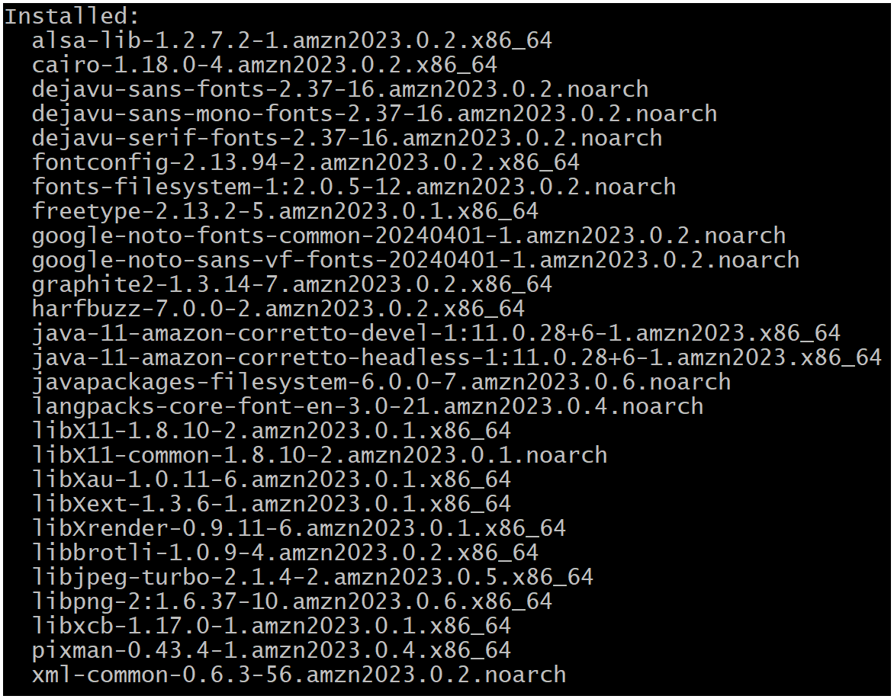

So, I Was Facing Some Error To Start The Junkins I Did Some Rnd To Get Error Free
[root@ip-172-31-16-80 \~]# java -version
openjdk version "17.0.16" 2025-07-15 LTS
OpenJDK Runtime Environment Corretto-17.0.16.8.1 (build 17.0.16+8-LTS)
OpenJDK 64-Bit Server VM Corretto-17.0.16.8.1 (build 17.0.16+8-LTS, mixed mode, sharing)
[root@ip-172-31-16-80 \~]# sudo systemctl status jenkins.service
× jenkins.service - Jenkins Continuous Integration Server
Loaded: loaded (/usr/lib/systemd/system/jenkins.service; enabled; preset: disabled)
Active: failed (Result: exit-code) since Mon 2025-08-18 09:46:31 UTC; 3min 59s ago
Process: 32603 ExecStart=/usr/bin/jenkins (code=exited, status=1/FAILURE)
Main PID: 32603 (code=exited, status=1/FAILURE)
CPU: 496ms
Aug 18 09:46:31 ip-172-31-16-80.ec2.internal systemd[1]: jenkins.service: Main process exited, code=exited, status=1/FAILURE
Aug 18 09:46:31 ip-172-31-16-80.ec2.internal systemd[1]: jenkins.service: Failed with result 'exit-code'.
Aug 18 09:46:31 ip-172-31-16-80.ec2.internal systemd[1]: Failed to start jenkins.service - Jenkins Continuous Integration Ser>
Aug 18 09:46:31 ip-172-31-16-80.ec2.internal systemd[1]: jenkins.service: Scheduled restart job, restart counter is at 5.
Aug 18 09:46:31 ip-172-31-16-80.ec2.internal systemd[1]: Stopped jenkins.service - Jenkins Continuous Integration Server.
Aug 18 09:46:31 ip-172-31-16-80.ec2.internal systemd[1]: jenkins.service: Start request repeated too quickly.
Aug 18 09:46:31 ip-172-31-16-80.ec2.internal systemd[1]: jenkins.service: Failed with result 'exit-code'.
Aug 18 09:46:31 ip-172-31-16-80.ec2.internal systemd[1]: Failed to start jenkins.service - Jenkins Continuous Integration Ser>
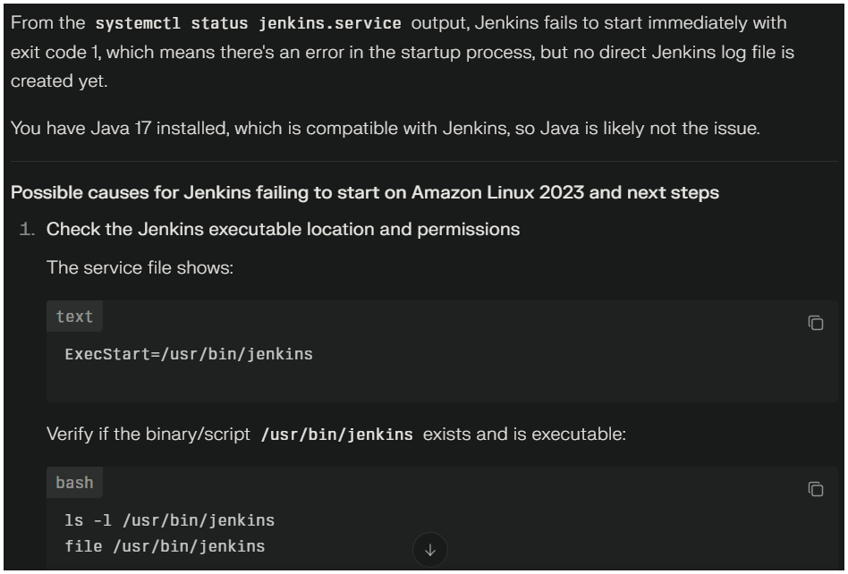
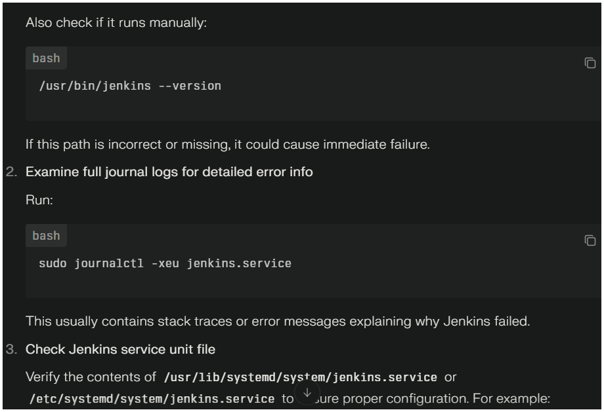
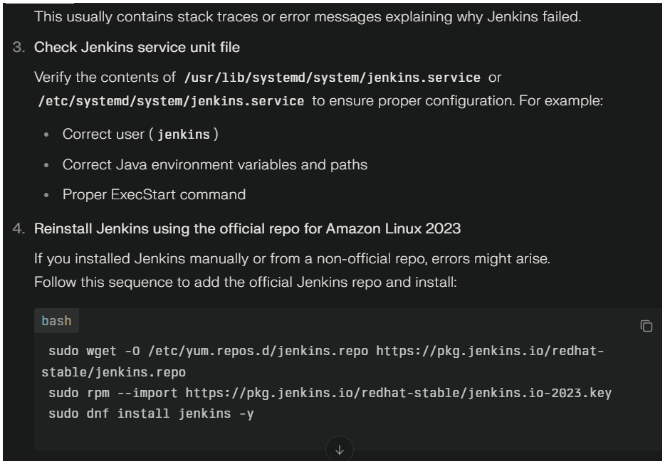
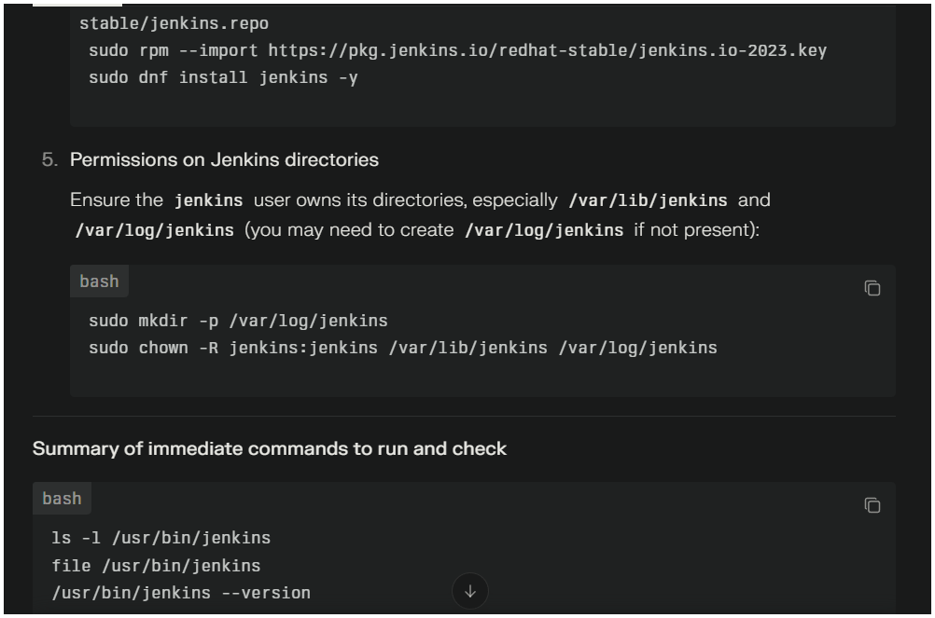

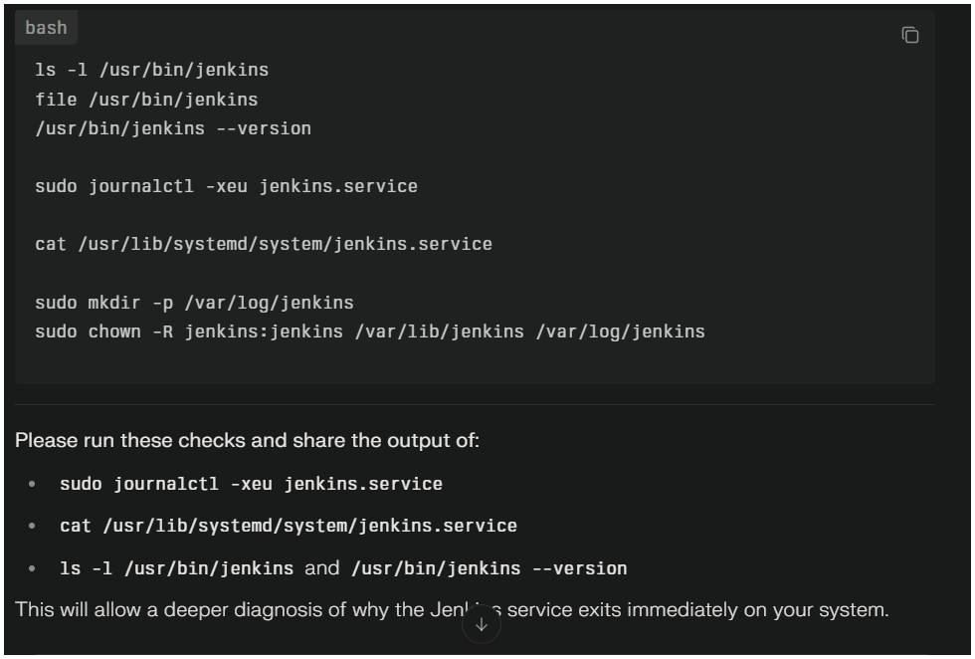
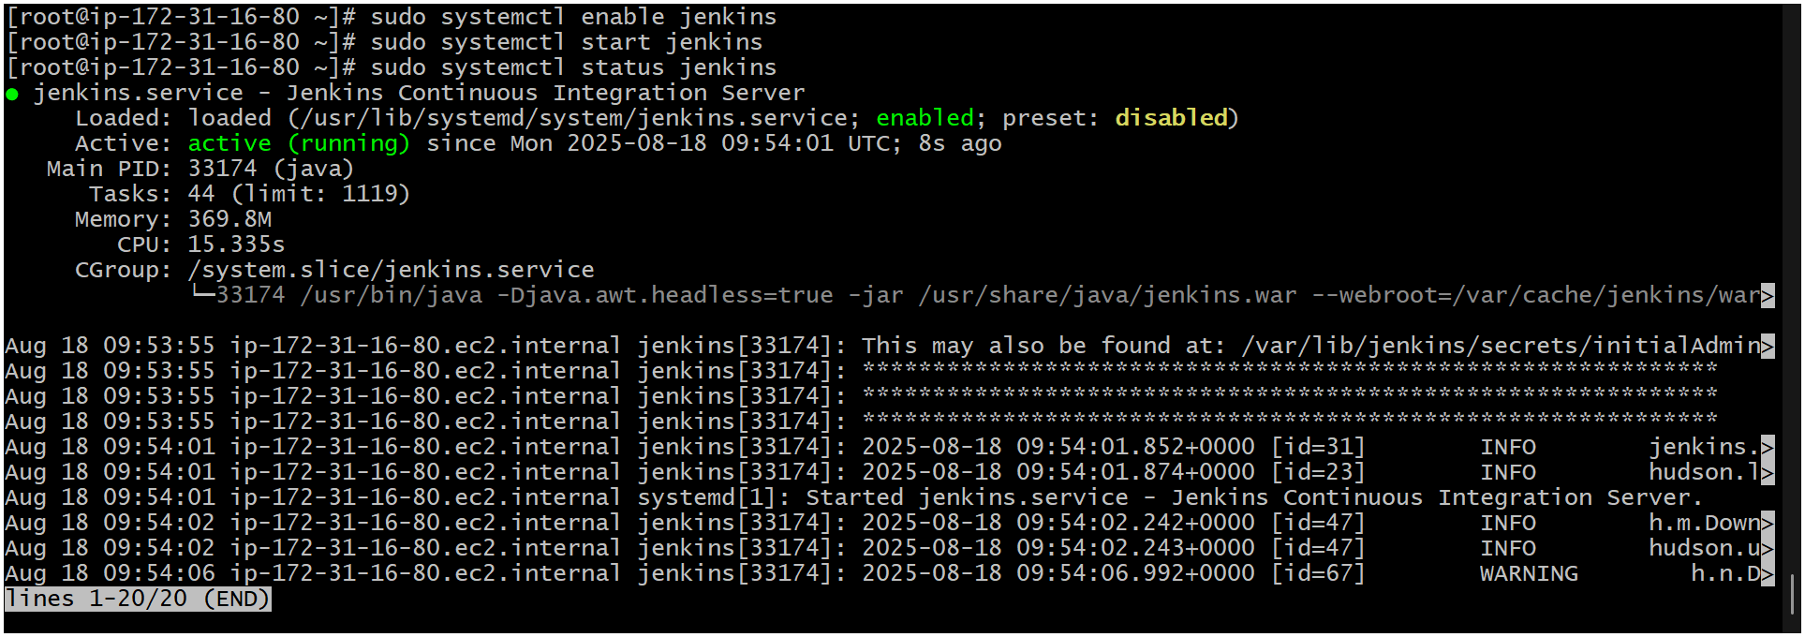
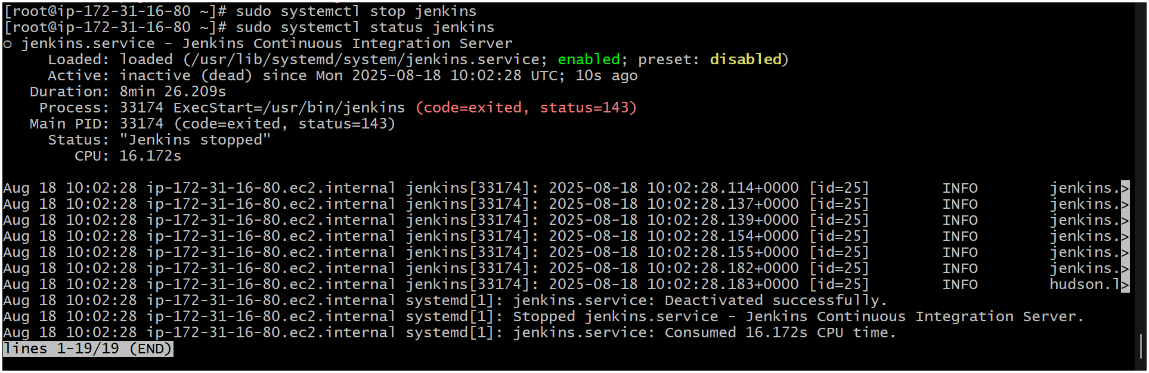

Install Apache
sudo yum install httpd -y
sudo systemctl enable httpd
sudo systemctl start httpd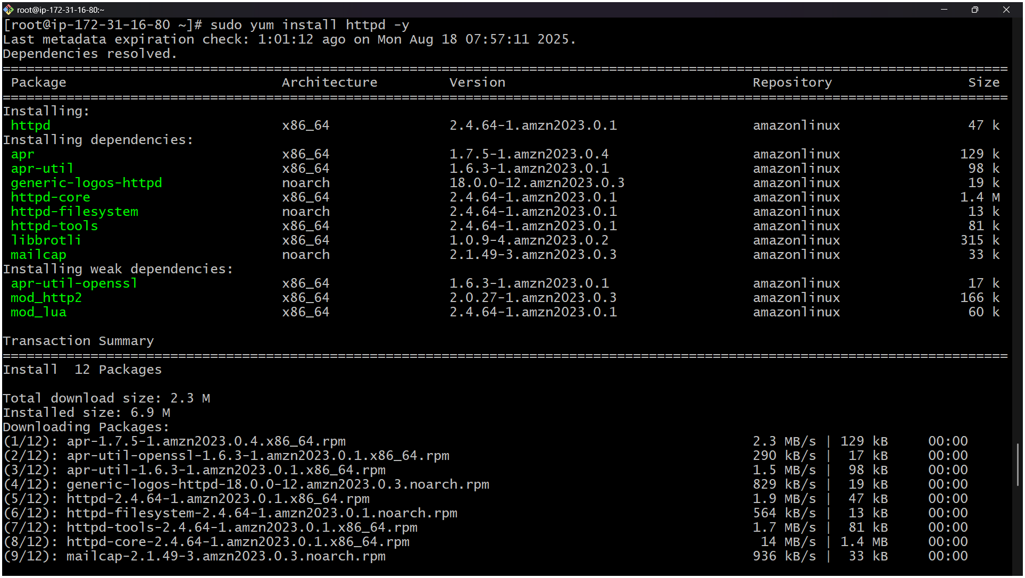
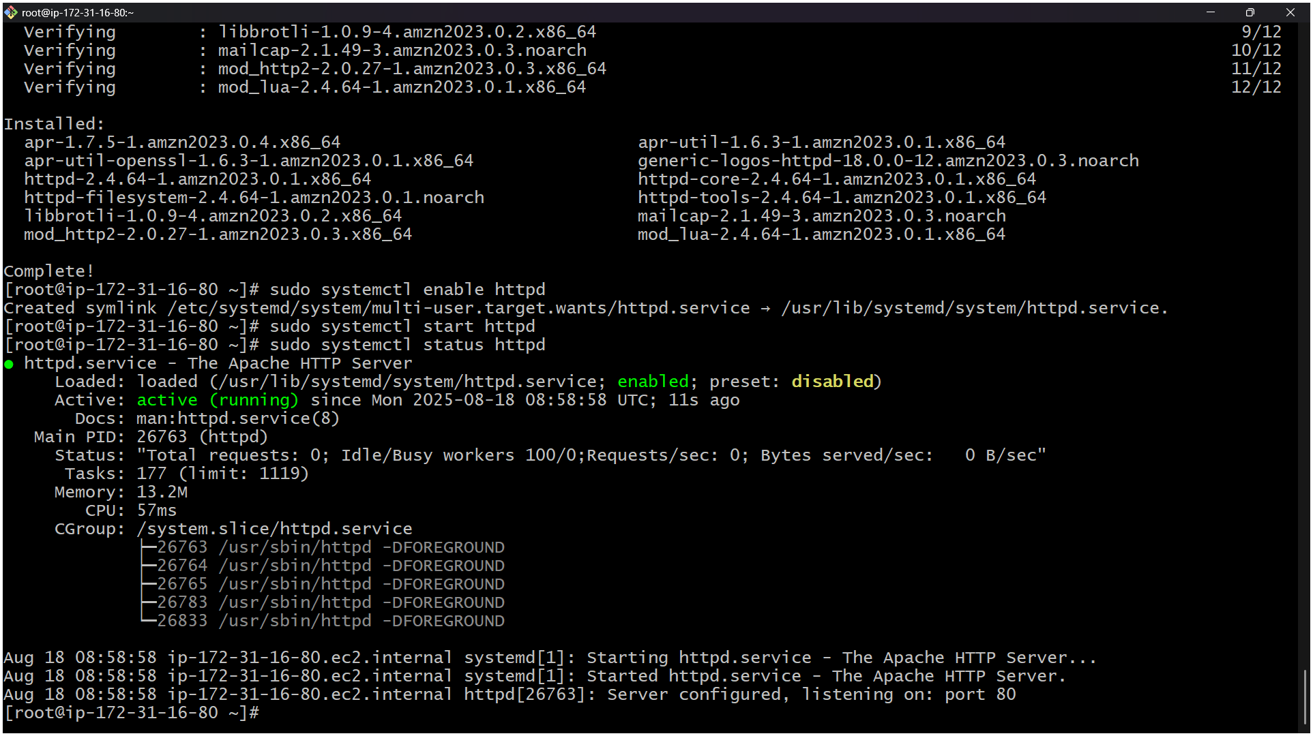
Install nginx
sudo amazon-linux-extras install nginx1 -y
sudo yum install nginx -y
sudo systemctl enable nginx
sudo systemctl start nginx
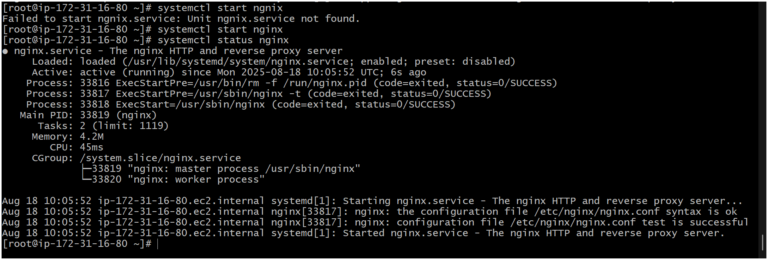
stop
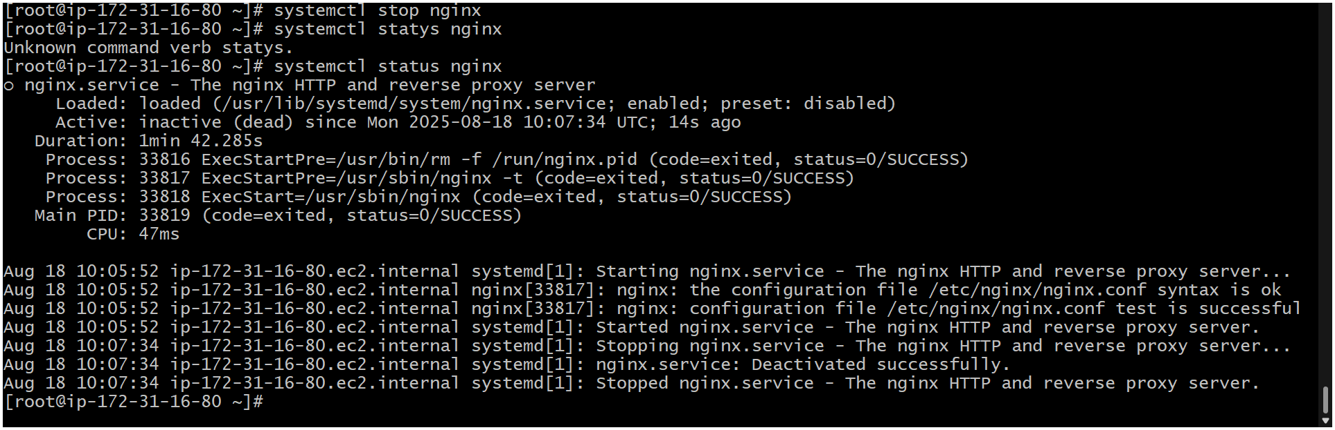

Install Apache Tomcat

Step’s to be followed to install Apache tomat
cd /opt
wget= https://dlcdn.apache.org/tomcat/tomcat-9/v9.0.108/bin/apache-tomcat-9.0.108.tar.gz
sudo tar xzf apache-tomcat-9.0.85.tar.gz
optional===/// sudo mv apache-tomcat-9.0.85 tomcat
=====sudo chmod +x /opt/tomcat9/bin/*.sh

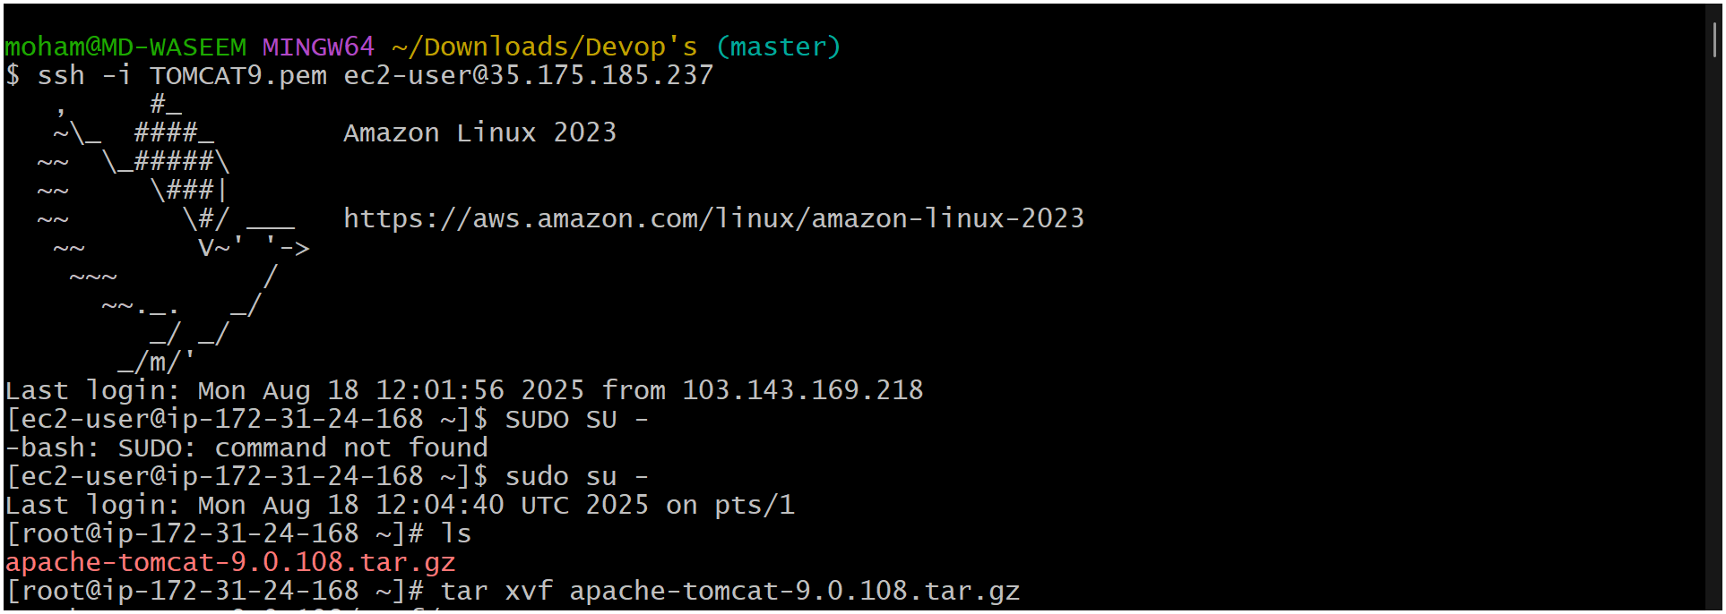

Cd apache-tomcat-9.0.108.tar.gz
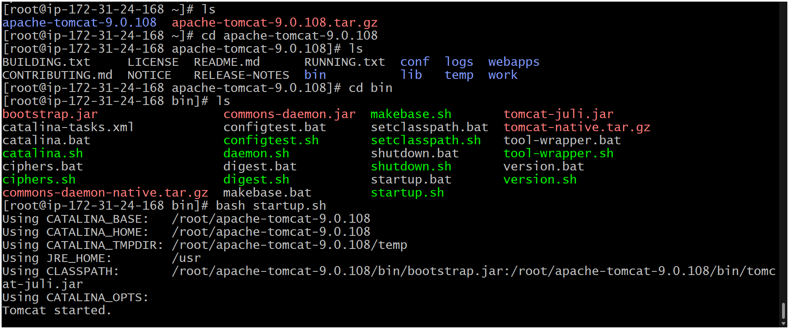
Ls
Cd /bin
Bash startup.bat
Copy the ip of public and past at last of address add :8080/
Eg :- http://35.175.185.237:8080/
