1st. First Create instances, then IAM
create role Trusted entity type AWS servicer Use Case select Lambda Next search AmazonEC2FullAccess next Give the name for your role Create Role button at the bottom left At Last Create Lambda…

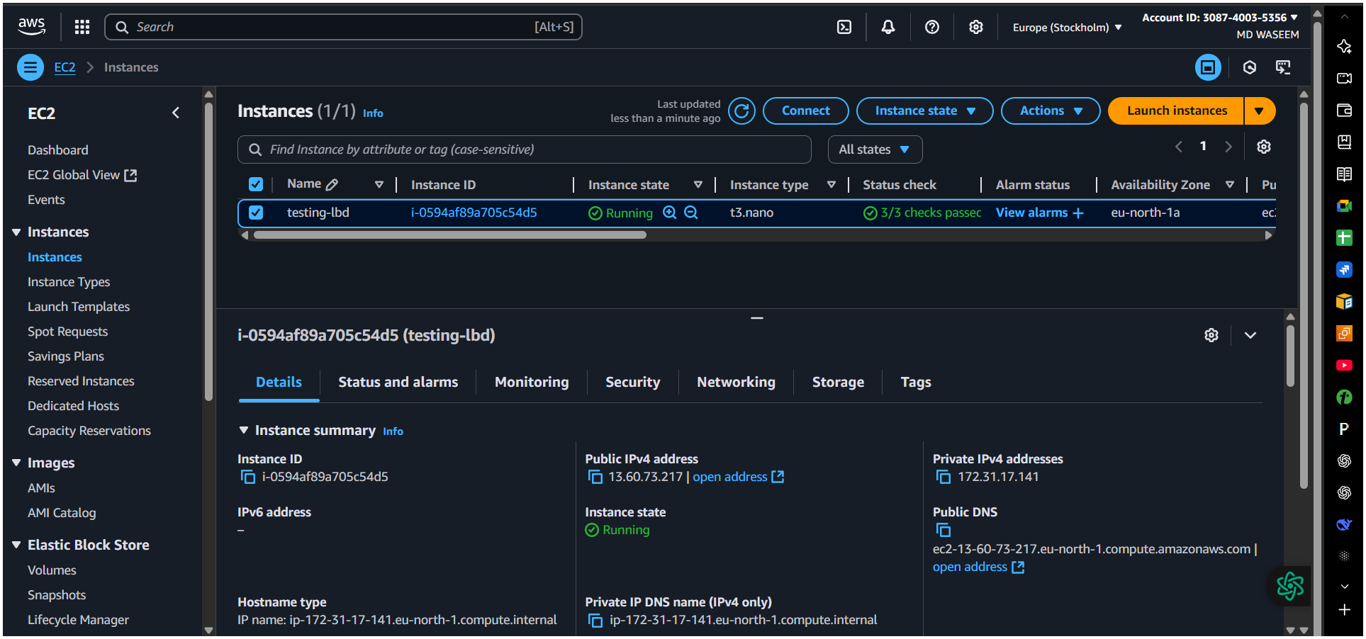
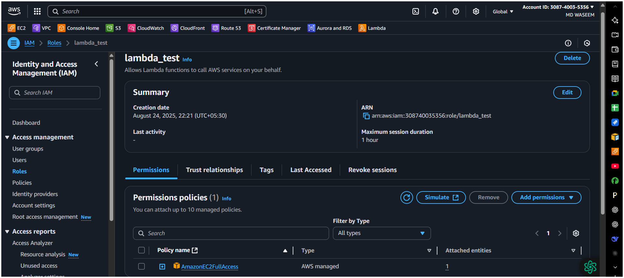
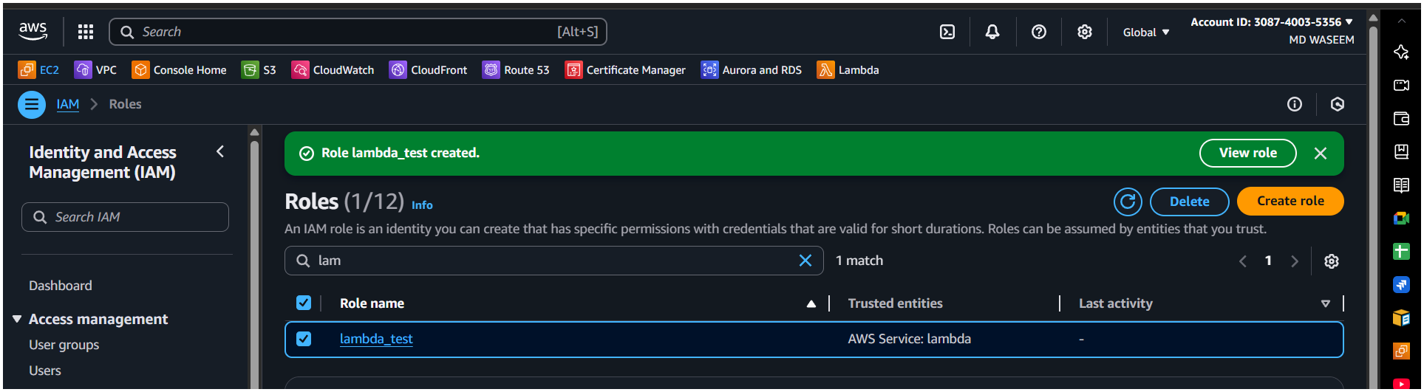

2nd. Click "Create Function"
On the Lambda dashboard, click the "Create Function" button (usually orange).
3rd. Choose Function Creation Method
You’ll see four options:
Author from scratch (Most common) → Start with an empty function.
Use a blueprint → Pre-built templates for common use cases (e.g., processing S3 files).
Container image → If your code is packaged as a Docker container.
From AWS Serverless Application Repository → Pre-configured serverless apps.
{Recommendation: If you're new, choose "Author from scratch."}

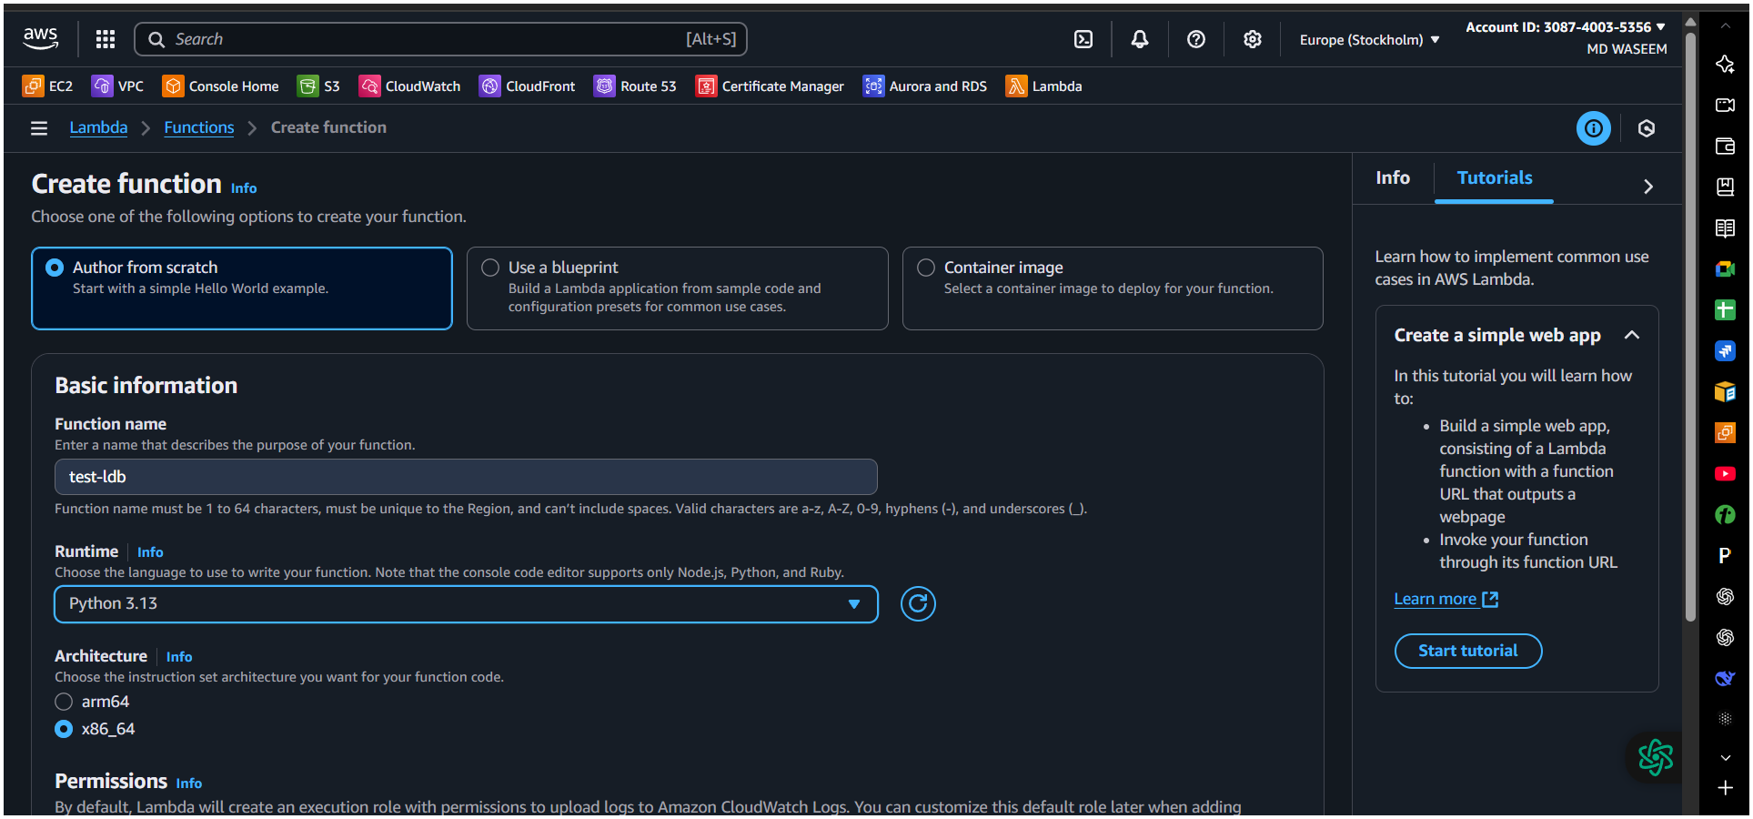
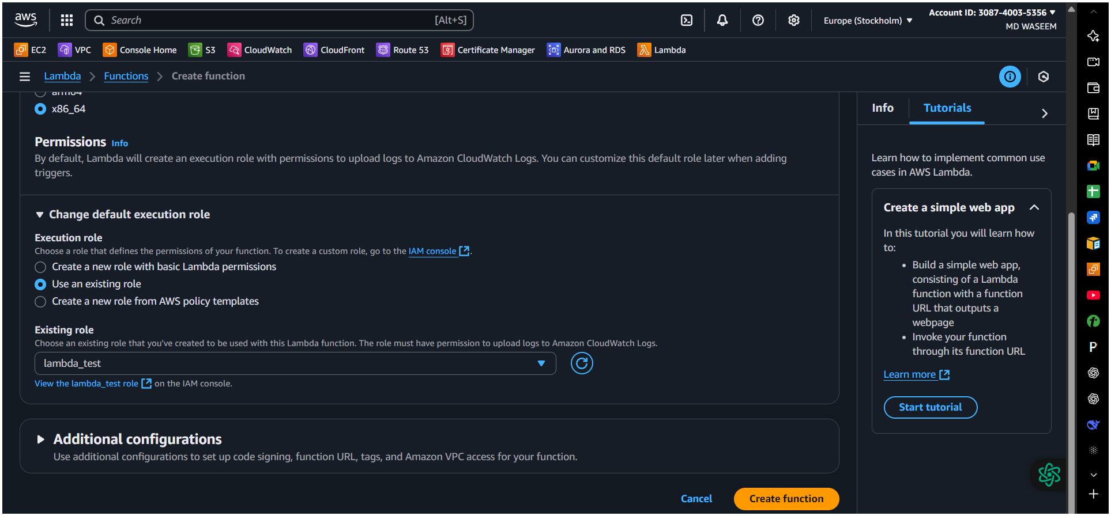
Here in the Lambda in setting (change default execution role) use an existing role
select your role (lambda test) create fuction
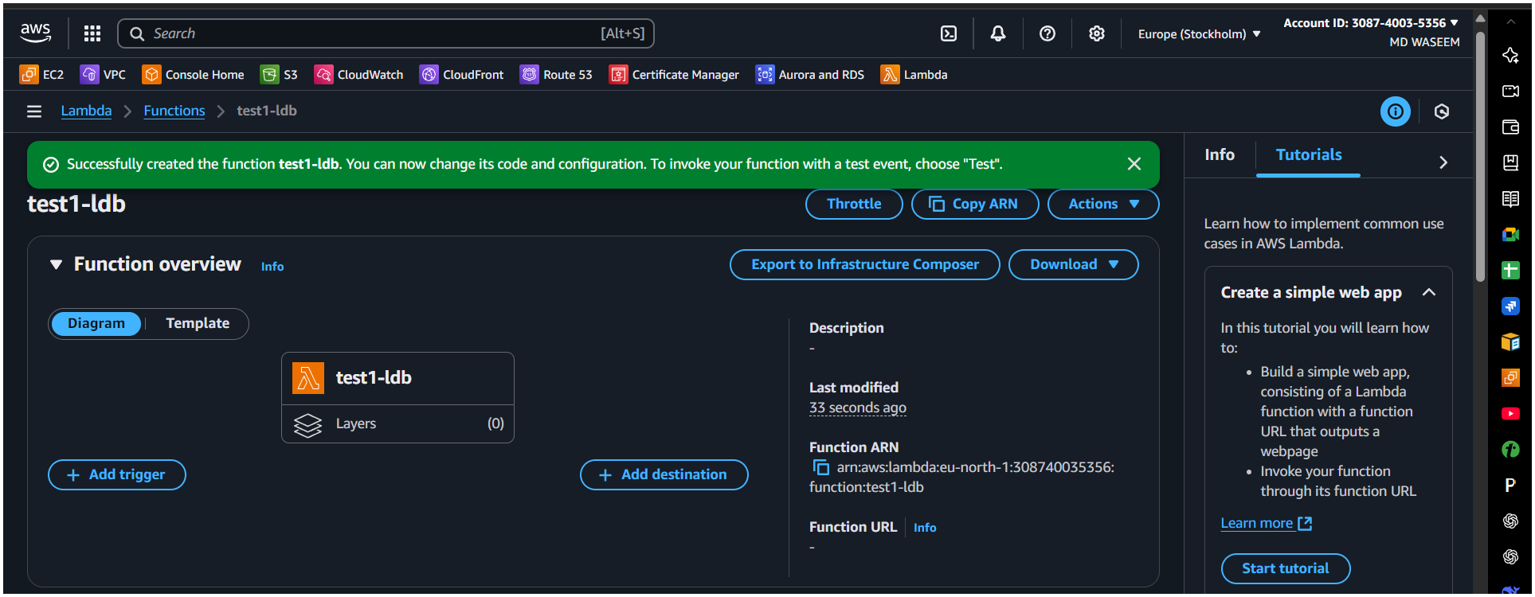
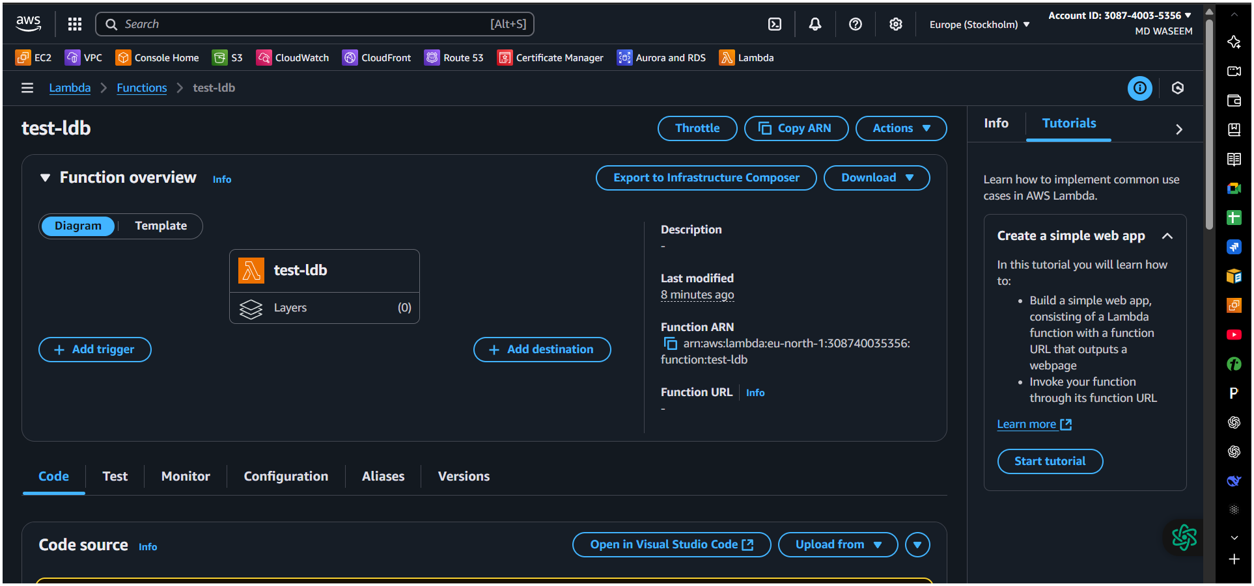

What It Does in Simple Terms
- When this Lambda function is triggered:
  - It connects to your EC2 service in the Stockholm region (eu-north-1).
  - Stops the instance with ID i-0594af89a705c54d5.
  - Prints/logs a message saying the instance has been stopped.

import boto3
region = 'eu-north-1'
instances = ['i-0594af89a705c54d5']
ec2 = boto3.client('ec2', region_name=region

def lambda_handler(event, context):
ec2.stop_instances(InstanceIds=instances)
print('stopped your instances: ' + str(instances))
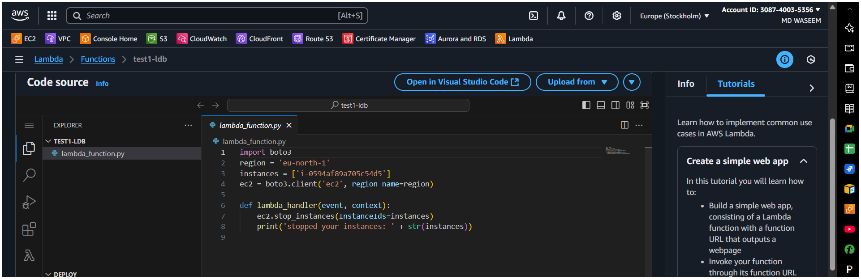
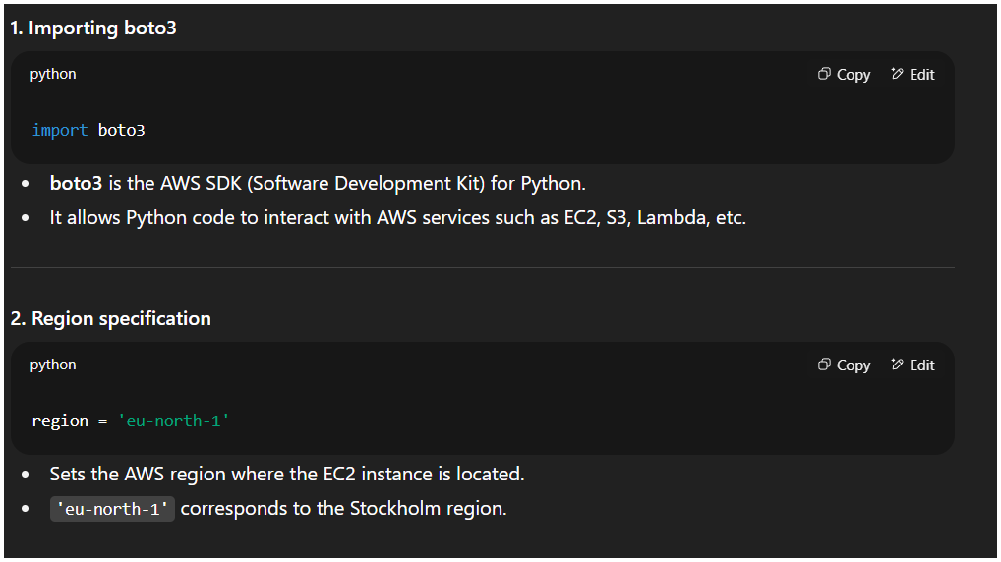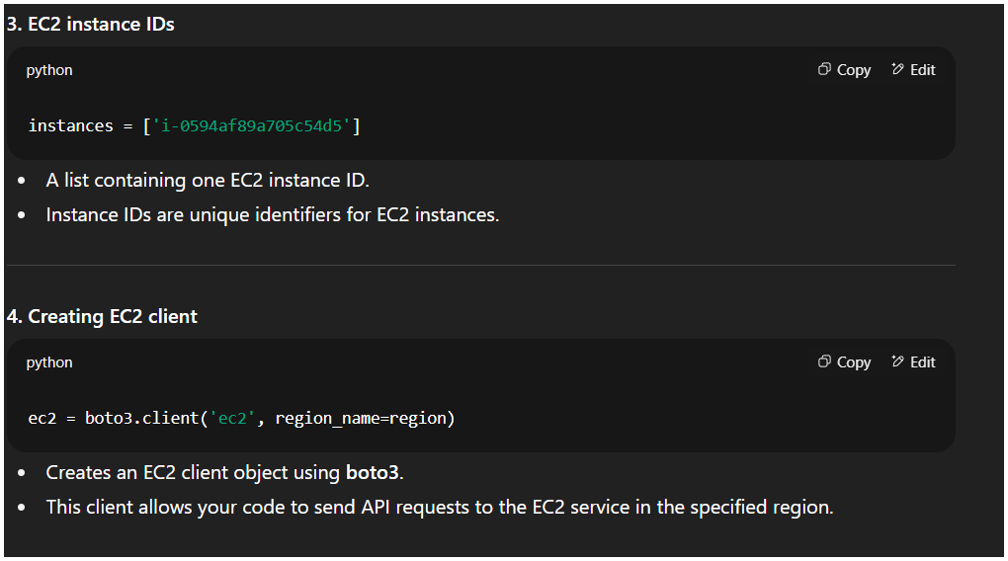
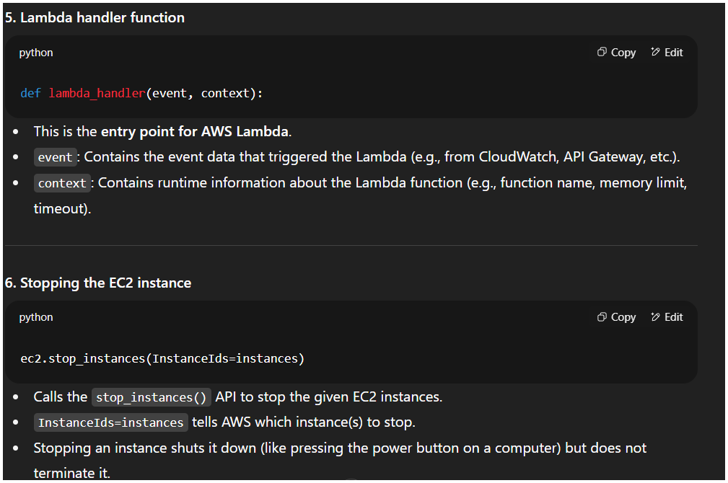
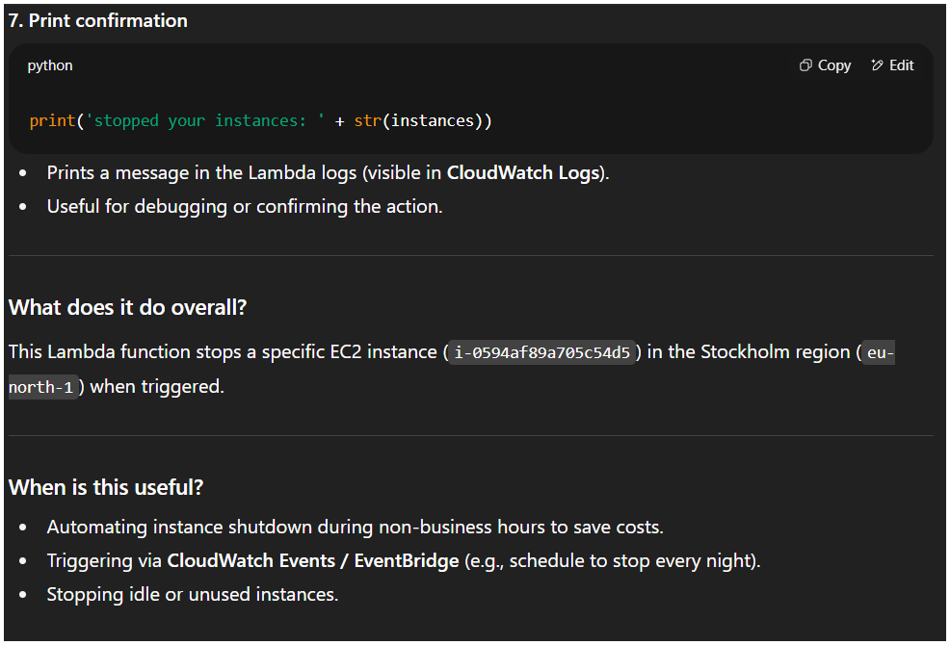

IN Lambda in past the above command and then press the deploy button then finally press test the below is the result ( THE COMMAND WITH STOP THE INSTANCES)
